|  |
| --- |
| [Company name] |
| [Document title] |
| [Document subtitle] |

|  |
| --- |
| bella abdelouahab  [Date] |

This rapport of practical work was made to complete the first one and remind us about other functionality of sql

The process starts by creating an non-organized data base and effect the necessary modification to run it and also getting more control over the data base

**INTRODUCTION**

# **Part** : Creating Data base and constraint

## Create table DEPT:

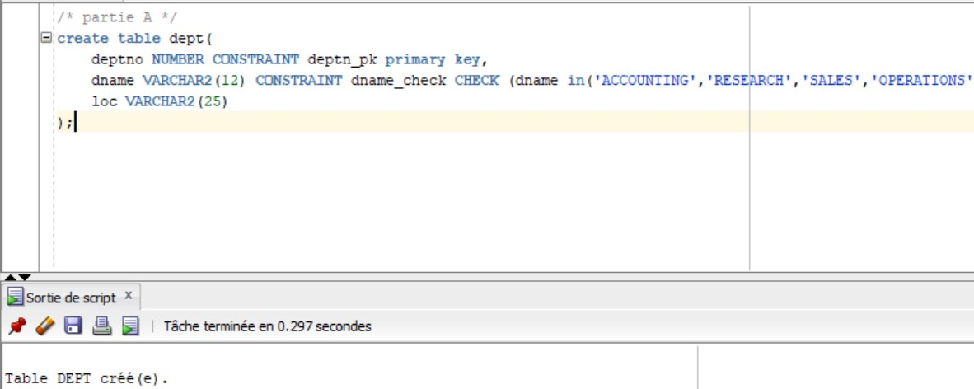

## Fill in the Data:

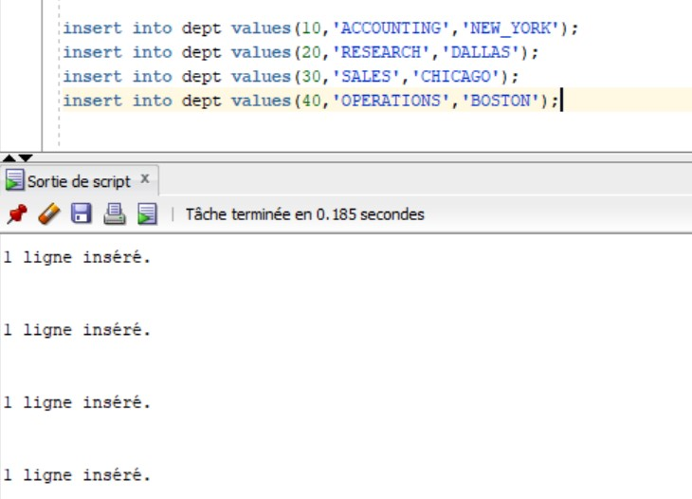

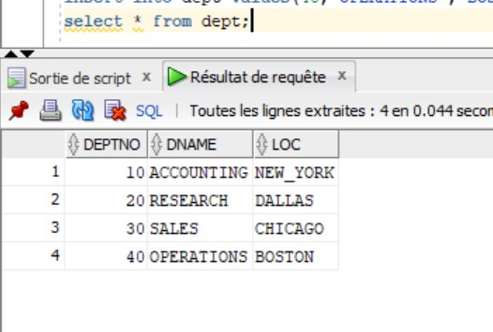

## Fill in the Data into EMP:

Because I don not have the table SCOOT.EMP we have to create table with the normal method :

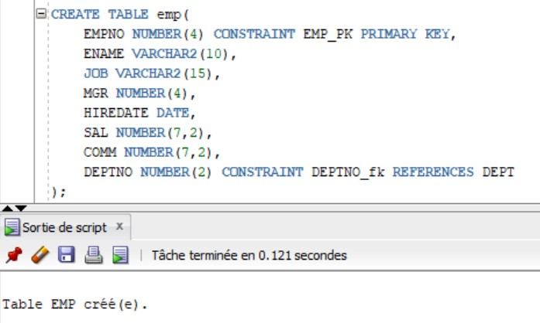

Now we fill in the data:

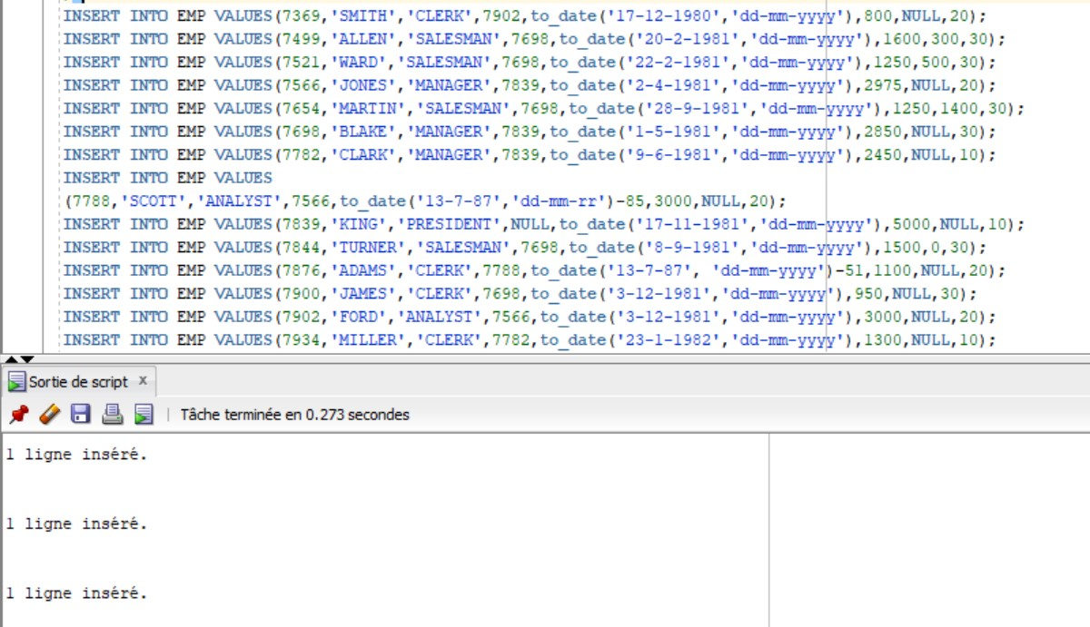

## Fill in the tuple to emp:

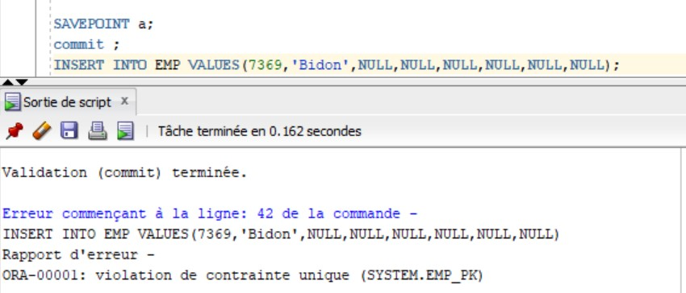

D.2:

no, because in my case I did not copy an array in emp, but if we copy an array within another array the command must check because the copy operation takes the values ​​not from the constraints.



## Cancel the task:

Because in the early picture I have created a check point now I can roll Back to it

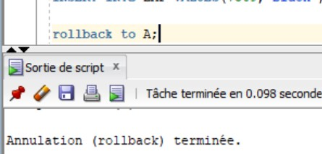

## Creating constraint :

Due to the table is not a copy so all the constraint remains valid.

## Adding the new employees to the table EMP:

# 

we notice the following error when we try to insert the data :

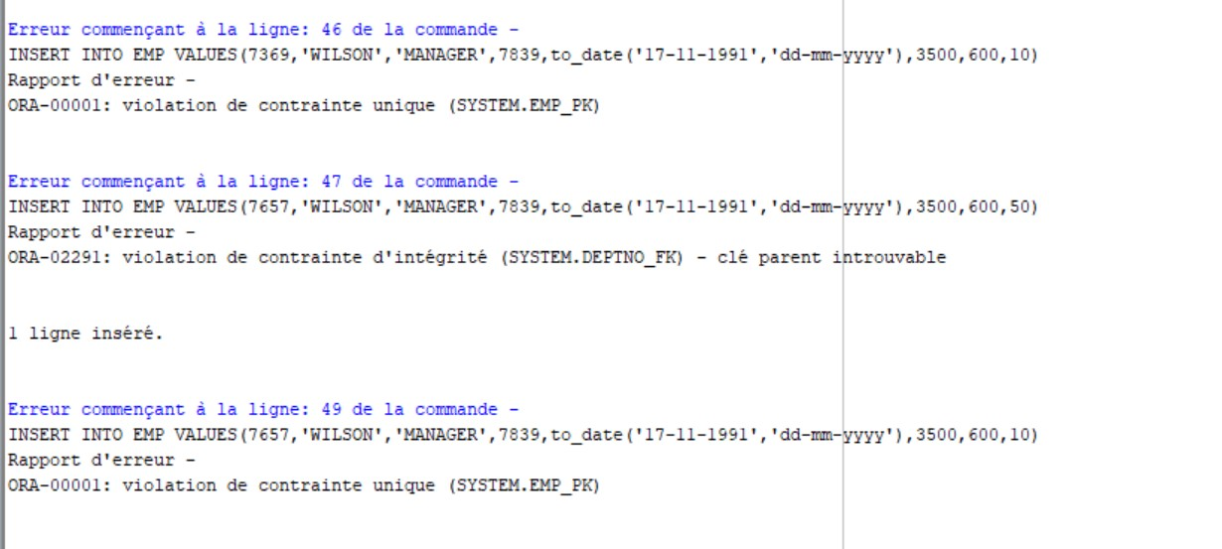

We can not insert the rows 1,2,4 because they violate the constraint (primary key and . foreign key ) but row 3 inserted seccessfully

## Validate the previous inserting :

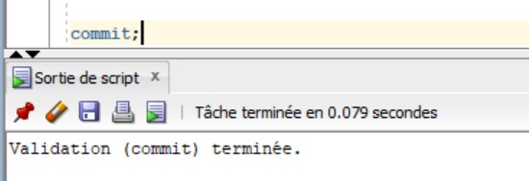

# Updating the Data Base :

## Changing location in EMP:

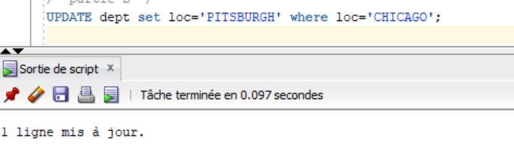

## Increasing the salary:

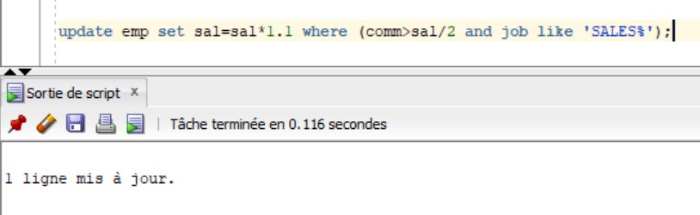

## Changing commission :

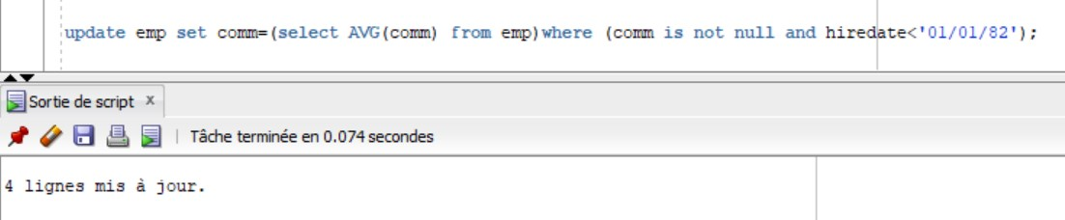

All the employees with hire date less than 1-1-82 will be updated

## Cancel all the three updates :

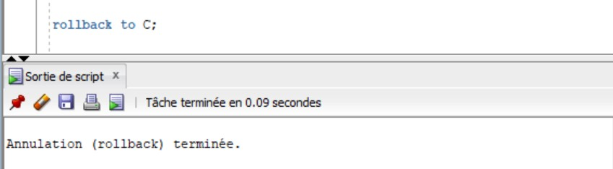

## Delete the department with number 20:

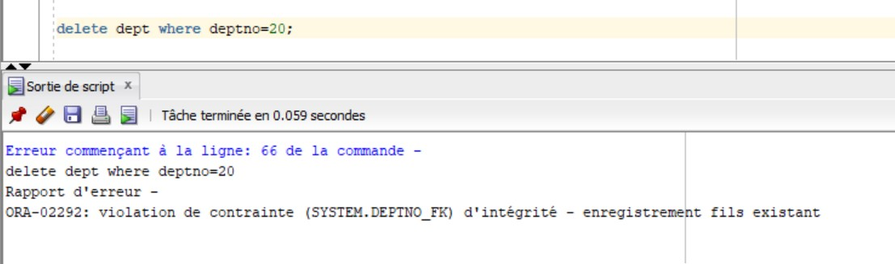

We notice that we are evaluate the previous constraint.

# Data Base Integration:

## Name (ENAME), salary, commission, salary + commission of all sellers (SALESMAN).

## 

## Name of salespeople in descending order of commission / salary ratio.

## 

## Name of salespeople whose commission is less than 25% of their salary.

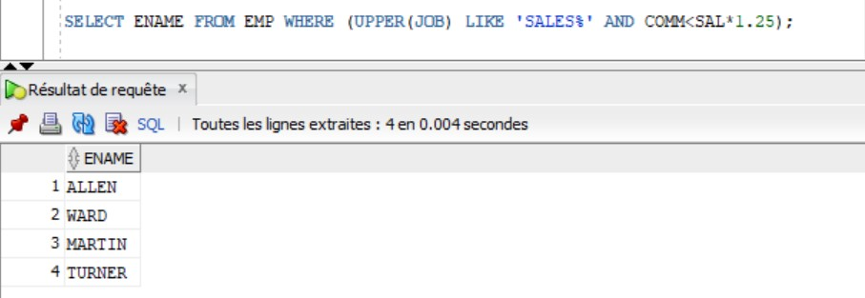

## Number of employees of department n ° 10.

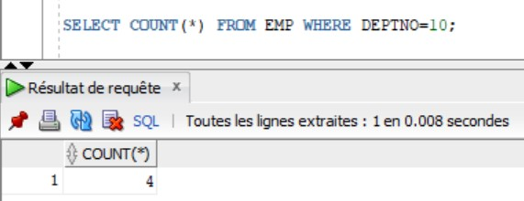

## Number of employees with a commission. 6) Number of different functions (JOB).

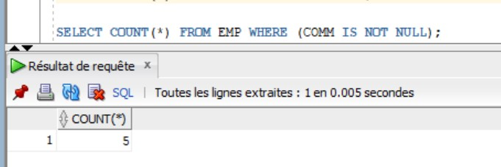

## Average salary by function (without taking into account commissions).

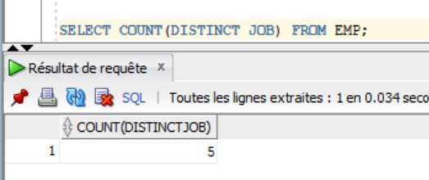

## Total SALES department salaries.

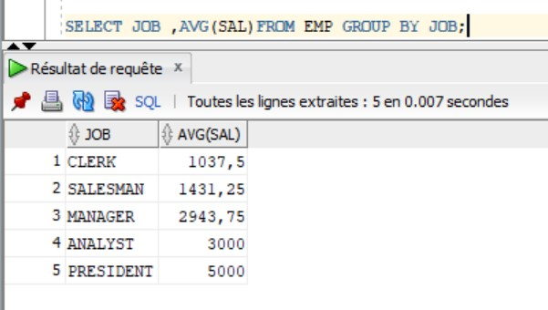

## Total SALES department salaries..

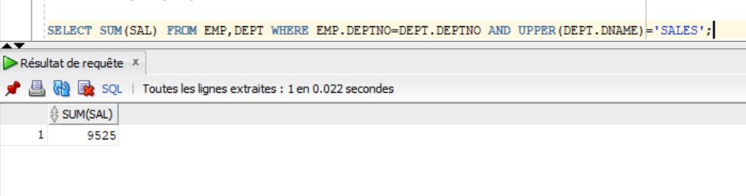

## Name of employees with the name of their department.

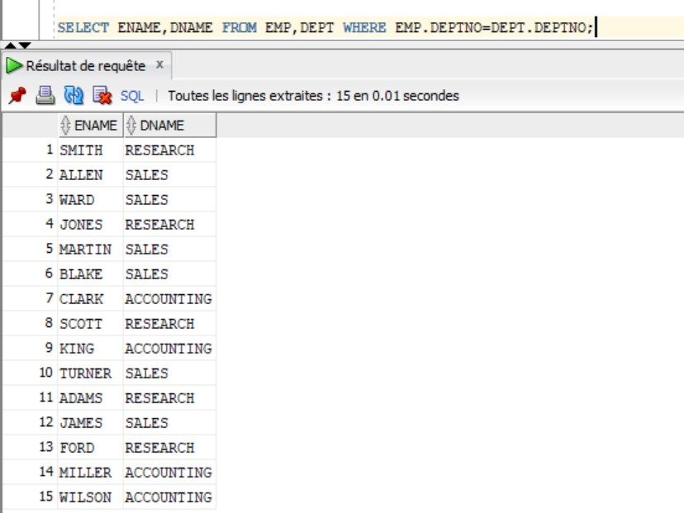

## Name, title and salary of the employee with the highest salary.

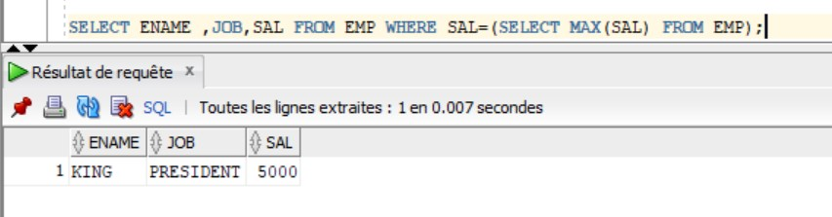

## Name of employees earning more than JONES.

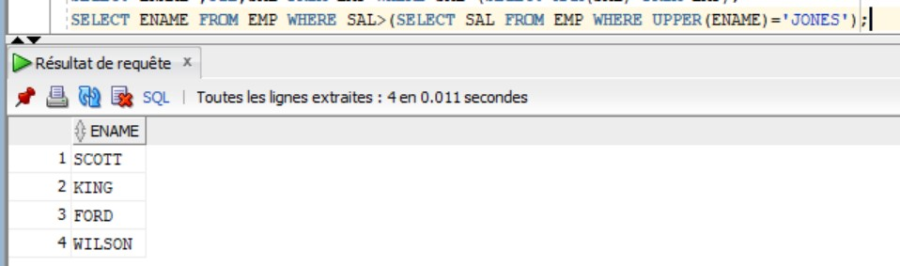

## Name of employees occupying the same function as JONES.

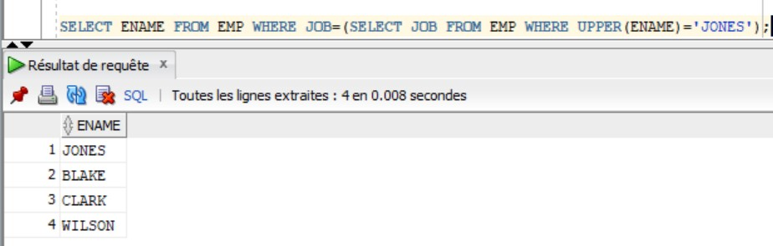

## Name of employees with the same manager (MGR) as CLARK.

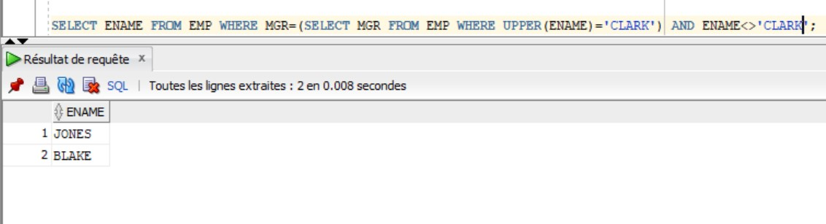

## Name and function of employees having the same function and same manager as TURNER.

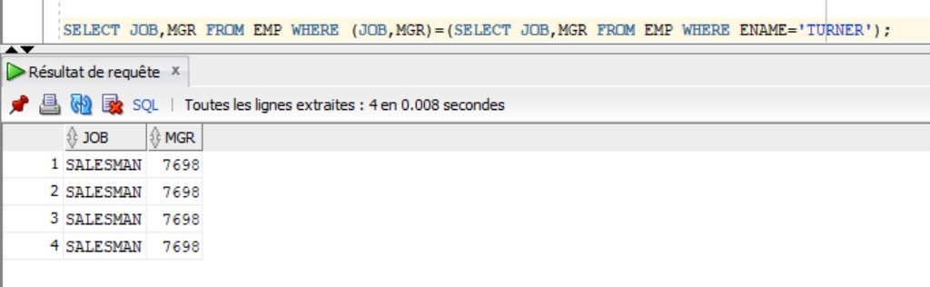

## Name of employees hired before all employees of department # 10.

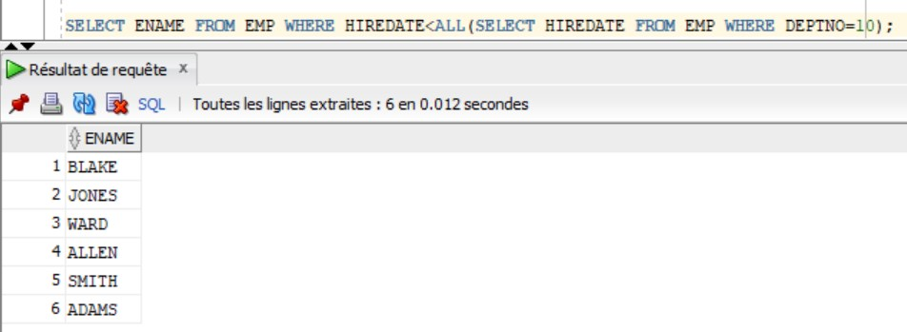

## List of employees, indicating for each their name and that of their manager

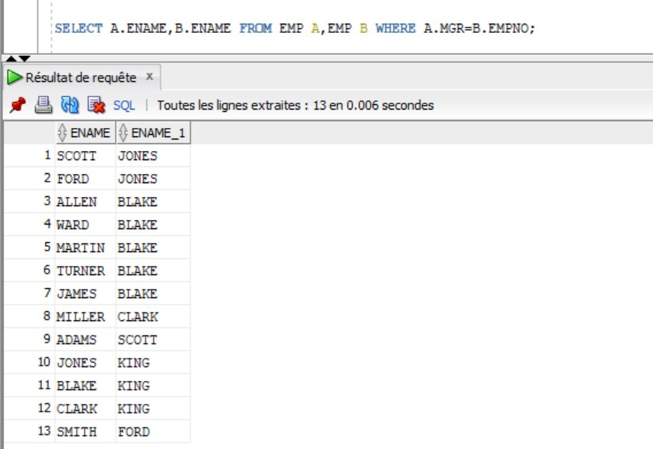

## Name of employees who do not work in the same department as their manager.

