**Group 2**

Giabella Apo

Brandon Benavides

Violet Gonzalez

Thunder Harding

Roald Medendorp

**Report 1:**

This report displays the relationship between the distributors, the wines they carry, and the amount they sell. This is achieved by combining the distributor column from the Distributor table with the wine and wine sold columns from the Wine table. This report can help us determine what is wine is being sold the most and by which distributors.

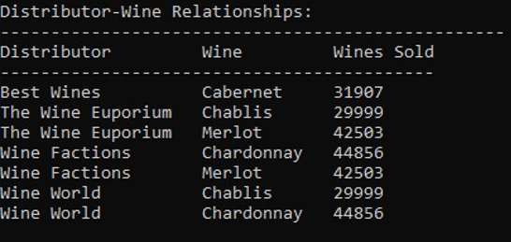

**Report 2:**

This report displays the names of the delivery, wine, and distribution along with their expected and actual delivery dates to show the delivery details of customer orders. This report combines three tables to obtain its data. The delivery name, expected date, and actual date columns are from the Delivery table. The distributor name column from the Distributor table. Finally, the wine name column is from the Wine table.

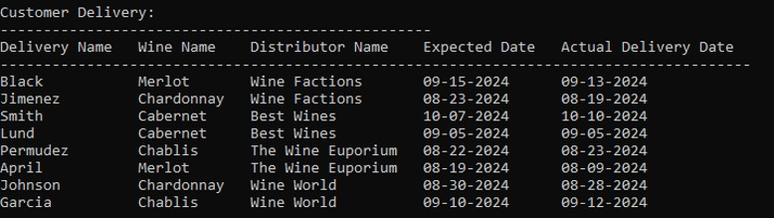

**Report 3:**

This report obtains all of its information from the Employee table. However only the employee last name, hours worked, and employee position columns are taken from the original table. This report is condensed to focus on the hours each employee works.

