Assignment 2.3: Data Models

Bella Apo

CSD310

June 3rd, 2024

ERD Data Structure:

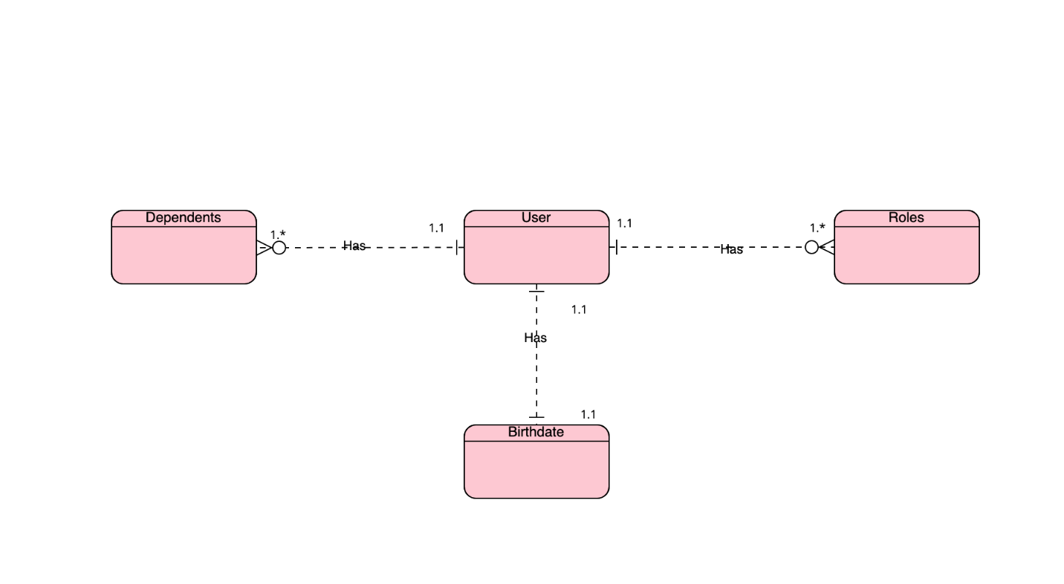

NoSQL Data Structure:

