Assignment 5.2: MySQL Functions

Bella Apo

June 17, 2024

CSD 310

**Function 1: NOW()**

NOW() function returns the current date and time. This is useful for timestamping records and logging events.

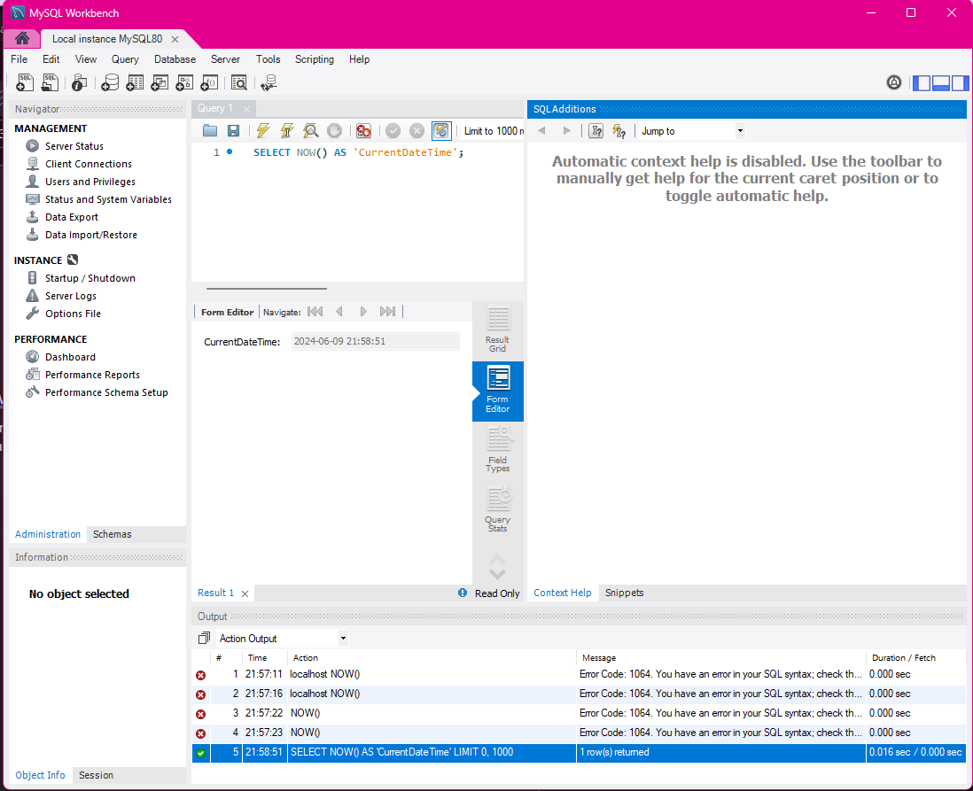

**Function 2: DAY()**

The DAY() function extracts the day from the date. This is useful if you want to look at the day of the month, regardless of the month it occurred, or the year it happened. Possible use cases could be seeing the bills due on the first of the month or sales trends on certain days.

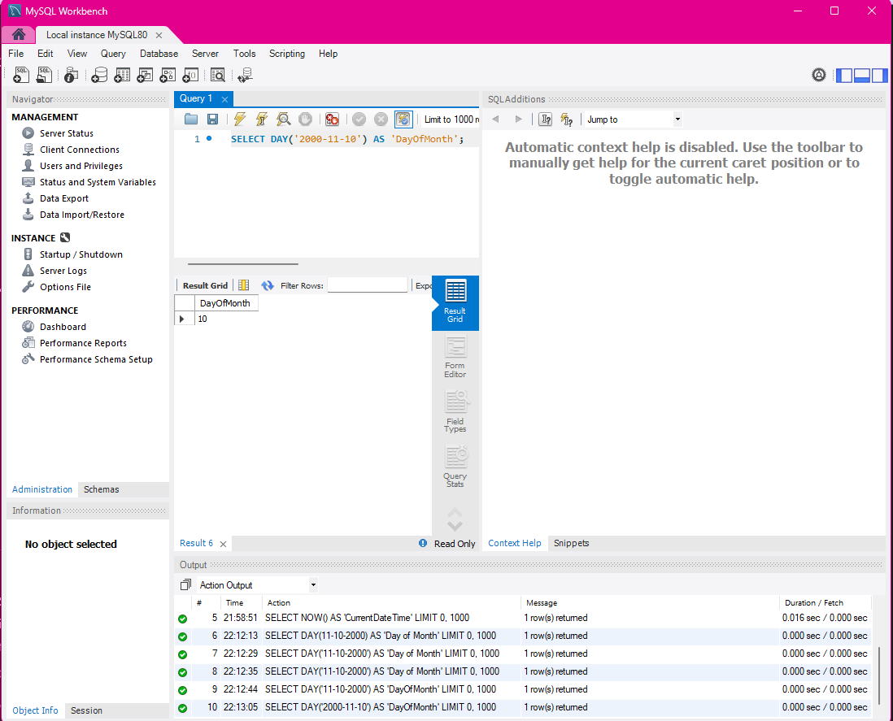I struggled a bit with the fact that the dates are a bit different than the formatting that I am used to, with the date coming first and that was hard for me to realize what was wrong. It’s something that might be tricky for me to remember to do.

**Function 3: LAST_DAY()**

The LAST_DAY() function extracts the last day of the month from the date provided. This is useful for generating month end reports, deadlines and due dates, and determining the end of the billing cycle.

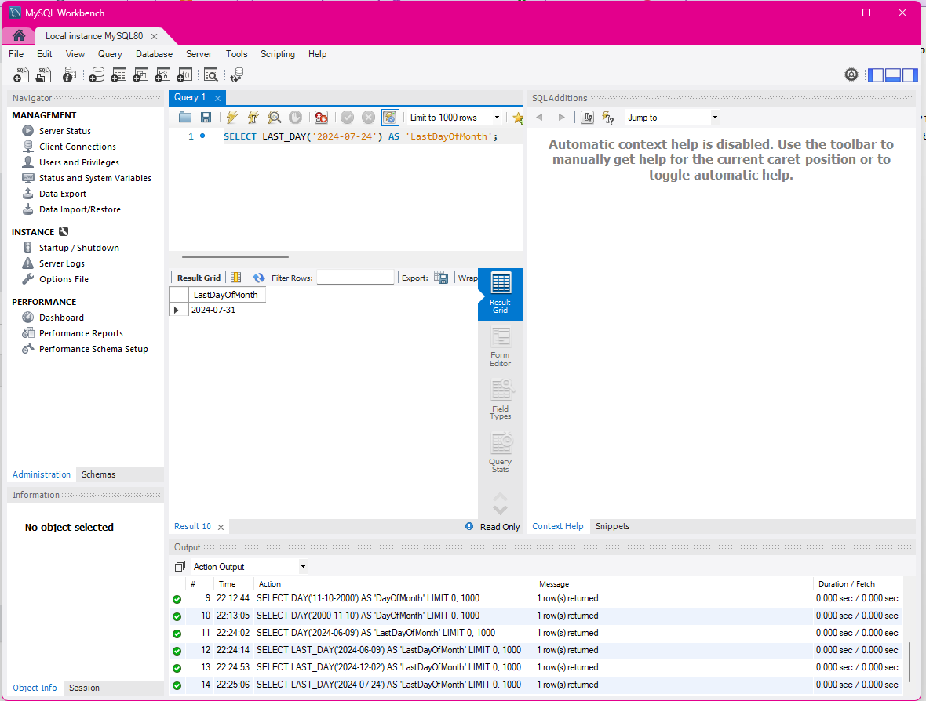

References:

*W3Schools.com*. (n.d.). <https://www.w3schools.com/sql/sql_ref_mysql.asp>