The relationship between House Investment and Economic Environment

Baoheng Huang

Harrisburg University of Science and Technology

The relationship between House Investment and Economic Environment

As is known, any commodity has both value and price. As one kind of merchandise, the house also has its intrinsic value and market price. The cost of a home is providing a living condition for one family or one person. The price of a house is currency amount basing on market value.

House price index is a broad measure of the price movement of the residential housing in the United States. Commonly, House price index is used widely for house price in the market, and it is a direct measurement of the house price. The House price index is a sales-repeated, weighted index, meaning that it measures average price changes on the same properties by refinancing or sales repeat. This information is obtained by reviewing to repeat mortgage transactions on single-family properties whose mortgages have been purchased or securitized by Fannie Mae or Freddie Mac since January 1975. Also, there are similar concepts published by other Institutes, such as Case-Shiller index prices, Residential Price Index.

In recent years, investment property is accessible worldwide. Investment property is a real-estate property that purchases with the intention of earning a return on the investment, either through house lease income, the future repeat-sale of the real estate or both. A property can be a long-term endeavor, such as land, or an intended short-term capital such as in the case of overturning, where investment property is purchased, renovated or remodeled, and sold at a profit or loss.

With the development of the financial market, people are more and more willing to invest in different kind of finance productions or derivatives. As a result, more and more people take houses as a long-term investment. This research will focus on the differences between the value of the home and the price of the house.

House investment is known similar to real estate investing which includes the purchase, sale, rent, management, and ownership of real estate for profit.

If the difference between value and price of a house is more than an average commodity, that means people prefer to take the home as the long-term investment. On the other side, it says people prefer to make the house as a living commodity.

The significant part of the research is to find suitable indexes to stand for the value of the house. It is an excellent choice to compare home with others living commodity. However, there is no similar commodity has such long-term value as the house. As a result, it is essential to select one economic variable as a useful benchmark with house value.

# Literature Review

In past 20 years, especially after 2009, there is a sharp increase in house price combined with the unbelievable economic development of China. Compared with U.S., house price level in China seems significantly higher than its justified by underlying fundamentals (Ahuja, 2010). It shows that property price changes affect the domestic demand for the house. In other words, house demand plays an impact on house price. Thus, It would be applied a similar model to check U.S. domestic demand for the house. Plus, house demand could divide into the residential claim and investment demand.

Figure 1shows the actual national house sales from the first quarter of the year 2000 to the current in U.S. Historically, existing house purchases accounted for 85 percent of the market, with new house purchases representing the remaining 15 percent. The share of actual house purchases began to rise in 2007 and is currently 90 percent, with the stock of new home sales dropping to 10 percent. Regarding average sales, the ratio of existing to new home sales historically has been 6 to 1, whereas the proportion is currently 9 to 1, although that ratio fell from 14 to 1 in 2011. It is well-known that sales are part of demand. Moreover, the trend of the market is corresponding to transactions.

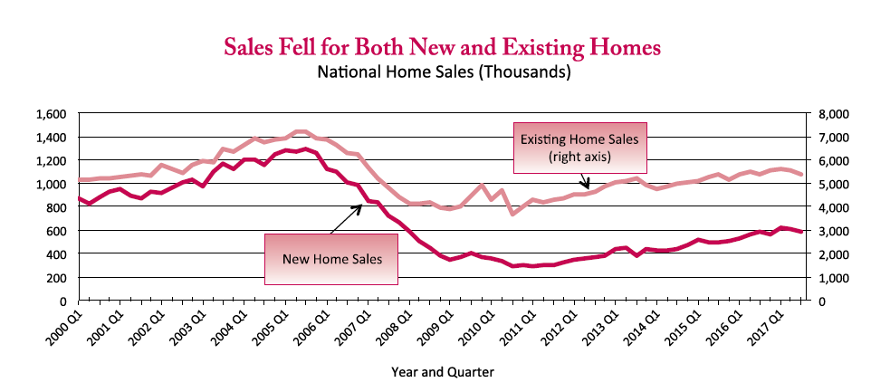

Figure 1. Historical house sales trend. Adapted from *U.S. Department of Housing and Urban Development*, Retrieved March 2018, from https://www.huduser.gov/portal/sites/default/files/pdf/nationalsummary-4Q17.pdf. Reprinted with permission.

Usually, housing economics is the application of economic techniques to real-estate markets. It tries to picture, explain, and forecast patterns of supply, demand, and prices. The intently related field of housing economics is narrower in scope, concentrating on residential real-estate markets, while the research of real-estate trends focuses on the business and structural changes affecting the industry. Both draw on partial equilibrium analysis (supply and demand), urban economics, spatial economics, extensive research, surveys, and finance. This proposal would pay more attention to what could stand for house demand in this model. The relationship between house price and household income could stand for house demand as well. Also, house price and household income are the primary variables in the model. This research needs to get suitable data for these variables first.

From 1990 through 2012, Rebucci makes research on the house environment. The relationship between economic growth and volatility of house price is favorable. Also, they correlate with capital flows more closely than in advanced economies (Cesa-Bianchi, Cespedes, & Rebucci, 2015). Hilbers researched the two different trends of House prices in Europe. House prices in have shown diverging trends, and this paper seeks to explain these differences by analyzing three groups of countries. Meanwhile, the impact of macroeconomic, prudential and structural policies on housing markets can be significant and should be a factor in policy decisions (Hilbers, Hoffmaister, Banerji, & Shi, 2008). One variable for house price is essential for the model which mentioned before. However, for macroeconomic, the house price life cycles are quite frequent for most countries, including both U.S. and China. At the same time, the average household income of people is keeping on creasing in most time. As a result, this project needs to adjust household income for the model (Pozdnyakova, 2017). Adjusted household income is in calculation by subtracting above-the-line deduction from household income.

The Household income and house price are affected by economic environment. For example, in Figure 2, Europe countries are usually divided into three groups basing on diverging trends: the fast lane, the average performers, and the slow movers (Hilbers et al., 2008). The states in the U.S. will state into different groups basing on diverging trends.

This research would apply an economic environment as an essential part of house demand to build a suitable model. In general, there are macroeconomics and microeconomics in the whole economy. Macroeconomics shows critical differences from microeconomics, which focuses on small elements that influence choices made by individuals and institutions. Factors researched in both microeconomics and macroeconomics typically affect one another. Macroeconomics is a branch of the economics that examines how the aggregate economy behaves. As a result, there is an introduction for some macroeconomic variables (risk drivers) related to this research predicted variables such as mortgage rate, gross domestic product, interest rate, unemployment rate and so on.

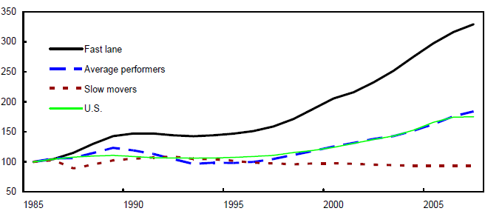

Figure 2 Real property prices trends. Adapted from House Price Developments in Europe: A Comparison, by Hilbers, P. Reprinted with permission.

Firstly, if the house price which is in one country or area is in the not market economic system, the household income has nothing to do with house price. House price developments can mainly explain the dynamics of fundamentals, such as gross domestic product, remittances and external financing (Stepanyan, Poghosyan, & Bibolov, 2010). As determinants of house prices, they employ real per capita gross domestic product, interest rates, unemployment, financial deepening, population, primary fiscal balance, and current accounts, with data covering 1980–2007. Meanwhile, house prices aligned with these fundamentals for their sample countries and that more than half of the price adjustment happens within one quarter. On the other hand, gross domestic product growth could summarize the information in the measure of household income (Tsatsaronis & Zhu, 2004).

If the country or area runs in the market economic system, mortgage rate is a significant risk factor for house price effect (Basten & Koch, 2015). The causal impact of house prices on mortgage demand and supply by exploiting exogenous shocks to immigration and thereby to house prices. In Figure 3, there are three links between house price and mortgage. First, there may be a positive causal effect running from house prices to the mortgage market via mortgage demand. It means that when house prices surge more than financial wealth, households demand higher mortgage amounts to afford the same quality of housing. Second, house prices may also exert a positive causal effect on mortgage supply, which means that if lenders who deem higher house prices sustainable and hence the collateral more valuable, they may be willing to lend more. Third, mortgage lending expansions enable buyers to bid more and thus bid up house prices.

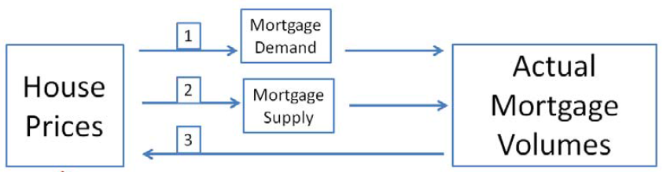

Figure 3. The links are between house price and actual mortgage volumes. Adapted from The causal effect of house prices on mortgage demand and mortgage supply evidence from Switzerland, by Baster, C., 2015.

The second risk driver is the House price index which is a proper measurement of the global recession for house price (Silver, 2012). In an effect to provide macro variables that are as relevant as possible to this research, house price index could be with different state-level weightings. This information is obtained by reviewing to repeat mortgage transactions on properties whose mortgages have been purchased or securitized by Fannie Mae or Freddie Mac since January 1975. The House price index serves as a timely, precise indicator of house price trends at various geographic degrees. Due to the breadth of the sample, it provides more information than is available in other House price indexes. It also includes housing economists with an improved analytical instrument that is useful for measuring changes in the prepayments, mortgage defaults rates and housing affordability in specific geographic areas. The House price index includes house price figures for the nine Census Bureau divisions, for the 50 states and the District of Columbia, and for Metropolitan Statistical Areas (MSAs) and Divisions. House price index is particularly prone to methodological differences, which can undermine both within-country and cross-country analysis. As the different states of U.S. are entirely different in economic, it is believed that House price index is the best choice for the model.

The third risk driver is the interest rate. It finds that interest rate shocks tend to have a significant adverse effect on house prices whereas monetary policy shocks per se do not appear to have a sizeable impact (Hirata, Kose, Fund, Otrok, & Terrones, 2013). This result is consistent with earlier findings in the literature analyzing the impact of national interest rate shocks on domestic house prices. Some researchers commonly interpret the result as evidence that monetary policy drives house price. In this view, interest rate shocks play a crucial role in making movements in house prices. What’s more, the impact of interest rates on house prices appears to be quite modest. In particular, Hirata found that the estimated effects of interest rates shocks on house prices in this research are consistently smaller than the predictions of the standard user cost theory of house prices. In reality, there are two types of interest rate in the market: short-term interest rate and long-term interest rate. The short-term interest rates correspond to nominal short-term government bill rates, generally the Treasury Bill Rates, and the long-term interest rates typically are those of the long-term government bonds. Frequently, the short-term interest rate is affected by monetary policy, and that policy interest rates may set intending to influencing house prices.

The fourth risk factor is consumer price index. The index measures changes in the price level of a market basket of consumer goods and services purchased by households. The stochastic approach to index numbers revisited. For more accurate calculation for investment, this proposal needs to take consumer price index as an important factor. Also, it needs to use more stable method for consumer price index. The housing prices in consumer price index could measure by specified approach (Sabourin & Duguay, 2015).

The fifth risk driver is inflation rate, the annualized percentage change in a general price index, usually the consumer price index, over time. Inflation is a continued increase in the general price level of goods and services in an economy over a period. Inflation affects house prices in two ways (Expenses, 2006). First, the higher wage for construction labor, higher construction material costs, and higher land prices. Second, inflation affects house price through its impact on rents. The house price is equal to the present value of future streams of actual payments. Thus, higher rents translate into higher house prices. This proposal should focus on the difference between growth rates for house price and consumer price index to conjecture the relationship between house prices and inflation.

The sixth risk driver is the birth rate. It is usually used to calculate population growth. Recognizing that housing is a significant cost associated with child rearing, and assuming that children are everyday goods, Dettling hypothesized that an increase in house price would have an adverse price effect on current period fertility (Dettling, 2011). It applies to both potential first-time homeowners and existing homeowners who might upgrade to a bigger house with the addition of a child. Besides, changes in house prices would exert a more considerable effect on birth rate than do changes in unemployment rates. Changes in unemployment rates are typically thought to affect the salaries of couples. Since the women need to bear the primary responsibility for childbearing, so they will choose to pay more attention to procreation when the opportunity cost is lower.

The seventh risk driver is the crude oil price. Oil price refers to the cash price of a barrel of benchmark crude oil a reference price for buyers and sellers of crude-oil. The plunge in oil prices could affect home prices to slip in the oil-producing markets of Texas, Oklahoma, Louisiana, and elsewhere. Based on Figure 4 and Figure 5, it typically takes two years for oil prices to affect home prices in those markets entirely. Meanwhile, lower oil prices could enhance home values in the Northeast and Midwest. Inexpensive oil could lead to higher home prices in much of the rest of the country. It is well-known that cheaper oil lowers the costs of driving, house heating, and other functions, stimulating local economies outside oil-producing regions. Notably, in the Northeast and Midwest, home prices tend to rise after oil prices fall. Markus examined the effect of oil price fluctuations on democratic institutions over the 1960-2007 period (Brückner, Ciccone, & Tesei, 2012). Brückner estimated that a one percentage point increase in per capita gross domestic product growth due to a favorable oil price shock increases the Polity democracy score by around 0.2 percentage points on impact and by approximately two percentage points in the long run. Mercedes found that Oil prices affect housing prices and rent in two ways. First, it generates employment which then pushes housing demand. Thus, the first step is to understand the effects of oil prices and other economic indicators on employment. Second, it generates prosperity concerning income and wealth. Here, a regression model will determine the oil prices and other economic indicators and its relation to house prices and rent directly (Padilla, 2005).

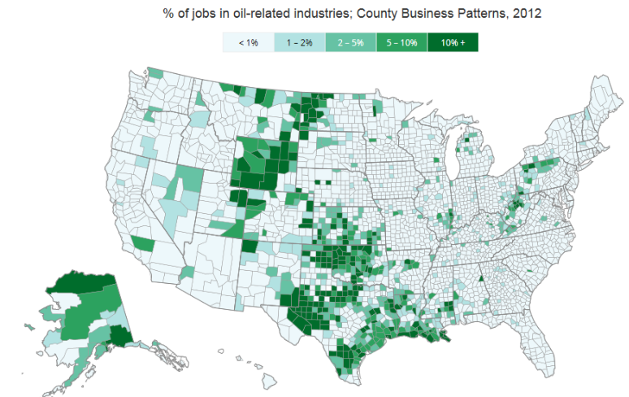

Figure 4. An oil Country business patterns map in the U.S.

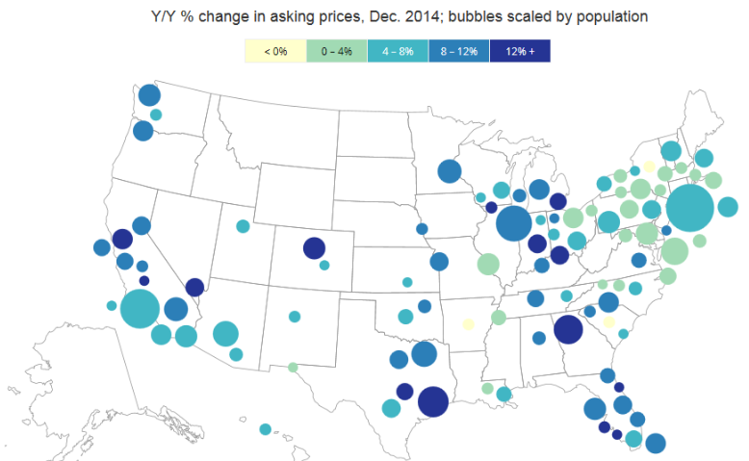

Figure 5 Home price changes in the 100 largest metros.

There are seven risk drivers to help to research on out topic: gross domestic product, House price index, interest rate, consumer price index, inflation rate, oil price and birth rate. Macroeconomics variables could take impacts on predictors, and they also affect each other.

Meanwhile, not all selected variables play a critical role on the dependents so that the ones will be filtered out. It, therefore, proposes a more comprehensive regression specification by including additional dummies that represent different general inflation rate levels and business cycle phases.

The coming step is to find a suitable model to test the hypothesis and analyze for this research, based on the selected variables.

The most common model is simple linear regression model, which is used to model the relevance of two or more variables by fitting a linear equation to observed data. However, there are seven risk drivers as variables in the model. In that case, the simple linear regression model will not be in selection for research.

As the divided the U.S. states into different groups and numbers of variables (Klyuev, 2008). Klyuev estimated the evolution of equilibrium real home prices in the United States. Basically, it topics on long-term trend and short-term dynamics through fundamentals model and asset price approach. For the empirical work, it is focused on the purchase-only index for single-family residences. This model will be a mixed linear regression model (Gupta & Majumdar, 2015). Gupta forecast the recent downturn in real house price growth rate for the twenty most significant U.S. states by Spatial Bayesian VARs (BVARs) model. Although this model significantly underestimates the future direction of house price, it can be well-equipped in decline. This model will be selected because it would provide the significant positive or negative relationship between house price and household income. Moreover, the mixed model allows dividing U.S. states into several groups basing on the economic level.

Other economic risk factors, for example, the unemployment will be added to the model with ordinary least squares (OLS) regression. OLS is a method for estimating the unknown parameters in a linear regression model. OLS chooses the settings of a linear function of a group of explanatory variables by minimizing the sum of the differences squares between the predicted dependent variable (values of the variable observed) in the given dataset and those predicted by the linear function. Zhu investigates the impact of unemployment on house price and the indication of the nature of their relationship (Qingyu & Zhu, 2010). By using OLS, Zhu does not find the real relationship between regional house price sensitivity to unemployment, and how relatively poor or rich an area is. Similarly, OLS estimate can be used to detect the relationship between house price and house investment.

The second approach is one three-equation model, which will calculate for this research. Turk examines the interactions between housing prices and household debt using a three-equation model (Turk, 2015). Turk pays a lot of attention to the relationship between household debt and housing prices. The ties and trends of household debt, real housing price, and disposable income. A reasonable hypothesis for house price is that ``higher level of household debt will cause higher house price'' And it is explained by monetary policy is driving up house price. In order to estimate moderate police effect, the long-run equilibrium levels could be estimated with interest rate and income growth rate. This paper tried to build some equation basing on risk factor such as a ratio of Household Debt to Disposable Income, Household Debt Ratios Household Debt. At last, it used these factors to build a three-equation model. What's more, this model could be used to get short-run household borrowing with house price. These conclusions could satisfy the hypothesis for house price and house debt. Equation 1 reflects the balance of demand and supply for the stock of housing; Equation 2 indicates changes in debt growth from both sources feed into the increase in housing prices; equation 3 captures changes in housing prices may also drive debt growth. The Equation 1 will be on the list, and some adjustments will be applied to equation 2 and equation 3. The Equation 2 could be adjusted to reflect changes in gross domestic product and consumer price index into growth in housing prices. And the Equation 3 could be modified to changes in housing price may drive gross domestic product growth and consumer price index growth. Then the performance of household income based on those variables can be shown up (Turk, 2015).

However, this non-linear regression model is not good at simulation future price of the house, and it can be in use for validation process (Journal, Kannan, Scott, & Rabanal, 2012). The validation process will provide further evidence for the hypothesis. Scott addresses three problems with simulations conducted using a model economy that has some of the critical features relevant for examining the potential role of monetary policy in mitigating the effects of asset price booms. Kahn also uses simulation for the model, which is mostly the neoclassical growth model. The model separates conveniently into its dynamic aggregate component and the sectorial variables. Moreover, the selected variables would include housing demand, house price index, house investment, mortgage rate and house price. It could help to understand the performances of house investors and mortgage issuers.

The third approach is panel regression approach. Panel analysis is a statistical method, widely used in social science, epidemiology, and econometrics to analyze two-dimensional (typically cross-sectional and longitudinal) panel data. This approach is estimated but with the dependent variable switched from gross housing capital income to net housing profit income (La Cava, 2016). Ashvin uses panel data to determine long-term equilibrium property prices (Ahuja et al., 2010). In this case, this approach can be applied to figure out explained risk factors for long-term equilibrium house price trajectories in the U.S. including mortgage interest rate and household income.

The fourth approach is asset pricing approach. It is a model which is used to estimate a theoretically adequate required rate of return of an asset, to make decisions about expanding holdings to a well-diversified portfolio. Ashvin uses asset pricing approach to gauge how far market prices may be deviating from benchmark levels that reflect the fundamentals, which would support costs in the medium term. Judgments on the level of rates are trying to make, but it is possible to compare prices with those suggested by asset pricing relationships. Because the benchmark in the asset pricing approach links to market rent and a set of fundamental factors, this measure of price deviation should give an early warning indicator of market abundance to compare across cities and over time. In this case, House price index and house investment will be in research.

The fifth approach is FAVAR model. It is factor-augmented vector autoregressive model and is now widely used in macroeconomics and finance. In this model, observable and unobservable factors jointly follow an autoregressive vector process, which further drives the comovement of a large number of visible variables. Based on this model, Hideaki (Hirata et al., 2013) finds that house prices synchronize across countries, and the degree of synchronization has improved over time and identify shocks using a recursive decomposition and consider demand, supply, house price, stock price, and oil price shocks (Hirata et al., 2013). As it is often the case in the FAVAR literature, concerning the modeling choices, the decisions would be challenging. Ideally, the same set of variables can use in each model. However, this would require a grand model to nest all the different specifications because identification of each shock with sign restrictions requires different data series.

Thus, the hypothesis in this research can state as "the area which is in the higher level of the economic environment has a better attitude toward to the ratio of house price to household income than the one which is in the lower level of the economic environment." That means risk factors would show the level of an economic environment and economic risk factors could reflect the ratio of house price and household income. For example, the rate of house price to household income in Los Angeles may be eight while the proportion of house price to household income in Detroit maybe only 1.7. It is because the city of Los Angeles has the higher gross domestic product and lower unemployment rate than the city of Detroit.

# Method

## Data Sources

The data that in this research is downloaded from following public data sources.

Bureau of Economic Analysis (BEA) website, which is offered officially by U.S. Department of Commerce. It is founded on January 1, 1972, with parent agency of Economics and Statistics Administration. BEA’s national economic accounts provide a comprehensive picture of the U.S. economy and feature many macroeconomic statistics. BEA produces financial accounts statistics that enable government and business decision-makers, researchers, and the American public to follow and understand the performance of the Nation's economy (US Department of Commerce, n.d.). BEA is a worldwide statistical institute. It generates the most closely observed economic statistic that affects the determination made by policies, households, business, individuals. Plus, it includes multiple accounts: industry accounts, national accounts, international accounts and regional economic accounts that present critical information on such vital issues as the interindustry relationships, economic growth, nation's position and local economic development in the world economy. BEA offer historical regional GDP and household income data. For GDP data, it is divided into two parts: 1997 forward and duration of 1963 to 1997. There is a discontinuity in the time series of GDP by the state in 1997. Meanwhile, it offers personal income data for states, countries, metropolitan area, micropolitan areas, and combined statistical areas.

Bureau of Labor Statistics (BLS) website, which is offered officially by U.S. Department of labor. It formed on June 27, 1884, with 133-year-old. The BLS is the principal federal agency responsible for measuring labor market activity, working conditions, and price changes in the economy. Its mission is to collect, analyze, and disseminate essential economic information to support public and private decision making. As an independent statistical agency, BLS serves its diverse user communities by providing products and services that are accurate, objective, relevant, timely, and accessible. To avoid the appearance of partiality, this project schedules the dates of significant data releases for more than a year in advance, in coordination with the Office of Management and Budget. Basically, statistics published by the BLS fall into following four main categories: prices, employment, and unemployment, compensation and working conditions, productivity. The prices category includes U.S. Consumer Price Index (CPI), U.S. Import and Export Price Indices, Consumer Expenditure Survey and Producer Price Index. The employment and unemployment category include population survey, employment statistics and dynamics program, unemployment statistics and dynamic programs. The compensation and working conditions category includes national compensation survey and workplace injury and fatality statistics. The productivity category includes labor and multifactor productivity. From BLS website, the data on CPI, inflation rate, and unemployment rate are generated in data tool section.

The United States Census Bureau (Census) is a principal agency of the U.S. Federal Statistical System, responsible for producing data about the American people and economy. It is founded on July 1, 1902, with 115 years old, which is part of the U.S. Department of Commerce. Census offers the best mix of timeliness, relevancy, quality, and cost of the data. Census collects data in following part: population and housing, economy and business, workforce and economic indicators. There are utilized for data in Census. Generally, the data can be used to distribute the federal funds to different level governments, to make plans for decisions about community services, to provide population density or age-related information, to establish the conditions of states and union. Under the section of economic indicators, the latest and historical economic data and documents are available to index and search. The research data of house sold price and household income is from this section of Census website.

The Federal Housing Finance Agency (FHFA) website, which is an independent federal agency created as the successor regulatory agency of the Federal Housing Finance Board (FHFB), the Office of Federal Housing Enterprise Oversight (OFHEO), and the U.S. Department of Housing and Urban Development government-sponsored enterprise mission team, absorbing the powers and regulatory authority of both entities, with expanded legal and regulatory authority, including the ability to place government-sponsored enterprises (GSEs) into receivership or conservatorship. It is formed from July 30, 2008, with ten years old only. Since 2008, FHFA has also served as conservator of Fannie Mae and Freddie Mac. FHFA has a mission to ensure that the housing government-sponsored enterprises operate in a safe and sound manner so that they serve as a reliable source of liquidity and funding for housing finance and community investment. Their values are into four parts: respect, excellence, integrity, and diversity. FHFA has multiple downloadable data and functional tools of HPI related (e.g., county map, conforming loan limits map, ZIP5 map, appreciation map, calculator, summary table and motion chart). Thus, the historical data of HPI by states is downloaded from this website.

Federal Reserve Economic Data (FRED) website, which is published on the Research division of the Federal Reserve Bank of St. Louis that has more than 500,000 economic time series from 81 sources. It was founded in 1914. There are some responsibilities in the different role, including monetary policy, supervisory functions, community development, economic research, economic education, U.S. treasury support, payment support and general outreach. FRED drive five main categories. The data in this website can be viewed in graphical and text form or downloaded for import to a database or spreadsheet and viewed on mobile devices. They cover banking, fiscal /business, consumer price indexes, employment and population, exchange rates, gross domestic product, interest rates, monetary aggregates, producer price indexes, reserves and monetary base, U.S. trade and international transactions, and U.S. financial data. The data of 30-year fixed rate mortgage average is downloaded from this website.

## Inclusion and exclusion criteria

The primary inclusion criteria set data frequency to annually. Various macro variables could be at multiple rates. For example: annually, semi-annually, quarterly, monthly, weekly and daily. In research data, see Table 1 weekly frequency data includes 30-year mortgage rate; monthly frequency data includes CPI, Unemployment, Inflation rate; quarterly frequency data includes HPI, personal income, and population; annually frequency data include house sold price and household income, GDP. The frequency selection should be in most cases so that the annual frequency would be in use.

Table 1

Data Frequency overview

|  |  |  |  |  |
| --- | --- | --- | --- | --- |
|  | Weekly (W) | Monthly (M) | Quarterly (Q) | Annually (A) |
| GDP |  |  |  | A |
| CPI |  | M |  |  |
| Unemployment rate |  | M |  |  |
| Inflation rate |  | M |  |  |
| HPI |  |  | Q |  |
| Mortgage rate | W |  |  |  |
| House sold Price |  |  |  | A |
| Household Income |  |  |  | A |

The secondary inclusion criteria set all sets of data into states. This research focuses on different levels of the economic environments, so data that based on a state will not be associated. There are two exceptions cited in research: inflation rate and mortgage rate. Since properties of specific data would be domestic only in recording, so there are two exceptions cited in research: inflation rate and mortgage rate.

The third inclusion criteria are data duration. The data period should be determined by at least one economic cycle, which is the natural fluctuation of the economy between periods of expansion (early and late growth) and contraction (early and late recession), see Figure 6. Probably it would be varied. Generally, it can be defined as ten years. In this case, all-time series data will be in over ten years period. Also, there still be an exception of personal income and population.

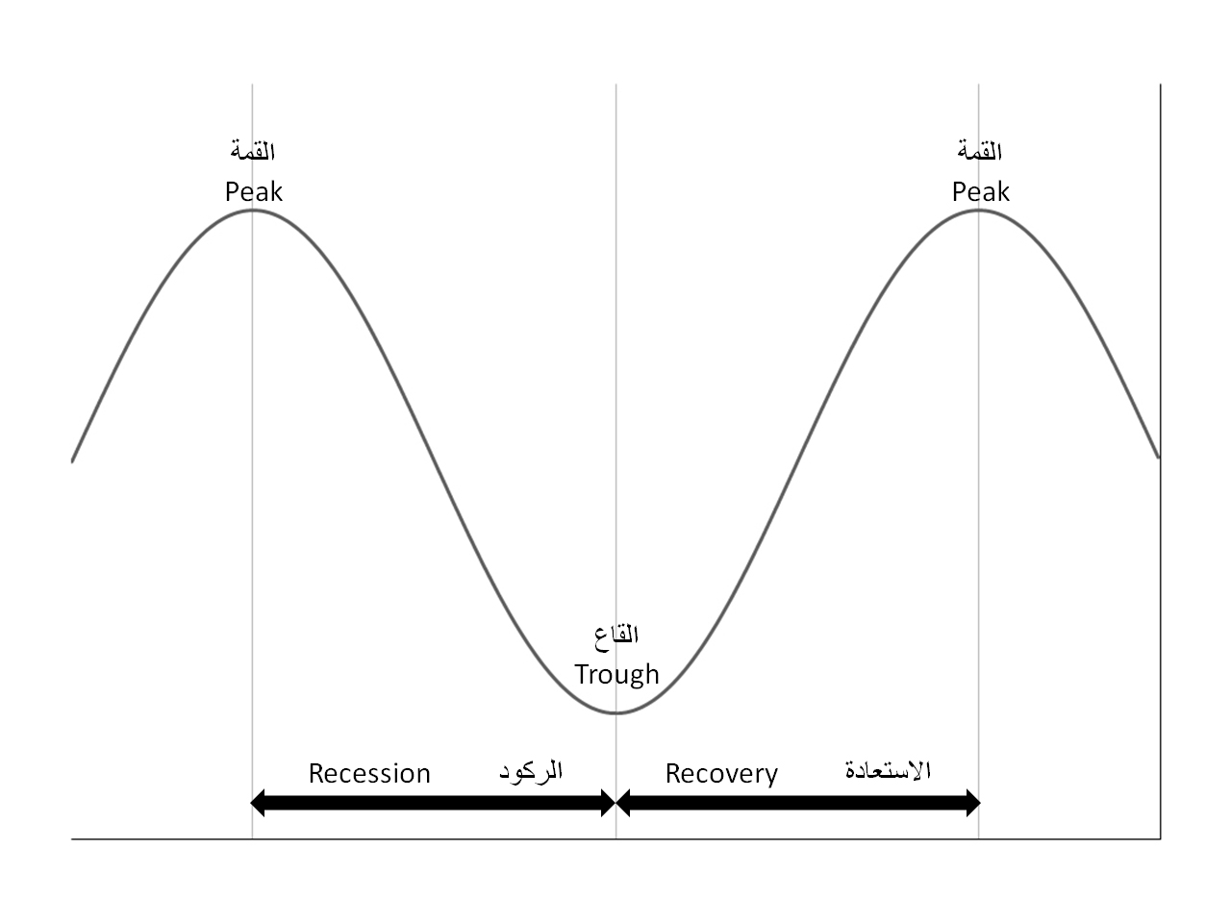

Figure 6 Phases of the business cycle.

For exclusion criteria, in determining the training window for the historical data used for research, extending the starting point into the 1980s carries the risk of incorporating the disinflation that characterized that decade, which is in view as more of a structural change to U.S. and world economies than a business cycle event. To ensure the historical data sample accurately reflects business cycle movements, the year 1990s should be in selection as an appropriate starting point. In the datasets, the unemployment rate is in shortest duration which starts from 1976. Considering the period of data is available from the 1976 year. Thus the starting point will be adjusted to an earlier point, not 1990s.

## Data Description

Macroeconomic indicators include gross domestic product, consumer price index, house price index, Unemployment rate, inflation rate and 30 years fixed mortgage rate. And research indicators include household income, house investment. Based on the inclusion and exclusion criteria, all observations by states would be in the time window from 1976 to 2017 without annually unadjusted.

All the data is from open data sources which are listed in data source section. There are two types of dataset: "csv" file and "xlsx" file. In the organization of data, same data are in simple time series format, and others are in year times months format. At this point, it is necessary to standardize the data in one format, which is simple time series format.

Based on data type, all data is in time series under different frequency. That means the quantitative data are used only in this research. However,

To transform the different frequency data to annual one, the method of median value is elective from different types. The median is also the number that is halfway into the set. To find the median, the data should be arranged in order from least to greatest. Basically, all the data at a different time point, average or annualize the data by a continuous method is not the best choice. Because the outlier would affect the results while median not. That is why the median method is selected for this research.

## Variables analyzed

To establish the states selected, the observations include personal income, region, and population. In this case, the dependent is states in the selection and variables are personal income and population data. The data on population and personal income at the state level can work on population density and personal income, so they are independent variables.

To determine the level of the state economic environment, the macro variable of GDP will be as the dependent variable and set some other macroeconomic indicators as the independent variables. The independent variables include CPI, HPI, unemployment rate, inflation rate and 30 years fixed mortgage rate. There could be a single factor; multiple factors work on the linear or nonlinear model. Since logistic regression will be applied, so GDP (dependent variable) should be reset to category variable. Generally, it is not critical for each independent variable as a significant role in this model process, and it is determined by the statistical test result to make a decision.

Unlike the previous stage, to estimate the relationship between house price and house investment, it assumes that the response variate is house sold price while the observations are the household income, GDP growth rate, HPI, CPI, unemployment rate. They are all in digital data type, no other special treatment for variables. All the independent variables are modeled in the first try, then adjusted in updating.

For the final step, calculate the ratio of house investment to personal income under various states to compare will be in process. Then, a comparison of ratio and economic state raking are tested inconsistently.

## Statistical Analysis

Overall, the models used in this project are divided into three approaches. They are cluster analysis for states selection, logistic regression for the level of economy estimation, linear regression for determination of house price. Meanwhile, there are several statistical tests are applied to figure out the quality of each choice and find the best fit one.

At the beginning of the data preparation, it is not essential to do research on every state. At this point, the critical part is to figure out the representative samples from the population. A region is an area of land that has standard features. A region can be defined by natural or artificial features. Based on the region definition from Census, there are four statistical regions according to their geographic position on the continent: West, Midwest, South, and Northeast. In this paper, the divisive (hierarchical) clustering method is applied to filter out the states. The divisive clustering is a "top-down" approach which all observations start in one cluster, and splits are performed recursively as moves down the hierarchy. Under this approach, group all states data by regions. Table 2 shows the region related states in the U.S. There are much more states in the south than others. Table *2* is the first step of Figure 7. By each region, research picks up a prototypical state whose any value of criteria is higher than the median value. The criteria not only include the personal income and population but also includes the growth rate of each factor mentioned.

Table 2

Region and states map

|  |  |
| --- | --- |
| Region | States |
| West | WA, MT, OR, ID, WY, NV, CA, AZ, UT, CO, NM |
| Midwest | ND, SD, NE, KS, MO, IA, MN, WI, IL, IN, MI, OH |
| South | TX, OK, AR, LA, MS, TN, KY, AL, GA, FL, SC, NC, WV, VA, DC, MD, DE |
| Northeast | PA, NJ, NY, RI, CT, MA, VT, NH, ME, MA |

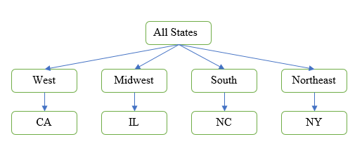

Figure 7. States Clustering

When the data is available to study, the following approach is coming out. This section provides a simple introduction on the statistical technique derived from forecasting the status of economic level. In this research, logistic regression will be applied. In regression analysis, logistic regression or logit regression is estimating the parameters of a logistic model. More formally, a logistic model is one where the log-odds of the probability of an event is a linear combination of independent or predictor variables. The two possible dependent variable values are often labeled as "0" and "1", which represent outcomes such as pass/fail, win/lose, alive/dead or healthy/sick.

In this paper, as a dependent variate, GDP is a numerical data from the dataset. Before constructing a model, GDP should retreat to category data. In reality, inflation reduces not only the level of business investment but also the efficiency with which productive factors are put to use (Nber, 2009). Actually, the inflation rate has the adverse effect on economic growth. It means that when the inflation rate is lower, the productive effects of reduction are enlarger. Thus it is probable that there is economic growth with causing inflation. To offset the inflation effect and to have the real economic growth, conservative treatment is used in this research. In this situation, see Equation 1, a definition for category setting is that if GDP is increasing or the growth rate of GDP is higher than inflation rate at the same point, then the GDP category data is set to “1”, inversely, “0”. If the values are "1", it means the economic growth is better than inflation development, while if the values are "0", it means the economic growth is worse than inflation development.

|  |  |
| --- | --- |
|  | (1) |

Where, .

In the modeling for logistic regression, the is treated as the responses, and the formula is shown: .

In the model processing, accessing the fit of regression models is necessary. There are three model fitting criteria: -2 log likelihood (-2LogL), Akaike’s information criterion (AIC) and Schwarz (Bayesian information) criterion (BIC). The formula of -2 log likelihood: . And AIC and BIC are related to -2LogL. The AIC and SC statistics give two different ways of adjusting the –2 Log L statistic for the number of terms in the model and the number of observations used. The difference in the –2 Log L statistics between the intercept-only model and the specified model has a degree-of-freedom chi-square distribution under the null hypothesis that all the graphics effects in the model are zero, where is the number of parameters in the specified model and is the number of intercepts. AIC tries to select the model that most adequately describes an unknown, high dimensional reality. This means that reality is never in the set of candidate models that are being considered. On the contrary, BIC tries to find the TRUE model among the set of candidates. AIC and BIC hold the same interpretation in terms of model comparison. That is, the more substantial difference in either AIC or BIC indicates stronger evidence for one model over the other. Thus, the lower AIC or BIC, the better model. The likelihood ratio test in the "Testing Global Null Hypothesis: BETA=0" table displays this difference and the associated p-value for this statistic. The score and Wald tests in that table test the same hypothesis and are asymptotically equivalent. What's more, those testing methods and criterion can help to remove the insignificant factors to optimize the model to a more desirable model many times.

For the previous section, the economic level determination is established by GDP. In current section, the economic level will be determined by house sold price. Expectedly, the model built in this section should be consistent with previous. In words, economic level by sample states would be in same order whatever which model is in use. The purpose of this step is to look for the house sold price valued by macro variables.

To validate the hypothesis, this project proposes statistical tests for following steps.

There are more than one states driven data and wish to test for differences in the means of House sold price broken down by levels of the macro indicators for constructing economic environment function. Considering this expectation, linear regression will be in utilized. In statistics, there are the simple linear regression, multiple linear regression, and multivariate multiple linear regression. The simple linear regression is an approach which involves one dependent variable and one independent variable. The multiple linear regression is an approach which includes one response and several observations. The multivariate multiple linear regression is an approach that has several objectives and several factors.

In the first step of the project, the multiple linear regression will be chosen in research. Because there is only one dependent variable (house sold price) and several independent variables (HPI, GDP, CPI, unemployment rate and mortgage rate). This approach should be applied to each state related data.

In the second step of this section, the multivariate multiple linear regression is selected. The variables are the same with first one. However, the data is total of 4 states.

In statistics, multivariate analysis of variance is a procedure for comparing multivariate sample means. As a multivariate procedure, it is used when there are two or more dependent variables and is typically followed by significance tests involving individual dependent variables separately (Rencher & Christensen, n.d.). In general, the purpose of analysis of variance (ANOVA) is to test for significant differences between means. Elementary Concepts provides a brief introduction to the basics of statistical significance testing. If we are only comparing two means, ANOVA will produce the same results as the t-test for independent samples or the t-test for dependent samples.

In statistics, the generalized linear model (GLM) is a flexible generalization of ordinary linear regression that allows for response variables that have error distribution models other than a normal distribution. The GLM generalizes linear regression by allowing the linear model to be related to the response variable via a link function and by allowing the magnitude of the variance of each measurement to be a function of its predicted value. Also, the GLM will be used in the model.

In the testing part, ANOVA test would be used to show the F test, and significant value and then the best independent variables would be selected.

In the single variable regression model, use some criteria to screen out the best performing model. The criteria would include p-value, R-square, AIC, and BIC.

On the final stage to validate the hypothesis, rank the economic condition of states by compounded House price index, and then map the ratio series to the corresponding state. Last, student’s t-test will be applied to determine if two sets are significantly different from each other.

# Results

Considering the assumption of economic level (flag) determination, this project analyzes the difference in GDP growth rate and inflation to category responses.

The economic flag model 1 is modeled by four macro risk factors. The model 1 formula includes: .

Figure 8 shows that the whole goodness of fit of statistics and test results. From the analysis maximum likelihood estimates, all independent variables have one degree of freedom. The estimates of the unemployment rate and mortgage rate are 0.24 and 0.19, respectively. However, the estimates of CPI and HPI are 0.00057 and 0.00061, and both the estimates are too small to be valued in model one. Meanwhile, the p-value is closed to one who is terrible to further research. According to the odds ratio estimates, the points of all estimates are closed to one which indicates almost no change, especially CPI and HPI risk factors. Differently, the other odds ratios estimates are reasonable results to show. Based on the points list above, economic flag model one is not a good model in some level. In the association of predicted probabilities and observed responses, c value is 0.734, which is moderate corresponds to the model predicting the response.

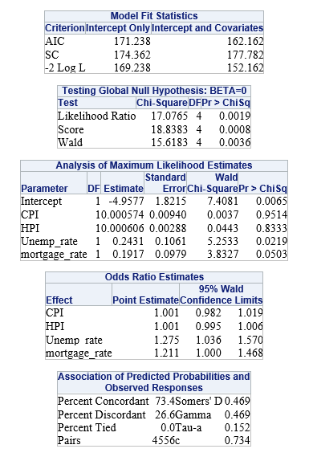

Figure 8 Model Fit Statistics of Economic level Model 1

Next, the economic flag model 2. There is transformation treatment for independent variables which are CPI and HPI. Since those two factors are not good for performing in model 1, so this project does the treatment on them. The economic flag model 2 is still modeled by four macro risk factors. The model 2 formula includes: .

Figure 9 shows that the whole goodness of fit of statistics and test results. From the analysis maximum likelihood estimates, the estimates of CPI, HPI, unemployment rate and mortgage rate are -1.86, 1.95, 0.26 and 0.20, respectively. However, the estimate of CPI is negative, that is not reasonable in reality. Meanwhile, the standard error of CPI and HPI are much more significant than others. It means CPI and HPI are in the lousy performance in the model. Also, there is the same situation in Wald Chi-square results. The p-value is a little bit small for the unemployment rate and mortgage rate. According to the odds ratio estimates, the points of all estimates are much higher than one which indicates an increase in the probability of the outcome event, especially HPI risk factor. However, the odds ratio of CPI is minimal, which indicates a decrease in the probability of the economic level flag. Based on the points list above, economic flag model two is a wrong model in some level. And the model could not be acceptable.

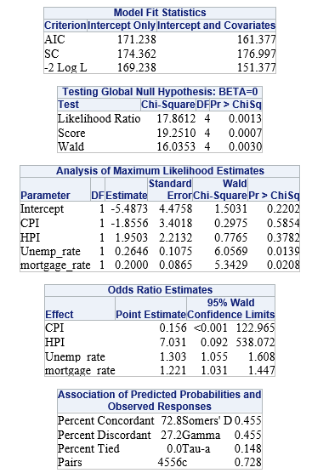

Figure 9 Model Fit Statistics of Economic level Model 2

The following model is the economic flag model 3. There is an adjustment for independent variables which is CPI variable removed. And log HPI is kept in the model. The model 3 formula includes: .

Figure 10 shows that the whole goodness of fit of statistics and test results. From the analysis maximum likelihood estimates, the estimates of HPI, unemployment rate and mortgage rate are 0.93, 0.25, 0.22, respectively. The estimates are in ethical values. However, the standard error of HPI is more significant than others. According to the odds ratio estimates, the points of all estimates are higher than one with a reasonable difference. Based on the points list above, economic flag model three is a good model. And the model could be acceptable.

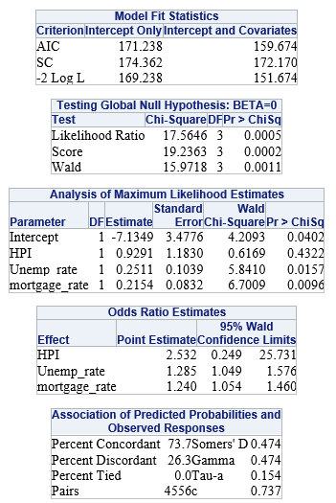

Figure 10 Model Fit Statistics of Economic level Model 3

The following model is the economic flag model 3. There is an adjustment for independent variables which is HPI variable removed. And log CPI is kept in the model. The model 4 formula includes: .

Figure 11 shows that the whole goodness of fit of statistics and test results. From the analysis maximum likelihood estimates, the estimates of CPI, unemployment rate and mortgage rate are 0.68, 0.24, 0.19, respectively. The estimates are in ethical values. The chi-squared values for each factor are acceptable. However, the standard error of HPI is more significant than others. According to the odds ratio estimates, the points of all estimates are higher than one with a reasonable difference. Based on the points list above, economic flag model three is a good model. And the model could be acceptable.

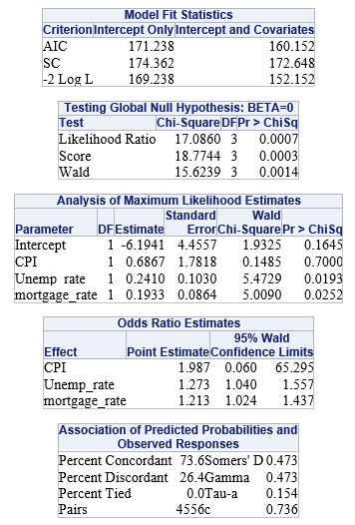

Figure 11 Model Fit Statistics of Economic level Model 4

Compare model 3 and model 4, the residuals in model 3 is less than model 4. It is same in other aspects in comparison. Thus, model 3 is better than model 4.

There are four models illustrated above. Considering the criterions, they include AIC, SC and -2LogL. Table 3 shows that there is a noticeable difference in AIC and SC. For AIC, the values are 162.162, 161.377, 159.674, 160.152 related to four models respectively. For SC, the values are 177.782, 176.997, 172.17, 172.648 related to four models respectively. Based on the property of AIC and SC, the model 3 is better than others.

Table

Model Fit Statistics Criterion of Economic Flag Models

|  |  |  |  |  |
| --- | --- | --- | --- | --- |
| Criterion | Model 1 | Model 2 | Model 3 | Model 4 |
| AIC | 162.162 | 161.377 | 159.674 | 160.152 |
| SC | 177.782 | 176.997 | 172.17 | 172.648 |
| -2 Log L | 152.162 | 151.377 | 151.674 | 152.152 |

Figure 12 shows influence diagnostics has four plots to model 3. The index plots of the Pearson residuals and the deviance residuals indicate that half part of four group cases is poorly accounted for by the model. The index plot of the diagonal elements of the hat matrix (leverage) suggests that case 1 and case 140 is an extreme point in the design space.

Finally, under the model 3 estimates table, the economic values of four states could be calculated. Table 4 shows the model results. The states would be in order: CA, NY, NC, IL.

Table

Economic order by states under GDP driven approach

|  |  |  |  |  |  |  |
| --- | --- | --- | --- | --- | --- | --- |
| Parameter | Intercept | CPI | Unemp_rate | mortgage_rate | Economic level | Order |
| Estimate | -6.1941 | 0.6867 | 0.241 | 0.1933 |  |  |
| NY |  | 263.24 | 4.2 | 4.56 | 176.466456 | 2 |
| CA |  | 265.84 | 4.5 | 4.56 | 178.324176 | 1 |
| IL |  | 235.065 | 4.3 | 4.56 | 157.1427835 | 4 |
| NC |  | 243.279 | 4.3 | 4.56 | 162.7833373 | 3 |

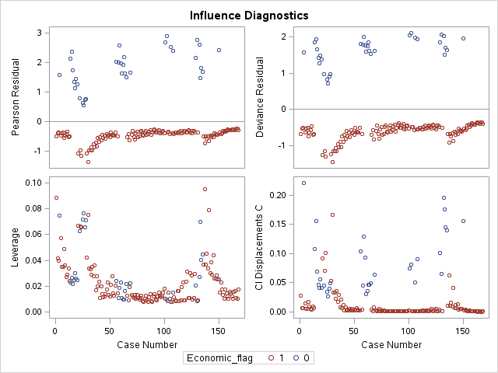

Figure 12 Influence Diagnostics of Economic level Model 4

The following models are driven by house sold price. There are two regression methods are applied to the model.

The first regression is multiple linear regression. The majority state would be CA. The models in following shown are based on CA data.

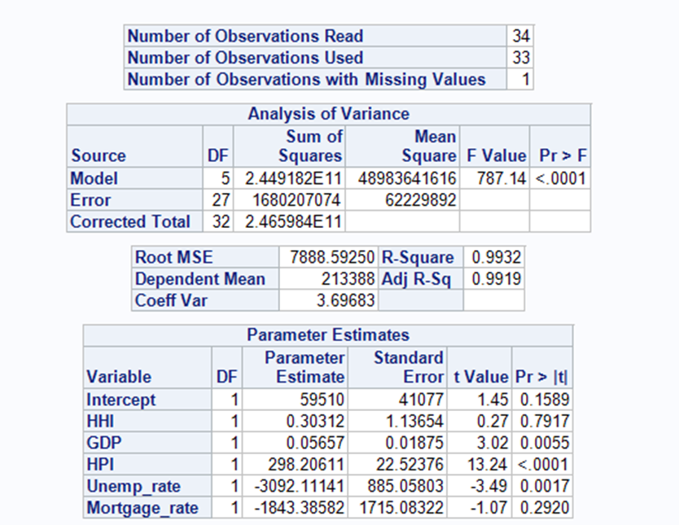

Figure 13 Multiple linear models one under CA

The model one is under one formula. House sold price is directly regression on multiple variables (household income, GDP, HPI, unemployment rate and mortgage rate). Figure 13 shows the results performance. From the table of analysis of variance, the sum of error squares is considerable. And in the table of parameter estimates, the estimates for factors are 0.303, 0.057, 298.206, -3092.11 and -1843.386, respectively. In this case, estimators of HPI, unemployment rate, and mortgage rate are not reasonable. Meanwhile, the standard error of them in hundreds value and p-value are significant. At this point, the model is not in performance.

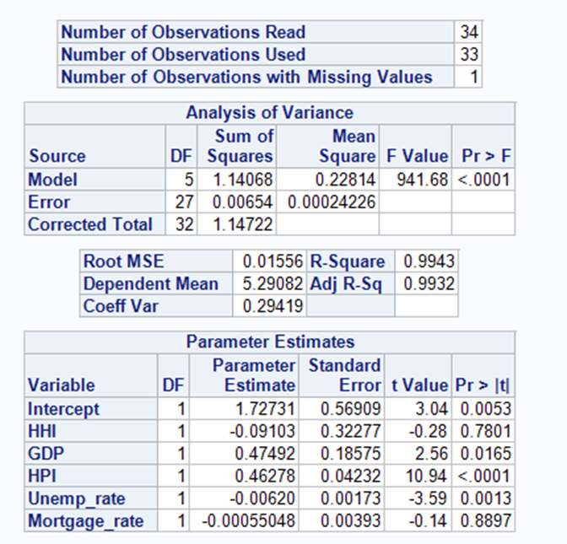

Figure 14 Multiple linear models two under CA

The model two is under a different formula. In this model. All variables are adjusted to log value under base 10. Figure 14 shows that the model results. The sum of model squares and error squares are much smaller than model one. However, the probability more substantial than f-value is significant. The R-square and adj R-square is closed to one. It means it is okay. Meanwhile, there are some negative estimators (household income, unemployment rate, and mortgage rate). In reality, when the household income goes up, people have more money to invest in a house. Thus, the correlation between household income and the house sold price should be positive, not negative. If the unemployment rate goes up, it means there are fewer people in work, then the total investment money will be in deduction. So, the unemployment rate is negative to house sold price. If the mortgage rate increase, the cost of mortgage fee will rise together, then people are not willing to invest more house in the future, the house price would go down. So, the mortgage rate is negative to house sold price. In model 2, based on the p-value, there is only one significant factor in the model, that is HPI. At this point, the model 2 is not acceptable.

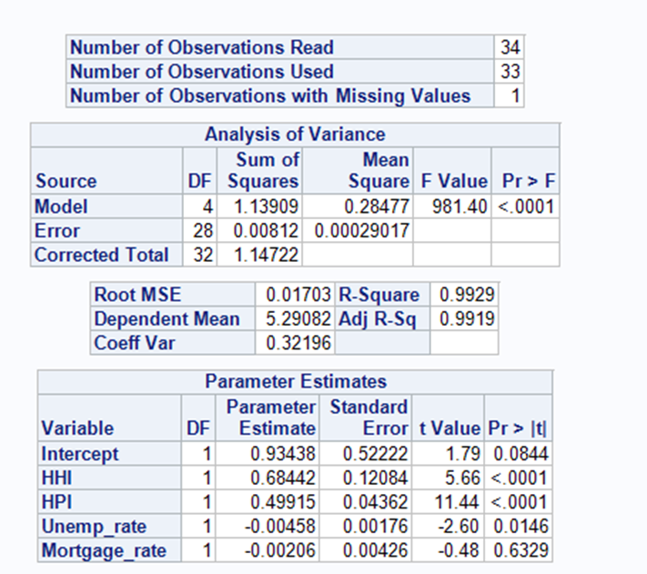

Figure 15 Multiple linear models three under CA

The model 3 is under another treatment without GDP. Figure 15 shows that the estimator of the unemployment rate and mortgage rate is negative. Based on the comments above, those negative values are reasonable. However, those factors are not significant to model while household income and HPI are. So, model 3 is not sufficient.

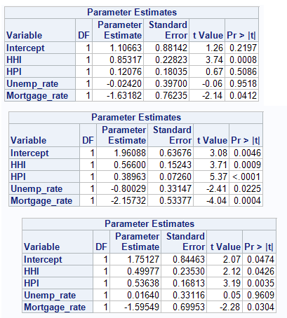

Figure 16 Multiple linear models four under IL, NY, NC

Also, there exists a model 4. There is a treatment for some variables (unemployment rate and mortgage rate). Since those factors are not significant in the previous model. To figure out how does them work on house sold price, they have been divided to 100. In this case, the formula is . Figure 17 shows the results of model 4 in CA. Similarity, the independent variables of the unemployment rate and 30 years fixed mortgage rate are not significant to model. The sum of error squares is small. And the household income and HPI are positive to house sold price. Figure 18 shows the residual plots under model 4. The plots for three variables are listed randomly in the small range. These plots are acceptable for the model.

Figure 16 shows the results model 4 under states of IL, NY, NC. And results are similar to the model 4 under CA.

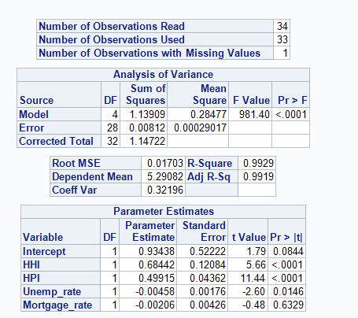

Figure 17 Multiple linear model 4 under CA

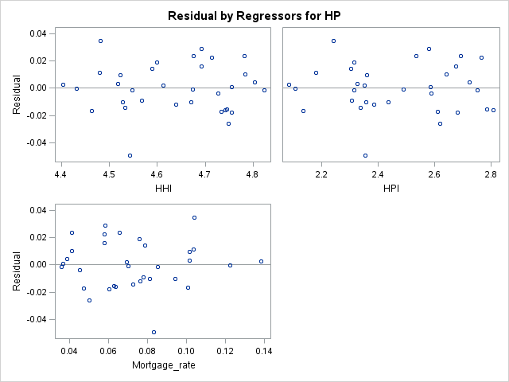

Figure 18 Residual of Multiple linear models four under CA

Besides, there is finally one approach which is applied to the model. The GLM run the programming code with the class of the state. Figure 19 Generalized linear modelshows the GLM type error of results. In this model, the factor of the unemployment rate is removed. Since in type I and III error table, the probability of unemployment rate is much higher than other factors. Thus, it is removed.

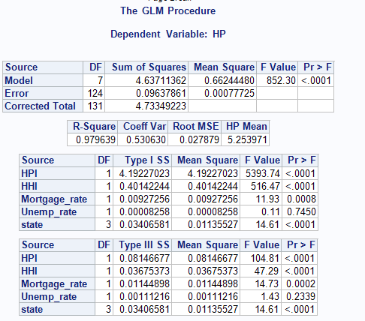

Figure 19 Generalized linear model

Table

Economic order by states under House-sold-price driven approach

|  |  |  |  |  |
| --- | --- | --- | --- | --- |
| State | CA | IL | NY | NC |
| Intercept | 0.49372 | 1.08511 | 1.081 | 1.77026 |
| HHI | 0.75386 | 0.85552 | 0.73001 | 0.49455 |
| HPI | 0.51777 | 0.12393 | 0.38743 | 0.53922 |
| Mortgage_rate | 0.34149 | -1.60707 | -1.38659 | -1.6095 |
| Order | 2 | 1 | 3 | 4 |

Table 5 shows the order of the final state by economic level. Based on the GLM regression, there are four sets of estimates to establish the economic level value. Then the order will be from low to high: IL, CA, NY, NC.

The order of IL is different from the GDP driven approach. Then there is a discussion in the following section.

# Discussion

With the help of the two models for economic factors and house price, more research has been finished with target data. It is easy to find out some conclusions. First, the assumption about the relationship between house price and household income is almost right. Second, some economic factors are highly related and getting rid of some risk factors are essential for the models. Third, property tax rate is essential for the house price while it sometimes affects house price randomly.

From the logistical model, we get the methodology to calculation economic developing level for different states. It is easy to find out that CPI and HPI are highly correlated with each other. And take only one of them will make the model better. And after calculation for the four states with the economic factor of 2018, we found the four states are in the order of CA > NY > NC >IL while they are still very close. It is because the whole U.S is in a proper development for the first 5 months of 2018. And the ranking of states stands for their developing level in past 5 months.

For the mixed linear model, we used several crucial economic risk factors in the model at first. However, the model reports are not stable for different states. In order to further develop the model, we use PROC GLM to test variables in the mixed linear regression. To make me the great surprise, the unemployment rate seems not significantly related to house price. The reason for it may be that the house price needs long-term economic environment while the unemployment is not a long-term economic risk factor. As a matter of fact, the unemployment would not keep on high for long-term unless the enormous national depression.

With the adjusted linear regression model for four states, the ratio between house price and household income is ranking as IL > CA > NY > NC. It is easy to be observed that three states are fitted well with economic model except for the state IL. And with further research for the IL state, we believe that it may because IL has much higher indeed property tax than other states, see Figure 20. The average tax rate of IL is almost twice of NY and three times of NC and CA. As a result, we could conclude that our assumption is right for our research, and for the higher level economic areas, people prefer to spend higher ratios of their income for the house. It is because that house is an excellent long-term investment in these areas.

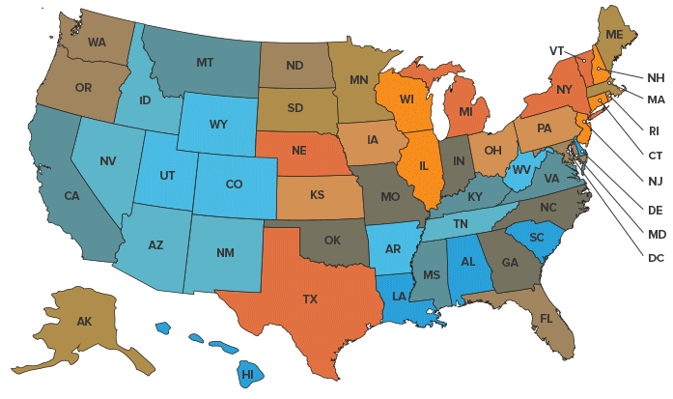

Figure 20 U.S. Real-Estate Property Taxes by State

References

Ahuja, A., Cheung, L., Han, G., Porter, N., & Zhang, W. (2010). Are House Price Rising too Fast in China? *IMF Working Papers*, *10*(December). Retrieved from http://scholar.google.com/scholar?hl=en&btnG=Search&q=intitle:No+Title#0

Bai, J., Li, K., & Lu, L. (2016). Estimation and Inference of FAVAR Models. *Journal of Business and Economic Statistics*, *34*(4), 620–641. https://doi.org/10.1080/07350015.2015.1111222

Basten, C., & Koch, C. (2015). The causal effect of house prices on mortgage demand and mortgage supply: Evidence from Switzerland. *Journal of Housing Economics*, *30*(555), 1–22. https://doi.org/10.1016/j.jhe.2015.07.001

Brückner, M., Ciccone, A., & Tesei, A. (2012). Oil Price Shocks, Income, and Democracy. *Review of Economics and Statistics*, *94*(2), 389–399. https://doi.org/10.1162/REST_a_00201

Cesa-Bianchi, A., Cespedes, L. F., & Rebucci, A. (2015). Global liquidity, house prices, and the macroeconomy: Evidence from advanced and emerging economies. *Journal of Money, Credit and Banking*, *47*(S1), 301–335. https://doi.org/10.1111/jmcb.12204

Dettling, L. J. (2011). House Prices and Birth Rates: The Impact of the Real Estate Market on the Decision to Have a Baby. Retrieved from www.nber.org/papers/w17485

Expenses, D. B. (2006). Home Investment: Residential Property Prices and Inflation. *Tierra Grande*, (January), 0–1. Retrieved from https://assets.recenter.tamu.edu/documents/articles/1762.pdf

Gupta, R., & Majumdar, A. (2015). Forecasting US real house price returns over 1831–2013: evidence from copula models. *Applied Economics*, *47*(48), 5204–5213. https://doi.org/10.1080/00036846.2015.1044648

Hilbers, P., Hoffmaister, A. W., Banerji, A., & Shi, H. (2008). House price developments in Europe: a comparison. *IMF Working Paper*, *8*(211), 1. https://doi.org/10.5089/9781451870695.001

Hirata, H., Kose, M. A., Fund, I. M., Otrok, C., & Terrones, M. E. (2013). Global House Price Fluctuations: Synchronization. *NBER Working Paper Series*, 44. https://doi.org/10.1086/669585

Journal, T. B. E., Kannan, P., Scott, A. M., & Rabanal, P. (2012). Monetary and Macroprudential Policy Rules in a Model with House Price Booms Monetary and Macroprudential Policy Rules in a Model with House Price Booms. *IMF Working Papers*, *12*(1). https://doi.org/10.1515/1935-1690.2268

Kahn, J. A. (2008). What Drives Housing Prices? *Federal Reserve Bank of New York Staff Reports*, (345). Retrieved from www.newyorkfed.org/medialibrary/media/research/staff_reports/sr345.pdf

Klyuev, V. (2008). What Goes Up Must Come Down? House Price Dynamics in the United States. *IMF Working Papers*, *8*(187), 1. https://doi.org/10.5089/9781451870459.001

La Cava, G. (2016). Housing Prices, Mortgage Interest Rates and the Rising Share of Capital Income in the United States. *BIS Working Paper*, (572), 1–35. Retrieved from www.bis.org/publ/work572.pdf

Landier, A., Sraer, D. A., & Thesmar, D. (2013). Banking Integration and House Price Comovement. *SSRN Electronic Journal*. https://doi.org/10.2139/ssrn.2347315

Liang, K. Y., & Yen, C. H. (2013). Measuring CPI’s reliability: The stochastic approach to index numbers revisited. *Applied Economics*, *45*(20), 2894–2908. https://doi.org/10.1080/00036846.2012.687097

Padilla, M. (2005). *The effects of oil prices and other economics indicator on housing prices in calgary, Canada MsC*. Retrieved from https://dspace.mit.edu/bitstream/handle/1721.1/33193/66140327-MIT.pdf?sequence=2

Pozdnyakova, T. M. (2017). An average salary: approaches to the index determination. *Statistics and Economics*, *0*(4), 82–89. https://doi.org/10.21686/2500-3925-2017-4-82-89

Qingyu, Z., & Zhu, Q. (2010). Regional unemployment and house price determination, (41785). https://doi.org/10.1227/01.NEU.0000349921.14519.2A

Sabourin, P., & Duguay, P. (2015). Measuring Durable Goods and Housing Prices in the CPI: An Empirical Assessment. *Bank of Canada Review*, *362*(362), 24–38. Retrieved from https://search.proquest.com/docview/1777459895?accountid=14542%0Ahttp://dn3nh3eq7d.search.serialssolutions.com/?genre=article&sid=ProQ:&atitle=Measuring+Durable+Goods+and+Housing+Prices+in+the+CPI%3A+An+Empirical+Assessment&title=Bank+of+Canada+Review&iss

Silver, M. (2012). Why House Price Indexes Differ: Measurement and Analysis. *IMF Working Papers*, *12*(125), 1. https://doi.org/10.5089/9781475503548.001

Stepanyan, V., Poghosyan, T., & Bibolov, A. (2010). House Price Determinants in Selected Countries of the Former Soviet Union, 16.

Sutton, G., Mihaljek, D., & Subelytė, A. (2017). Interest rates and house prices in the United States and around the world. *BIS Working Papers*, *665*(665).

Tilly, C., & Tilly, C. (2005). The Economic Environment of Housing: Income Inequality and Insecurity. *10*. Retrieved from https://www.uml.edu/docs/Housing-Tilly chapter-GRBT106-2299G-01-020-037_tcm18-75299.pdf

Tsatsaronis, K., & Zhu, H. (2004). What drives housing price dynamics: cross-country evidence. *BIS Quarterly Review*, (March), 65–78. Retrieved from https://www.bis.org/publ/qtrpdf/r_qt0403f.pdf

Turk, R. A. (2015). Housing Price and Household Debt Interactions in Sweden. *IMF Working Paper*, *15*(276). https://doi.org/http://www.imf.org/external/pubs/cat/longres.aspx?sk=43494

Wang, S., & Tumbarello, P. (2010). What Drives House Prices in Australia? A+L4584 Cross-Country Approach. *IMF Working Papers*, *10*(291), 1. https://doi.org/10.5089/9781455211722.001