The relationship between House Investment and Economic Environment

Baoheng Huang

Harrisburg University of Science and Technology

The relationship between House Investment and Economic Environment

As is known, any commodity has both value and price. As one kind of merchandise, the house also has its intrinsic value and market price. The cost of a home is providing a living condition for one family or one person. The price of a house is currency amount basing on market value.

House price index is a broad measure of the price movement of the residential housing in the United States. Commonly, House price index is used widely for house price in the market, and it is a direct measurement for house price. The House price index is a weighted, repeat-sales index, meaning that it measures average price changes in repeat sales or refinancing on the same properties. This information is obtained by reviewing to repeat mortgage transactions on single-family properties whose mortgages have been purchased or securitized by Fannie Mae or Freddie Mac since January 1975. Also, there are similar concepts published by other Institutes, such as Case-Shiller index prices, Residential Price Index.

In recent years, investment property is accessible worldwide. Investment property is a real-estate property that purchases with the intention of earning a return on the investment, either through rental income, the future resale of the property or both. An investment property can be a long-term endeavor, such as land, or an intended short-term investment such as in the case of flipping, where real estate is bought, remodeled or renovated, and sold at a profit.

With the development of the financial market, people are more and more willing to invest in different kind of finance productions or derivatives. As a result, more and more people take houses as a long-term investment. Our research will focus on the differences between the value of the home and the price of the house.

House investment is known similar to real estate investing which includes the purchase, sale, rent, management, and ownership of real estate for profit.

If the difference of value and price of a house is more than an average commodity, that means people prefer to take the home as the long-term investment. On the other side, it says people prefer to make the house as a living commodity.

The significant part of the research is to find suitable indexes to stand for the value of the house. It is an excellent choice to compare home with others living commodity. But there is no similar commodity has such long-term value as the house. As a result, we choose one economic variable as a useful benchmark with house value.

# Literature Review

In past 20 years, especially after 2009, there is a sharp increase in house price combined with the unbelievable economic development of China. Compared with U.S., house price level in China seems significantly higher than its justified by underlying fundamentals (Ahuja, 2010). It shows that property price changes affect the domestic demand of house. In other words, house demand plays an impact on house price. Thus, I plan to apply a similar model to check U.S. domestic demand for the house. Plus, house demand could divide into the residential claim and investment demand.

Figure 1shows the actual national house sales from the first quarter of the year 2000 to the current in U.S. Historically, existing home sales accounted for 85 percent of the market, with new home sales representing the remaining 15 percent. The share of existing home sales began to rise in 2007 and is currently 90 percent, with the stock of new home sales dropping to 10 percent. Regarding average sales, the ratio of existing to new home sales historically has been 6 to 1, whereas the proportion is currently 9 to 1, although that ratio fell from 14 to 1 in 2011. As we know, sales are part of demand. And the trend of the market is corresponding to transactions.

Usually, housing economics is the application of economic techniques to real-estate markets. It tries to describe, explain, and predict patterns of prices, supply, and demand. The closely related field of housing economics is narrower in scope, concentrating on residential real-estate markets, while the research of real-estate trends focuses on the business and structural changes affecting the industry. Both draw on partial equilibrium analysis (supply and demand), urban economics, spatial economics, extensive research, surveys, and finance. we need to do further research on what could stand for house demand in our model. The relationship between house price and household income could stand for house demand as well. And house price and household income are the primary variables in our model. This research needs to get suitable data for these variables first.

In the duration of 1990 - 2012, Rebucci make research on the house environment. The relationship between economic growth and volatility of house price is positive. And they correlate with capital flows more closely than in advanced economies (Cesa-Bianchi, Cespedes, & Rebucci, 2015). Hilbers researched on the two different trends of House prices in Europe. House prices in have shown diverging trends, and this paper seeks to explain these differences by analyzing three groups of countries. Meanwhile, the impact of macroeconomic, prudential and structural policies on housing markets can be significant and should be a factor in policy decisions (Hilbers, Hoffmaister, Banerji, & Shi, 2008). One variable for house price is essential for the model which mentioned before. But for macroeconomic, the house price life cycles are quite frequent for most countries, including both U.S. and China. At the same time, the average household income of people is keeping on creasing in most time. As a result, we need to adjust household income for the model (Pozdnyakova, 2017). Adjusted household income is in calculation by subtracting above-the-line deduction from household income.

The Household income and house price are apparently affected by economic environment. For example, in Figure 2, Europe countries are usually divided into three groups basing on diverging trends: the fast lane, the average performers, and the slow movers (Hilbers et al., 2008). The states in the U.S. will state into different groups basing on diverging trends.

To build a suitable model for this research, I need to take an economic environment as an essential part of house demand. In general, there are macroeconomics and microeconomics in the whole economy. Macroeconomics differs from microeconomics, which focuses on smaller factors that affect choices made by individuals and companies. Factors studied in both microeconomics and macroeconomics typically influence one another. Macroeconomics is a branch of the economics that examines how the aggregate economy behaves. As a result, there is an introduction for some macroeconomic variables (risk drivers) related to this research predicted variables such as mortgage rate, gross domestic product, interest rate, unemployment rate and so on.

Firstly, if the house price which is in one country or area is in the not market economic system, the household income has nothing to do with house price. House price developments can mainly explain the dynamics of fundamentals, such as gross domestic product, remittances and external financing (Stepanyan, Poghosyan, & Bibolov, 2010). As determinants of house prices, they employ real per capita gross domestic product, interest rates, unemployment, financial deepening, population, primary fiscal balance, and current accounts, with data covering 1980–2007. Meanwhile, house prices aligned with these fundamentals for their sample countries and that more than half of the price adjustment happens within one quarter. On the other hand, gross domestic product growth could summarize the information in the measure of household income (Tsatsaronis & Zhu, 2004).

If the country or area runs in the market economic system, mortgage rate is a significant risk factor for house price effect (Basten & Koch, 2015). The causal impact of house prices on mortgage demand and supply by exploiting exogenous shocks to immigration and thereby to house prices. In Figure 3, there are three links between house price and mortgage. First, there may be a positive causal effect running from house prices to the mortgage market via mortgage demand. It means that when house prices surge more than financial wealth, households demand higher mortgage amounts to afford the same quality of housing. Second, house prices may also exert a positive causal effect on mortgage supply, which means that if lenders who deem higher house prices sustainable and hence the collateral more valuable, they may be willing to lend more. Third, mortgage lending expansions enable buyers to bid more and thus bid up house prices.

The second risk driver is the House price index which is a proper measurement for the global recession for house price (Silver, 2012). The House price index is a weighted, repeat-sales index, meaning that it measures average price changes in repeat sales or refinancing on the same properties. This information is obtained by reviewing to repeat mortgage transactions on properties whose mortgages have been purchased or securitized by Fannie Mae or Freddie Mac since January 1975. The House price index serves as a timely, accurate indicator of house price trends at various geographic levels. Because of the breadth of the sample, it provides more information than is available in other House price indexes. It also includes housing economists with an improved analytical tool that is useful for estimating changes in the rates of mortgage defaults, prepayments and housing affordability in specific geographic areas. The House price index includes house price figures for the nine Census Bureau divisions, for the 50 states and the District of Columbia, and for Metropolitan Statistical Areas (MSAs) and Divisions. House price index is particularly prone to methodological differences, which can undermine both within-country and cross-country analysis. As the different states of U.S. are entirely different in economic, we believe that House price index is the best choice for our model.

The third risk driver is the interest rate. It finds that interest rate shocks tend to have a significant adverse effect on house prices whereas monetary policy shocks per se do not appear to have a sizeable impact (Hirata, Kose, Fund, Otrok, & Terrones, 2013). This result is consistent with earlier findings in the literature analyzing the impact of national interest rate shocks on domestic house prices. Some researchers commonly interpret the result as evidence that monetary policy drives house price. In this view, interest rate shocks play a crucial role in making movements in house prices. What’s more, the impact of interest rates on house prices appears to be quite modest. In particular, Hirata found that the estimated effects of interest rates shocks on house prices in this research are consistently smaller than the predictions of the standard user cost theory of house prices. In reality, there are two types of interest rate in the market: short-term interest rate and long-term interest rate. The short-term interest rates correspond to nominal short-term government bill rates, generally the Treasury Bill Rates, and the long-term interest rates typically are those of the long-term government bonds. Frequently, the short-term interest rate is affected by monetary policy, and that policy interest rates may set intending to influencing house prices.

The fourth risk factor is consumer price index. The index measures changes in the price level of a market basket of consumer goods and services purchased by households. The stochastic approach to index numbers revisited. For more accurate calculation for investment, we need to take consumer price index as an important factor. We need use more stable method for consumer price index. The housing prices in consumer price index could measure by specified approach (Sabourin & Duguay, 2015).

The fifth risk driver is inflation rate, the annualized percentage change in a general price index, usually the consumer price index, over time. Inflation is a sustained increase in the general price level of goods and services in an economy over a period. Inflation affects house prices in two ways (Expenses, 2006). First, the higher wage for construction labor, higher construction material costs, and higher land prices. Second, inflation affects house price through its impact on rents. The house price is equal to the present value of future streams of actual payments. Thus, higher rents translate into higher house prices. To estimate the relationship between house prices and inflation, we can focus on the difference between growth rates for house price and consumer price index.

The sixth risk driver is the birth rate. It is usually used to calculate population growth. Recognizing that housing is a significant cost associated with child rearing, and assuming that children are everyday goods, Dettling hypothesized that an increase in house price will have an adverse price effect on current period fertility (Dettling, 2011). It applies to both potential first-time homeowners and existing homeowners who might upgrade to a bigger house with the addition of a child. Besides, changes in house prices would exert a more considerable effect on birth rate than do changes in unemployment rates. Changes in unemployment rates are typically thought to affect the salaries of couples. Since the women need to bear the primary responsibility for childbearing, so they will choose to pay more attention to procreation when the opportunity cost is lower.

The seventh risk driver is the crude oil price. Oil price refers to the spot price of a barrel of benchmark crude oil a reference price for buyers and sellers of crude-oil. The plunge in oil prices could cause home prices to slip in the oil-producing markets of Texas, Oklahoma, Louisiana, and elsewhere. Based on Figure 4 and Figure 5, it typically takes two years for oil prices to affect home prices in those markets entirely. At the same time, lower oil prices could boost home values in the Northeast and Midwest. Cheap oil could lead to higher home prices in much of the rest of the country. As we know, cheaper oil lowers the costs of driving, heating a home and other activities, boosting local economies outside oil-producing regions. In the Northeast and Midwest especially, home prices tend to rise after oil prices fall. Markus examined the effect of oil price fluctuations on democratic institutions over the 1960-2007 period (Brückner, Ciccone, & Tesei, 2012). Brückner estimated that a one percentage point increase in per capita gross domestic product growth due to a favorable oil price shock increases the Polity democracy score by around 0.2 percentage points on impact and by approximately two percentage points in the long run. Mercedes found that Oil prices affect housing prices and rent in two ways. First, it generates employment which then pushes housing demand. Thus, the first step is to understand the effects of oil prices and other economic indicators on employment. Second, it generates prosperity concerning income and wealth. Here, a regression model will determine the oil prices and other economic indicators and its relation to house prices and rent directly (Padilla, 2005).

There are seven risk drivers to help to research on out topic: gross domestic product, House price index, interest rate, consumer price index, inflation rate, oil price and birth rate. Macroeconomics variables could take impacts on predictors, and they also affect each other.

Meanwhile, not all selected variables play a critical role on the dependents so that the ones will be filtered out. It, therefore, proposes a more comprehensive regression specification by including additional dummies that represent different general inflation rate levels and business cycle phases.

The next step is to find a suitable model to test the hypothesis and analyze for this research, based on the selected variables.

The most common model is simple linear regression model, which is used to model the relationship between two variables by fitting a linear equation to observed data. However, there are seven risk drivers as variables in the model. In that case, the simple linear regression model will not be in selection for research.

As the divided the U.S. states into different groups and numbers of variables (Klyuev, 2008). Klyuev estimated the evolution of equilibrium real home prices in the United States. Basically, it topics on long term trend and short-term dynamics through fundamentals model and asset price approach. For the empirical work, we focused on the purchase-only index for single-family residences. The model estimated the supply and demand equations for existing homes using annual regional data. They posited that housing supply is affected by real construction costs and the average household size, the latter variable reflecting a relative supply shrinkage caused by an aging population. In the last few years, home prices had risen to unsustainable levels and then started to decline. In this paper we use a variety of techniques to assess the current extent of over valuation. This model will be a mixed linear regression model (Gupta & Majumdar, 2015). Gupta forecast the recent downturn in real house price growth rate for the twenty most significant U.S. states by Spatial Bayesian VARs (BVARs) model. Although this model significantly underestimates the future direction of house price, it can be well-equipped in decline. This model will be selected because it would provide the significant positive or negative relationship between house price and household income. And mixed model allows dividing U.S. states into several groups basing on the economic level.

Other economic risk factors, for example, the unemployment will be added to the model with ordinary least squares (OLS) regression. OLS is a method for estimating the unknown parameters in a linear regression model. OLS chooses the settings of a linear function of a set of explanatory variables by minimizing the sum of the squares of the differences between the observed dependent variable (values of the variable predict) in the given dataset and those predicted by the linear function. Zhu investigates the impact of unemployment on house price and the indication of the nature of their relationship (Qingyu & Zhu, 2010). By using OLS, Zhu does not find the real relationship regional house price sensitivity to unemployment, and how relatively poor or rich an area is. Similarly, OLS estimate can be used to detect the relationship between house price and house investment.

The second approach is one three-equation model, which will calculate for this research. Turk examines the interactions between housing prices and household debt using a three-equation model (Turk, 2015). Turk pays a lot attention to the relationship between household debt and housing prices. The relationship and trends of household debt, real housing price and disposable income. A good hypothesis for house price is that ``higher level of household debt will cause higher house price'' And it is explained by monetary policy is driving up house price. In order to estimate moderate police effect, the long-run equilibrium levels could be estimated with interest rate and income growth rate. This paper tried to build some equation basing on risk factor such as ratio of Household Debt to Disposable Income, Household Debt Ratios Household Debt. At last, it used these factors to build a three-equation model. What’s more, this model could be used to get short-run household borrowing with house price. These conclusions could satisfy with the hypothesis for house price and house debt. Equation 1 reflects the balance of demand and supply for the stock of housing; Equation 2 indicates changes in debt growth from both sources feed into the increase in housing prices; equation 3 captures changes in housing prices may also drive debt growth. The Equation 1 will be on the list, and some adjustments will be applied to equation 2 and equation 3. The Equation 2 could be adjusted to reflect changes in gross domestic product and consumer price index into growth in housing prices. And the Equation 3 could be modified to changes in housing price may drive gross domestic product growth and consumer price index growth. Then the performance of household income based on those variables can be shown up (2015).

But this non-linear regression model is not good at simulation future price of the house, and it can be in use for validation process (Journal, Kannan, Scott, & Rabanal, 2012). The validation process will provide further evidence for our hypothesis. Scott addresses three problems with simulations conducted using a model economy that has some of the critical features relevant for examining the potential role of monetary policy in mitigating the effects of asset price booms. Kahn also uses simulation for the model, which is mostly the neoclassical growth model. The model separates conveniently into its dynamic aggregate component and the sectorial variables. And the selected variables would include housing demand, house price index, house investment, mortgage rate and house price. It could help to understand the performances of house investors and mortgage issuers.

The third approach is panel regression approach. Panel analysis is a statistical method, widely used in social science, epidemiology, and econometrics to analyze two-dimensional (typically cross-sectional and longitudinal) panel data. This approach is estimated but with the dependent variable switched from gross housing capital income to net housing profit income (La Cava, 2016). Ashvin uses panel data to determine long-term equilibrium property prices (Ahuja et al., 2010). In this case, this approach can be applied to figure out explained risk factors for long-term equilibrium house price trajectories in the U.S. including mortgage interest rate and household income.

The fourth approach is asset pricing approach. It is a model used to determine a theoretically appropriate required rate of return of an asset, to make decisions about adding assets to a well-diversified portfolio. Ashvin uses asset pricing approach to gauge how far market prices may be deviating from benchmark levels that reflect the fundamentals, which would support costs in the medium term. Judgments on the level of rates are trying to make, but it is possible to compare prices with those suggested by asset pricing relationships. Because the benchmark in the asset pricing approach links to market rent and a set of fundamental factors, this measure of price deviation should give us an early warning indicator of market abundance that we can compare across cities and over time. In this case, House price index and house investment will be in research.

The fifth approach is FAVAR model. It is factor-augmented vector autoregressive model and is now widely used in macroeconomics and finance. In this model, observable and unobservable factors jointly follow an autoregressive vector process, which further drives the comovement of a large number of visible variables. Based on this model, Hideaki (Hirata et al., 2013) finds that house prices synchronize across countries, and the degree of synchronization has increased over time and identify shocks using a recursive decomposition and consider demand, supply, house price, stock price, and oil price shocks (Hirata et al., 2013). As it is often the case in the FAVAR literature, I need to make challenging decisions concerning our modeling choices. Ideally, the same set of variables can use in each model. However, this would require a grand model to nest all the different specifications because identification of each shock with sign restrictions requires different data series.

Thus, the hypothesis in this research can state as "the area which is in the higher level of the economic environment has a better attitude toward to the ratio of house price to household income than the one which is in the lower level of the economic environment." That means risk factors would show the level of an economic environment and economic risk factors could reflect the ratio of house price and household income. For example, the rate of house price to household income in Los Angeles may be eight while the proportion of house price to household income in Detroit maybe only 1.7. It is because the city of Los Angeles has the higher gross domestic product and lower unemployment rate than the city of Detroit.

References

Ahuja, A., Cheung, L., Han, G., Porter, N., & Zhang, W. (2010). Are House Price Rising too Fast in China? *IMF Working Papers*, *10*(December). Retrieved from http://scholar.google.com/scholar?hl=en&btnG=Search&q=intitle:No+Title#0

Bai, J., Li, K., & Lu, L. (2016). Estimation and Inference of FAVAR Models. *Journal of Business and Economic Statistics*, *34*(4), 620–641. https://doi.org/10.1080/07350015.2015.1111222

Basten, C., & Koch, C. (2015). The causal effect of house prices on mortgage demand and mortgage supply: Evidence from Switzerland. *Journal of Housing Economics*, *30*(555), 1–22. https://doi.org/10.1016/j.jhe.2015.07.001

Brückner, M., Ciccone, A., & Tesei, A. (2012). Oil Price Shocks, Income, and Democracy. *Review of Economics and Statistics*, *94*(2), 389–399. https://doi.org/10.1162/REST_a_00201

Cesa-Bianchi, A., Cespedes, L. F., & Rebucci, A. (2015). Global liquidity, house prices, and the macroeconomy: Evidence from advanced and emerging economies. *Journal of Money, Credit and Banking*, *47*(S1), 301–335. https://doi.org/10.1111/jmcb.12204

Dettling, L. J. (2011). House Prices and Birth Rates: The Impact of the Real Estate Market on the Decision to Have a Baby. Retrieved from www.nber.org/papers/w17485

Expenses, D. B. (2006). Home Investment: Residential Property Prices and Inflation. *Tierra Grande*, (January), 0–1. Retrieved from https://assets.recenter.tamu.edu/documents/articles/1762.pdf

Gupta, R., & Majumdar, A. (2015). Forecasting US real house price returns over 1831–2013: evidence from copula models. *Applied Economics*, *47*(48), 5204–5213. https://doi.org/10.1080/00036846.2015.1044648

Hilbers, P., Hoffmaister, A. W., Banerji, A., & Shi, H. (2008). House price developments in Europe: a comparison. *IMF Working Paper*, *8*(211), 1. https://doi.org/10.5089/9781451870695.001

Hirata, H., Kose, M. A., Fund, I. M., Otrok, C., & Terrones, M. E. (2013). Global House Price Fluctuations: Synchronization. *NBER Working Paper Series*, 44. https://doi.org/10.1086/669585

Journal, T. B. E., Kannan, P., Scott, A. M., & Rabanal, P. (2012). Monetary and Macroprudential Policy Rules in a Model with House Price Booms Monetary and Macroprudential Policy Rules in a Model with House Price Booms. *IMF Working Papers*, *12*(1). https://doi.org/10.1515/1935-1690.2268

Kahn, J. A. (2008). What Drives Housing Prices? *Federal Reserve Bank of New York Staff Reports*, (345). Retrieved from www.newyorkfed.org/medialibrary/media/research/staff_reports/sr345.pdf

Klyuev, V. (2008). What Goes Up Must Come Down? House Price Dynamics in the United States. *IMF Working Papers*, *8*(187), 1. https://doi.org/10.5089/9781451870459.001

La Cava, G. (2016). Housing Prices, Mortgage Interest Rates and the Rising Share of Capital Income in the United States. *BIS Working Paper*, (572), 1–35. Retrieved from www.bis.org/publ/work572.pdf

Landier, A., Sraer, D. A., & Thesmar, D. (2013). Banking Integration and House Price Comovement. *SSRN Electronic Journal*. https://doi.org/10.2139/ssrn.2347315

Liang, K. Y., & Yen, C. H. (2013). Measuring CPI’s reliability: The stochastic approach to index numbers revisited. *Applied Economics*, *45*(20), 2894–2908. https://doi.org/10.1080/00036846.2012.687097

Padilla, M. (2005). *The effects of oil prices and other economics indicator on housing prices in calgary, Canada MsC*. Retrieved from https://dspace.mit.edu/bitstream/handle/1721.1/33193/66140327-MIT.pdf?sequence=2

Pozdnyakova, T. M. (2017). An average salary: approaches to the index determination. *Statistics and Economics*, *0*(4), 82–89. https://doi.org/10.21686/2500-3925-2017-4-82-89

Qingyu, Z., & Zhu, Q. (2010). Regional unemployment and house price determination, (41785). https://doi.org/10.1227/01.NEU.0000349921.14519.2A

Sabourin, P., & Duguay, P. (2015). Measuring Durable Goods and Housing Prices in the CPI: An Empirical Assessment. *Bank of Canada Review*, *362*(362), 24–38. Retrieved from https://search.proquest.com/docview/1777459895?accountid=14542%0Ahttp://dn3nh3eq7d.search.serialssolutions.com/?genre=article&sid=ProQ:&atitle=Measuring+Durable+Goods+and+Housing+Prices+in+the+CPI%3A+An+Empirical+Assessment&title=Bank+of+Canada+Review&iss

Silver, M. (2012). Why House Price Indexes Differ: Measurement and Analysis. *IMF Working Papers*, *12*(125), 1. https://doi.org/10.5089/9781475503548.001

Stepanyan, V., Poghosyan, T., & Bibolov, A. (2010). House Price Determinants in Selected Countries of the Former Soviet Union, 16.

Sutton, G., Mihaljek, D., & Subelytė, A. (2017). Interest rates and house prices in the United States and around the world. *BIS Working Papers*, *665*(665).

Tilly, C., & Tilly, C. (2005). The Economic Environment of Housing: Income Inequality and Insecurity. *10*. Retrieved from https://www.uml.edu/docs/Housing-Tilly chapter-GRBT106-2299G-01-020-037_tcm18-75299.pdf

Tsatsaronis, K., & Zhu, H. (2004). What drives housing price dynamics: cross-country evidence. *BIS Quarterly Review*, (March), 65–78. Retrieved from https://www.bis.org/publ/qtrpdf/r_qt0403f.pdf

Turk, R. A. (2015). Housing Price and Household Debt Interactions in Sweden. *IMF Working Paper*, *15*(276). https://doi.org/http://www.imf.org/external/pubs/cat/longres.aspx?sk=43494

Wang, S., & Tumbarello, P. (2010). What Drives House Prices in Australia? A+L4584 Cross-Country Approach. *IMF Working Papers*, *10*(291), 1. https://doi.org/10.5089/9781455211722.001

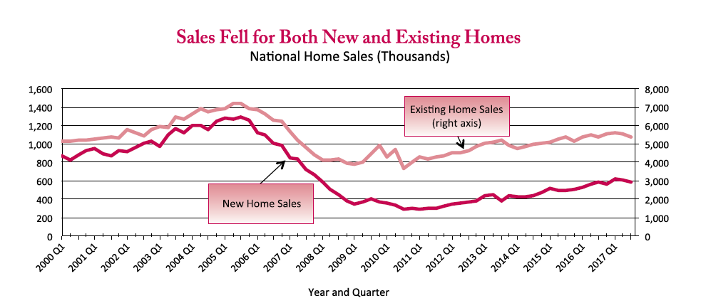

Figure 1. Historical house sales trend. Adapted from *U.S. Department of Housing and Urban Development*, Retrieved March, 2018, from https://www.huduser.gov/portal/sites/default/files/pdf/nationalsummary-4Q17.pdf. Reprinted with permission.

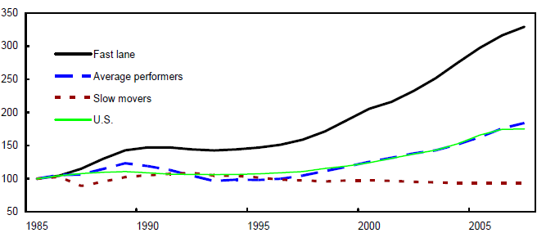

Figure 2 Real property prices trends. Adapted from House Price Developments in Europe: A Comparison, by Hilbers, P. Reprinted with permission.

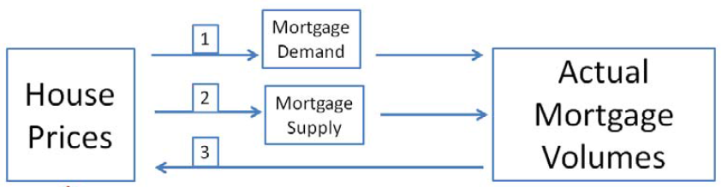

Figure 3. The links between house price and actual mortgage volumes. Adapted from The causal effect of house prices on mortgage demand and mortgage supply evidence from Switzerland, by Baster, C., 2015.

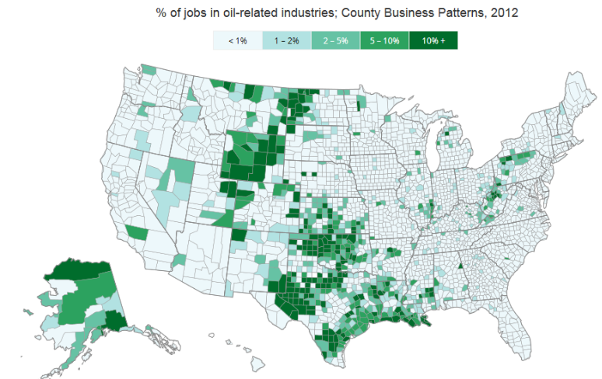

Figure 4. Oil Country business patterns map in U.S.

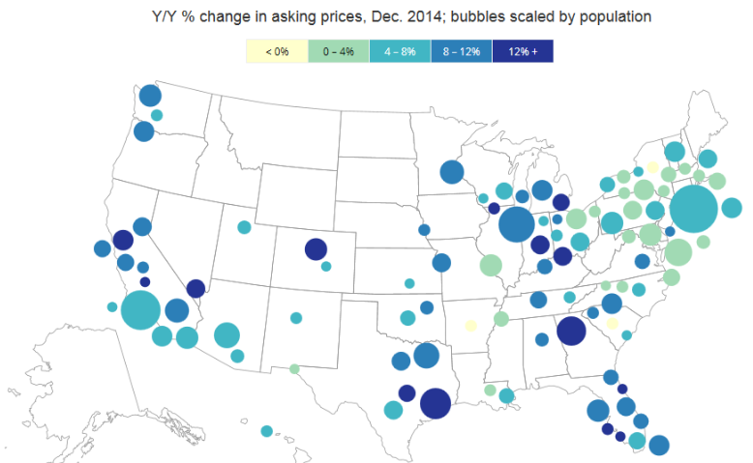

Figure 5 Home price changes in the 100 largest metros.