1. Get the economic flag and 4 economic factors ready for model

model Economic_flag = HPI Unemp_rate mortgage_rate;

| **Model Fit Statistics** | | |
| --- | --- | --- |
| **Criterion** | **Intercept Only** | **Intercept and Covariates** |
| AIC | 171.238 | 162.162 |
| SC | 174.362 | 177.782 |
| -2 Log L | 169.238 | 152.162 |

| **Testing Global Null Hypothesis: BETA=0** | | | |
| --- | --- | --- | --- |
| **Test** | **Chi-Square** | **DF** | **Pr > ChiSq** |
| Likelihood Ratio | 17.0765 | 4 | 0.0019 |
| Score | 18.8383 | 4 | 0.0008 |
| Wald | 15.6183 | 4 | 0.0036 |

| **Analysis of Maximum Likelihood Estimates** | | | | | |
| --- | --- | --- | --- | --- | --- |
| **Parameter** | **DF** | **Estimate** | **Standard Error** | **Wald Chi-Square** | **Pr > ChiSq** |
| Intercept | 1 | -4.9577 | 1.8215 | 7.4081 | 0.0065 |
| CPI | 1 | 0.000574 | 0.00940 | 0.0037 | 0.9514 |
| HPI | 1 | 0.000606 | 0.00288 | 0.0443 | 0.8333 |
| Unemp_rate | 1 | 0.2431 | 0.1061 | 5.2533 | 0.0219 |
| mortgage_rate | 1 | 0.1917 | 0.0979 | 3.8327 | 0.0503 |

| **Odds Ratio Estimates** | | | |
| --- | --- | --- | --- |
| **Effect** | **Point Estimate** | **95% Wald Confidence Limits** | |
| CPI | 1.001 | 0.982 | 1.019 |
| HPI | 1.001 | 0.995 | 1.006 |
| Unemp_rate | 1.275 | 1.036 | 1.570 |
| mortgage_rate | 1.211 | 1.000 | 1.468 |

| **Association of Predicted Probabilities and Observed Responses** | | | |
| --- | --- | --- | --- |
| Percent Concordant | 73.4 | Somers' D | 0.469 |
| Percent Discordant | 26.6 | Gamma | 0.469 |
| Percent Tied | 0.0 | Tau-a | 0.152 |
| Pairs | 4556 | c | 0.734 |

Conclusion: The HPI and CPI Estimate is too close to 0 and P value is terrible for further research

1. Transfer CPI and HPI with Log10, which could help the model to be more smother

model Economic_flag = log10(CPI) log10(HPI) Unemp_rate mortgage_rate;

| **Model Fit Statistics** | | |
| --- | --- | --- |
| **Criterion** | **Intercept Only** | **Intercept and Covariates** |
| AIC | 171.238 | 161.377 |
| SC | 174.362 | 176.997 |
| -2 Log L | 169.238 | 151.377 |

| **Testing Global Null Hypothesis: BETA=0** | | | |
| --- | --- | --- | --- |
| **Test** | **Chi-Square** | **DF** | **Pr > ChiSq** |
| Likelihood Ratio | 17.8612 | 4 | 0.0013 |
| Score | 19.2510 | 4 | 0.0007 |
| Wald | 16.0353 | 4 | 0.0030 |

| **Analysis of Maximum Likelihood Estimates** | | | | | |
| --- | --- | --- | --- | --- | --- |
| **Parameter** | **DF** | **Estimate** | **Standard Error** | **Wald Chi-Square** | **Pr > ChiSq** |
| Intercept | 1 | -5.4873 | 4.4758 | 1.5031 | 0.2202 |
| CPI | 1 | -1.8556 | 3.4018 | 0.2975 | 0.5854 |
| HPI | 1 | 1.9503 | 2.2132 | 0.7765 | 0.3782 |
| Unemp_rate | 1 | 0.2646 | 0.1075 | 6.0569 | 0.0139 |
| mortgage_rate | 1 | 0.2000 | 0.0865 | 5.3429 | 0.0208 |

| **Odds Ratio Estimates** | | | |
| --- | --- | --- | --- |
| **Effect** | **Point Estimate** | **95% Wald Confidence Limits** | |
| CPI | 0.156 | <0.001 | 122.965 |
| HPI | 7.031 | 0.092 | 538.072 |
| Unemp_rate | 1.303 | 1.055 | 1.608 |
| mortgage_rate | 1.221 | 1.031 | 1.447 |

| **Association of Predicted Probabilities and Observed Responses** | | | |
| --- | --- | --- | --- |
| Percent Concordant | 72.8 | Somers' D | 0.455 |
| Percent Discordant | 27.2 | Gamma | 0.455 |
| Percent Tied | 0.0 | Tau-a | 0.148 |
| Pairs | 4556 | c | 0.728 |

Conclustion: CPI get a negative estimate, that is not quite reasonable. It may be because that the HPI and CPI are high correlated.

1. Remove CPI from the model and estmate only 3 economic factors

model Economic_flag = log10(HPI) Unemp_rate mortgage_rate;

| **Model Fit Statistics** | | |
| --- | --- | --- |
| **Criterion** | **Intercept Only** | **Intercept and Covariates** |
| AIC | 171.238 | 159.674 |
| SC | 174.362 | 172.170 |
| -2 Log L | 169.238 | 151.674 |

| **Testing Global Null Hypothesis: BETA=0** | | | |
| --- | --- | --- | --- |
| **Test** | **Chi-Square** | **DF** | **Pr > ChiSq** |
| Likelihood Ratio | 17.5646 | 3 | 0.0005 |
| Score | 19.2363 | 3 | 0.0002 |
| Wald | 15.9718 | 3 | 0.0011 |

| **Analysis of Maximum Likelihood Estimates** | | | | | |
| --- | --- | --- | --- | --- | --- |
| **Parameter** | **DF** | **Estimate** | **Standard Error** | **Wald Chi-Square** | **Pr > ChiSq** |
| Intercept | 1 | -7.1349 | 3.4776 | 4.2093 | 0.0402 |
| HPI | 1 | 0.9291 | 1.1830 | 0.6169 | 0.4322 |
| Unemp_rate | 1 | 0.2511 | 0.1039 | 5.8410 | 0.0157 |
| mortgage_rate | 1 | 0.2154 | 0.0832 | 6.7009 | 0.0096 |

| **Odds Ratio Estimates** | | | |
| --- | --- | --- | --- |
| **Effect** | **Point Estimate** | **95% Wald Confidence Limits** | |
| HPI | 2.532 | 0.249 | 25.731 |
| Unemp_rate | 1.285 | 1.049 | 1.576 |
| mortgage_rate | 1.240 | 1.054 | 1.460 |

| **Association of Predicted Probabilities and Observed Responses** | | | |
| --- | --- | --- | --- |
| Percent Concordant | 73.7 | Somers' D | 0.474 |
| Percent Discordant | 26.3 | Gamma | 0.474 |
| Percent Tied | 0.0 | Tau-a | 0.154 |
| Pairs | 4556 | c | 0.737 |

Conclustion: this model produce good estimate for HPI and better model predication

1. Produce one comparation with removing HPI and keeping CPI

model Economic_flag = log10(CPI) Unemp_rate mortgage_rate;

| **Model Fit Statistics** | | |
| --- | --- | --- |
| **Criterion** | **Intercept Only** | **Intercept and Covariates** |
| AIC | 171.238 | 160.152 |
| SC | 174.362 | 172.648 |
| -2 Log L | 169.238 | 152.152 |

| **Testing Global Null Hypothesis: BETA=0** | | | |
| --- | --- | --- | --- |
| **Test** | **Chi-Square** | **DF** | **Pr > ChiSq** |
| Likelihood Ratio | 17.0860 | 3 | 0.0007 |
| Score | 18.7744 | 3 | 0.0003 |
| Wald | 15.6239 | 3 | 0.0014 |

| **Analysis of Maximum Likelihood Estimates** | | | | | |
| --- | --- | --- | --- | --- | --- |
| **Parameter** | **DF** | **Estimate** | **Standard Error** | **Wald Chi-Square** | **Pr > ChiSq** |
| Intercept | 1 | -6.1941 | 4.4557 | 1.9325 | 0.1645 |
| CPI | 1 | 0.6867 | 1.7818 | 0.1485 | 0.7000 |
| Unemp_rate | 1 | 0.2410 | 0.1030 | 5.4729 | 0.0193 |
| mortgage_rate | 1 | 0.1933 | 0.0864 | 5.0090 | 0.0252 |

| **Odds Ratio Estimates** | | | |
| --- | --- | --- | --- |
| **Effect** | **Point Estimate** | **95% Wald Confidence Limits** | |
| CPI | 1.987 | 0.060 | 65.295 |
| Unemp_rate | 1.273 | 1.040 | 1.557 |
| mortgage_rate | 1.213 | 1.024 | 1.437 |

| **Association of Predicted Probabilities and Observed Responses** | | | |
| --- | --- | --- | --- |
| Percent Concordant | 73.6 | Somers' D | 0.473 |
| Percent Discordant | 26.4 | Gamma | 0.473 |
| Percent Tied | 0.0 | Tau-a | 0.154 |
| Pairs | 4556 | c | 0.736 |

Conclustion: CPI’s P-value is much worse than HPI’s P-Value

1. Plot the influnce Diagnostics for this model

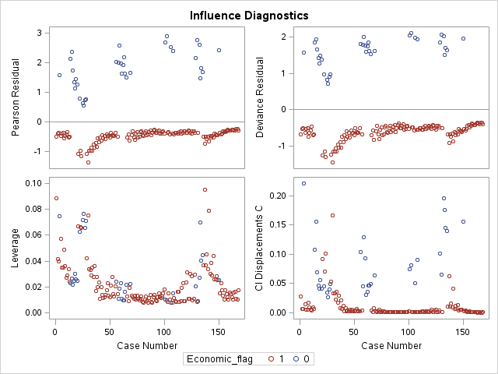

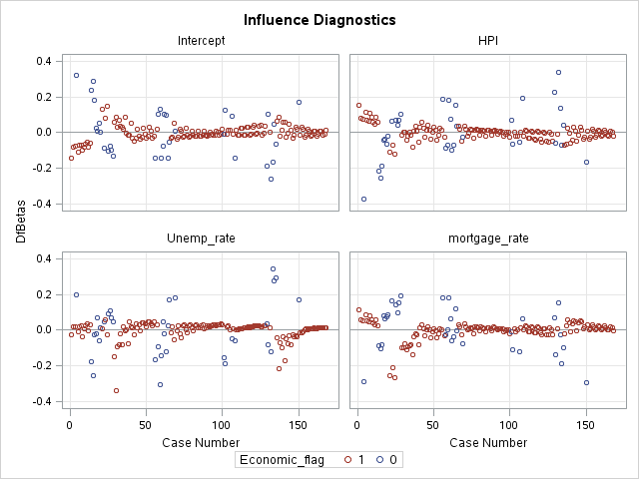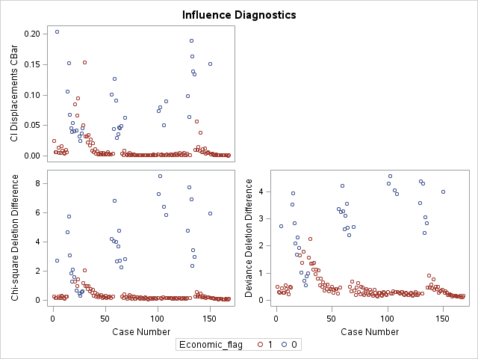Conclustion: The residual is not random for developing and non_developing observation. As is shown, the Non_developing observation has larger distribution than developing one.