1. Model (common one)

**proc** **reg** data=CA_model;

model HP=HHI GDP HPI Unemp_rate Mortgage_rate;

**run**;

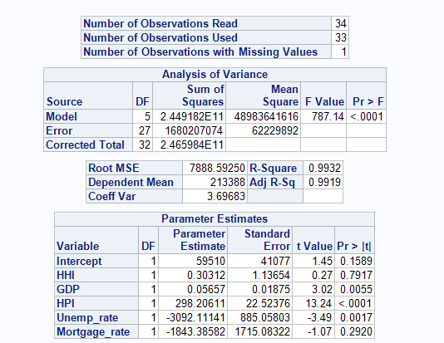

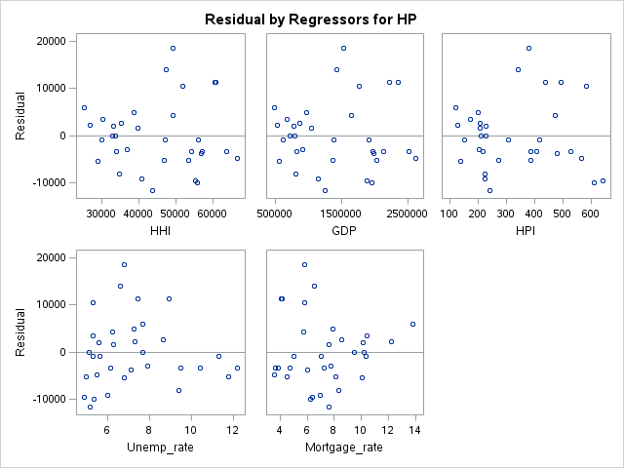

Residual is too large while estimate is too vary for factor

1. Model 2 (adjusted HP,HHI, GDP, HPI with Log10)

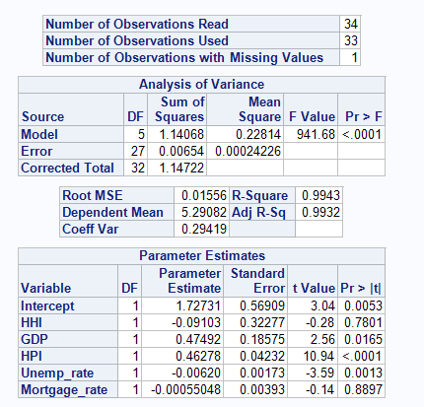

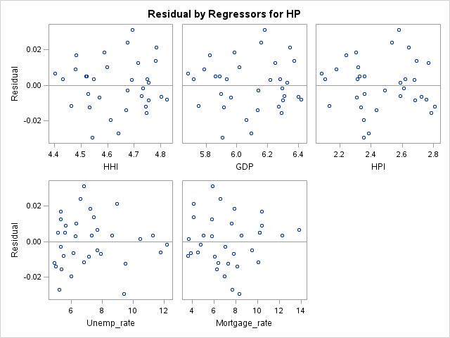

P value of HHI is too large. Maybe GDP or HPI are high related with HHI

1. Model 3( remove GDP to get rid of correlation)

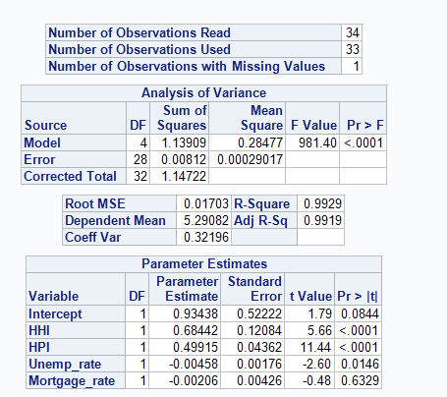

Rate have too small P value

1. Model 4 (adjusted rate with unemp_rate/100 and mortgage_rate/100)

**proc** **reg** data=CA_model;

model HP=HHI HPI Unemp_rate Mortgage_rate;

**run**;

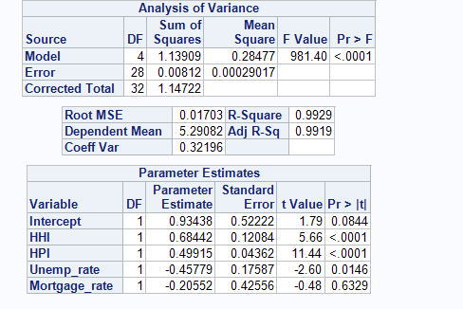

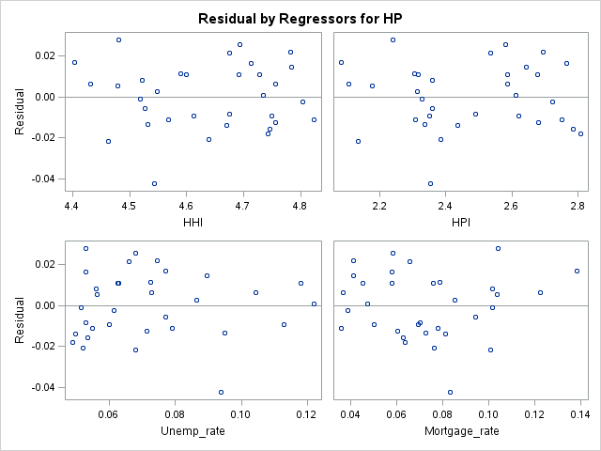

It seams that Mortgage rate has very limited effection for HP

**proc** **reg** data=IL_model;

model HP=HHI HPI Unemp_rate Mortgage_rate;

**run**;

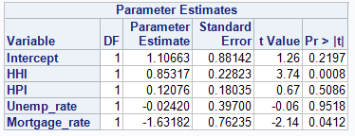

**proc** **reg** data=NY_model;

model HP=HHI HPI Unemp_rate Mortgage_rate;

**run**;

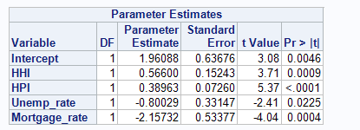

**proc** **reg** data=NC_model;

model HP=HHI HPI Unemp_rate Mortgage_rate;

**run**;

