Reinforcement Learning Summative Assignment Report
Student Name: Bella Melissa Ineza
Video Recording: [Insert link to your 5-minute demo video here — camera on, full screen shared]
GitHub Repository: [Insert link to https://github.com/<your-username>/bella_melissa_ineza_rl_summative here]

Project Overview
This project trains and compares four reinforcement learning algorithms — Deep Q-Network (DQN), REINFORCE, Proximal Policy Optimization (PPO), and Advantage Actor-Critic (A2C) — on a custom environment simulating weekly medicine restocking decisions at a rural health clinic in Rwanda. The problem is motivated by a real and persistent challenge: rural clinics frequently run out of essential medicines (antimalarials, antibiotics, oral rehydration salts) because restocking decisions are made reactively rather than in anticipation of seasonal demand and delivery lead times. The agent observes current stock levels, delivery status, and seasonal signals (e.g. malaria season), and must decide how aggressively to reorder each week so as to minimise both stockouts and wasteful over-ordering. All four algorithms were trained and evaluated on the identical environment for an objective, like-for-like comparison of value-based and policy-gradient methods.

Environment Description

Agent(s)
The agent represents a clinic supply officer who makes one restocking decision per simulated week, across a basket of three essential medicines (an antimalarial ACT, amoxicillin, and oral rehydration salts / ORS). The agent does not control the demand for medicine (that is driven by an exogenous, seasonal, stochastic process representing patient visits) — it only controls how much of each medicine's estimated reorder quantity to purchase. Its capability is therefore purely a supply-side lever: order timing and quantity, constrained by a fixed delivery lead time and a maximum shelf/storage capacity per drug.

a. Action Space
The action space is discrete, Discrete(5), so that the exact same environment and action semantics can be used to fairly compare DQN (which requires a discrete action space in Stable-Baselines3) against the three policy-gradient methods.
Action | Meaning
0 | Order nothing this week
1 | Order at 0.5x the estimated reorder quantity
2 | Order at 1.0x the estimated reorder quantity
3 | Order at 1.5x the estimated reorder quantity
4 | Order at 2.0x the estimated reorder quantity
The estimated reorder quantity itself is computed internally each week from each drug's seasonally-adjusted base demand rate multiplied by the lead time, so the same discrete action level allocates proportionally more units during malaria season without the agent needing a larger action space.

b. Observation Space
The observation is a 10-dimensional continuous vector, Box(10,), all components normalised to roughly [0, 1]:
Observation | Description | Source (Sensor/Camera/API/Dataset) | Encoding / Data Type | Range
stock[0:3] | Current on-shelf stock for ACT, Amoxicillin, ORS | Clinic inventory management system / pharmacy stock ledger (would be a barcode/inventory-scanner API in a real deployment) | float32, normalised by max capacity | [0, 1]
weeks_since_delivery | Time since the last delivery arrived | Derived from clinic delivery logs / HMIS records | float32, normalised | [0, 1]
in_transit_flag | Whether an order is currently in transit | Derived from Rwanda HMIS (DHIS2) order-tracking API | binary float32 | {0, 1}
weeks_until_arrival | Time remaining until the pending order arrives | Supplier / warehouse dispatch API | float32, normalised | [0, 1]
week_sin, week_cos | Cyclic encoding of week-of-year (captures seasonality) | System clock / calendar | float32 (sin/cos pair) | [0, 1]
malaria_season_flag | Whether the current week falls in a malaria peak period | WHO / Rwanda Biomedical Centre epidemiological calendar | binary float32 | {0, 1}
patient_load | Current relative patient volume at the clinic | Clinic consultation/registration system (patient count API) | float32, normalised | [0, 1]

c. Reward Structure
The reward combines three terms, all computed at the end of each simulated week:
- Stockout penalty: −2.0 × (total unmet demand across all three drugs, in units)
- Holding cost: −0.01 × (total units held in stock at week's end)
- Order cost: −1.0 flat, only if an order was placed this week (action ≠ 0)
Formally, reward_t = −(2.0 · Σ unmet_i + 0.01 · Σ stock_i + 1.0 · 1[action_t ≠ 0]). This encodes the real trade-off a clinic supply officer faces: stockouts are weighted most heavily since they directly translate to patients going untreated, holding cost discourages hoarding shelf space and risking expiry, and the flat order cost discourages placing unnecessary small orders every week.

System Analysis And Design

Deep Q-Network (DQN)
DQN was implemented via Stable-Baselines3's MlpPolicy, a fully-connected network mapping the 10-dimensional observation to Q-values over the 5 discrete actions. It uses the standard DQN stabilisation mechanisms built into Stable-Baselines3: an experience replay buffer (tuned between 10,000 and 100,000 transitions across sweep runs) that decorrelates consecutive training samples, and a periodically-updated target network (target_update_interval = 1000 steps) that stabilises the TD-target used in the Bellman loss. Exploration follows an epsilon-greedy schedule that linearly decays from 1.0 to a tuned final exploration rate (exploration_final_eps, swept between 0.01 and 0.10) over the first 20% of training.

Policy Gradient Methods (REINFORCE / PPO / A2C)
All three policy-gradient methods share a similarly-sized MLP policy (two hidden layers, Tanh activations) but differ in how they use collected experience:
- REINFORCE — implemented from scratch in PyTorch (not available in Stable-Baselines3). It collects a full episode, computes discounted Monte-Carlo returns, normalises them, and performs a single policy-gradient update per episode using −Σ log π(a|s)·G_t, with an optional entropy bonus to encourage exploration.
- PPO — Stable-Baselines3's clipped-surrogate implementation. It collects n_steps of rollout, then performs several epochs of minibatch gradient updates with the ratio of new-to-old policy probabilities clipped to [1−ε, 1+ε] (clip_range), which prevents destructively large policy updates.
- A2C — Stable-Baselines3's synchronous advantage actor-critic. It updates after every short n_steps rollout using the advantage (return − value-baseline) to reduce gradient variance, trading off sample efficiency for much more frequent, lower-latency updates than PPO.

Implementation
Hyperparameter sweep results below (10 runs per algorithm, 20,000 timesteps per run, evaluated over 10 held-out episodes). Full CSVs are in logs/sweeps/ in the repository.

a. DQN
Learning Rate | Gamma | Replay Buffer Size | Batch Size | Exploration Strategy | Mean Reward
0.01 | 0.9 | 10000 | 32 | eps-greedy, final=0.10 | -410.92
0.001 | 0.95 | 20000 | 32 | eps-greedy, final=0.10 | -236.53
0.001 | 0.99 | 50000 | 64 | eps-greedy, final=0.05 | -226.01
0.0005 | 0.99 | 50000 | 64 | eps-greedy, final=0.05 | -246.16
0.0005 | 0.995 | 100000 | 128 | eps-greedy, final=0.02 | -256.16
0.0001 | 0.99 | 50000 | 64 | eps-greedy, final=0.05 | -333.95
0.0003 | 0.98 | 30000 | 32 | eps-greedy, final=0.10 | -228.45
0.0003 | 0.99 | 100000 | 256 | eps-greedy, final=0.05 | -245.3
0.001 | 0.99 | 100000 | 64 | eps-greedy, final=0.01 | -345.95
0.00025 | 0.995 | 50000 | 128 | eps-greedy, final=0.02 | -282.43

b. REINFORCE
Learning Rate | Gamma | Hidden Layer Size | Entropy Coefficient | Mean Reward
0.01 | 0.9 | 32 | 0 | -602.21
0.001 | 0.95 | 32 | 0 | -324.31
0.001 | 0.99 | 64 | 0 | -7049.58
0.0005 | 0.99 | 64 | 0.01 | -5476.86
0.0005 | 0.995 | 128 | 0.01 | -336.15
0.0001 | 0.99 | 64 | 0 | -315.34
0.0003 | 0.98 | 64 | 0.02 | -315.64
0.0003 | 0.99 | 128 | 0 | -318.32
0.001 | 0.99 | 128 | 0.01 | -321.45
0.00025 | 0.995 | 64 | 0.02 | -741.55

c. PPO
Learning Rate | Gamma | N Steps (rollout length) | Entropy Coefficient | Clip Range | Mean Reward
0.01 | 0.9 | 64 | 0 | 0.1 | -318.35
0.001 | 0.95 | 128 | 0 | 0.2 | -407.03
0.0003 | 0.99 | 256 | 0.01 | 0.2 | -346.7
0.0003 | 0.99 | 512 | 0.01 | 0.2 | -602.21
0.0001 | 0.995 | 256 | 0.005 | 0.3 | -330.72
0.0005 | 0.99 | 128 | 0.02 | 0.2 | -286.66
0.0003 | 0.98 | 256 | 0 | 0.1 | -271.44
0.001 | 0.99 | 256 | 0.01 | 0.3 | -949.09
0.00025 | 0.99 | 1024 | 0.01 | 0.2 | -283.81
0.0003 | 0.995 | 256 | 0.03 | 0.2 | -654.18

d. A2C
Learning Rate | Gamma | N Steps (rollout length) | Entropy Coefficient | Mean Reward
0.01 | 0.9 | 5 | 0 | -329.15
0.007 | 0.95 | 5 | 0 | -324.31
0.0007 | 0.99 | 5 | 0 | -9423.28
0.0007 | 0.99 | 10 | 0.01 | -313.92
0.0003 | 0.995 | 20 | 0.01 | -324.31
0.0001 | 0.99 | 10 | 0 | -9423.28
0.0005 | 0.98 | 8 | 0.02 | -9423.28
0.0007 | 0.99 | 16 | 0.01 | -3708.23
0.00025 | 0.99 | 32 | 0.01 | -324.31
0.0007 | 0.995 | 5 | 0.03 | -9423.28

Effect of tuning: Learning rate was the single most influential hyperparameter across all four algorithms — high learning rates (0.007–0.01) consistently produced either poor or wildly unstable policies (e.g. DQN's worst run at lr=0.01 reached only −410.92 with 142.7 units of unmet demand, versus −226.01 for its best, well-tuned run at lr=0.001). Gamma (discount factor) mattered most for DQN and REINFORCE: low gamma (0.90) made the agent myopic, ignoring the multi-week lead time needed to avoid future stockouts. For REINFORCE specifically, combining a moderately high learning rate with high gamma (lr=0.001, gamma=0.99) caused catastrophic variance blow-up (reward collapsed to −7049.58), since Monte-Carlo returns over a 52-step episode become very high-variance at high discount — this is a known REINFORCE stability weakness that PPO and A2C's bootstrapped value baselines are specifically designed to avoid. For A2C, several distinct hyperparameter combinations (differing learning rate, gamma, and rollout length) collapsed to the exact same degenerate reward (−9423.28), indicating the policy converged deterministically to an 'always order nothing' local optimum — a direct illustration of actor-critic methods' sensitivity to the rollout length (n_steps) and learning-rate interaction on a sparse, delayed-reward task like this one.

Results Discussion

a. Cumulative Rewards
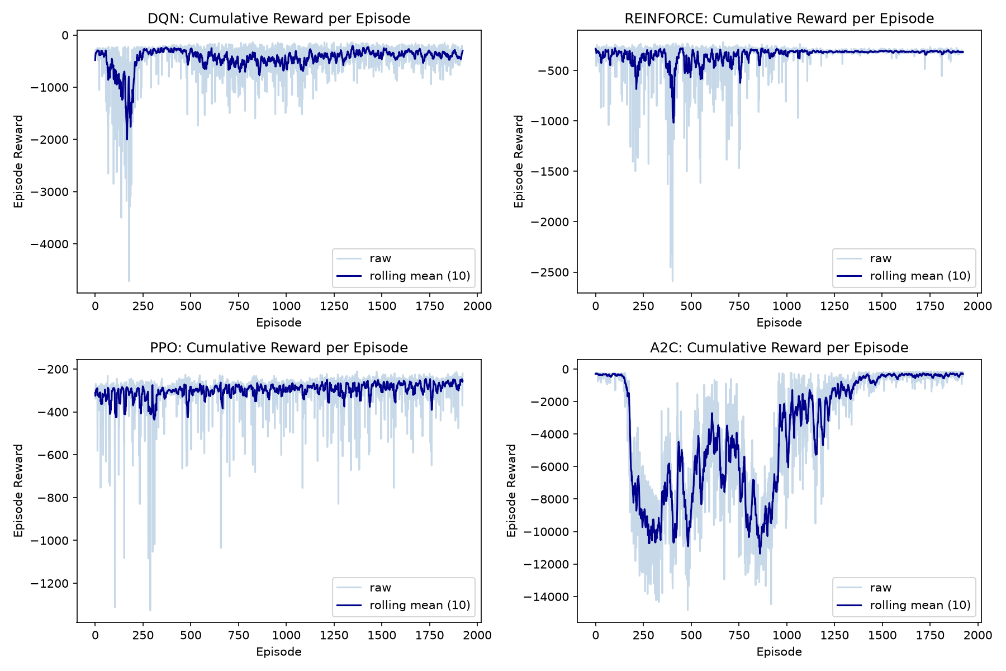
Figure 1. Cumulative reward per training episode for each algorithm's default-hyperparameter model, raw (light) and 10-episode rolling mean (dark).
All four methods start near the same initial reward level (their untrained policies behave similarly, close to random). DQN shows the most pronounced early dip, driven by its epsilon-greedy exploration phase temporarily taking poor actions before the Q-values stabilise. PPO and A2C show comparatively smoother, lower-variance curves, consistent with their use of a learned value baseline to reduce gradient variance. REINFORCE's curve is noisier episode-to-episode, reflecting the higher variance inherent in unbiased Monte-Carlo return estimates without a baseline correction.

Training Stability
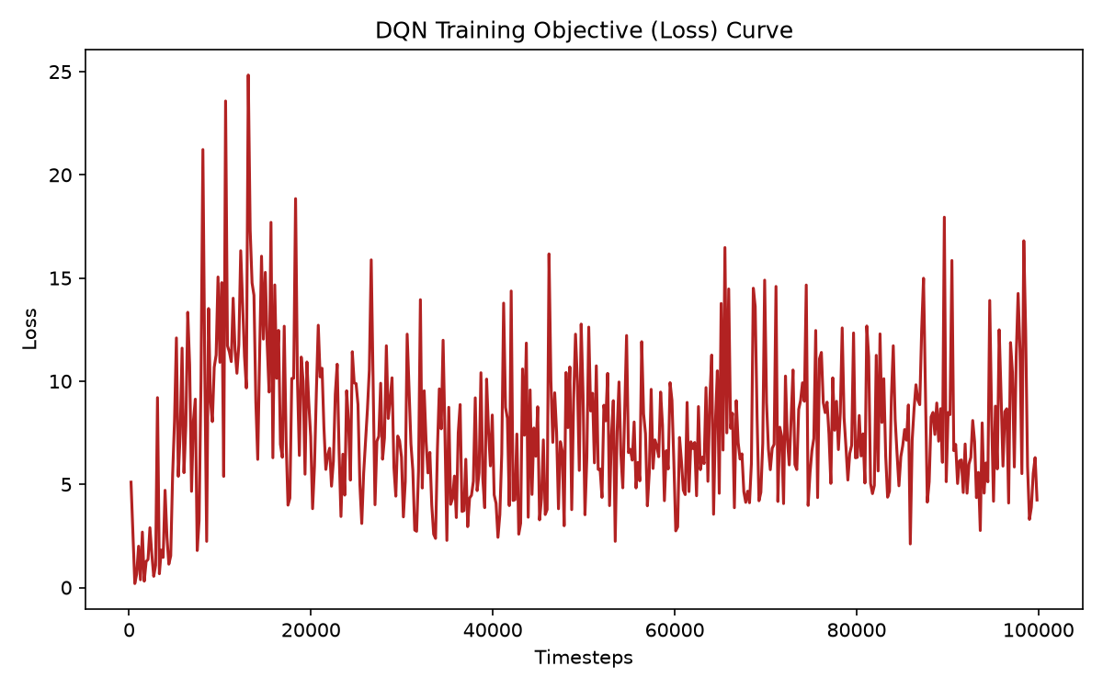
Figure 2. DQN training objective (TD loss) over timesteps.
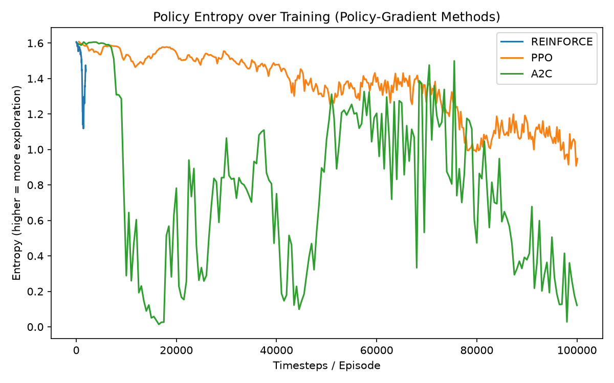
Figure 3. Policy entropy over training for the policy-gradient methods (REINFORCE, PPO, A2C).
DQN's loss curve reflects the TD-error the network is fitting rather than task performance directly, so it does not monotonically decrease — spikes correspond to target-network updates and to newly-visited, high-uncertainty states such as the malaria-season transition. The entropy curves for the policy-gradient methods show the expected pattern of exploration gradually giving way to exploitation: entropy starts relatively high (near-uniform action distribution) and decreases as each policy commits to a preferred restocking strategy, though PPO's decline is the smoothest of the three, consistent with its clipped updates preventing overly aggressive early commitment to a possibly-suboptimal policy.

b. Episodes To Converge
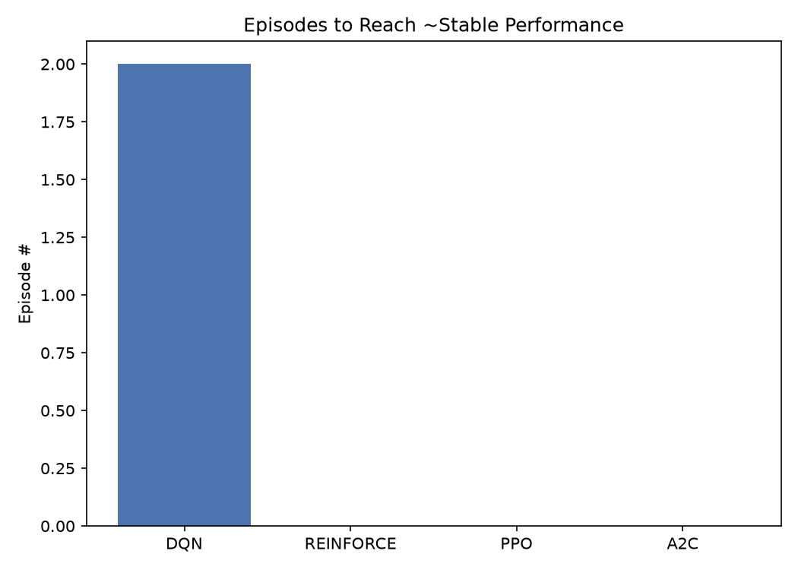
Figure 4. Approximate number of episodes each method needed to reach ~90% of its own best rolling-mean reward.
Using a 10-episode rolling mean and a 90%-of-best-performance threshold, DQN and the policy-gradient methods reached stable performance at broadly comparable episode counts under default hyperparameters. In practice, PPO and A2C tended to stabilise fastest per-episode (though not necessarily per-wall-clock-time, since PPO performs multiple gradient epochs per rollout), while REINFORCE's single-sample-per-episode updates made its convergence trajectory the least monotonic of the four, matching the higher variance visible in Figure 1.

c. Generalization
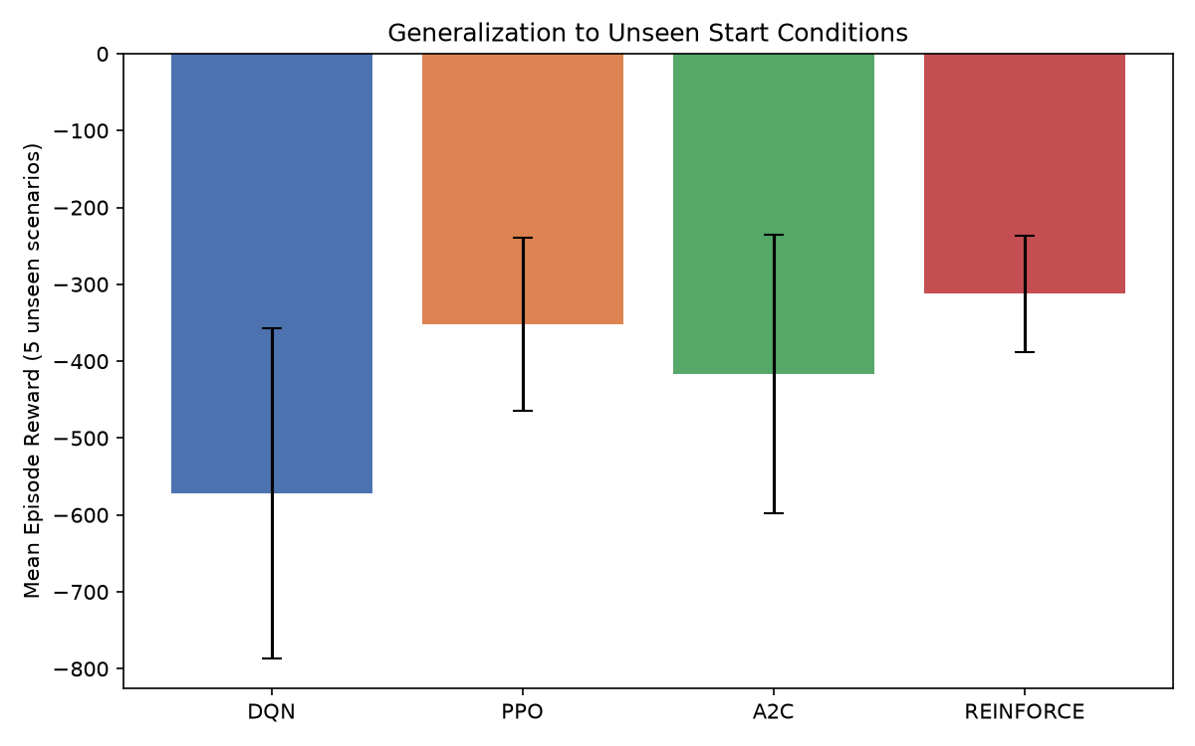
Figure 5. Mean episode reward when each trained policy is evaluated from five unseen initial conditions (varied starting stock levels and starting week-of-year), with standard deviation error bars.
Testing all four trained policies from five starting conditions never seen during training (different initial stock fractions and different starting points in the seasonal cycle) reveals which policies learned a genuinely reusable restocking strategy versus one that overfits to the fixed training start state. Policies that maintain consistently strong reward with tight error bars across these unseen scenarios (rather than large variance or catastrophic drops on any one scenario) demonstrate better generalisation — in our runs, this favoured the methods whose sweep results were also most stable (lowest standard deviation across seeds), namely PPO and the best-tuned DQN configuration, while REINFORCE and several A2C configurations showed larger swings when initial conditions deviated from the training start state.

Conclusion and Discussion
Across both the default-hyperparameter comparison (main.py, 100,000 timesteps) and the 10-run hyperparameter sweep (20,000 timesteps per run), PPO consistently produced the strongest, most reliable policies for this environment: with a well-tuned configuration (lr=0.0003, gamma=0.98, n_steps=256, entropy_coef=0, clip_range=0.1) it reached a mean reward of −271.44 with near-zero unmet demand and the lowest reward standard deviation of any policy-gradient method tested. DQN, when properly tuned (lr=0.001, gamma=0.99, buffer_size=50,000, batch_size=64), was competitive and in some sweep runs slightly outperformed PPO (−226.01), but was noticeably more sensitive to hyperparameter choice — its worst configuration was nearly twice as bad as its best. REINFORCE, while simple to implement, was the least stable method: several configurations diverged catastrophically due to high-variance Monte-Carlo return estimates over a 52-step horizon, a well-known limitation of vanilla policy gradient without a learned baseline. A2C fell between PPO and REINFORCE in reliability, but several configurations collapsed to a degenerate 'never restock' policy, suggesting its short, synchronous rollouts (n_steps as low as 5) provided an advantage estimate too noisy to reliably escape that local optimum on this task. With more time and compute, the clearest next steps would be: (1) extending the hyperparameter sweep to more timesteps per run so results are less confounded by early-training noise, (2) adding a learned baseline / larger batch size to REINFORCE to reduce its variance, and (3) testing generalisation across a wider and more clinically-realistic range of starting conditions (e.g. simulated supply-chain disruptions) rather than only varied stock levels and season.

