Sentiment Classification of Kinyarwanda Tweets: Comparing Classical, Recurrent and Transformer Models on AfriSenti
YOUR FULL NAME · Machine Learning / NLP - Summative Project
GitHub Repository | https://github.com/belladev250/kin-sentiment
Demo Video | https://YOUR-VIDEO-LINK
Live System | https://huggingface.co/spaces/bellahug3/kin-sentiment

Abstract
Sentiment analysis tools rarely exist for African languages, even widely spoken ones such as Kinyarwanda. This project builds and deploys a three-way (positive / neutral / negative) sentiment classifier for Kinyarwanda tweets using the Kinyarwanda portion of the AfriSenti benchmark (Muhammad et al., 2023a), which contains 5,155 human-annotated tweets. A TF-IDF word-unigram logistic regression baseline achieved 57.9 test macro-F1. Adding character n-grams, which capture the agglutinative morphology of Kinyarwanda, raised this to 62.3 (E6, Linear SVM), a statistically significant improvement (McNemar p = 0.0002). BiLSTM models trained from scratch performed worse than the baseline (57.2), which we attribute to the 31.2% out-of-vocabulary rate and small training set. Fine-tuning pretrained Transformers showed that pretraining on the target language is decisive: mBERT, which saw no Kinyarwanda during pretraining, reached only 57.6, whereas the African-centric AfroXLMR-base reached 67.5 ± 0.7 (mean of three seeds), significantly better than the best classical model (McNemar p = 0.0022); it is the deployed model. Error analysis shows that most mistakes involve the neutral class and that human annotators themselves agreed unanimously on only 35.8% of tweets (Fleiss' κ = 0.318), suggesting label ambiguity limits achievable accuracy. The final model is deployed as a Gradio web application.

1. Introduction
Social media is now a primary channel through which people in Rwanda discuss public services, news, sport, entertainment and politics. Organisations such as government agencies, telecom companies, banks and media houses increasingly want to understand public opinion expressed online, but almost all off-the-shelf sentiment tools are built for English and a few other high-resource languages. Joshi et al. (2020) show that the vast majority of the world's languages, including most African languages, are severely under-represented in NLP resources and research. Kinyarwanda, the national language of Rwanda, is one of these: despite a large speaker population, labelled datasets are small and only a few pretrained models include it (Niyongabo et al., 2020; Nzeyimana & Niyongabo Rubungo, 2022).
Kinyarwanda is a Bantu language with rich agglutinative morphology: a single word can combine subject, tense, object and negation markers around a stem (Nzeyimana & Niyongabo Rubungo, 2022). For example, the gratitude expressions urakoze, murakoze and mwakoze ("thank you", singular/plural/past) are different surface words sharing the stem -koze. This makes word-level models sparse and motivates sub-word and character-level representations. Tweets add further challenges: informal spelling, elongated characters, emojis and frequent code-switching with English and French.
Objective. The goal of this project is to build, evaluate and deploy a sentiment classifier that assigns Kinyarwanda text to one of three classes (positive, neutral, negative), and to understand which modelling choices matter for a low-resource, morphologically rich language. Specifically, we ask: (RQ1) Does a meaningful model beat a simple bag-of-words baseline? (RQ2) Do character-level features help, given Kinyarwanda morphology? (RQ3) Do neural sequence models trained from scratch help on only ~3,300 training tweets? (RQ4) Does African-centric pretraining help compared with generic multilingual pretraining? (RQ5) Which kinds of tweets remain hard, and why? Choice of language and task. Although Kinyarwanda is the national language of Rwanda, sentiment resources for it consist mainly of the AfriSenti benchmark and a handful of shared-task systems (Muhammad et al., 2023b). The restriction on well-resourced languages in this assignment applies to machine translation; for text classification, no established, publicly usable Kinyarwanda sentiment tool exists, and the published shared-task systems report leaderboard scores without a deployable interface. Target users are Rwandan organisations and researchers who want to monitor public sentiment in Kinyarwanda, e.g. customer feedback for a telecom or public reaction to a government announcement.

2. Related Work
African-language sentiment analysis. AfriSenti (Muhammad et al., 2023a) is the largest sentiment benchmark for African languages, with over 110,000 tweets in 14 languages annotated by native speakers, and was the basis of the SemEval-2023 Task 12 shared task (Muhammad et al., 2023b). In the shared task, the strongest Kinyarwanda systems used pretrained Transformers and scored around 72–73 weighted-F1: the top team reached 72.63, and the KINLP team ranked second of 34 with 72.50 using KinyaBERT, a morphology-aware Kinyarwanda language model (Nzeyimana, 2023; Nzeyimana & Niyongabo Rubungo, 2022). For Kinyarwanda text classification more broadly, Niyongabo et al. (2020) released KINNEWS, a 14-class news corpus, and showed that classical models with TF-IDF features are competitive with neural models when data is limited.
Classical vs neural text classification. Linear models over n-gram features remain strong baselines for short-text sentiment; Wang and Manning (2012) showed that Naive Bayes and SVM variants with bigrams are hard to beat on short snippets, and Joulin et al. (2017) showed that simple linear models with sub-word n-grams rival deep networks at a fraction of the cost. Recurrent networks such as LSTMs (Hochreiter & Schmidhuber, 1997) with attention (Bahdanau et al., 2015) model word order, but typically need more data to learn good embeddings from scratch.
Pretrained multilingual Transformers. mBERT (Devlin et al., 2019) and XLM-R (Conneau et al., 2020) are pretrained on 100+ languages but include little or no Kinyarwanda. African-centric models address this: AfriBERTa (Ogueji et al., 2021) was pretrained from scratch on under 1 GB of text in 11 African languages including Kinyarwanda/Kirundi, and AfroXLMR (Alabi et al., 2022) adapts XLM-R to 17 African languages through multilingual adaptive fine-tuning (MAFT).
Gap addressed. Most published Kinyarwanda sentiment systems are shared-task submissions that report a single leaderboard score. This project contributes a controlled comparison of classical, recurrent and Transformer approaches under the same splits and preprocessing, with ablations, significance testing and an analysis of annotator disagreement, and it packages the result as a deployed, usable application.

3. Dataset and Data Preparation
Source and licence. We use the Kinyarwanda subset of AfriSenti (Muhammad et al., 2023a), downloaded from the official AfriSenti-SemEval GitHub repository (CC BY 4.0). The tweets are real, naturally occurring posts collected from Twitter and labelled by three native-speaker annotators; the final label is the majority vote. No synthetic or machine-generated data is used. We keep the official train / dev / test split so that results are comparable with the literature.
Table 1. AfriSenti-Kinyarwanda splits and label distribution.
Split | Tweets | Negative | Neutral | Positive
Train | 3302 | 1146 | 1257 | 899
Dev (validation) | 827 | 287 | 315 | 225
Test | 1026 | 355 | 393 | 278
Total | 5155 | 1788 | 1965 | 1402

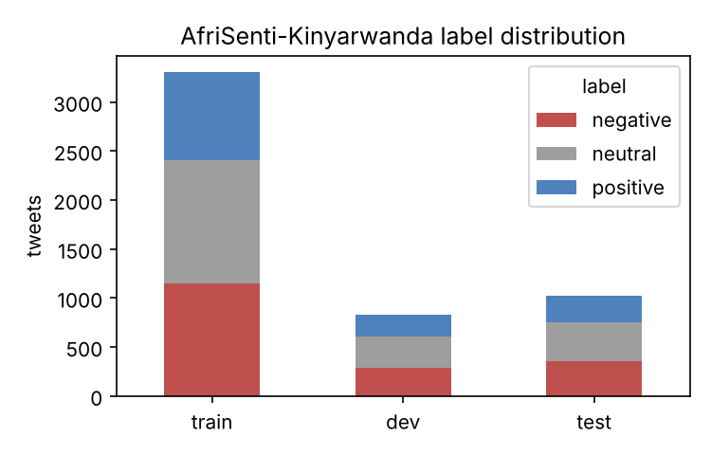
Figure 1. Label distribution per split. Classes are moderately imbalanced (positive is smallest).
Characteristics and quality issues. Inspecting the data revealed: (i) many replies begin with long chains of anonymised mentions (up to 11 "@user" tokens); (ii) URLs, hashtags and elongated words such as Hhhhhh or Yoooo; (iii) emojis in 29.6% of test tweets; (iv) code-switching with English/French in about 11.4% of test tweets; (v) many news-style and promotional tweets whose sentiment is implicit. The data files are sorted by label, so shuffling during training is essential. Most importantly, the individual annotations released with AfriSenti show that the three annotators gave the same label to only 35.8% of Kinyarwanda tweets, with Fleiss' κ = 0.318 ("fair" agreement; Fleiss, 1971). Annotators also used 'mixed' (1567 labels) and 'indeterminate' (466) labels that were later collapsed. Label noise is therefore substantial and sets a ceiling on achievable performance.
Preprocessing (src/preprocess.py). For classical and BiLSTM models: lower-casing; URLs → xxurl; runs of @-mentions → a single xxuser token (keeping the "this is a reply" signal); any character repeated 3+ times is capped at two (hhhhhh → hh); emojis are kept and separated into their own tokens; remaining punctuation is removed. We deliberately do not remove stopwords, because the standard Kinyarwanda stopword list (Niyongabo et al., 2020) contains the negation word nta, and removing negation can flip sentiment; this decision is tested in ablation A3. For Transformers we apply only light cleaning (mentions, URLs, elongation), leaving case, punctuation and emojis to the model's sub-word tokenizer.

4. Methodology
All models map a tweet to one of three labels. Hyper-parameters are selected only on the dev set; the test set is used once per configuration for reporting. Because the classes are imbalanced and all three matter equally, macro-F1 is our primary metric; we also report accuracy and weighted-F1 (the official AfriSenti metric) for comparability.

4.1 Baseline
E1: TF-IDF word unigrams + logistic regression. Each tweet is represented as a sparse vector of sub-linear TF-IDF weights over its words, and a multinomial logistic regression with balanced class weights is trained on top (regularisation strength C ∈ {0.1, 0.3, 1, 3, 10} tuned on dev). This is the standard, transparent starting point for text classification and was also used as a baseline for KINNEWS (Niyongabo et al., 2020). A majority-class predictor (E0) is reported as a floor.

4.2 Classical experiments
Building on E1 we vary one factor at a time: word bigrams (E2); character n-grams of length 2–5 within word boundaries (E3), which let the model share information across morphological variants such as urakoze/murakoze/mwakoze; the union of word 1–2-grams and character 2–5-grams (E4); and the classifier on the E4 features: Multinomial Naive Bayes (E5) and a linear SVM (E6). Ablations test preprocessing choices on the E4 configuration: raw text (A1), emojis removed (A2), and stopwords removed (A3).

4.3 BiLSTM trained from scratch
To test whether modelling word order helps, we implemented a BiLSTM classifier in PyTorch (src/bilstm.py). Input words are mapped to indices (vocabulary built from training words with frequency ≥ 2; 4,345 types; unknown words → <unk>), passed through a 100-dimensional embedding layer learned from scratch, dropout (0.5), and a bidirectional LSTM with 64 hidden units per direction. The 128-dimensional hidden states are pooled into one sentence vector either by max-pooling over time (N1) or by additive attention (N2), where each state h_t receives a weight a_t = softmax(vᵀ tanh(W h_t)) and the sentence vector is Σ a_t h_t (Bahdanau et al., 2015). A linear layer maps it to three logits. Training uses cross-entropy loss, Adam (learning rate 2×10⁻³), batch size 32, gradient clipping at 1.0, and early stopping on dev macro-F1 (patience 3, max 30 epochs). N3 doubles the embedding (200) and hidden (128) sizes. Each configuration is run with three random seeds and we report mean ± standard deviation.

4.4 Fine-tuned Transformers
We fine-tune three pretrained encoders with the Hugging Face Transformers library (Wolf et al., 2020) (src/finetune_transformer.py): T1 mBERT (Devlin et al., 2019), whose pretraining data does not include Kinyarwanda; T2 AfriBERTa-base (Ogueji et al., 2021); and T3 AfroXLMR-base (Alabi et al., 2022). The tweet is split into sub-word tokens (max 128), the final-layer representation of the first token is fed to a randomly initialised linear classification head, and all weights are updated (full fine-tuning) with AdamW, weight decay 0.01, linear warm-up over 10% of steps, 5 epochs, batch size 32, learning rate 3×10⁻⁵ (5×10⁻⁵ for AfriBERTa), mixed precision on a Colab T4 GPU. The checkpoint with the best dev macro-F1 is kept, and each model is run with three seeds. Sub-word tokenization addresses the out-of-vocabulary problem that limits the word-level BiLSTM.

4.5 Own work vs existing resources
Table 2. Distinction between existing resources and own implementation.
Existing resources used | Implemented in this project
AfriSenti-Kin data and annotator labels (Muhammad et al., 2023a) | Data inspection, cleaning pipeline, agreement analysis
Kinyarwanda stopword list (Niyongabo et al., 2020) | Baseline, 10 classical experiments and ablations with dev-set tuning
scikit-learn, PyTorch, Hugging Face Transformers libraries | BiLSTM + attention model and training loop written from scratch
Pretrained mBERT, AfriBERTa, AfroXLMR checkpoints | Fine-tuning script, multi-seed evaluation, model selection
Gradio, Hugging Face Spaces and Hub | Error analysis (incl. Transformer vs SVM), significance tests, figures, web app, this report

5. Experiments and Results
Table 3. All experiments (scores ×100). M-F1 = macro-F1, W-F1 = weighted-F1. Neural rows: mean ± std over 3 seeds.
ID | Approach | Best param | Dev M-F1 | Test Acc | Test M-F1 | Test W-F1
E0 | Majority class (neutral) | - | 18.4 | 38.3 | 18.5 | 21.2
E1 | TF-IDF word unigrams + LogReg | 1.0 | 59.8 | 57.4 | 57.9 | 57.4
E2 | TF-IDF word 1-2grams + LogReg | 10.0 | 58.6 | 58.2 | 58.7 | 58.3
E3 | TF-IDF char 2-5grams + LogReg | 1.0 | 63.2 | 61.1 | 61.3 | 60.9
E4 | Word 1-2 + char 2-5 + LogReg | 10.0 | 64.4 | 62.0 | 62.4 | 61.9
E5 | Word 1-2 + char 2-5 + Multinomial NB | 0.3 | 64.2 | 61.6 | 62.0 | 61.7
E6 | Word 1-2 + char 2-5 + Linear SVM | 0.1 | 64.7 | 62.0 | 62.3 | 61.8
A1 | E4 on RAW text (no preprocessing) | 1.0 | 63.9 | 61.1 | 61.5 | 61.0
A2 | E4 with emojis REMOVED | 1.0 | 63.6 | 61.2 | 61.7 | 61.1
A3 | E2 with stopwords REMOVED (word only) | 0.3 | 58.0 | 55.9 | 56.5 | 55.7
N1 | BiLSTM + max-pooling (emb 100, hid 64) | 3 seeds | 58.4 | 57.3 | 57.2 ± 1.5 | 57.2
N2 | BiLSTM + additive attention (emb 100, hid 64) | 3 seeds | 58.3 | 55.8 | 56.1 ± 0.7 | 55.8
N3 | BiLSTM + attention, bigger (emb 200, hid 128) | 3 seeds | 57.7 | 55.3 | 55.3 ± 0.2 | 55.1
T1 | mBERT-base (no Kinyarwanda in pretraining) | lr 3e-05 | 57.2 | – | 57.6 ± 0.7 | 57.4
T2 | AfriBERTa-base (African-only pretraining) | lr 5e-05 | 64.4 | – | 63.3 ± 0.3 | 63.1
T3 | AfroXLMR-base (XLM-R + African MAFT) | lr 3e-05 | 68.7 | – | 67.5 ± 0.7 | 67.1

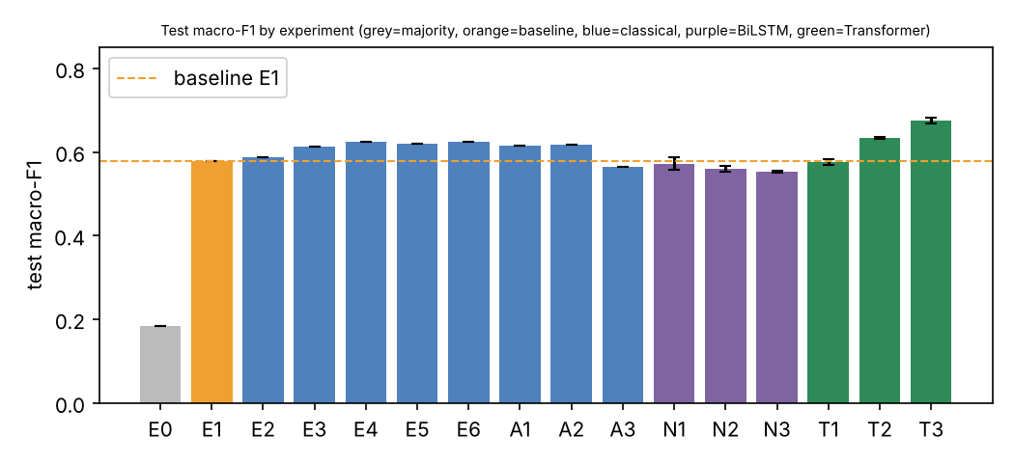
Figure 2. Test macro-F1 per experiment; dashed line = baseline E1. Error bars = std over seeds.
RQ1 – baseline vs better models. The majority-class floor (E0) scores only 18.5 macro-F1, while the word-unigram baseline reaches 57.9. The best classical model, E6, improves this by 4.4 points to 62.3 (95% bootstrap CI 59.4–65.3 vs 54.8–61.0 for the baseline). On the paired test predictions it fixes 103 baseline errors while breaking 56, and McNemar's exact test gives p = 0.0002, so the improvement is unlikely to be chance.
RQ2 – character n-grams. Word bigrams alone barely help (E2: 58.7), because with only 3,302 tweets most bigrams occur once. Switching to character 2–5-grams gives the largest single jump (E3: 61.3, +3.4 points). This supports our hypothesis: character n-grams recover shared stems and affixes of agglutinative Kinyarwanda words (e.g. -koze in all 'thank you' variants) and are robust to spelling variation, so a word never seen in training can still activate useful features. Combining word and character features (E4) adds a further gain (62.4). With these features the choice of classifier matters little: Naive Bayes, logistic regression and SVM are within about 0.4 points, i.e. representation matters more than the classifier.
Ablations. Keeping emojis helps: removing them (A2) lowers dev macro-F1 from 64.4 to 63.6, and in the error analysis tweets containing emojis are classified more accurately (65.8% vs 60.4%). Our cleaning gives a small gain over raw text (A1: 63.9 dev), mainly by collapsing mention chains and elongations. Removing stopwords hurts (A3: 56.5 vs 58.7 test for the same model), consistent with our concern that the list removes the negator nta. Note that with 827 dev tweets, differences below ~1–2 points are within noise.
RQ3 – BiLSTM from scratch. All BiLSTM variants performed worse than the linear baseline (best N1: 57.2 ± 1.5), and attention (N2) or a larger network (N3) did not help. We investigated why: 31.2% of test tokens are out of the training vocabulary, so a third of each tweet reaches the LSTM as the same <unk> vector, whereas character n-grams still extract information from those words. With only ~3,300 short tweets, the embedding layer (≈430k parameters) cannot learn good word representations, and the dev score peaks within 6–13 epochs before over-fitting. The larger N3 over-fit fastest (best epoch 6–7). This matches the observation of Niyongabo et al. (2020) that classical models are competitive on small Kinyarwanda datasets, and shows that model complexity is not a substitute for data.
RQ4 – pretrained Transformers. Pretraining data turned out to matter more than model size or architecture. mBERT (T1), whose pretraining corpus contains no Kinyarwanda, reached only 57.6 ± 0.7 test macro-F1, no better than the TF-IDF baseline (57.9) and below the character n-gram models, despite having ~180M parameters. Its sub-word vocabulary splits Kinyarwanda words into fragments that carry no learned meaning, so fine-tuning on 3,302 tweets has to learn the language almost from scratch. AfriBERTa (T2), pretrained on African languages including Kinyarwanda, reached 63.3 ± 0.3, slightly above the best classical model. AfroXLMR-base (T3), which starts from XLM-R and continues pretraining on 17 African languages (MAFT), was best on both dev (68.7) and test (67.5 ± 0.7 macro-F1, 67.1 weighted-F1), +5.1 points over E6. The low standard deviations across seeds (≤ 0.7 points) show that the ranking T3 > T2 > T1 is stable rather than a lucky seed.
The deployed T3 checkpoint (the seed with the best dev score) scores 66.8 macro-F1 on test (95% bootstrap CI 63.8–69.7). On paired predictions it corrects 148 of E6's errors while introducing 99 new ones; McNemar's test gives p = 0.0022 against E6 and p < 0.0001 against the baseline, so the Transformer's advantage is statistically significant. Our 67.1 weighted-F1 is below the ~72.5 of the best SemEval systems (Muhammad et al., 2023b; Nzeyimana, 2023), which used larger models (e.g. AfroXLMR-large), Kinyarwanda-specific pretraining (KinyaBERT) and ensembles; our result is from a single base-size model trained for five epochs on a free GPU.

6. Error Analysis and Discussion
We first analyse the best classical model (E6), whose errors can be traced to individual n-gram features, and then compare it with the deployed Transformer (T3) on the same test tweets (Section 6.2).

6.1 Classical model (E6)
Table 4. Per-class test results for E6.
Class | Precision | Recall | F1
negative | 61.1 | 67.6 | 64.2
neutral | 60.1 | 53.9 | 56.8
positive | 65.7 | 66.2 | 65.9

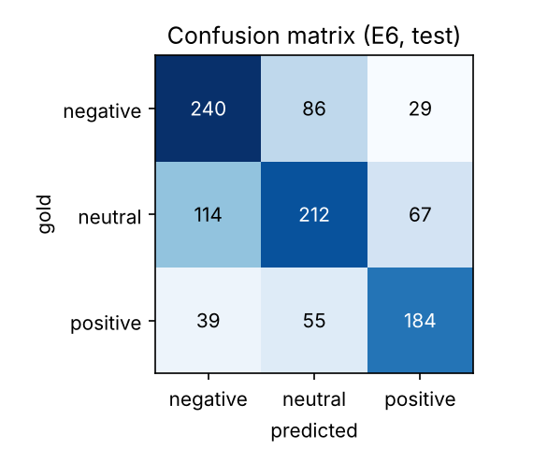
Figure 3. Confusion matrix of E6 on the test set.
Where the model fails. E6 makes 390 errors on 1,026 test tweets. Neutral is the hardest class (F1 56.8) and the two most frequent confusions both involve it: neutral→negative (114) and negative→neutral (86). Direct polarity flips (positive↔negative) are rare (68), so the model has learned polarity but struggles with its intensity and with implicit sentiment. We grouped test tweets by properties (Table 5) to find systematic weaknesses.
Table 5. E6 accuracy on subsets of the test set (OOV = share of words unseen in training).
Tweet property | n | Accuracy | Accuracy (others)
≤ 5 content words (short) | 74 | 56.8% | 62.4%
Contains a question mark | 180 | 55.6% | 63.4%
Code-switched (English/French words) | 117 | 59.8% | 62.3%
Contains emoji | 304 | 65.8% | 60.4%
OOV rate ≤ 10% | 162 | 66.0% | -
OOV rate 10–30% | 516 | 63.9% | -
OOV rate > 30% | 348 | 57.2% | -

Accuracy falls steadily as the share of unseen words rises (from 66.0% to 57.2%), confirming that vocabulary coverage is the main bottleneck for a 3,300-tweet training set. Questions, which often express sarcasm or rhetorical complaint without explicit sentiment words, and very short tweets, which give few features, are also harder. Code-switched tweets are slightly harder because English/French words are sparse in the training data.
Representative examples (English glosses are approximate):
- Correct, high confidence: "Urakoze cyane nawe umunsi mwiza 🥰" ("Thank you very much, have a good day too") → positive. Formulaic gratitude (urakoze/murakoze), umunsi mwiza ("good day") and positive emojis are strong, frequent cues.
- Negation (bag-of-n-grams limitation): "Ntacyo itwaye ikibazo ndumva ari battery😂" ("It doesn't matter, I think the problem is the battery") – gold neutral, predicted negative. ikibazo ("problem") is a strong negative feature, and a linear model over n-grams cannot compose it with ntacyo itwaye ("it's nothing").
- Implicit sentiment needing world knowledge: "Inama y'Abaminisitiri yatangaje ko bitakiri itegeko kwambara agapfukamunwa" ("The Cabinet announced that wearing masks is no longer mandatory") – gold positive, predicted neutral. The tweet is written in neutral news style; it is positive only because readers know the news is welcome.
- Negative news in neutral style: "Rutahizamu … yahagaritswe iminsi 8 … kubera imyitwarire itari myiza" ("The striker has been suspended for 8 days for bad behaviour") – gold negative, predicted neutral. Similar sports/news reports are labelled neutral elsewhere in the data, which illustrates annotator inconsistency.
- Humour and emojis: "…none banz nkicyonka😭😭😭" – gold neutral, predicted negative. Crying emojis are used humorously here, but the model has learned 😭 as a negative cue.
- Religious text: "Wiringire Uwiteka n'umutima wawe wose…" (Proverbs 3:5, "Trust in the Lord with all your heart") – gold neutral, predicted positive. Religious vocabulary is positive in tone, but annotators judged the verse as neutral.

6.2 Transformer (T3) compared with the classical model
Table 6. Per-class precision (P), recall (R) and F1 on test: E6 vs T3.
Class | E6 P | E6 R | E6 F1 | T3 P | T3 R | T3 F1
negative | 61.1 | 67.6 | 64.2 | 64.0 | 77.2 | 70.0
neutral | 60.1 | 53.9 | 56.8 | 70.4 | 53.2 | 60.6
positive | 65.7 | 66.2 | 65.9 | 67.1 | 72.7 | 69.8

T3 improves negative and positive F1 by about 4–6 points each, mainly through higher recall: negative→neutral errors fall from 86 to 49 and positive→neutral from 55 to 39. In contrast, neutral recall does not improve (53.9 vs 53.2), and neutral→negative remains the single largest error type (117). The Transformer is better at recognising sentiment that is expressed, but not at deciding when a tweet that mentions a problem is nevertheless neutral, which is the distinction annotators also find hardest.
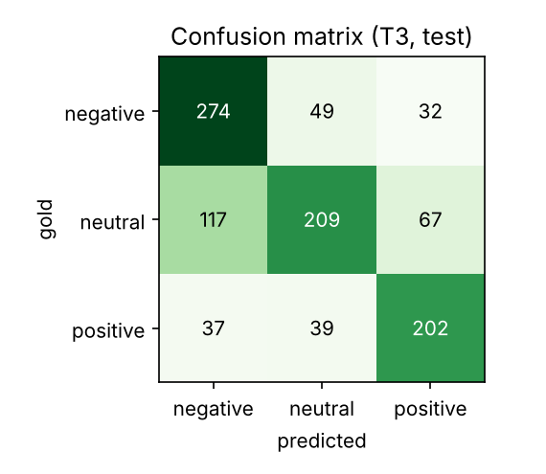
Figure 4. Confusion matrix of T3 (AfroXLMR-base) on the test set.
Table 7. Accuracy of E6 and T3 on the same test subsets as Table 5.
Tweet property | n | E6 acc. | T3 acc. | Gain
≤ 5 content words (short) | 74 | 56.8% | 71.6% | +14.9
Contains a question mark | 180 | 55.6% | 61.7% | +6.1
Code-switched | 117 | 59.8% | 68.4% | +8.5
Contains emoji | 304 | 65.8% | 67.4% | +1.6
OOV rate ≤ 10% | 162 | 66.0% | 66.7% | +0.6
OOV rate 10–30% | 516 | 63.9% | 68.4% | +4.5
OOV rate > 30% | 348 | 57.2% | 64.4% | +7.2
All test tweets | 1026 | 62.0% | 66.8% | +4.8

Table 7 shows where pretraining helps. The largest gains are on short tweets (+14.9 points), where an n-gram model has too few features but a pretrained model already knows the meaning of each word; on tweets with many unseen words (OOV > 30%: +7.2), where sub-word tokens and pretraining supply knowledge that 3,302 training tweets cannot; and on code-switched tweets (+8.5), because XLM-R was pretrained on English and French as well. Gains are small on tweets with emojis (+1.6), where emojis already gave the SVM a strong signal, and on tweets with few unseen words, where the two models have similar information. This confirms the diagnosis from Section 6.1: vocabulary coverage, not the classifier, was the main bottleneck.
Annotator agreement. We matched 958 of the 1,026 test tweets to their three individual annotations. On the 288 tweets where all three annotators agreed, the models reach 73.3% (E6) and 75.0% (T3); on the 667 tweets labelled by a 2-vs-1 majority, accuracy drops to 58.2% and 64.2%. Both models are therefore much more accurate where humans agree, and a large share of the remaining errors fall on tweets whose gold label is itself disputed. Interestingly, most of T3's gain comes from the disputed tweets, which suggests that pretraining helps the model match the majority reading of ambiguous texts.
Persistent errors. 242 test tweets are misclassified by both models. All five failure examples listed in Section 6.1 (negation with ntacyo itwaye, the mask announcement, the striker's suspension, humorous 😭 and the Bible verse) are still misclassified by T3, in the same way as by the SVM. These are cases that require world knowledge, pragmatic interpretation or a consistent annotation guideline rather than better word representations, so a bigger model alone is unlikely to fix them. A typical case that T3 does fix is "Uko abikingiza biyongera ni ko business zikomorerwa… twikingize ku bwinshi" (approximately "As more people get vaccinated, businesses reopen… let's get vaccinated in large numbers"), gold positive: the SVM predicts neutral, plausibly because no individually strong positive word appears, while T3 predicts positive, consistent with reading the encouraging message of the sentence as a whole.
Relation to label quality and the literature. Many 'errors' are tweets on which humans also disagree. Only 35.8% of Kinyarwanda tweets received three identical labels (κ = 0.318), and the neutral/negative boundary in news-style tweets is exactly where annotators diverge. Thus the achievable score is well below 100%, which helps explain why even the best SemEval systems plateau around 72–73 weighted-F1 on Kinyarwanda (Muhammad et al., 2023b). Our results agree with Alabi et al. (2022) and Ogueji et al. (2021) that pretraining on African languages is what makes Transformers effective for them, and with Niyongabo et al. (2020) that, without such pretraining, simple n-gram models are hard to beat on small Kinyarwanda datasets.

7. Deployment
The system is deployed as a Gradio (Abid et al., 2019) web application hosted on Hugging Face Spaces: https://huggingface.co/spaces/bellahug3/kin-sentiment. The fine-tuned T3 model (AfroXLMR-base, ~1.1 GB) was uploaded to the Hugging Face Hub (https://huggingface.co/bellahug3/kin-sentiment-transformer). On start-up the app downloads it and loads the tokenizer and classification model on the Space's free CPU. When a user types Kinyarwanda text, the app applies the same light cleaning used during fine-tuning (mentions, URLs, elongations), tokenizes the text into sub-words, runs the model, and applies a softmax to the three output logits. It then displays the predicted label, the probability of each class and the cleaned text the model actually saw (useful for explaining errors); a low-confidence warning appears when no class exceeds 0.5. As a fallback, the app can serve the classical E6 pipeline (models/best_classical.joblib, ~4 MB): it is used automatically if the Transformer cannot be loaded, or when the Space variable MODEL_ID is set to 'classical'. If the Space is asleep, it wakes on the first visit (about a minute), and the app can also be run locally with `python app/app.py` (see README).

8. Limitations and Future Work
- Data size and label noise. 3,302 training tweets with fair inter-annotator agreement limit every model. Future work: train with soft labels from the three individual annotations, or remove highly disputed tweets from training.
- Domain. All data are tweets from a specific period (e.g. COVID-19, CHOGM 2022, sport); performance on customer reviews, SMS or news comments is untested and likely lower.
- Model limitations. Neither model handles negation scope, sarcasm or sentiment that depends on world knowledge, and the Transformer does not improve neutral recall. We fine-tuned only base-size models for five epochs with one learning rate per model, because of free-GPU limits; a learning-rate search, AfroXLMR-large, the morphology-aware KinyaBERT (Nzeyimana & Niyongabo Rubungo, 2022) and further pretraining on unlabelled Kinyarwanda tweets are promising next steps. The Transformer is also harder to explain than the linear model, whose individual n-gram weights can be inspected.
- Evaluation. A single fixed test set of 1,026 tweets gives confidence intervals of about ±3 points; cross-validation and evaluation by additional native speakers on new data would give a more reliable picture.
- Deployment. The free hosting tier sleeps when idle and loading a 1.1 GB model makes the first request slow; the app does not yet log feedback from users, which could be used to collect new labelled data.

9. Conclusion
This project built and deployed a Kinyarwanda tweet sentiment classifier. The best model, T3 (AfroXLMR-base), reached 67.5 macro-F1 and 67.1 weighted-F1 (mean of three seeds), significantly above both a word-level TF-IDF baseline (57.9) and the best classical model (62.3). The main lessons were: (1) for a morphologically rich, low-resource language, the input representation matters more than the classifier; among classical models, character n-grams give most of the gain; (2) a more complex neural model trained from scratch (BiLSTM with attention) did not beat the baseline, because of high out-of-vocabulary rates and little data; (3) pretraining on the target language is decisive: the same fine-tuning procedure gave 57.6 macro-F1 with mBERT, which never saw Kinyarwanda, and 67.5 with AfroXLMR, whose gains came mostly from short tweets and tweets with unseen words; (4) seemingly harmless preprocessing such as stopword removal can hurt by deleting negation; and (5) a large share of remaining errors lie on the neutral/negative boundary and on tweets where annotators disagree, which no model in this study solved. Larger and morphology-aware pretrained models, more data and better handling of label uncertainty are the clearest routes to further improvement.

Use of AI Tools
[EDIT THIS TO DESCRIBE YOUR OWN USE ACCURATELY] AI assistants were used to help draft parts of the code, debug the Colab notebook and edit the text of this report. All experiments were run by the author, every result reported here was produced by the code in the repository, and the author reviewed, tested and is responsible for all code and text.

References
Abid, A., Abdalla, A., Abid, A., Khan, D., Alfozan, A., & Zou, J. (2019). Gradio: Hassle-free sharing and testing of ML models in the wild. arXiv:1906.02569.
Alabi, J. O., Adelani, D. I., Mosbach, M., & Klakow, D. (2022). Adapting pre-trained language models to African languages via multilingual adaptive fine-tuning. In Proceedings of COLING 2022 (pp. 4336–4349).
Bahdanau, D., Cho, K., & Bengio, Y. (2015). Neural machine translation by jointly learning to align and translate. In Proceedings of ICLR 2015.
Conneau, A., Khandelwal, K., Goyal, N., Chaudhary, V., Wenzek, G., Guzmán, F., Grave, E., Ott, M., Zettlemoyer, L., & Stoyanov, V. (2020). Unsupervised cross-lingual representation learning at scale. In Proceedings of ACL 2020 (pp. 8440–8451).
Devlin, J., Chang, M.-W., Lee, K., & Toutanova, K. (2019). BERT: Pre-training of deep bidirectional Transformers for language understanding. In Proceedings of NAACL-HLT 2019 (pp. 4171–4186).
Fleiss, J. L. (1971). Measuring nominal scale agreement among many raters. Psychological Bulletin, 76(5), 378–382.
Hochreiter, S., & Schmidhuber, J. (1997). Long short-term memory. Neural Computation, 9(8), 1735–1780.
Joshi, P., Santy, S., Budhiraja, A., Bali, K., & Choudhury, M. (2020). The state and fate of linguistic diversity and inclusion in the NLP world. In Proceedings of ACL 2020 (pp. 6282–6293).
Joulin, A., Grave, E., Bojanowski, P., & Mikolov, T. (2017). Bag of tricks for efficient text classification. In Proceedings of EACL 2017 (pp. 427–431).
Muhammad, S. H., Abdulmumin, I., Ayele, A. A., Ousidhoum, N., Adelani, D. I., Yimam, S. M., et al. (2023a). AfriSenti: A Twitter sentiment analysis benchmark for African languages. In Proceedings of EMNLP 2023. Dataset: https://github.com/afrisenti-semeval/afrisent-semeval-2023 (CC BY 4.0).
Muhammad, S. H., Abdulmumin, I., Yimam, S. M., Adelani, D. I., Ahmad, I. S., Ousidhoum, N., Ayele, A., Mohammad, S. M., Beloucif, M., & Ruder, S. (2023b). SemEval-2023 Task 12: Sentiment analysis for African languages (AfriSenti-SemEval). In Proceedings of SemEval-2023. ACL.
Nzeyimana, A. (2023). KINLP at SemEval-2023 Task 12: Kinyarwanda tweet sentiment analysis. In Proceedings of SemEval-2023. ACL. arXiv:2304.12569.
Niyongabo, R. A., Qu, H., Kreutzer, J., & Huang, L. (2020). KINNEWS and KIRNEWS: Benchmarking cross-lingual text classification for Kinyarwanda and Kirundi. In Proceedings of COLING 2020 (pp. 5507–5521).
Nzeyimana, A., & Niyongabo Rubungo, A. (2022). KinyaBERT: A morphology-aware Kinyarwanda language model. In Proceedings of ACL 2022 (pp. 5347–5363).
Ogueji, K., Zhu, Y., & Lin, J. (2021). Small data? No problem! Exploring the viability of pretrained multilingual language models for low-resourced languages. In Proceedings of the 1st Workshop on Multilingual Representation Learning (pp. 116–126).
Pedregosa, F., et al. (2011). Scikit-learn: Machine learning in Python. Journal of Machine Learning Research, 12, 2825–2830.
Paszke, A., et al. (2019). PyTorch: An imperative style, high-performance deep learning library. In Advances in NeurIPS 32.
Wang, S., & Manning, C. D. (2012). Baselines and bigrams: Simple, good sentiment and topic classification. In Proceedings of ACL 2012 (pp. 90–94).
Wolf, T., et al. (2020). Transformers: State-of-the-art natural language processing. In Proceedings of EMNLP 2020: System Demonstrations (pp. 38–45).

