Reading Tracker Wireframes

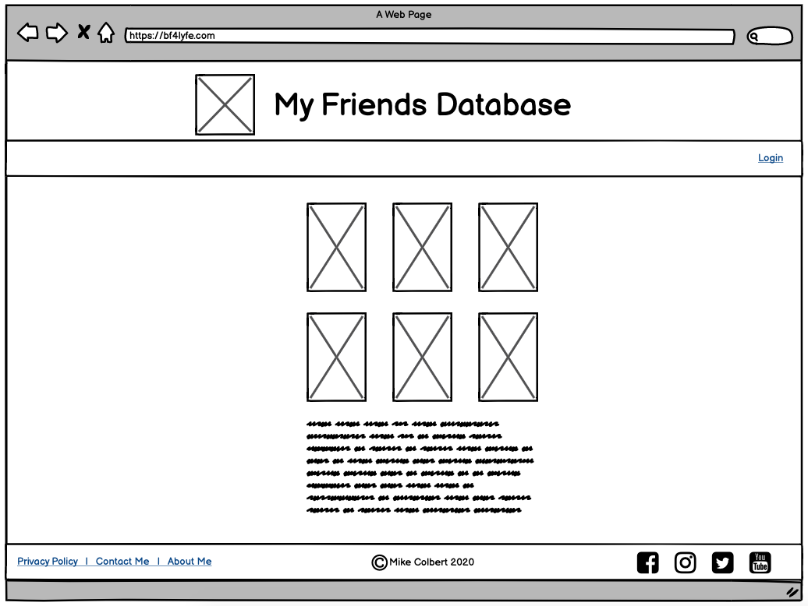
Homepage (unauthenticated)
Reading Tracker

About (unauthenticated)

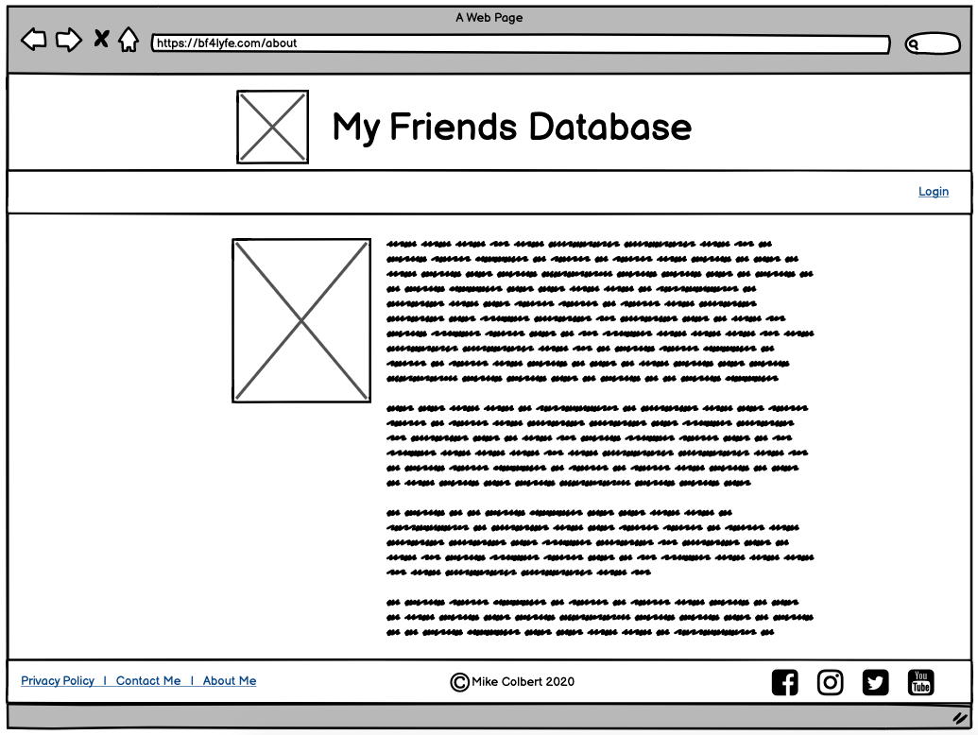
All About Reading Tracking

Login (unauthenticated)

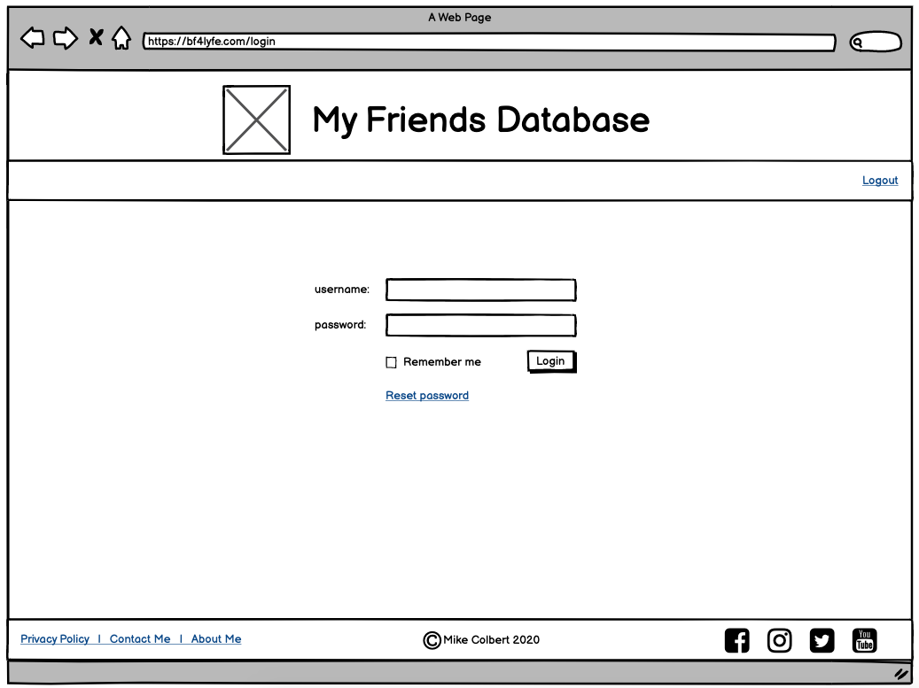
Login

Friends summary (authenticated)

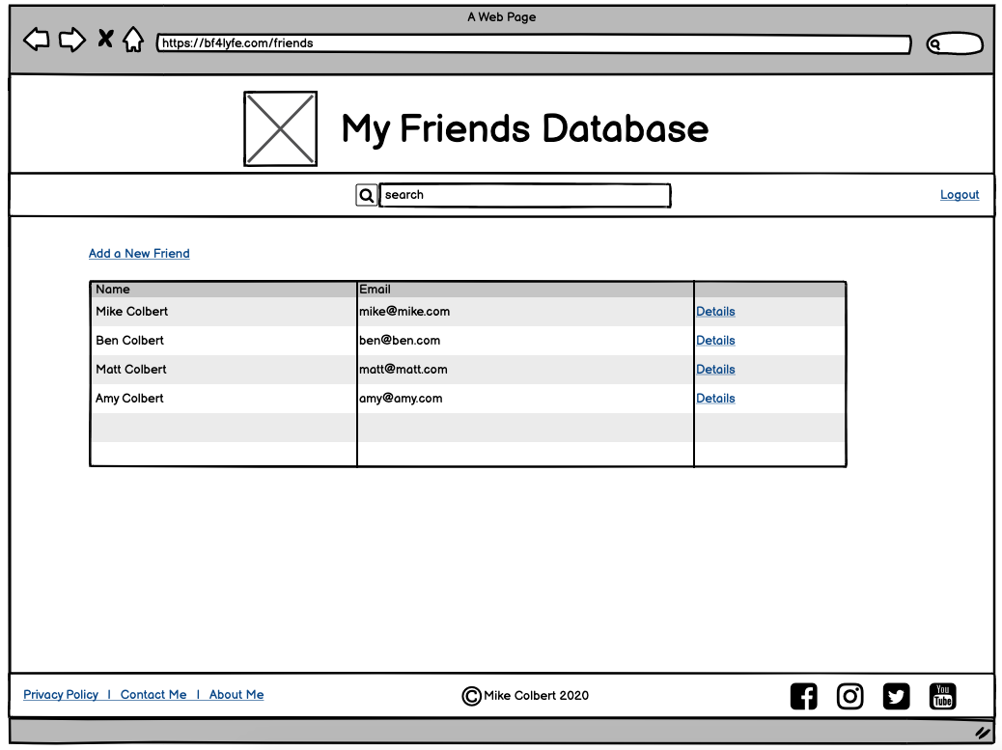
Dashboard

Friend details (authenticated)

