**Introduction**: Chatbots powered by artificial intelligence (AI) are a fascinating innovation in today's digital technology scene. They can assist you in ordering a pizza, answering particular inquiries, or taking you through a sophisticated B2B sales process.

**Description**: This project is about to build an AI chatbot that can assist customers with the guidelines for sending SMS to each country with Telnyx. I have used OpenAI that offers an API to generate embeddings for a string of text using its language model. I feed it any text information (blog articles, documentation, company's knowledge base) then the application embeds the document to my vector database (Pinecone). When user ask a question then it do a similarity search for the answer in our vector database and it writes a script with closest answer of the question and provide to the user with good manner.

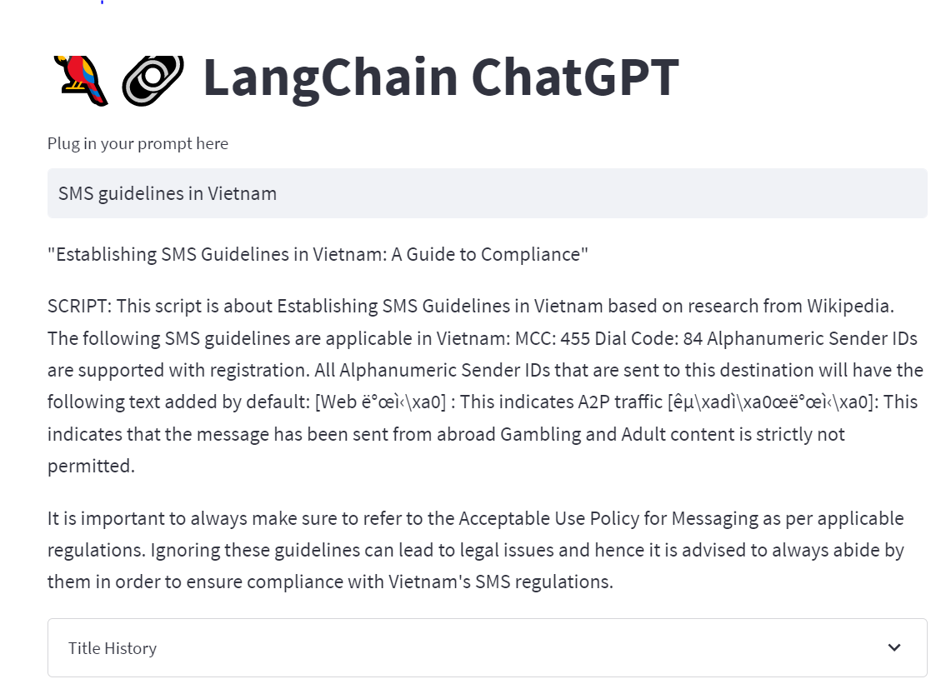

**How does works: The application has been created using the OpenAiEmbedding system.**

**Technology Used**:

1. Langchain (Large Language Model) is a is a framework built around LLMs. We can use it for chatbots, [**G**enerative **Q**uestion-**A**nswering (GQA)](https://www.pinecone.io/learn/openai-gen-qa/), summarization, and much more.

2. Streamlit is an open-source Python library that makes it easy to create and share beautiful, custom web apps for machine learning and data science

3. Python 3.8

4. OpenAPI

5. Pinecone (Vector Database)

**How to install run the project:**

1. download the project in your local machine or clone it from github.
2. Create a Pinecone free account, get the apikey in apikey section and environment (next to apikey) and place it in the script.

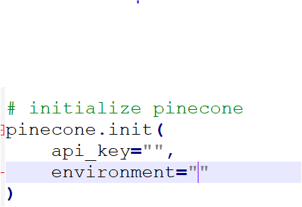

1. Create an openai account, get the apikey and place it in the script.

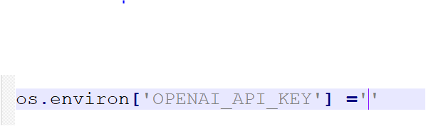

1. Go to the project folder in windows command line (eg: CD Downloads/chatbot).
2. Run the pip install -r requirements.txt to install all requirements.

6. Run streamlit run app.py to run the app.

7. A browser will be open and you will be directed to the browser.

8. simply ask your question in the prompt and wait to get the answer.

**Problems**: there was some issue during developing the application. I have tried to use ChromDB as my vector database and it was giving me an error. So I decided to use Pinecone as it is easy and simple and it works for me. I was also giving me an error when I was running the app multiple time to create an index in pinecone database. So I have used if else statement to check if the index is already exist there in pinecone. If it is then simply print that text “The index is already exist” if not then go ahead with creating the new index. Now it is working fine.

**Conclusion**: A chatbot is a simple way to transmit facts from a computer without having to think of appropriate keywords to look up in a search or explore numerous web sites to collect information; users can just enter their inquiry in natural language and get information. I was verry excited creating the application and I am looking forward to explore more about it.