WEEK 7 Practical OSSP

PART 1 — Program to display memory-segment addresses

Observation: Created the C program in a new folder and compiled it. The important observation is that different types of variables are stored in different regions of the process's virtual address space.

PART 2 — Examine the process using /proc/<PID>/maps
- Terminal 1 and Terminal 2

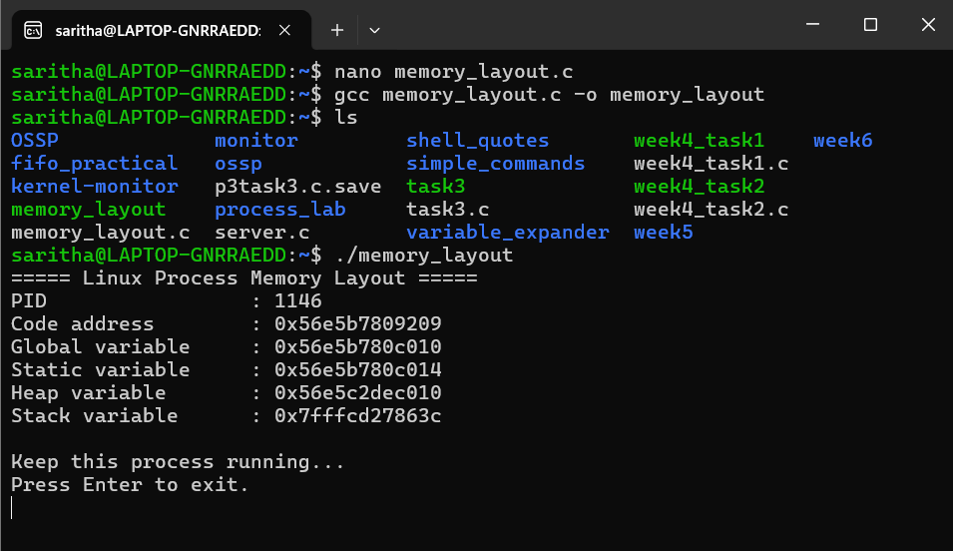
- Make the /proc/maps output easier to understand
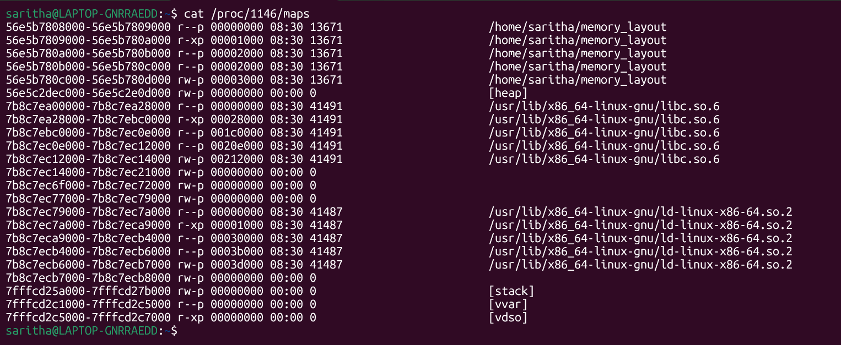

Summary:
A C program was developed to display the virtual addresses of code, global, static, heap and stack variables. The program also displayed its process ID so that its memory layout could be examined through the Linux /proc filesystem.

The /proc/<PID>/maps file was used to observe the virtual memory regions allocated to the running process. The mappings showed separate regions for the executable, heap, stack and shared libraries, along with their access permissions.

PART 3 — Memory Analysis with pmap
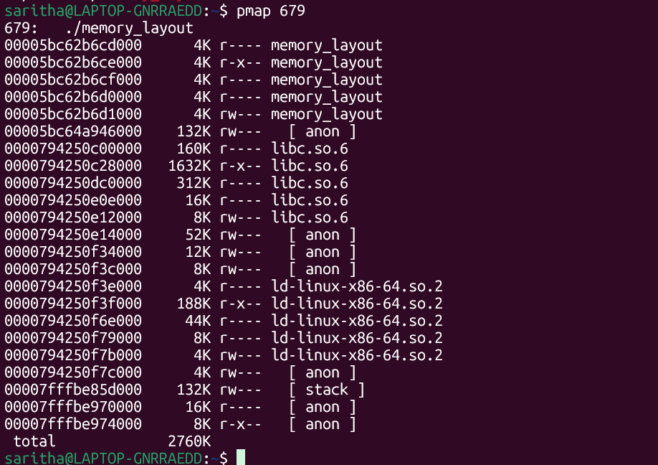

PART 4 — Check Virtual Memory Statistics
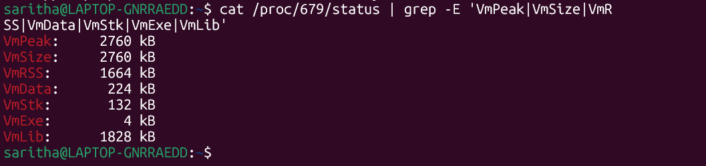

PART 5 — Observe the Page Size
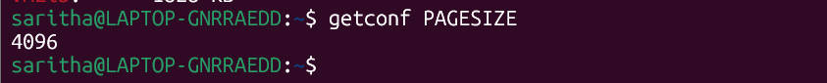

Conclusion:
The program successfully displayed the virtual addresses of code, global, static, heap and stack variables. The /proc/<PID>/maps file confirmed that these regions are mapped separately within the process's virtual address space.
Using pmap and /proc/<PID>/status, the memory organization and memory usage of the running process were analyzed. The experiment also demonstrated the role of virtual memory, page tables and the TLB in translating virtual addresses to physical addresses.

