QUESTION
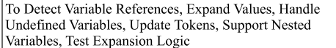
ANSWER
Source code
