Dunkle_NestedData

#### MRDunkle

#### 2023-04-13

Global Options

Working with Nested Data

Nesting creates a list-column of data frames – think of it as adding a 3rd dimension to your data –

unnesting flattens it back out into regular columns. Nesting is implicitly a summarising operation:

you get one row for each group defined by the non-nested columns.

This is useful in conjunction with other summaries that work with whole datasets, most notably models or functions

Southeast Alaska Example

###Example 1: Calculate diversity metrics for several months at multiple sites

step 1: Nest the data

## <list_of<  
## tbl_df<  
## StreamID : character  
## Acari : double  
## Ameletus : double  
## Araneae : double  
## Baetis : double  
## Brachycera : double  
## Capnia : double  
## Chelifera/Metachela : double  
## Chironomidae : double  
## Cinygmula : double  
## Collembola : double  
## Daphnia : double  
## Empididae : double  
## Ephemerellidae : double  
## Gammarus : double  
## Haploperla : double  
## Hemiptera: Heteroptera : double  
## Heptageniidae : double  
## Isoperla : double  
## Kathroperla : double  
## Nemoura : double  
## Nemouridae : double  
## Oligochaeta : double  
## Podmosta : double  
## Prosimulium : double  
## Rhithrogena : double  
## Rhyacophila : double  
## Simulium : double  
## Soyedina : double  
## Suwallia : double  
## Taenionema : double  
## Tipula : double  
## Tipuloidea : double  
## Trichocera : double  
## Unionoida : double  
## Zapada cinctipes : double  
## Zapada oregonensis group : double  
## Despaxia augusta : double  
## Deuterophlebia : double  
## Ferrissia : double  
## Protanypus : double  
## Simuliidae : double  
## Zapada : double  
## Drunella : double  
## Epeorus : double  
## Hydroptilidae : double  
## Curculionidae : double  
## Hydrophilidae : double  
## Hymenoptera sawflies : double  
## Staphylinidae : double  
## Glossosoma : double  
## Chloroperlidae : double  
## Doddsia occidentalis : double  
## Noctuidae : double  
## Oreogeton : double  
## Sphaeriidae : double  
## Sweltsa : double  
## Visoka cataractae : double  
## Attenella : double  
## Capniidae : double  
## Polycentropus : double  
## Brachycentrus : double  
## Gammaridae : double  
## sp. NA : double  
## Tipulidae : double  
## Ceratopogonidae : double  
## Chelifera : double  
## Dyticidae : double  
## Gastropoda : double  
## Hemiptera: Sternorrhyncha: double  
## Hesperoconopa : double  
## Lepidostoma : double  
## Onocosmoecus : double  
## Perlomyia : double  
## Psychoglypha : double  
## Deuterophlebiidae : double  
## Leptophlebia : double  
## Limoniidae : double  
## Paraleuctra : double  
## Tabanidae : double  
## Dicosmoecus atripes : double  
## Erioptera : double  
## Siimulium : double  
## Amphizoa : double  
## Coleoptera : double  
## Cyclopodae : double  
## Ecclisiomyia : double  
## Gerridae : double  
## Homoptera : double  
## Nepidae : double  
## Oregeton : double  
## Ptychopteridae : double  
## Tenthredinidae : double  
## Chyranda centralis : double  
## Taeniopteryx : double  
## Limnephilidae : double  
## Psychodidae : double  
## Sarcophagidae : double  
## Eleophila? : double  
## Limoniiidae : double  
## Tabanus? : double  
## Dapnia : double  
## Eucapnopsis brevicauda : double  
## Eulophidae? : double  
## Pomoleuctra : double  
## Posmosta : double  
## Baetis tricaudatus group : double  
## Cascadoperla trinctura : double  
## Ecclisomyia : double  
## Lenarchus : double  
## Leptophlebius : double  
## Zapada frigida : double  
## Phryganeidae : double  
## Leptophlebium : double  
## Psychoglypha subborealis : double  
## Ceratopogon : double  
## Goeridae : double  
## Molannodes tinctus : double  
## Oxyethira : double  
## Protanyderus : double  
## Neophylax : double  
## Phryganidae : double  
## Amphipoda : double  
## Baeits : double  
## Chlorperlidae : double  
## Desmona : double  
## Dicranomyia : double  
## Ecclisocosmoecus : double  
## Odonata : double  
## Ecclisomyida : double  
## Hesperophylax : double  
## Narpus : double  
## Psychodini : double  
## Sisy : double  
## Trichoptera : double  
## sp. p : double  
## Molusca : double  
## Antocha : double  
## Blephariceridae : double  
## Cascadoperla trictura : double  
## Ephemerella : double  
## Leptophlebiinae : double  
## Limnophila : double  
## Mesocapnia : double  
## Zapada columbiana : double  
## Heptageniidae-stream : double  
## Hydropsychidae : double  
## Psephenus : double  
## Taeniopterygidae : double  
## Arctopsyche : double  
## Hydrachnidae : double  
## Micrasema : double  
## Pedicia : double  
## Perlodidae : double  
## Tinodes : double  
## Triznaka : double  
## Chimarra : double  
## Elmidae : double  
## Leptophlebiidae : double  
## Parapsyche : double  
## Plumiperla : double  
## Corixidae : double  
## Lepidoptera : double  
## Chilopoda : double  
## Neothremma : double  
## Saldidae : double  
## Phryganea : double  
## >  
## >[1]>  
## [[1]]  
## # A tibble: 5 × 167  
## StreamID Acari Ameletus Araneae Baetis Brachycera Capnia `Chelifera/Metachela`  
## <chr> <dbl> <dbl> <dbl> <dbl> <dbl> <dbl> <dbl>  
## 1 Herbert… 0 0 1 31.2 1 14 0  
## 2 Montana… 9.8 2 0 89 1 18 0  
## 3 Peterso… 4 1.67 0 13.2 0 7.4 0  
## 4 Steep C… 2.75 1.5 0 122. 2 3 0  
## 5 Steep C… 0 0 0 0 0 0 0  
## # ℹ 159 more variables: Chironomidae <dbl>, Cinygmula <dbl>, Collembola <dbl>,  
## # Daphnia <dbl>, Empididae <dbl>, Ephemerellidae <dbl>, Gammarus <dbl>,  
## # Haploperla <dbl>, `Hemiptera: Heteroptera` <dbl>, Heptageniidae <dbl>,  
## # Isoperla <dbl>, Kathroperla <dbl>, Nemoura <dbl>, Nemouridae <dbl>,  
## # Oligochaeta <dbl>, Podmosta <dbl>, Prosimulium <dbl>, Rhithrogena <dbl>,  
## # Rhyacophila <dbl>, Simulium <dbl>, Soyedina <dbl>, Suwallia <dbl>,  
## # Taenionema <dbl>, Tipula <dbl>, Tipuloidea <dbl>, Trichocera <dbl>, …

Step 2: Write a funcion to run the vegan diversity function across nested data

library(vegan)  
library(broom)  
  
vegan_function = function(nested_df, metric){  
 nested_df %>% as.data.frame(., row.names = 1) %>%   
 tibble::column_to_rownames("StreamID") %>%   
 as.matrix() %>%   
 vegan::diversity(., index = metric)  
}  
  
  
results = NULL  
  
for (i in 1:length(SEAK_Inverts_Diversity_Nested$data)){  
 tmp = vegan_function(SEAK_Inverts_Diversity_Nested$data[[1]], "shannon") %>% #make a temporary file to store output  
 tibble::enframe() %>% dplyr::rename(StreamID = name, Shannon = value) %>% #make into a tibble  
 mutate(MonthYear = SEAK_Inverts_Diversity_Nested$monthyear[i])  
   
 results = rbind(results, tmp) #bind them together into 'results'  
}  
  
  
results

## # A tibble: 40 × 3  
## StreamID Shannon MonthYear  
## <chr> <dbl> <chr>   
## 1 Herbert River 2.18 Apr-2018   
## 2 Montana Creek 2.29 Apr-2018   
## 3 Peterson Creek 2.17 Apr-2018   
## 4 Steep Creek 1.89 Apr-2018   
## 5 Herbert River 2.18 Apr-2019   
## 6 Montana Creek 2.29 Apr-2019   
## 7 Peterson Creek 2.17 Apr-2019   
## 8 Steep Creek 1.89 Apr-2019   
## 9 Herbert River 2.18 Aug-2018   
## 10 Montana Creek 2.29 Aug-2018   
## # ℹ 30 more rows

Step 3: Write a second function to calculate beta diversity comparisons between streams

#function to run nested data through vegan::betadiver()  
beta_diversity = function(nested_df, metric){  
 nested_df %>% filter(Baetis>0) %>%   
 #as.data.frame(., row.names = 1) %>%   
 tibble::column_to_rownames("StreamID") %>%   
 as.matrix %>%   
 vegan::betadiver(., metric)  
}  
  
#Goal: successfully run this function on each nested dataframe  
SEAK_Inverts_Diversity_Nested$data[[1]] %>% column_to_rownames("StreamID") %>% as.matrix %>%   
 betadiver(., "w")

## Herbert River Montana Creek Peterson Creek  
## Montana Creek 0.5211268   
## Peterson Creek 0.5000000 0.4084507   
## Steep Creek 0.4523810 0.4457831 0.4523810

#does our function work?  
beta_diversity(SEAK_Inverts_Diversity_Nested$data[[1]],"w")

## Herbert River Montana Creek Peterson Creek  
## Montana Creek 0.5211268   
## Peterson Creek 0.5000000 0.4084507   
## Steep Creek 0.4523810 0.4457831 0.4523810

#Now clear output  
beta = NULL  
tmp = NULL  
  
  
#Create a for loop to iterate the 'beta_diversity' function we created through each of the nested data frames  
for (i in 1:length(SEAK_Inverts_Diversity_Nested$data)){  
 tmp = beta_diversity(SEAK_Inverts_Diversity_Nested$data[[i]], "w") %>%   
 tidy() %>% #make a temporary file to store output  
 dplyr::rename(Stream_1 = item1, Stream_2 = item2, beta.diversity = distance) %>%   
 mutate(MonthYear = SEAK_Inverts_Diversity_Nested$monthyear[i])  
   
 beta = rbind(beta, tmp) #bind them together into 'results'  
}  
  
  
#check the results  
beta

## # A tibble: 60 × 4  
## Stream_1 Stream_2 beta.diversity MonthYear  
## <fct> <fct> <dbl> <chr>   
## 1 Herbert River Montana Creek 0.521 Apr-2018   
## 2 Herbert River Peterson Creek 0.5 Apr-2018   
## 3 Herbert River Steep Creek 0.452 Apr-2018   
## 4 Montana Creek Peterson Creek 0.408 Apr-2018   
## 5 Montana Creek Steep Creek 0.446 Apr-2018   
## 6 Peterson Creek Steep Creek 0.452 Apr-2018   
## 7 Herbert River Montana Creek 0.474 Apr-2019   
## 8 Herbert River Peterson Creek 0.6 Apr-2019   
## 9 Herbert River Steep Creek 0.455 Apr-2019   
## 10 Montana Creek Peterson Creek 0.387 Apr-2019   
## # ℹ 50 more rows

#plot  
beta %>% ggplot(aes(x = MonthYear, y= beta.diversity))+geom_point()+  
 geom_smooth()

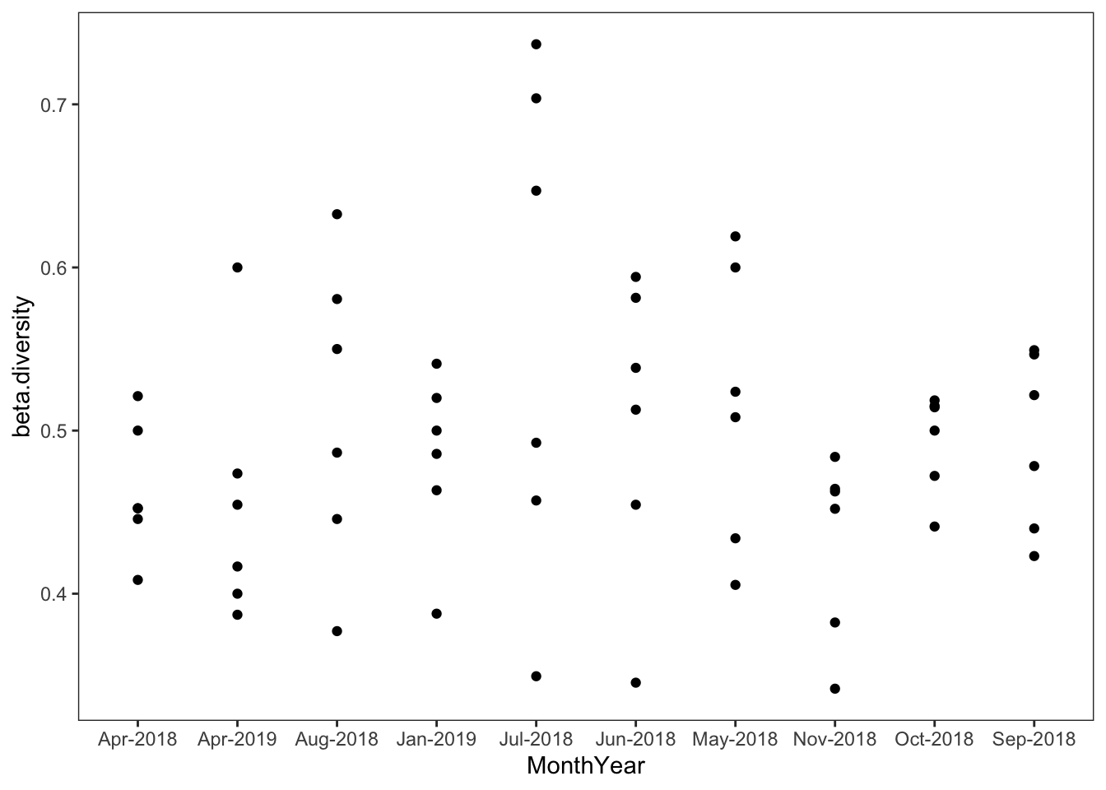

Example 2: Estimate Secondary Production from a list of body length data

Here, I use the size-frequency approach from Benke et al., 2017 to estimate production using size-frequency.

Take the body length data and convert it to size classes and arrange for Size-Frequency Analysis

Steps: 1. Read in a data file 2. Data wrangling to summarize the Number, mean(Body Length), mean(Individual Mass), and estimated CPI (voltinism) for each family 3. Add a column for the number of size classes 4. Convert to a nested dataset by c(StreamID, Family.x)

SEAK_SecondaryProduction_Nested_SF =   
 SEAK_EPT_IndMeasure %>%   
 mutate(monthyear = format(Date, "%Y-%b")) %>% #create a 'monthyear' column rather than 'Date,' since we sampled each stream on different days, but same month-year  
 mutate(BodyLength =case_when(StreamID %in% c("Peterson Creek","Montana Creek","Steep Creek") ~ round_any(BodyLength, .5),  
 TRUE ~ round_any(BodyLength, .5, f = ceiling))) %>% #All sites except Herbert River are rounded to the nearest 0.5 (some taxa in Herbert are too small and being rounded down to 0 so here I'm rounding up. Not ideal, but functional/reasonable for now)  
 group_by(StreamID, BodyLength, Family, Sample_Number, monthyear) %>%   
 summarise(Biomass_Ind = mean(Biomass_Ind, na.rm=T), BodyLength = mean(BodyLength, na.rm=T), count = n(), Voltinism = mean(Voltinism)) %>%   
 ungroup() %>%  
 group_by(StreamID, BodyLength, Family) %>%  
 arrange(StreamID, Family, BodyLength) %>%  
 summarise(Density = sum(count, na.rm=T)/.75, IndividualMass = mean(Biomass_Ind, na.rm=T), Biomass = Density*IndividualMass, Voltinism = mean(Voltinism, na.rm=T)) %>%  
 ungroup() %>%  
 group_by(StreamID, Family) %>% dplyr::mutate(No_SizeClasses = n_distinct(BodyLength)) %>%  
 arrange(Family) %>% as.data.frame() %>%  
 group_by(StreamID, Family) %>%  
 group_nest(keep = TRUE) %>% arrange(Family)  
  
SEAK_SecondaryProduction_Nested_SF$data[20]

## <list_of<  
## tbl_df<  
## StreamID : character  
## BodyLength : double  
## Family : character  
## Density : double  
## IndividualMass: double  
## Biomass : double  
## Voltinism : double  
## No_SizeClasses: integer  
## >  
## >[1]>  
## [[1]]  
## # A tibble: 14 × 8  
## StreamID BodyLength Family Density IndividualMass Biomass Voltinism  
## <chr> <dbl> <chr> <dbl> <dbl> <dbl> <dbl>  
## 1 Montana Creek 1 Ephemerell… 10.7 0.0019 0.0203 2  
## 2 Montana Creek 1.5 Ephemerell… 14.7 0.0110 0.161 2  
## 3 Montana Creek 2 Ephemerell… 10.7 0.0209 0.223 2  
## 4 Montana Creek 2.5 Ephemerell… 1.33 0.120 0.159 2  
## 5 Montana Creek 3 Ephemerell… 1.33 0.0850 0.113 2  
## 6 Montana Creek 3.5 Ephemerell… 6.67 0.145 0.966 2  
## 7 Montana Creek 4 Ephemerell… 1.33 0.230 0.307 2  
## 8 Montana Creek 4.5 Ephemerell… 2.67 0.346 0.922 2  
## 9 Montana Creek 5 Ephemerell… 2.67 0.498 1.33 2  
## 10 Montana Creek 6.5 Ephemerell… 1.33 1.23 1.65 2  
## 11 Montana Creek 7 Ephemerell… 2.67 1.60 4.25 2  
## 12 Montana Creek 7.5 Ephemerell… 1.33 2.03 2.70 2  
## 13 Montana Creek 11 Ephemerell… 1.33 7.62 10.2 2  
## 14 Montana Creek 11.5 Ephemerell… 1.33 8.89 11.8 2  
## # ℹ 1 more variable: No_SizeClasses <int>

Calculate Secondary Production

Here, I’m writing a function –

secondary_Prod_SF = function(data, Family, StreamID, IndividualMass, Density, Biomass) {  
 data %>% filter(BodyLength != "NaN") %>%   
 #double check that we don't have any missing values that will cause errors  
   
 arrange(BodyLength) %>% mutate(Density = Density) %>%   
   
 #make sure everything is still in order by *BodyLength*  
   
 dplyr::mutate(No_Lost = (lag(Density) - Density),   
 #create called *No_Lost* which subtracts *Density*2 from previous value for *Density*1  
 Mass_at_Loss = (IndividualMass+ lag(IndividualMass))/2) %>%   
 #create *Mass_at_Loss* which is mass1 plus mass 2/2  
   
   
 mutate(Mass_at_Loss = replace(Mass_at_Loss, n(),max(IndividualMass))) %>%   
   
   
 mutate(Biomass_Lost = Mass_at_Loss*No_Lost,   
 #create *Biomass_Lost* which is mean individual mass X number lost   
 Times_no.SizeClasses = Biomass_Lost*mean(No_SizeClasses),   
 #Multiplied by size classes  
 Voltinism = case_when(Voltinism %in% c(0,"NA", NA,"NaN")~1/4, TRUE~Voltinism/4)) %>%  
   
 #Making sure Voltinism isn't 0. Here, I'm assuming a CPI of 12 for taxa w/ no data  
 group_by(StreamID, Family) %>%   
   
   
 #group by site and taxa  
 dplyr::summarise(StreamID = first(StreamID),   
 #Change *summarise* to *mutate* to get full calculations rather than summary calculations  
 #Taxon = first(Family.x),   
 #Make sure we're only using the one taxa name, not repeating the values X number of size classes  
 Production_uncorrected = case_when(Times_no.SizeClasses[2] > 0 ~sum(Times_no.SizeClasses, na.rm=T),  
 Times_no.SizeClasses[2] <= 0~ sum(Times_no.SizeClasses[3:length(Times_no.SizeClasses)], na.rm=T)),   
 Production_uncorrected_dontcountuntilpositive = sum(Times_no.SizeClasses[min(which(Times_no.SizeClasses>0)):length(Times_no.SizeClasses)], na.rm=T),  
 #Drop arbitrary first value if negative  
 AnnualP = (Production_uncorrected_dontcountuntilpositive*Voltinism), AnnualB = sum(Biomass),   
 AnnualP_to_B = AnnualP/AnnualB, CohortP_to_B = AnnualP_to_B/Voltinism) %>%   
   
 #And finally, Annual Production (P_uncorrected X 12/CPI)  
 distinct()   
 #really make sure we're not ending up with a bunch of duplicate rows...  
}

Now that we have a nested dataset and a function we would like to run on each of those nested data, we can use ‘map’ to run the function on each:

map_df(SEAK_SecondaryProduction_Nested_SF$data, secondary_Prod_SF) %>% head()

## # A tibble: 6 × 8  
## # Groups: StreamID, Family [6]  
## StreamID Family Production_uncorrected Production_uncorrect…¹ AnnualP AnnualB  
## <chr> <chr> <dbl> <dbl> <dbl> <dbl>  
## 1 Herbert … Amele… -26.9 -22.1 -11.0 62.6  
## 2 Montana … Amele… 17.2 19.9 9.95 13.4  
## 3 Peterson… Amele… 71.0 71.0 35.5 42.8  
## 4 Steep Cr… Amele… -17.8 -17.8 -8.90 20.2  
## 5 Herbert … Baeti… 1286. 1401. 1051. 214.   
## 6 Montana … Baeti… 966. 966. 724. 219.   
## # ℹ abbreviated name: ¹​Production_uncorrected_dontcountuntilpositive  
## # ℹ 2 more variables: AnnualP_to_B <dbl>, CohortP_to_B <dbl>

#Use simpler Instantaneous Growth Method

####Instantaneous growth method #####  
  
#file  
SEAK_EPT_IndMeasure %>% head()

## X StreamID Date Sample_Number Order Family BodyLength  
## 1 1 Steep Creek 2018-04-18 Surber_03 Ephemeroptera Baetidae 1.763948  
## 2 2 Steep Creek 2018-04-18 Surber_03 Ephemeroptera Baetidae 1.763948  
## 3 3 Steep Creek 2018-04-18 Surber_03 Ephemeroptera Baetidae 1.763948  
## 4 4 Steep Creek 2018-04-18 Surber_03 Ephemeroptera Baetidae 1.763948  
## 5 5 Steep Creek 2018-04-18 Surber_03 Ephemeroptera Baetidae 1.763948  
## 6 6 Steep Creek 2018-04-18 Surber_03 Ephemeroptera Baetidae 1.763948  
## Split Biomass_Ind Voltinism  
## 1 1 0.0270971 3  
## 2 1 0.0270971 3  
## 3 1 0.0270971 3  
## 4 1 0.0270971 3  
## 5 1 0.0270971 3  
## 6 1 0.0270971 3

#create a nested data frame by StreamID and Family  
SEAK_EPT_IndMeas_Nest = SEAK_EPT_IndMeasure %>% nest_by(StreamID, Family, .keep=T)  
  
SEAK_EPT_IndMeas_Nest$data[1]

## <list_of<  
## tbl_df<  
## X : integer  
## StreamID : character  
## Date : date  
## Sample_Number: character  
## Order : character  
## Family : character  
## BodyLength : double  
## Split : double  
## Biomass_Ind : double  
## Voltinism : integer  
## >  
## >[1]>  
## [[1]]  
## # A tibble: 24 × 10  
## X StreamID Date Sample_Number Order Family BodyLength Split  
## <int> <chr> <date> <chr> <chr> <chr> <dbl> <dbl>  
## 1 44362 Herbert River 2018-05-16 Surber_05 Ephemer… Amele… 10.7 1  
## 2 44532 Herbert River 2018-05-16 Surber_05 Ephemer… Amele… 11.3 1  
## 3 44533 Herbert River 2018-05-16 Surber_05 Ephemer… Amele… 6.72 1  
## 4 44534 Herbert River 2018-05-16 Surber_05 Ephemer… Amele… 7.87 1  
## 5 44535 Herbert River 2018-05-16 Surber_07 Ephemer… Amele… 10.7 1  
## 6 44536 Herbert River 2018-05-16 Surber_07 Ephemer… Amele… 8.44 1  
## 7 44623 Herbert River 2018-04-19 Surber_04 Ephemer… Amele… 7.29 1  
## 8 44624 Herbert River 2018-04-19 Surber_04 Ephemer… Amele… 8.44 1  
## 9 44636 Herbert River 2018-04-19 Surber_02 Ephemer… Amele… 10.2 1  
## 10 44651 Herbert River 2018-06-14 Surber_04 Ephemer… Amele… 9.59 1  
## # ℹ 14 more rows  
## # ℹ 2 more variables: Biomass_Ind <dbl>, Voltinism <int>

#Write a function to calculate daily production based on instantaneous growth  
Inst_growth = function(Data){  
 Data %>% filter(BodyLength != "NaN") %>%   
 group_by(StreamID, Order, Family, Date) %>% dplyr::summarise(meanWeight = mean(Biomass_Ind, na.rm=T), Biomass = sum(Biomass_Ind, na.rm=T)) %>%   
 arrange(Date) %>% dplyr::mutate(timespan = lubridate::time_length(Date-lag(Date), unit = "days"), Biom_Mean = (Biomass+lag(Biomass))/2) %>%   
 dplyr::mutate(growth = log10(meanWeight/lag(meanWeight))/timespan, dailyP = growth*Biom_Mean)   
}  
  
  
#Run this function across nested data using map_df  
  
SEAK_Production_InstGrowth = map_df(SEAK_EPT_IndMeas_Nest$data, Inst_growth)  
  
#plot  
SEAK_Production_InstGrowth %>% mutate(Date_1 = Date - timespan) %>% rename(Date_2 = Date) %>%   
 ggplot(aes(color = Order))+  
 geom_segment(aes(x=Date_1, xend = Date_2, y = dailyP, yend = dailyP))+  
 geom_hline(aes(yintercept = 0), linetype = "dashed")+  
 facet_wrap(~StreamID, scales = "free")+  
 geom_smooth(aes(x=Date_2, y = dailyP, group = Order), se=F)+  
 theme(axis.title.x = element_blank())

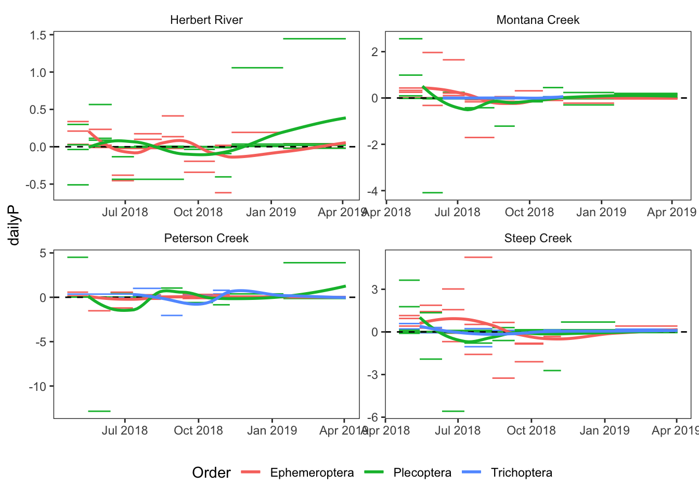

NMDS

nmds_scores = nmds_family %>% ungroup() %>%mutate(code = paste(StreamID, monthyear, Sample_Number, sep = "_")) %>% dplyr::select(-monthyear, -Sample_Number,-StreamID) %>%   
 column_to_rownames(var = "code") %>%   
 as.matrix() %>%   
 metaMDS(., distance = "bray", autotransform = T) %>% scores(tidy = T) %>%   
 rownames_to_column("code")

## Square root transformation  
## Wisconsin double standardization  
## Run 0 stress 0.1910887   
## Run 1 stress 0.1935385   
## Run 2 stress 0.1977795   
## Run 3 stress 0.1971976   
## Run 4 stress 0.1958811   
## Run 5 stress 0.19568   
## Run 6 stress 0.1971976   
## Run 7 stress 0.1963388   
## Run 8 stress 0.1927082   
## Run 9 stress 0.2216562   
## Run 10 stress 0.1927287   
## Run 11 stress 0.1967478   
## Run 12 stress 0.1956679   
## Run 13 stress 0.1945747   
## Run 14 stress 0.1969741   
## Run 15 stress 0.1911917   
## ... Procrustes: rmse 0.004225442 max resid 0.05330848   
## Run 16 stress 0.1904005   
## ... New best solution  
## ... Procrustes: rmse 0.01273929 max resid 0.1584005   
## Run 17 stress 0.1958742   
## Run 18 stress 0.1935901   
## Run 19 stress 0.1937334   
## Run 20 stress 0.1902738   
## ... New best solution  
## ... Procrustes: rmse 0.004084643 max resid 0.04979074   
## *** Best solution was not repeated -- monoMDS stopping criteria:  
## 1: no. of iterations >= maxit  
## 17: stress ratio > sratmax  
## 2: scale factor of the gradient < sfgrmin

nmds_df = full_join(nmds_family %>% ungroup() %>%mutate(code = paste(StreamID, monthyear, Sample_Number, sep = "_")) %>% dplyr::select(StreamID, monthyear, Sample_Number, code), nmds_scores) %>% filter(is.na(StreamID) == F)  
  
NMDS_Family_Plot = ggplot(nmds_df%>%   
 mutate(StreamID = factor(StreamID, levels = c("Herbert River","Montana Creek","Steep Creek","Peterson Creek"), labels = c("Glacial","Transitional","Snowmelt","Rainfed"))), aes(x = NMDS1, y = NMDS2, color = StreamID, shape = StreamID, group = StreamID))+  
 geom_point(size = 3, alpha = 0.8) +  
 scale_colour_manual(values = c("grey68","gold2","dodgerblue","chocolate4"))+  
 stat_ellipse(linetype = 2, linewidth = 1) +  
 labs(title = "NMDS Based on Family-level Abundance")+theme(legend.title = element_blank())  
  
NMDS_Family_Plot

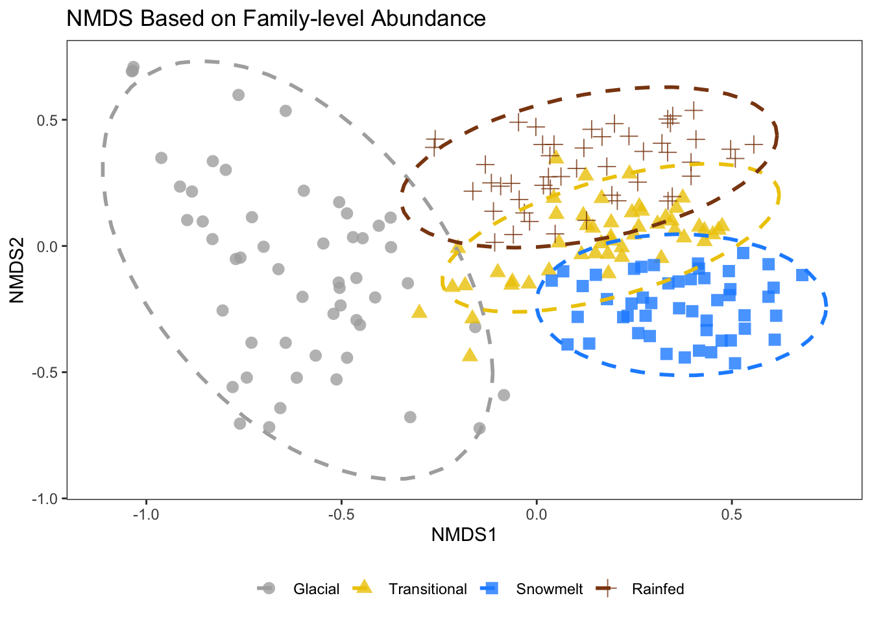

What about PCA/RDA analyses?

library("BiodiversityR")  
# Run PCA  
rda.out <- vegan::rda(nmds_family[,-c(1:4)], scale = TRUE)  
  
  
# extract scores  
rda_scores = scores(rda.out)  
  
biplot(rda.out,   
 display = c("sites","species"))

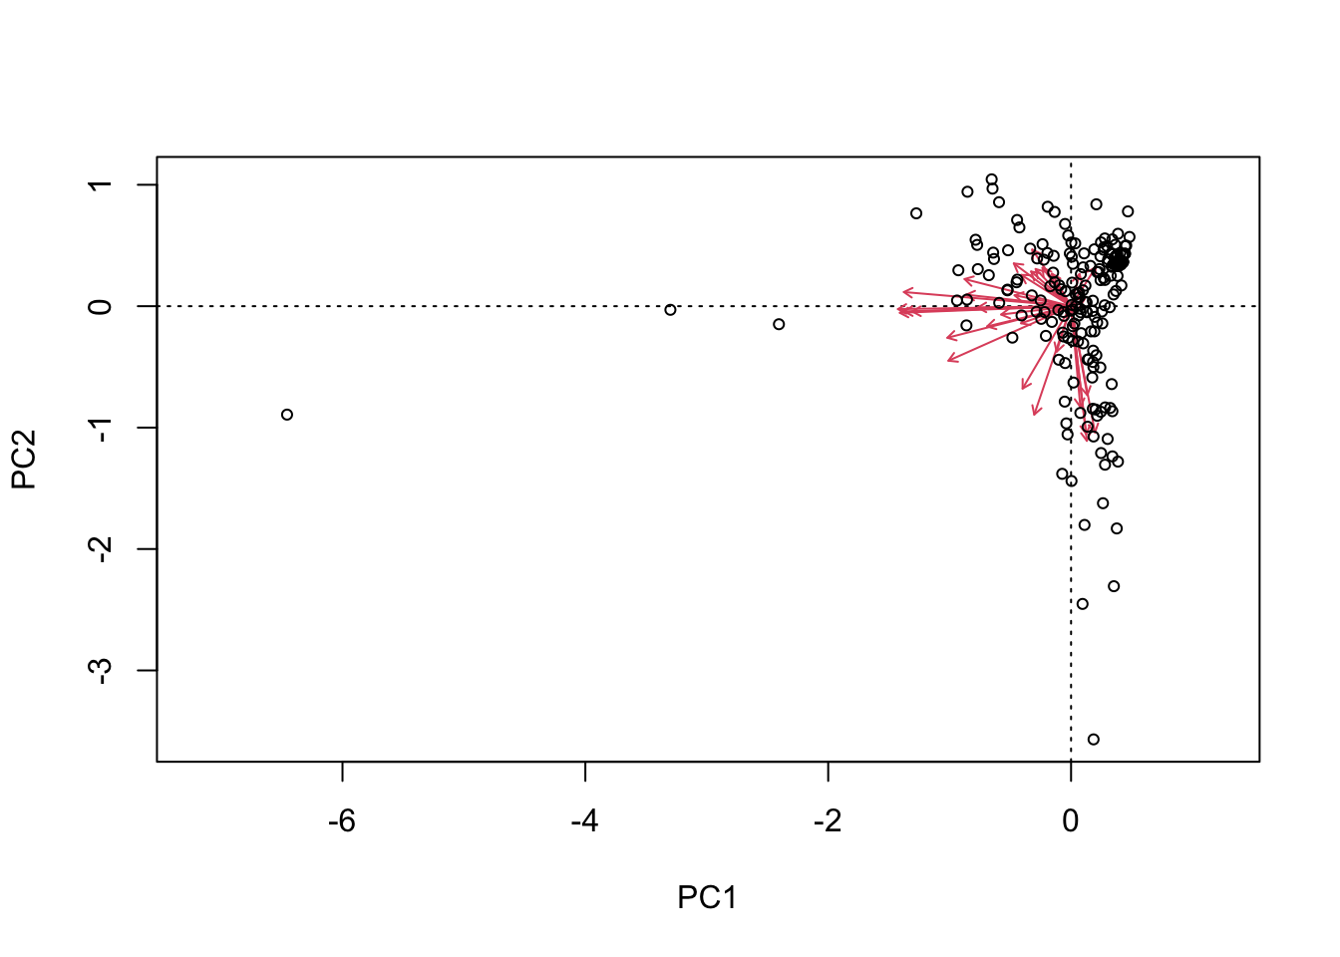

biplot(rda.out, display = "species")

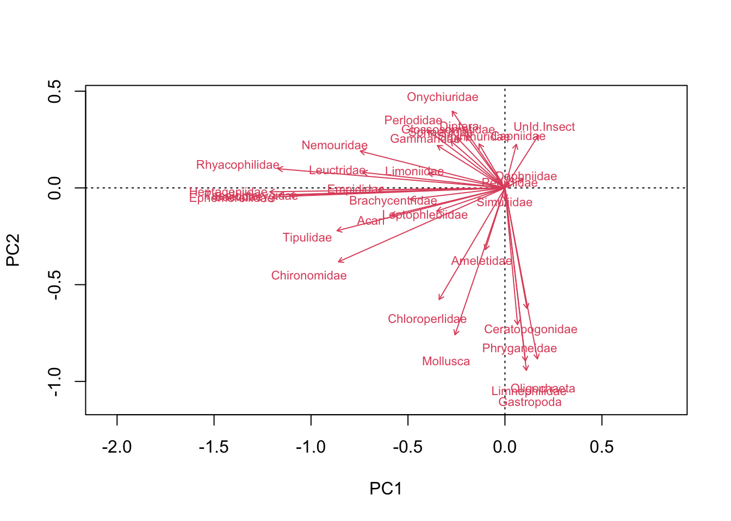

First use ‘ordiplot’ to look at the distribution

plot1 = ordiplot(rda.out, choices = c(1,2))

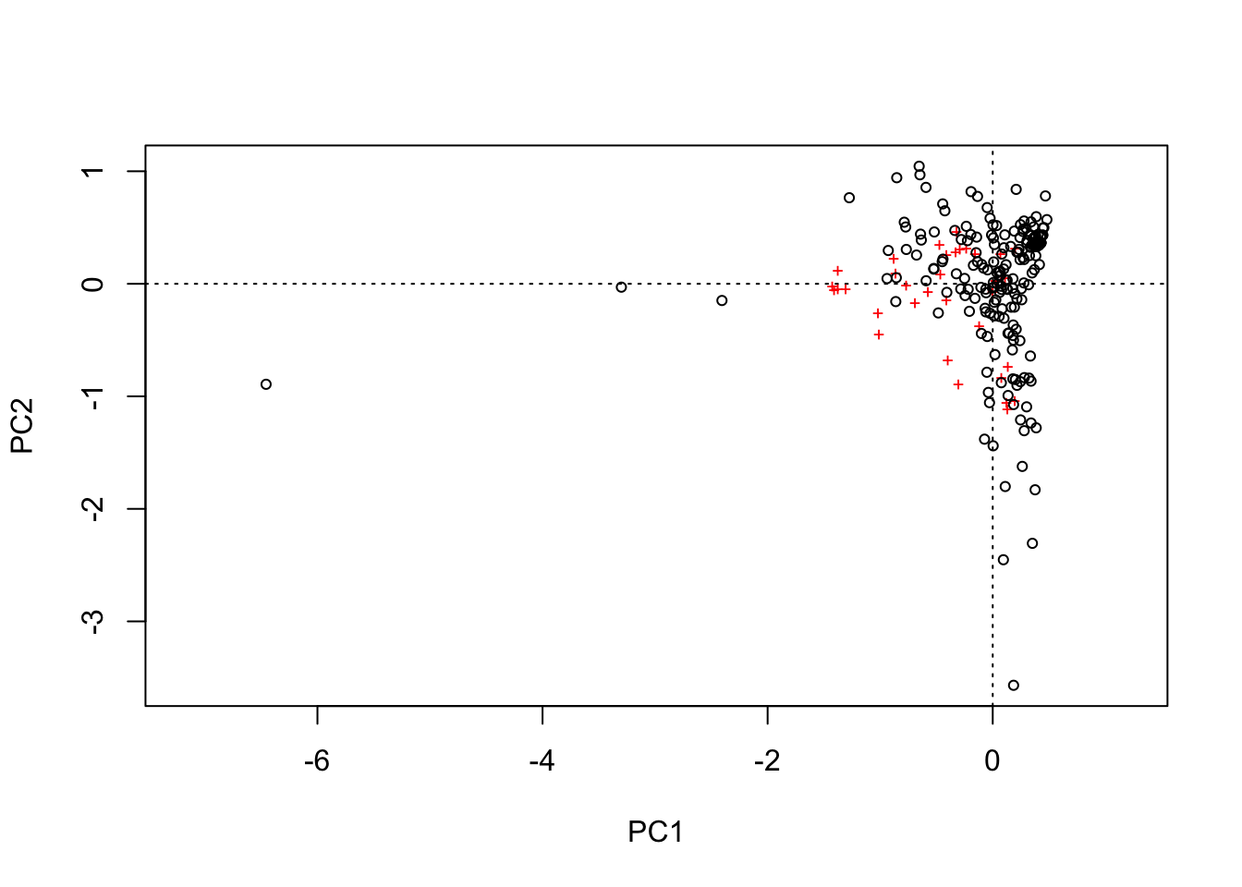 ### Lets use GGplot to plot the same figure but include site information

sites.long1 <- sites.long(plot1, env.data=nmds_family)  
head(sites.long1)

## X StreamID monthyear Sample_Number Ameletidae Baetidae Capniidae  
## sit1 1 Herbert River 2018-Apr Surber_01 2 92 128  
## sit2 2 Herbert River 2018-Apr Surber_02 4 87 135  
## sit3 3 Herbert River 2018-Apr Surber_03 1 89 47  
## sit4 4 Herbert River 2018-Apr Surber_04 3 75 132  
## sit5 5 Herbert River 2018-Apr Surber_05 0 39 36  
## sit6 6 Herbert River 2018-Aug Surber_01 0 5 0  
## Chironomidae Chloroperlidae Heptageniidae Nemouridae Oligochaeta  
## sit1 138 5 7 110 1  
## sit2 118 3 9 100 6  
## sit3 98 4 6 61 27  
## sit4 133 3 4 92 13  
## sit5 90 3 0 44 2  
## sit6 23 0 2 0 1  
## Daphniidae Perlodidae Simuliidae UnId.Insect Mollusca Acari Empididae  
## sit1 0 0 0 0 0 0 0  
## sit2 1 2 0 0 0 0 0  
## sit3 1 2 2 5 0 0 0  
## sit4 1 1 0 0 0 0 0  
## sit5 0 0 0 0 0 0 0  
## sit6 0 0 0 1 0 0 0  
## Ephemerellidae Pediciidae Onychiuridae Limoniidae Taeniopterygidae  
## sit1 0 0 0 0 0  
## sit2 0 0 0 0 0  
## sit3 0 0 0 0 0  
## sit4 0 0 0 0 0  
## sit5 0 0 0 0 0  
## sit6 0 0 0 0 0  
## Brachycentridae Tipulidae Gastropoda Leptophlebiidae Limnephilidae  
## sit1 0 0 0 0 0  
## sit2 0 0 0 0 0  
## sit3 0 0 0 0 0  
## sit4 0 0 0 0 0  
## sit5 0 0 0 0 0  
## sit6 0 0 0 0 0  
## Ceratopogonidae Phryganeidae Leuctridae Rhyacophilidae Gammaridae  
## sit1 0 0 0 0 0  
## sit2 0 0 0 0 0  
## sit3 0 0 0 0 0  
## sit4 0 0 0 0 0  
## sit5 0 0 0 0 0  
## sit6 0 0 0 0 0  
## Glossosomatidae Diptera Sminthuridae Sphaeriidae axis1 axis2  
## sit1 0 0 0 0 0.002557499 0.5239559  
## sit2 0 0 0 0 -0.023534368 0.5825508  
## sit3 0 0 0 0 0.208098945 0.8391173  
## sit4 0 0 0 0 0.034328489 0.5173298  
## sit5 0 0 0 0 0.242012873 0.4111491  
## sit6 0 0 0 0 0.434942436 0.4238626  
## labels  
## sit1 sit1  
## sit2 sit2  
## sit3 sit3  
## sit4 sit4  
## sit5 sit5  
## sit6 sit6

SEAK_rda_raw <- ggplot() +   
 geom_vline(xintercept = c(0), color = "grey70", linetype = 2) +  
 geom_hline(yintercept = c(0), color = "grey70", linetype = 2) +   
 xlab("NMDS1") +  
 ylab("NMDS2") +   
 scale_x_continuous(sec.axis = dup_axis(labels=NULL, name=NULL)) +  
 scale_y_continuous(sec.axis = dup_axis(labels=NULL, name=NULL)) +   
 geom_point(data=sites.long1,   
 aes(x=axis1, y=axis2, colour=StreamID, shape=StreamID),   
 size=5) +  
 scale_colour_manual(values = c("grey68","gold2","chocolate4","dodgerblue"))+  
 coord_fixed(ratio=1)  
  
SEAK_rda_raw

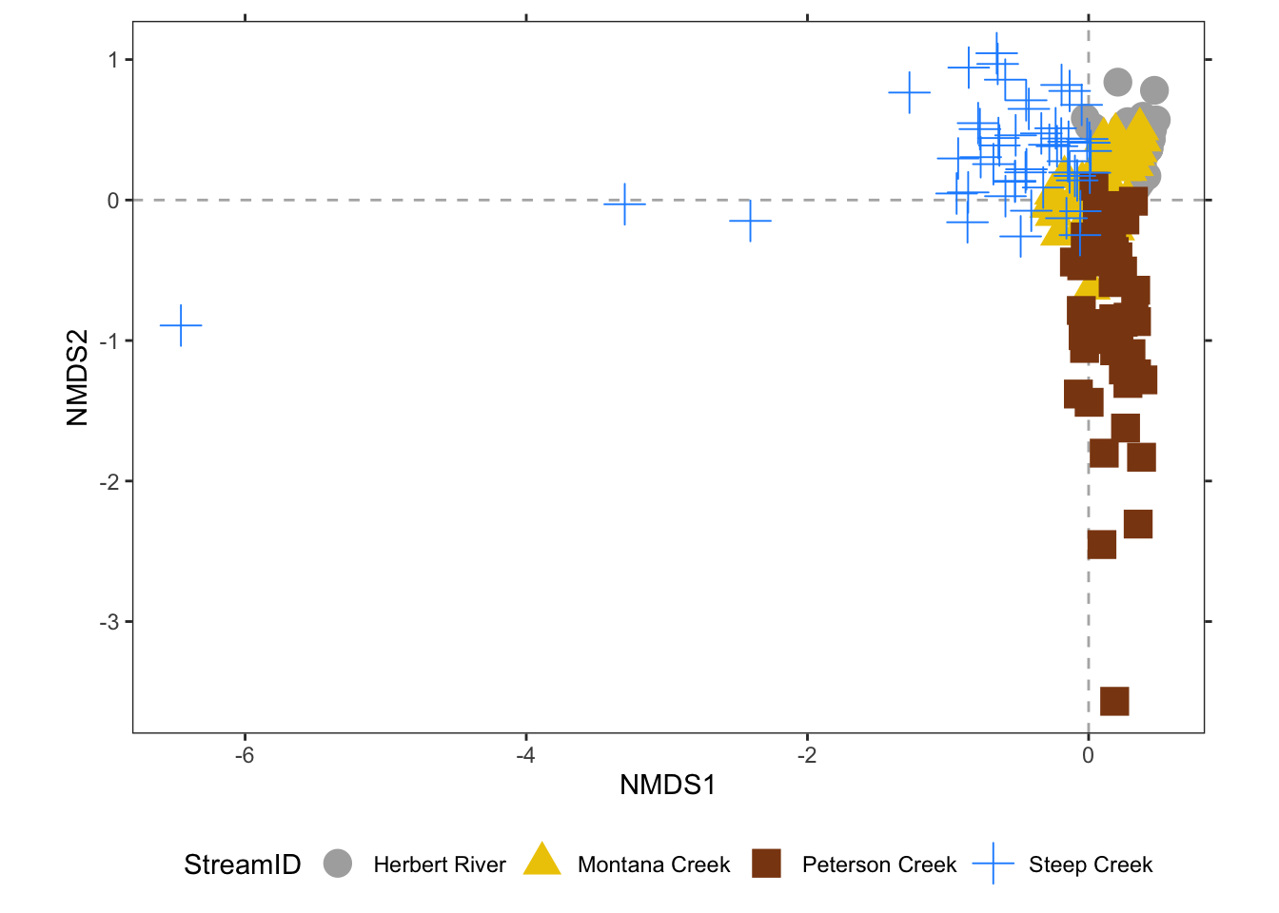 Unfortunately, this is hard to interpret. Part of the issue is likely that Peterson Creek and Steep Creek have vastly different total invertebrate abundances than the much colder locations at Herbert and Montana

Hellinger Constrained Ordination

Hellinger transformation converts species abundances from absolute to relative values (i.e. standardizes the abundances to sample totals) and then square roots them. This could be useful if we are not interested in changes of absolute species abundances, but relative abundances.

seak.Hellinger = disttransform(nmds_family[,-c(1:4)], method = "hellinger")  
  
Ordination.model2 = rda(seak.Hellinger~StreamID, data = nmds_family, scaling = "species")  
summary(Ordination.model2)

##   
## Call:  
## rda(formula = seak.Hellinger ~ StreamID, data = nmds_family, scaling = "species")   
##   
## Partitioning of variance:  
## Inertia Proportion  
## Total 0.29422 1.0000  
## Constrained 0.09138 0.3106  
## Unconstrained 0.20284 0.6894  
##   
## Eigenvalues, and their contribution to the variance   
##   
## Importance of components:  
## RDA1 RDA2 RDA3 PC1 PC2 PC3 PC4  
## Eigenvalue 0.05305 0.02963 0.008701 0.04096 0.03675 0.02567 0.02036  
## Proportion Explained 0.18031 0.10072 0.029573 0.13920 0.12491 0.08724 0.06920  
## Cumulative Proportion 0.18031 0.28102 0.310597 0.44980 0.57471 0.66196 0.73115  
## PC5 PC6 PC7 PC8 PC9 PC10  
## Eigenvalue 0.01677 0.01025 0.00994 0.00775 0.005563 0.004611  
## Proportion Explained 0.05700 0.03485 0.03378 0.02634 0.018907 0.015672  
## Cumulative Proportion 0.78815 0.82300 0.85678 0.88313 0.902032 0.917704  
## PC11 PC12 PC13 PC14 PC15 PC16  
## Eigenvalue 0.003525 0.00295 0.002626 0.002427 0.001979 0.001665  
## Proportion Explained 0.011981 0.01003 0.008927 0.008250 0.006727 0.005658  
## Cumulative Proportion 0.929685 0.93971 0.948637 0.956887 0.963614 0.969272  
## PC17 PC18 PC19 PC20 PC21 PC22  
## Eigenvalue 0.001368 0.001189 0.001089 0.0008342 0.0008278 0.000599  
## Proportion Explained 0.004650 0.004042 0.003702 0.0028354 0.0028136 0.002036  
## Cumulative Proportion 0.973921 0.977964 0.981666 0.9845016 0.9873152 0.989351  
## PC23 PC24 PC25 PC26 PC27  
## Eigenvalue 0.0005774 0.0004962 0.0004146 0.0003726 0.0002620  
## Proportion Explained 0.0019624 0.0016866 0.0014091 0.0012664 0.0008906  
## Cumulative Proportion 0.9913133 0.9929999 0.9944090 0.9956754 0.9965660  
## PC28 PC29 PC30 PC31 PC32  
## Eigenvalue 0.0002459 0.0002274 0.0001665 0.0001230 0.0001183  
## Proportion Explained 0.0008358 0.0007729 0.0005659 0.0004179 0.0004021  
## Cumulative Proportion 0.9974018 0.9981748 0.9987407 0.9991586 0.9995607  
## PC33 PC34  
## Eigenvalue 6.858e-05 6.066e-05  
## Proportion Explained 2.331e-04 2.062e-04  
## Cumulative Proportion 9.998e-01 1.000e+00  
##   
## Accumulated constrained eigenvalues  
## Importance of components:  
## RDA1 RDA2 RDA3  
## Eigenvalue 0.05305 0.02963 0.008701  
## Proportion Explained 0.58052 0.32427 0.095214  
## Cumulative Proportion 0.58052 0.90479 1.000000  
##   
## Scaling 2 for species and site scores  
## * Species are scaled proportional to eigenvalues  
## * Sites are unscaled: weighted dispersion equal on all dimensions  
## * General scaling constant of scores: 2.769656   
##   
##   
## Species scores  
##   
## RDA1 RDA2 RDA3 PC1 PC2 PC3  
## Ameletidae -0.014929 0.01396 -0.003340 0.0592013 -0.0283373 0.0027800  
## Baetidae 0.575357 -0.13500 -0.038040 0.5715561 -0.1649416 -0.2479967  
## Capniidae 0.105517 0.08150 -0.264892 0.6192276 -0.0414770 0.1800193  
## Chironomidae 0.060607 0.27873 0.110625 -0.2157467 0.6884173 -0.2421203  
## Chloroperlidae -0.498536 -0.27645 -0.029792 -0.4207704 -0.5859972 -0.3237578  
## Heptageniidae 0.133585 -0.49110 0.033859 0.1616205 -0.0892560 -0.2623906  
## Nemouridae 0.313476 0.05629 0.011794 0.2109843 -0.0431746 0.0175197  
## Oligochaeta -0.744832 0.12676 0.037052 -0.1359968 -0.0054680 0.5106498  
## Daphniidae 0.130363 0.13782 -0.013760 -0.1076833 -0.1985305 0.1981902  
## Perlodidae 0.106889 0.05989 0.010694 0.0221474 -0.0701891 -0.0281041  
## Simuliidae -0.116459 0.01777 -0.057462 0.0364861 0.1688840 -0.1203236  
## UnId.Insect 0.080221 0.08481 -0.008467 -0.0243493 0.0278820 0.0340538  
## Mollusca -0.106697 -0.06473 0.092951 -0.1351887 -0.1482681 0.1251146  
## Acari -0.107004 -0.21286 -0.023187 -0.0635411 0.0284203 0.0359012  
## Empididae -0.024931 -0.16737 -0.078229 -0.0350168 -0.0042299 0.0067403  
## Ephemerellidae 0.040592 -0.28179 0.183946 -0.0150430 0.0249872 0.0222404  
## Pediciidae -0.149729 -0.23655 -0.251726 -0.0534094 -0.0537044 0.0399984  
## Onychiuridae 0.030601 -0.10730 0.008186 -0.0105553 0.0120188 0.0368824  
## Limoniidae 0.024840 -0.12359 -0.015449 -0.0117305 -0.0129771 0.0152716  
## Taeniopterygidae 0.039237 -0.10790 0.028455 0.0066613 -0.0041948 -0.0149186  
## Brachycentridae 0.008534 -0.11168 0.056928 -0.0082008 -0.0102914 0.0484267  
## Tipulidae -0.021159 -0.06603 0.038892 -0.0138770 -0.0019448 -0.0252568  
## Gastropoda -0.031094 0.01289 0.021094 -0.0022908 -0.0120245 0.0106305  
## Leptophlebiidae -0.012602 -0.02604 0.044511 0.0037296 0.0097587 -0.0252785  
## Limnephilidae -0.072593 0.03010 0.049245 -0.0035624 -0.0179226 0.0158753  
## Ceratopogonidae -0.044745 0.01855 0.030354 0.0045315 0.0052527 0.0094550  
## Phryganeidae -0.041896 0.01737 0.028421 -0.0081590 -0.0031311 0.0191225  
## Leuctridae 0.009862 -0.01992 0.011514 0.0001371 -0.0059056 -0.0006549  
## Rhyacophilidae 0.079983 -0.16152 0.093380 0.0033803 0.0008227 0.0128199  
## Gammaridae 0.022726 -0.04589 0.026532 -0.0049637 0.0125497 0.0144235  
## Glossosomatidae 0.021763 -0.04395 0.025408 -0.0088875 0.0085178 0.0187531  
## Diptera 0.014936 -0.03016 0.017437 0.0046517 0.0045136 0.0054778  
## Sminthuridae 0.012288 -0.02481 0.014346 0.0058603 0.0044323 0.0119521  
## Sphaeriidae 0.008977 -0.01813 0.010481 0.0041686 -0.0008153 -0.0028300  
##   
##   
## Site scores (weighted sums of species scores)  
##   
## RDA1 RDA2 RDA3 PC1 PC2 PC3  
## row1 0.3685137 0.305486 -0.494288 0.3227130 -0.0343268 0.085091  
## row2 0.3463200 0.317412 -0.520804 0.3389793 -0.0604831 0.169847  
## row3 0.2592326 0.332598 -0.324565 0.2317479 -0.0438926 0.194544  
## row4 0.2973572 0.370003 -0.496596 0.2980358 -0.0242157 0.226732  
## row5 0.3116752 0.413300 -0.327009 0.1943317 0.0574461 0.096539  
## row6 0.2071370 0.330420 0.290165 -0.1200266 0.2980566 -0.056667  
## row7 0.2248849 0.287018 0.235320 -0.0739918 0.2194055 -0.026452  
## row8 0.3246448 0.272274 0.211095 -0.0526648 0.2870688 -0.211455  
## row9 0.2047104 0.525385 0.274559 -0.1308746 0.3092861 0.106130  
## row10 0.2665899 0.249281 0.216959 -0.0051380 0.1910231 -0.082388  
## row11 0.0396828 0.153776 0.328774 -0.3985385 0.1837823 -0.262366  
## row12 0.1101738 0.564906 0.371082 -0.3736470 0.4946055 -0.011117  
## row13 0.1101738 0.564906 0.371082 -0.3736470 0.4946055 -0.011117  
## row14 0.0360747 0.453906 0.226078 -0.1105262 0.1952561 0.291084  
## row15 0.1101738 0.564906 0.371082 -0.3736470 0.4946055 -0.011117  
## row16 0.2976059 -0.048987 -0.071908 0.1970883 -0.2005458 -0.115990  
## row17 0.3537273 -0.195207 -0.172882 0.3046516 -0.3086880 -0.110524  
## row18 0.4058876 -0.015768 0.044188 0.1211277 -0.1833126 -0.303137  
## row19 0.4900649 0.168848 0.089443 0.2054356 0.0002362 -0.197933  
## row20 0.4879441 -0.112298 0.052363 0.2553886 -0.1589526 -0.251896  
## row21 0.4571884 0.222066 -0.341353 0.3499979 0.0446605 -0.075371  
## row22 0.1559328 0.459085 -0.384255 0.1720468 0.1519942 0.265853  
## row23 0.4714970 0.109825 -0.120863 0.2868292 0.0261515 -0.168341  
## row24 0.3047317 0.484733 -0.133571 0.0627973 0.3139441 -0.043477  
## row25 0.4648664 0.179397 -0.235079 0.3333080 -0.0673717 -0.056264  
## row26 0.4293336 0.189244 -0.312715 0.3156401 0.0444397 -0.162592  
## row27 0.3533209 0.266586 -0.175255 0.2506363 0.0544396 -0.003490  
## row28 0.2982278 -0.017192 -0.031283 0.1397799 -0.2149067 -0.211794  
## row29 0.1453748 0.281966 -0.111094 -0.1902745 -0.3924735 0.443813  
## row30 0.1913254 0.207057 0.069850 -0.2001668 -0.2642383 0.101705  
## row31 0.1905432 -0.094714 -0.058696 -0.0355370 -0.5651948 0.046252  
## row32 0.1485200 0.338174 -0.091239 -0.2674413 -0.3836067 0.528002  
## row33 0.2025011 0.347498 -0.106919 -0.2190674 -0.3895347 0.503160  
## row34 0.2310904 0.261868 -0.049844 -0.0493591 -0.1362282 0.184919  
## row35 0.2686759 0.022819 -0.037692 -0.0002678 -0.1839123 -0.272874  
## row36 0.1137518 0.168415 0.146763 -0.1372993 -0.1974431 0.125163  
## row37 -0.0621670 -0.045760 0.034247 -0.3212449 -0.3802464 -0.124214  
## row38 -0.1178271 0.584793 0.286904 -0.2928671 0.1955183 0.619141  
## row39 0.1824083 0.344324 0.299191 -0.2151244 0.3727132 -0.106343  
## row40 0.2598687 0.124568 0.230752 -0.1294752 0.0173956 -0.305399  
## row41 0.1556613 0.209839 0.324397 -0.1730568 0.0770229 -0.080674  
## row42 0.0937540 0.241847 0.288012 -0.1803289 0.1320026 -0.053724  
## row43 0.0912005 0.177571 0.285540 -0.2268704 0.0589672 -0.109050  
## row44 0.3319437 0.292685 -0.323918 0.2414937 0.0451436 -0.032346  
## row45 0.1679768 0.241296 -0.372678 0.1375538 -0.0125701 0.054092  
## row46 0.1428117 0.311769 -0.123176 0.1059660 0.0899494 0.181878  
## row47 0.2442326 0.338183 -0.036476 0.0386070 0.1745389 -0.051605  
## row48 -0.0733518 0.556351 0.019176 -0.2505952 0.2705839 0.304998  
## row49 0.1460922 0.199715 -0.426589 0.1312374 -0.0726222 -0.008636  
## row50 0.1931094 -0.042345 -0.082517 -0.0739835 -0.3060466 -0.384457  
## row51 0.0748308 0.002232 0.088468 -0.1837422 -0.2336959 -0.279910  
## row52 0.1889621 -0.010167 -0.254871 0.0514352 -0.3839415 -0.223969  
## row53 0.1594784 0.080866 -0.189002 0.0725749 -0.0963925 -0.122253  
## row54 0.2294105 0.023566 -0.714511 0.5264162 -0.0419276 0.076142  
## row55 0.0972800 0.077836 -0.650296 0.4313911 0.0333448 0.156164  
## row56 0.1186675 0.014219 -0.753783 0.4531349 -0.1365669 0.126067  
## row57 0.1068405 0.012732 -0.759018 0.4423640 -0.1376197 0.106935  
## row58 0.1048599 0.102995 -0.690657 0.4521461 0.0548065 0.215604  
## row59 -0.1716285 -0.159280 -0.315687 -0.1100794 0.0918858 0.148087  
## row60 -0.2889942 -0.219138 -0.154908 -0.2502031 -0.0352914 0.105313  
## row61 -0.2686617 -0.205052 -0.399454 -0.2216609 0.0170961 0.101560  
## row62 -0.2050864 -0.176220 -0.455291 -0.0966227 0.0862444 0.235425  
## row63 -0.3318991 -0.197027 -0.346099 -0.2011191 -0.0254777 0.256818  
## row64 -0.1878410 0.119453 -0.008984 -0.1172017 0.2773191 0.087422  
## row65 -0.2319715 0.025144 0.213008 -0.1848552 0.1462825 0.041730  
## row66 -0.2469558 0.066677 0.218358 -0.1551476 0.2355366 0.192520  
## row67 -0.2619113 -0.086646 -0.032714 -0.1562206 0.0420121 0.022155  
## row68 -0.1514243 -0.014608 0.128041 -0.1506273 0.2602438 -0.008139  
## row69 -0.0734732 -0.017355 -0.110611 0.0084324 0.2607252 -0.073932  
## row70 -0.0397579 -0.072353 -0.070679 -0.0184089 0.3092263 -0.145296  
## row71 -0.0999873 0.008384 -0.007106 -0.0525271 0.3306538 -0.013828  
## row72 -0.0755187 -0.067784 -0.076387 0.0451272 0.2509480 -0.038794  
## row73 -0.1778957 0.029793 0.056981 -0.1031621 0.2716710 0.017810  
## row74 0.1561018 0.052464 0.081493 0.1255829 0.2729669 -0.233762  
## row75 -0.0419629 -0.108112 -0.157657 -0.0399726 0.1514015 -0.182326  
## row76 -0.2759327 0.182780 -0.025164 -0.0731571 0.2375431 0.486005  
## row77 -0.1052674 0.023437 -0.176745 -0.0286120 0.1617388 -0.051779  
## row78 -0.0402635 -0.192974 -0.093233 -0.0288192 0.0015630 -0.240469  
## row79 -0.2680868 -0.234080 -0.139983 -0.1726616 -0.2667278 0.072156  
## row80 -0.2515404 -0.147526 -0.278448 -0.1620981 -0.0965493 0.129137  
## row81 -0.2875056 -0.226335 -0.225920 -0.3236158 -0.2933908 -0.096015  
## row82 -0.2134383 -0.321890 -0.430447 -0.1044333 -0.3046406 -0.052203  
## row83 -0.2619872 -0.245010 -0.361865 -0.2319023 -0.3106416 -0.076582  
## row84 -0.2548183 -0.068601 -0.140792 -0.3628674 -0.1370947 -0.207242  
## row85 -0.3289210 -0.091153 -0.184217 -0.3962033 -0.2080701 -0.114216  
## row86 -0.2740942 -0.131826 -0.346652 -0.3114221 -0.1790111 -0.161250  
## row87 -0.2877764 -0.096078 -0.079697 -0.3845921 -0.2808172 -0.223089  
## row88 -0.2936264 -0.095615 -0.246240 -0.3039880 -0.0856039 -0.072316  
## row89 -0.0628414 -0.276866 -0.147789 -0.0742767 -0.0226816 -0.191099  
## row90 -0.0618367 -0.258952 -0.270974 -0.0865167 -0.0192838 -0.242660  
## row91 -0.1312965 -0.229041 -0.113907 -0.1497271 -0.0235506 -0.192083  
## row92 -0.1183014 -0.206881 -0.224682 -0.1227156 -0.1284156 -0.203944  
## row93 -0.1682352 -0.266260 -0.189882 -0.1602736 -0.1864181 -0.185858  
## row94 -0.0873541 -0.182063 -0.259584 -0.0186233 -0.1703666 -0.156568  
## row95 -0.1440896 -0.220264 -0.128352 -0.0628613 -0.2173571 -0.099316  
## row96 0.0215395 -0.206657 -0.401552 0.1668700 -0.1174386 -0.103262  
## row97 -0.0847341 -0.150328 -0.388767 0.0764353 -0.0863805 0.035228  
## row98 -0.0473000 -0.175499 -0.384144 0.1516587 -0.1341603 0.022785  
## row99 0.2061363 -0.062247 -1.085576 0.5195851 0.0020006 0.054503  
## row100 0.1140399 0.049011 -1.234089 0.5852352 -0.0284535 0.342043  
## row101 0.1749859 0.022690 -0.908377 0.4699098 0.0834004 0.096667  
## row102 0.1391013 0.025237 -1.013640 0.5142416 0.0665757 0.170758  
## row103 0.1308412 -0.019530 -0.969984 0.4486443 0.0287506 0.066990  
## row104 -0.1584593 -0.088865 -0.094921 0.0271354 -0.1454511 -0.400519  
## row105 -0.1269790 0.013752 -0.134638 0.1668894 -0.0212930 -0.246559  
## row106 -0.0488576 0.121523 -0.096514 0.2983022 0.0723831 -0.086351  
## row107 -0.1407216 0.304316 0.211939 0.0290823 0.3087964 -0.055158  
## row108 -0.1819529 -0.064211 -0.041870 0.0399113 -0.1615425 -0.336023  
## row109 -0.4541519 0.230271 0.323929 -0.0481866 -0.0460159 0.456426  
## row110 -0.4173750 0.177988 0.301621 -0.0873128 -0.0796583 0.274852  
## row111 -0.4617520 0.220909 0.350847 -0.1600041 0.0033797 0.273468  
## row112 -0.3570593 -0.007711 0.263582 -0.0842860 -0.2022010 0.041987  
## row113 -0.2969732 0.070722 0.455151 -0.0344384 -0.1272779 0.110636  
## row114 -0.1771777 0.249483 0.403544 0.0269058 0.2197993 -0.045112  
## row115 -0.2090667 0.198504 0.343573 0.0416361 0.1886683 0.044255  
## row116 -0.1564735 0.194834 0.403102 0.0752274 0.2260710 -0.034653  
## row117 -0.1044934 0.378500 0.388350 0.0510057 0.3694625 0.029535  
## row118 -0.2634388 0.343357 0.504812 -0.0444264 0.2552245 0.180703  
## row119 -0.2305818 0.159536 0.307700 -0.0058649 0.1809998 -0.125939  
## row120 -0.2020753 0.009096 0.149729 0.0916241 0.0938845 -0.176655  
## row121 -0.1374907 0.032605 0.090260 0.0667849 0.1336079 -0.334749  
## row122 -0.1517437 0.137519 0.216319 -0.0020331 0.2214611 -0.310463  
## row123 -0.1388909 -0.015630 0.057899 0.1028938 0.0892471 -0.335988  
## row124 -0.1889668 0.182592 0.302383 -0.0100514 0.1606825 -0.172386  
## row125 -0.2768850 0.187928 0.222209 -0.0560992 0.0912816 -0.077262  
## row126 -0.0858237 0.228718 0.261353 0.0040143 0.2277408 -0.291892  
## row127 -0.0939266 0.273439 0.264540 -0.0316283 0.2955664 -0.282230  
## row128 -0.4776897 0.051058 0.050374 -0.0729454 -0.2812214 0.265436  
## row129 -0.4825119 0.136585 0.127259 -0.0561902 -0.1856309 0.426147  
## row130 -0.4958190 0.150814 0.122055 0.0003622 -0.1586281 0.548101  
## row131 -0.4717047 0.120359 0.156063 -0.0759941 -0.1719542 0.297359  
## row132 -0.3159224 0.091456 0.216862 -0.0831098 -0.0667109 -0.080108  
## row133 -0.2445402 0.047294 0.061911 0.1951191 -0.0370771 0.201860  
## row134 -0.4756749 0.049440 0.138857 -0.0491481 -0.2313457 0.321875  
## row135 -0.3544632 0.057167 0.240677 -0.0904243 -0.0938051 0.068003  
## row136 -0.3641215 -0.140585 0.268479 -0.0727408 -0.3582778 -0.038287  
## row137 -0.4949282 0.016866 -0.086438 0.0503536 -0.4388568 0.478750  
## row138 -0.2691764 0.349295 0.395430 -0.0758538 0.1909331 0.062992  
## row139 -0.3521550 0.322702 0.309125 -0.0905727 0.1041657 0.189546  
## row140 -0.2565237 0.306658 0.263948 -0.1528361 0.1325808 -0.116808  
## row141 -0.2062492 0.281823 0.397555 -0.1129428 0.1752378 -0.121796  
## row142 -0.2743523 0.251035 0.284256 -0.1468114 0.1585080 -0.065672  
## row143 -0.4137365 0.020915 -0.056748 0.0374346 -0.1769336 0.230243  
## row144 -0.3733825 0.025228 -0.070426 0.0184118 -0.1001124 0.127349  
## row145 -0.3530092 0.089173 -0.037160 0.0370461 -0.0938326 0.120730  
## row146 -0.2228235 0.142973 0.024993 0.0469060 0.1250317 -0.085284  
## row147 -0.2425556 0.018797 -0.064403 0.1363939 -0.0711415 0.009447  
## row148 -0.1737208 -0.189101 0.031746 0.0133209 -0.2443349 -0.306580  
## row149 -0.1159762 -0.160752 0.292865 0.0092812 -0.1314349 -0.299808  
## row150 -0.1368690 -0.091566 0.064208 0.1198236 -0.1287977 -0.225725  
## row151 -0.3330920 -0.116240 0.075023 0.0505641 -0.2863627 0.087099  
## row152 -0.2348164 0.100586 0.291174 -0.0925293 0.0151846 -0.194792  
## row153 0.3483794 -0.320679 0.118591 0.2275288 -0.0399863 -0.142527  
## row154 0.2809355 -0.232218 0.241924 0.1258466 0.0630489 -0.072440  
## row155 0.3224123 -0.314513 0.077904 0.1936728 -0.0709060 -0.151899  
## row156 0.3178948 -0.223491 0.084264 0.1861186 0.0106602 -0.129519  
## row157 0.3528769 -0.246774 0.115348 0.2433783 -0.0203426 -0.102370  
## row158 0.0433195 -0.288384 0.374770 -0.1495929 0.0250535 0.080328  
## row159 0.0005343 -0.104085 0.003183 -0.1204659 0.0556901 0.127067  
## row160 0.1124042 -0.225926 0.173151 -0.0747504 0.0699183 -0.024012  
## row161 -0.0109836 -0.266904 0.198533 -0.1207948 0.0581251 0.184018  
## row162 0.0712862 -0.218686 0.321147 -0.0996090 0.0773119 0.174539  
## row163 0.0913494 -0.214572 0.346810 -0.0590741 0.1140203 -0.008493  
## row164 0.1879445 -0.176412 0.357042 -0.0139650 0.0959162 -0.025438  
## row165 0.1814695 -0.234759 0.328227 0.0179192 0.0685314 -0.003634  
## row166 0.0948397 -0.191451 0.233693 -0.1094434 0.1371193 -0.088594  
## row167 0.0636529 -0.243558 0.154039 -0.0963767 0.0701885 -0.067681  
## row168 0.1567379 -0.245651 0.064705 -0.0171358 -0.0606249 -0.159016  
## row169 0.2243133 -0.234357 0.020716 0.0656138 -0.0075595 -0.186846  
## row170 0.2021400 -0.247383 0.109185 0.0631608 0.0230969 -0.106737  
## row171 0.2097476 -0.173519 0.069533 0.0731711 0.1130951 -0.119881  
## row172 0.1824050 -0.247242 0.078951 0.0451123 0.0072881 -0.124943  
## row173 0.1487156 -0.276143 0.235222 0.0444167 -0.0036187 -0.036527  
## row174 0.1415279 -0.467509 0.146262 0.0495843 -0.1591584 -0.038146  
## row175 0.1606759 -0.382294 0.070717 0.0931629 -0.0628467 -0.000839  
## row176 0.1480190 -0.263475 0.090368 0.0301608 0.0176594 -0.042460  
## row177 0.1463040 -0.369851 0.003294 0.0849065 -0.0774279 -0.031613  
## row178 -0.0741391 -0.426408 0.078040 -0.2463892 -0.3031370 -0.111021  
## row179 -0.1579686 -0.287942 0.153273 -0.3347802 -0.3672021 -0.061291  
## row180 -0.1333621 -0.380694 0.085246 -0.3016436 -0.3435719 -0.059938  
## row181 -0.0975158 -0.285728 0.073684 -0.3275504 -0.2769538 -0.179856  
## row182 -0.0512918 -0.450032 0.086386 -0.1889223 -0.4144645 -0.071029  
## row183 0.0626101 -0.121022 0.328275 -0.1122749 0.3009135 0.394215  
## row184 0.0350431 -0.238710 0.297848 -0.0771445 0.1618443 0.236436  
## row185 0.0817102 -0.179731 0.385905 -0.0700875 0.2505554 0.250524  
## row186 -0.0579082 -0.133231 0.321219 -0.1839602 0.1893566 0.412572  
## row187 0.0922255 -0.164035 0.184278 0.0028571 0.1912922 0.235003  
## row188 0.1382395 -0.101700 0.027860 -0.0068231 0.0991419 0.099187  
## row189 0.2005632 -0.263813 -0.118732 0.1352412 0.0955639 0.151145  
## row190 0.2547898 -0.243167 -0.062330 0.1903560 -0.1160926 0.110695  
## row191 0.1838454 -0.446887 0.056550 0.1235853 -0.0933810 0.104474  
## row192 0.2251114 -0.371882 0.263168 0.1258580 -0.0131484 0.174599  
## row193 0.3119029 -0.352958 0.185963 0.2199256 -0.0894237 -0.114172  
## row194 0.2302927 -0.320564 0.425293 0.0425692 0.0812844 -0.089219  
## row195 0.1827821 -0.301012 0.304541 0.0154026 0.0819958 -0.067897  
## row196 0.1677493 -0.202182 0.291115 -0.0226555 0.1284460 -0.070604  
## row197 0.1815732 -0.369838 0.203716 0.0604950 -0.0146620 -0.013663  
## row198 0.1916354 -0.317088 0.065626 0.0992931 0.0347780 0.005600  
## row199 0.1776120 -0.289427 0.002623 0.1059032 0.0175434 -0.032400  
## row200 0.1171660 -0.378743 0.122317 -0.0240018 -0.0740814 -0.086941  
## row201 0.2015342 -0.378454 -0.023717 0.0922015 -0.0308491 -0.118754  
##   
##   
## Site constraints (linear combinations of constraining variables)  
##   
## RDA1 RDA2 RDA3 PC1 PC2 PC3  
## row1 0.2237 0.23654 -0.02362 0.3227130 -0.0343268 0.085091  
## row2 0.2237 0.23654 -0.02362 0.3389793 -0.0604831 0.169847  
## row3 0.2237 0.23654 -0.02362 0.2317479 -0.0438926 0.194544  
## row4 0.2237 0.23654 -0.02362 0.2980358 -0.0242157 0.226732  
## row5 0.2237 0.23654 -0.02362 0.1943317 0.0574461 0.096539  
## row6 0.2237 0.23654 -0.02362 -0.1200266 0.2980566 -0.056667  
## row7 0.2237 0.23654 -0.02362 -0.0739918 0.2194055 -0.026452  
## row8 0.2237 0.23654 -0.02362 -0.0526648 0.2870688 -0.211455  
## row9 0.2237 0.23654 -0.02362 -0.1308746 0.3092861 0.106130  
## row10 0.2237 0.23654 -0.02362 -0.0051380 0.1910231 -0.082388  
## row11 0.2237 0.23654 -0.02362 -0.3985385 0.1837823 -0.262366  
## row12 0.2237 0.23654 -0.02362 -0.3736470 0.4946055 -0.011117  
## row13 0.2237 0.23654 -0.02362 -0.3736470 0.4946055 -0.011117  
## row14 0.2237 0.23654 -0.02362 -0.1105262 0.1952561 0.291084  
## row15 0.2237 0.23654 -0.02362 -0.3736470 0.4946055 -0.011117  
## row16 0.2237 0.23654 -0.02362 0.1970883 -0.2005458 -0.115990  
## row17 0.2237 0.23654 -0.02362 0.3046516 -0.3086880 -0.110524  
## row18 0.2237 0.23654 -0.02362 0.1211277 -0.1833126 -0.303137  
## row19 0.2237 0.23654 -0.02362 0.2054356 0.0002362 -0.197933  
## row20 0.2237 0.23654 -0.02362 0.2553886 -0.1589526 -0.251896  
## row21 0.2237 0.23654 -0.02362 0.3499979 0.0446605 -0.075371  
## row22 0.2237 0.23654 -0.02362 0.1720468 0.1519942 0.265853  
## row23 0.2237 0.23654 -0.02362 0.2868292 0.0261515 -0.168341  
## row24 0.2237 0.23654 -0.02362 0.0627973 0.3139441 -0.043477  
## row25 0.2237 0.23654 -0.02362 0.3333080 -0.0673717 -0.056264  
## row26 0.2237 0.23654 -0.02362 0.3156401 0.0444397 -0.162592  
## row27 0.2237 0.23654 -0.02362 0.2506363 0.0544396 -0.003490  
## row28 0.2237 0.23654 -0.02362 0.1397799 -0.2149067 -0.211794  
## row29 0.2237 0.23654 -0.02362 -0.1902745 -0.3924735 0.443813  
## row30 0.2237 0.23654 -0.02362 -0.2001668 -0.2642383 0.101705  
## row31 0.2237 0.23654 -0.02362 -0.0355370 -0.5651948 0.046252  
## row32 0.2237 0.23654 -0.02362 -0.2674413 -0.3836067 0.528002  
## row33 0.2237 0.23654 -0.02362 -0.2190674 -0.3895347 0.503160  
## row34 0.2237 0.23654 -0.02362 -0.0493591 -0.1362282 0.184919  
## row35 0.2237 0.23654 -0.02362 -0.0002678 -0.1839123 -0.272874  
## row36 0.2237 0.23654 -0.02362 -0.1372993 -0.1974431 0.125163  
## row37 0.2237 0.23654 -0.02362 -0.3212449 -0.3802464 -0.124214  
## row38 0.2237 0.23654 -0.02362 -0.2928671 0.1955183 0.619141  
## row39 0.2237 0.23654 -0.02362 -0.2151244 0.3727132 -0.106343  
## row40 0.2237 0.23654 -0.02362 -0.1294752 0.0173956 -0.305399  
## row41 0.2237 0.23654 -0.02362 -0.1730568 0.0770229 -0.080674  
## row42 0.2237 0.23654 -0.02362 -0.1803289 0.1320026 -0.053724  
## row43 0.2237 0.23654 -0.02362 -0.2268704 0.0589672 -0.109050  
## row44 0.2237 0.23654 -0.02362 0.2414937 0.0451436 -0.032346  
## row45 0.2237 0.23654 -0.02362 0.1375538 -0.0125701 0.054092  
## row46 0.2237 0.23654 -0.02362 0.1059660 0.0899494 0.181878  
## row47 0.2237 0.23654 -0.02362 0.0386070 0.1745389 -0.051605  
## row48 0.2237 0.23654 -0.02362 -0.2505952 0.2705839 0.304998  
## row49 0.2237 0.23654 -0.02362 0.1312374 -0.0726222 -0.008636  
## row50 0.2237 0.23654 -0.02362 -0.0739835 -0.3060466 -0.384457  
## row51 0.2237 0.23654 -0.02362 -0.1837422 -0.2336959 -0.279910  
## row52 0.2237 0.23654 -0.02362 0.0514352 -0.3839415 -0.223969  
## row53 0.2237 0.23654 -0.02362 0.0725749 -0.0963925 -0.122253  
## row54 -0.1061 -0.09186 -0.30913 0.5264162 -0.0419276 0.076142  
## row55 -0.1061 -0.09186 -0.30913 0.4313911 0.0333448 0.156164  
## row56 -0.1061 -0.09186 -0.30913 0.4531349 -0.1365669 0.126067  
## row57 -0.1061 -0.09186 -0.30913 0.4423640 -0.1376197 0.106935  
## row58 -0.1061 -0.09186 -0.30913 0.4521461 0.0548065 0.215604  
## row59 -0.1061 -0.09186 -0.30913 -0.1100794 0.0918858 0.148087  
## row60 -0.1061 -0.09186 -0.30913 -0.2502031 -0.0352914 0.105313  
## row61 -0.1061 -0.09186 -0.30913 -0.2216609 0.0170961 0.101560  
## row62 -0.1061 -0.09186 -0.30913 -0.0966227 0.0862444 0.235425  
## row63 -0.1061 -0.09186 -0.30913 -0.2011191 -0.0254777 0.256818  
## row64 -0.1061 -0.09186 -0.30913 -0.1172017 0.2773191 0.087422  
## row65 -0.1061 -0.09186 -0.30913 -0.1848552 0.1462825 0.041730  
## row66 -0.1061 -0.09186 -0.30913 -0.1551476 0.2355366 0.192520  
## row67 -0.1061 -0.09186 -0.30913 -0.1562206 0.0420121 0.022155  
## row68 -0.1061 -0.09186 -0.30913 -0.1506273 0.2602438 -0.008139  
## row69 -0.1061 -0.09186 -0.30913 0.0084324 0.2607252 -0.073932  
## row70 -0.1061 -0.09186 -0.30913 -0.0184089 0.3092263 -0.145296  
## row71 -0.1061 -0.09186 -0.30913 -0.0525271 0.3306538 -0.013828  
## row72 -0.1061 -0.09186 -0.30913 0.0451272 0.2509480 -0.038794  
## row73 -0.1061 -0.09186 -0.30913 -0.1031621 0.2716710 0.017810  
## row74 -0.1061 -0.09186 -0.30913 0.1255829 0.2729669 -0.233762  
## row75 -0.1061 -0.09186 -0.30913 -0.0399726 0.1514015 -0.182326  
## row76 -0.1061 -0.09186 -0.30913 -0.0731571 0.2375431 0.486005  
## row77 -0.1061 -0.09186 -0.30913 -0.0286120 0.1617388 -0.051779  
## row78 -0.1061 -0.09186 -0.30913 -0.0288192 0.0015630 -0.240469  
## row79 -0.1061 -0.09186 -0.30913 -0.1726616 -0.2667278 0.072156  
## row80 -0.1061 -0.09186 -0.30913 -0.1620981 -0.0965493 0.129137  
## row81 -0.1061 -0.09186 -0.30913 -0.3236158 -0.2933908 -0.096015  
## row82 -0.1061 -0.09186 -0.30913 -0.1044333 -0.3046406 -0.052203  
## row83 -0.1061 -0.09186 -0.30913 -0.2319023 -0.3106416 -0.076582  
## row84 -0.1061 -0.09186 -0.30913 -0.3628674 -0.1370947 -0.207242  
## row85 -0.1061 -0.09186 -0.30913 -0.3962033 -0.2080701 -0.114216  
## row86 -0.1061 -0.09186 -0.30913 -0.3114221 -0.1790111 -0.161250  
## row87 -0.1061 -0.09186 -0.30913 -0.3845921 -0.2808172 -0.223089  
## row88 -0.1061 -0.09186 -0.30913 -0.3039880 -0.0856039 -0.072316  
## row89 -0.1061 -0.09186 -0.30913 -0.0742767 -0.0226816 -0.191099  
## row90 -0.1061 -0.09186 -0.30913 -0.0865167 -0.0192838 -0.242660  
## row91 -0.1061 -0.09186 -0.30913 -0.1497271 -0.0235506 -0.192083  
## row92 -0.1061 -0.09186 -0.30913 -0.1227156 -0.1284156 -0.203944  
## row93 -0.1061 -0.09186 -0.30913 -0.1602736 -0.1864181 -0.185858  
## row94 -0.1061 -0.09186 -0.30913 -0.0186233 -0.1703666 -0.156568  
## row95 -0.1061 -0.09186 -0.30913 -0.0628613 -0.2173571 -0.099316  
## row96 -0.1061 -0.09186 -0.30913 0.1668700 -0.1174386 -0.103262  
## row97 -0.1061 -0.09186 -0.30913 0.0764353 -0.0863805 0.035228  
## row98 -0.1061 -0.09186 -0.30913 0.1516587 -0.1341603 0.022785  
## row99 -0.1061 -0.09186 -0.30913 0.5195851 0.0020006 0.054503  
## row100 -0.1061 -0.09186 -0.30913 0.5852352 -0.0284535 0.342043  
## row101 -0.1061 -0.09186 -0.30913 0.4699098 0.0834004 0.096667  
## row102 -0.1061 -0.09186 -0.30913 0.5142416 0.0665757 0.170758  
## row103 -0.1061 -0.09186 -0.30913 0.4486443 0.0287506 0.066990  
## row104 -0.2693 0.11166 0.18271 0.0271354 -0.1454511 -0.400519  
## row105 -0.2693 0.11166 0.18271 0.1668894 -0.0212930 -0.246559  
## row106 -0.2693 0.11166 0.18271 0.2983022 0.0723831 -0.086351  
## row107 -0.2693 0.11166 0.18271 0.0290823 0.3087964 -0.055158  
## row108 -0.2693 0.11166 0.18271 0.0399113 -0.1615425 -0.336023  
## row109 -0.2693 0.11166 0.18271 -0.0481866 -0.0460159 0.456426  
## row110 -0.2693 0.11166 0.18271 -0.0873128 -0.0796583 0.274852  
## row111 -0.2693 0.11166 0.18271 -0.1600041 0.0033797 0.273468  
## row112 -0.2693 0.11166 0.18271 -0.0842860 -0.2022010 0.041987  
## row113 -0.2693 0.11166 0.18271 -0.0344384 -0.1272779 0.110636  
## row114 -0.2693 0.11166 0.18271 0.0269058 0.2197993 -0.045112  
## row115 -0.2693 0.11166 0.18271 0.0416361 0.1886683 0.044255  
## row116 -0.2693 0.11166 0.18271 0.0752274 0.2260710 -0.034653  
## row117 -0.2693 0.11166 0.18271 0.0510057 0.3694625 0.029535  
## row118 -0.2693 0.11166 0.18271 -0.0444264 0.2552245 0.180703  
## row119 -0.2693 0.11166 0.18271 -0.0058649 0.1809998 -0.125939  
## row120 -0.2693 0.11166 0.18271 0.0916241 0.0938845 -0.176655  
## row121 -0.2693 0.11166 0.18271 0.0667849 0.1336079 -0.334749  
## row122 -0.2693 0.11166 0.18271 -0.0020331 0.2214611 -0.310463  
## row123 -0.2693 0.11166 0.18271 0.1028938 0.0892471 -0.335988  
## row124 -0.2693 0.11166 0.18271 -0.0100514 0.1606825 -0.172386  
## row125 -0.2693 0.11166 0.18271 -0.0560992 0.0912816 -0.077262  
## row126 -0.2693 0.11166 0.18271 0.0040143 0.2277408 -0.291892  
## row127 -0.2693 0.11166 0.18271 -0.0316283 0.2955664 -0.282230  
## row128 -0.2693 0.11166 0.18271 -0.0729454 -0.2812214 0.265436  
## row129 -0.2693 0.11166 0.18271 -0.0561902 -0.1856309 0.426147  
## row130 -0.2693 0.11166 0.18271 0.0003622 -0.1586281 0.548101  
## row131 -0.2693 0.11166 0.18271 -0.0759941 -0.1719542 0.297359  
## row132 -0.2693 0.11166 0.18271 -0.0831098 -0.0667109 -0.080108  
## row133 -0.2693 0.11166 0.18271 0.1951191 -0.0370771 0.201860  
## row134 -0.2693 0.11166 0.18271 -0.0491481 -0.2313457 0.321875  
## row135 -0.2693 0.11166 0.18271 -0.0904243 -0.0938051 0.068003  
## row136 -0.2693 0.11166 0.18271 -0.0727408 -0.3582778 -0.038287  
## row137 -0.2693 0.11166 0.18271 0.0503536 -0.4388568 0.478750  
## row138 -0.2693 0.11166 0.18271 -0.0758538 0.1909331 0.062992  
## row139 -0.2693 0.11166 0.18271 -0.0905727 0.1041657 0.189546  
## row140 -0.2693 0.11166 0.18271 -0.1528361 0.1325808 -0.116808  
## row141 -0.2693 0.11166 0.18271 -0.1129428 0.1752378 -0.121796  
## row142 -0.2693 0.11166 0.18271 -0.1468114 0.1585080 -0.065672  
## row143 -0.2693 0.11166 0.18271 0.0374346 -0.1769336 0.230243  
## row144 -0.2693 0.11166 0.18271 0.0184118 -0.1001124 0.127349  
## row145 -0.2693 0.11166 0.18271 0.0370461 -0.0938326 0.120730  
## row146 -0.2693 0.11166 0.18271 0.0469060 0.1250317 -0.085284  
## row147 -0.2693 0.11166 0.18271 0.1363939 -0.0711415 0.009447  
## row148 -0.2693 0.11166 0.18271 0.0133209 -0.2443349 -0.306580  
## row149 -0.2693 0.11166 0.18271 0.0092812 -0.1314349 -0.299808  
## row150 -0.2693 0.11166 0.18271 0.1198236 -0.1287977 -0.225725  
## row151 -0.2693 0.11166 0.18271 0.0505641 -0.2863627 0.087099  
## row152 -0.2693 0.11166 0.18271 -0.0925293 0.0151846 -0.194792  
## row153 0.1356 -0.27378 0.15828 0.2275288 -0.0399863 -0.142527  
## row154 0.1356 -0.27378 0.15828 0.1258466 0.0630489 -0.072440  
## row155 0.1356 -0.27378 0.15828 0.1936728 -0.0709060 -0.151899  
## row156 0.1356 -0.27378 0.15828 0.1861186 0.0106602 -0.129519  
## row157 0.1356 -0.27378 0.15828 0.2433783 -0.0203426 -0.102370  
## row158 0.1356 -0.27378 0.15828 -0.1495929 0.0250535 0.080328  
## row159 0.1356 -0.27378 0.15828 -0.1204659 0.0556901 0.127067  
## row160 0.1356 -0.27378 0.15828 -0.0747504 0.0699183 -0.024012  
## row161 0.1356 -0.27378 0.15828 -0.1207948 0.0581251 0.184018  
## row162 0.1356 -0.27378 0.15828 -0.0996090 0.0773119 0.174539  
## row163 0.1356 -0.27378 0.15828 -0.0590741 0.1140203 -0.008493  
## row164 0.1356 -0.27378 0.15828 -0.0139650 0.0959162 -0.025438  
## row165 0.1356 -0.27378 0.15828 0.0179192 0.0685314 -0.003634  
## row166 0.1356 -0.27378 0.15828 -0.1094434 0.1371193 -0.088594  
## row167 0.1356 -0.27378 0.15828 -0.0963767 0.0701885 -0.067681  
## row168 0.1356 -0.27378 0.15828 -0.0171358 -0.0606249 -0.159016  
## row169 0.1356 -0.27378 0.15828 0.0656138 -0.0075595 -0.186846  
## row170 0.1356 -0.27378 0.15828 0.0631608 0.0230969 -0.106737  
## row171 0.1356 -0.27378 0.15828 0.0731711 0.1130951 -0.119881  
## row172 0.1356 -0.27378 0.15828 0.0451123 0.0072881 -0.124943  
## row173 0.1356 -0.27378 0.15828 0.0444167 -0.0036187 -0.036527  
## row174 0.1356 -0.27378 0.15828 0.0495843 -0.1591584 -0.038146  
## row175 0.1356 -0.27378 0.15828 0.0931629 -0.0628467 -0.000839  
## row176 0.1356 -0.27378 0.15828 0.0301608 0.0176594 -0.042460  
## row177 0.1356 -0.27378 0.15828 0.0849065 -0.0774279 -0.031613  
## row178 0.1356 -0.27378 0.15828 -0.2463892 -0.3031370 -0.111021  
## row179 0.1356 -0.27378 0.15828 -0.3347802 -0.3672021 -0.061291  
## row180 0.1356 -0.27378 0.15828 -0.3016436 -0.3435719 -0.059938  
## row181 0.1356 -0.27378 0.15828 -0.3275504 -0.2769538 -0.179856  
## row182 0.1356 -0.27378 0.15828 -0.1889223 -0.4144645 -0.071029  
## row183 0.1356 -0.27378 0.15828 -0.1122749 0.3009135 0.394215  
## row184 0.1356 -0.27378 0.15828 -0.0771445 0.1618443 0.236436  
## row185 0.1356 -0.27378 0.15828 -0.0700875 0.2505554 0.250524  
## row186 0.1356 -0.27378 0.15828 -0.1839602 0.1893566 0.412572  
## row187 0.1356 -0.27378 0.15828 0.0028571 0.1912922 0.235003  
## row188 0.1356 -0.27378 0.15828 -0.0068231 0.0991419 0.099187  
## row189 0.1356 -0.27378 0.15828 0.1352412 0.0955639 0.151145  
## row190 0.1356 -0.27378 0.15828 0.1903560 -0.1160926 0.110695  
## row191 0.1356 -0.27378 0.15828 0.1235853 -0.0933810 0.104474  
## row192 0.1356 -0.27378 0.15828 0.1258580 -0.0131484 0.174599  
## row193 0.1356 -0.27378 0.15828 0.2199256 -0.0894237 -0.114172  
## row194 0.1356 -0.27378 0.15828 0.0425692 0.0812844 -0.089219  
## row195 0.1356 -0.27378 0.15828 0.0154026 0.0819958 -0.067897  
## row196 0.1356 -0.27378 0.15828 -0.0226555 0.1284460 -0.070604  
## row197 0.1356 -0.27378 0.15828 0.0604950 -0.0146620 -0.013663  
## row198 0.1356 -0.27378 0.15828 0.0992931 0.0347780 0.005600  
## row199 0.1356 -0.27378 0.15828 0.1059032 0.0175434 -0.032400  
## row200 0.1356 -0.27378 0.15828 -0.0240018 -0.0740814 -0.086941  
## row201 0.1356 -0.27378 0.15828 0.0922015 -0.0308491 -0.118754  
##   
##   
## Biplot scores for constraining variables  
##   
## RDA1 RDA2 RDA3 PC1 PC2 PC3  
## StreamIDMontana Creek -0.3125 -0.2706 -0.9106 0 0 0  
## StreamIDPeterson Creek -0.7828 0.3245 0.5310 0 0 0  
## StreamIDSteep Creek 0.3940 -0.7957 0.4600 0 0 0  
##   
##   
## Centroids for factor constraints  
##   
## RDA1 RDA2 RDA3 PC1 PC2 PC3  
## StreamIDHerbert River 0.2237 0.23654 -0.02362 0 0 0  
## StreamIDMontana Creek -0.1061 -0.09186 -0.30913 0 0 0  
## StreamIDPeterson Creek -0.2693 0.11166 0.18271 0 0 0  
## StreamIDSteep Creek 0.1356 -0.27378 0.15828 0 0 0

plot2 = ordiplot(Ordination.model2, choices = c(1,2))

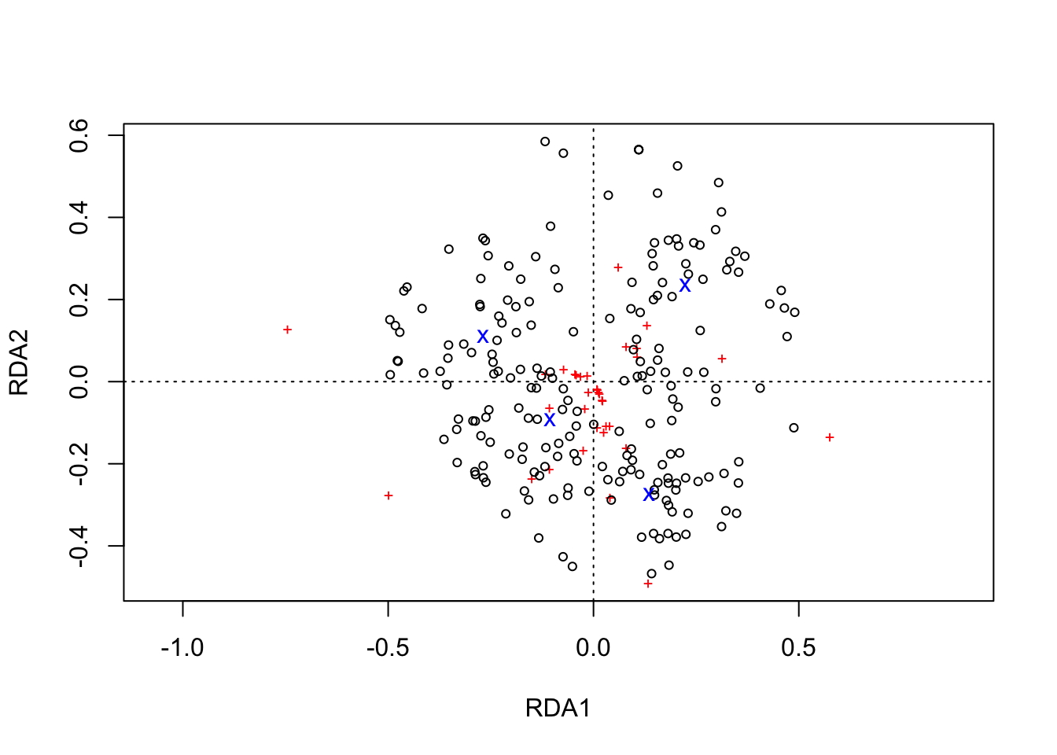

sites.long2 <- sites.long(plot2, env.data=nmds_family)  
head(sites.long1)

## X StreamID monthyear Sample_Number Ameletidae Baetidae Capniidae  
## sit1 1 Herbert River 2018-Apr Surber_01 2 92 128  
## sit2 2 Herbert River 2018-Apr Surber_02 4 87 135  
## sit3 3 Herbert River 2018-Apr Surber_03 1 89 47  
## sit4 4 Herbert River 2018-Apr Surber_04 3 75 132  
## sit5 5 Herbert River 2018-Apr Surber_05 0 39 36  
## sit6 6 Herbert River 2018-Aug Surber_01 0 5 0  
## Chironomidae Chloroperlidae Heptageniidae Nemouridae Oligochaeta  
## sit1 138 5 7 110 1  
## sit2 118 3 9 100 6  
## sit3 98 4 6 61 27  
## sit4 133 3 4 92 13  
## sit5 90 3 0 44 2  
## sit6 23 0 2 0 1  
## Daphniidae Perlodidae Simuliidae UnId.Insect Mollusca Acari Empididae  
## sit1 0 0 0 0 0 0 0  
## sit2 1 2 0 0 0 0 0  
## sit3 1 2 2 5 0 0 0  
## sit4 1 1 0 0 0 0 0  
## sit5 0 0 0 0 0 0 0  
## sit6 0 0 0 1 0 0 0  
## Ephemerellidae Pediciidae Onychiuridae Limoniidae Taeniopterygidae  
## sit1 0 0 0 0 0  
## sit2 0 0 0 0 0  
## sit3 0 0 0 0 0  
## sit4 0 0 0 0 0  
## sit5 0 0 0 0 0  
## sit6 0 0 0 0 0  
## Brachycentridae Tipulidae Gastropoda Leptophlebiidae Limnephilidae  
## sit1 0 0 0 0 0  
## sit2 0 0 0 0 0  
## sit3 0 0 0 0 0  
## sit4 0 0 0 0 0  
## sit5 0 0 0 0 0  
## sit6 0 0 0 0 0  
## Ceratopogonidae Phryganeidae Leuctridae Rhyacophilidae Gammaridae  
## sit1 0 0 0 0 0  
## sit2 0 0 0 0 0  
## sit3 0 0 0 0 0  
## sit4 0 0 0 0 0  
## sit5 0 0 0 0 0  
## sit6 0 0 0 0 0  
## Glossosomatidae Diptera Sminthuridae Sphaeriidae axis1 axis2  
## sit1 0 0 0 0 0.002557499 0.5239559  
## sit2 0 0 0 0 -0.023534368 0.5825508  
## sit3 0 0 0 0 0.208098945 0.8391173  
## sit4 0 0 0 0 0.034328489 0.5173298  
## sit5 0 0 0 0 0.242012873 0.4111491  
## sit6 0 0 0 0 0.434942436 0.4238626  
## labels  
## sit1 sit1  
## sit2 sit2  
## sit3 sit3  
## sit4 sit4  
## sit5 sit5  
## sit6 sit6

species.long2 <- species.long(plot2)  
species.long2

## axis1 axis2 labels  
## Ameletidae -0.014928623 0.01396252 Ameletidae  
## Baetidae 0.575356676 -0.13500249 Baetidae  
## Capniidae 0.105516874 0.08150122 Capniidae  
## Chironomidae 0.060606957 0.27873448 Chironomidae  
## Chloroperlidae -0.498536048 -0.27644909 Chloroperlidae  
## Heptageniidae 0.133585444 -0.49109892 Heptageniidae  
## Nemouridae 0.313475530 0.05629011 Nemouridae  
## Oligochaeta -0.744832409 0.12676483 Oligochaeta  
## Daphniidae 0.130362982 0.13781993 Daphniidae  
## Perlodidae 0.106888698 0.05989159 Perlodidae  
## Simuliidae -0.116458877 0.01777177 Simuliidae  
## UnId.Insect 0.080221039 0.08480980 UnId.Insect  
## Mollusca -0.106697398 -0.06472536 Mollusca  
## Acari -0.107003830 -0.21286107 Acari  
## Empididae -0.024931126 -0.16736809 Empididae  
## Ephemerellidae 0.040591660 -0.28179384 Ephemerellidae  
## Pediciidae -0.149729197 -0.23655051 Pediciidae  
## Onychiuridae 0.030601476 -0.10729690 Onychiuridae  
## Limoniidae 0.024839512 -0.12359340 Limoniidae  
## Taeniopterygidae 0.039236798 -0.10790399 Taeniopterygidae  
## Brachycentridae 0.008534436 -0.11167749 Brachycentridae  
## Tipulidae -0.021159181 -0.06602825 Tipulidae  
## Gastropoda -0.031094300 0.01289081 Gastropoda  
## Leptophlebiidae -0.012601760 -0.02604218 Leptophlebiidae  
## Limnephilidae -0.072593025 0.03009501 Limnephilidae  
## Ceratopogonidae -0.044745464 0.01855020 Ceratopogonidae  
## Phryganeidae -0.041895940 0.01736887 Phryganeidae  
## Leuctridae 0.009862331 -0.01991600 Leuctridae  
## Rhyacophilidae 0.079983495 -0.16151871 Rhyacophilidae  
## Gammaridae 0.022725840 -0.04589257 Gammaridae  
## Glossosomatidae 0.021762625 -0.04394746 Glossosomatidae  
## Diptera 0.014935555 -0.03016087 Diptera  
## Sminthuridae 0.012287838 -0.02481407 Sminthuridae  
## Sphaeriidae 0.008977407 -0.01812898 Sphaeriidae

axis.long2 <- axis.long(Ordination.model2, choices=c(1, 2))  
axis.long2

## axis ggplot label  
## 1 1 xlab.label RDA1 (18%)  
## 2 2 ylab.label RDA2 (10.1%)

plot using ggplot with colors by site

plotgg2 <- ggplot() +   
 geom_vline(xintercept = c(0), color = "grey70", linetype = 2) +  
 geom_hline(yintercept = c(0), color = "grey70", linetype = 2) +   
 xlab(axis.long2[1, "label"]) +  
 ylab(axis.long2[2, "label"]) +   
 scale_x_continuous(sec.axis = dup_axis(labels=NULL, name=NULL)) +  
 scale_y_continuous(sec.axis = dup_axis(labels=NULL, name=NULL)) +   
 geom_point(data=sites.long2,   
 aes(x=axis1, y=axis2, colour=StreamID, shape=StreamID),   
 size=5, alpha= .5) +  
 geom_point(data=species.long2,   
 aes(x=axis1, y=axis2)) +  
 scale_colour_manual(values = c("grey68","gold2","chocolate4","dodgerblue"))+  
 coord_fixed(ratio=1)  
  
plotgg2

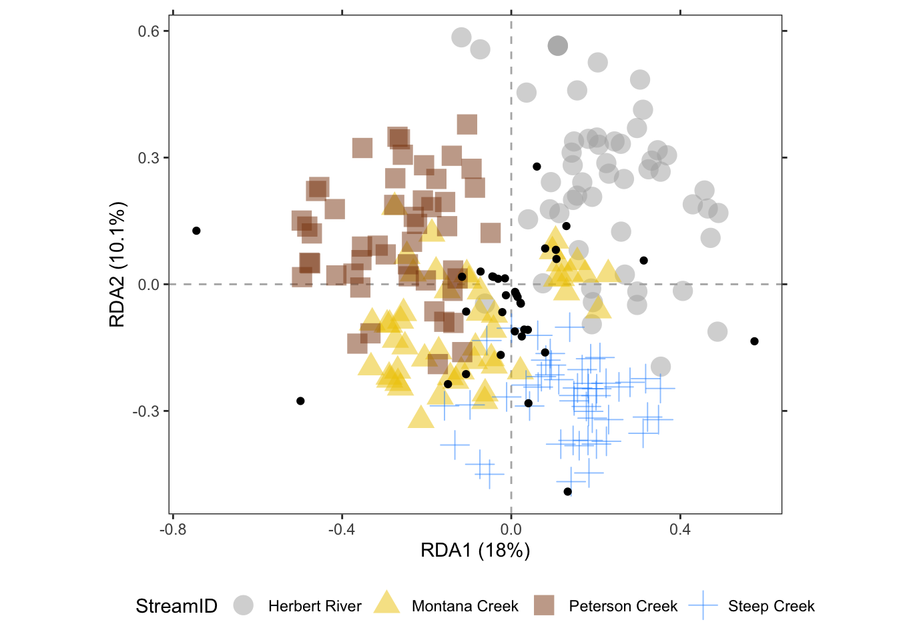

which species are driving the variation?

spec.envfit <- envfit(plot2, env=seak.Hellinger)  
spec.data.envfit <- data.frame(r=spec.envfit$vectors$r, p=spec.envfit$vectors$pvals)  
  
  
species.long2 <- species.long(plot2, spec.data=spec.data.envfit)  
species.long2 #all data

## r p axis1 axis2 labels  
## Ameletidae 0.005378478 0.610 -0.014928623 0.01396252 Ameletidae  
## Baetidae 0.723986883 0.001 0.575356676 -0.13500249 Baetidae  
## Capniidae 0.164373631 0.001 0.105516874 0.08150122 Capniidae  
## Chironomidae 0.334385065 0.001 0.060606957 0.27873448 Chironomidae  
## Chloroperlidae 0.631983148 0.001 -0.498536048 -0.27644909 Chloroperlidae  
## Heptageniidae 0.721525676 0.001 0.133585444 -0.49109892 Heptageniidae  
## Nemouridae 0.353245236 0.001 0.313475530 0.05629011 Nemouridae  
## Oligochaeta 0.724646836 0.001 -0.744832409 0.12676483 Oligochaeta  
## Daphniidae 0.053483728 0.006 0.130362982 0.13781993 Daphniidae  
## Perlodidae 0.125651156 0.001 0.106888698 0.05989159 Perlodidae  
## Simuliidae 0.013543367 0.285 -0.116458877 0.01777177 Simuliidae  
## UnId.Insect 0.127031706 0.001 0.080221039 0.08480980 UnId.Insect  
## Mollusca 0.194400733 0.001 -0.106697398 -0.06472536 Mollusca  
## Acari 0.414697196 0.001 -0.107003830 -0.21286107 Acari  
## Empididae 0.384745756 0.001 -0.024931126 -0.16736809 Empididae  
## Ephemerellidae 0.292827842 0.001 0.040591660 -0.28179384 Ephemerellidae  
## Pediciidae 0.310119248 0.001 -0.149729197 -0.23655051 Pediciidae  
## Onychiuridae 0.202566244 0.001 0.030601476 -0.10729690 Onychiuridae  
## Limoniidae 0.210647708 0.001 0.024839512 -0.12359340 Limoniidae  
## Taeniopterygidae 0.274360632 0.001 0.039236798 -0.10790399 Taeniopterygidae  
## Brachycentridae 0.223899945 0.001 0.008534436 -0.11167749 Brachycentridae  
## Tipulidae 0.116451832 0.001 -0.021159181 -0.06602825 Tipulidae  
## Gastropoda 0.157751090 0.001 -0.031094300 0.01289081 Gastropoda  
## Leptophlebiidae 0.029319972 0.061 -0.012601760 -0.02604218 Leptophlebiidae  
## Limnephilidae 0.205440282 0.001 -0.072593025 0.03009501 Limnephilidae  
## Ceratopogonidae 0.163144729 0.001 -0.044745464 0.01855020 Ceratopogonidae  
## Phryganeidae 0.091962102 0.001 -0.041895940 0.01736887 Phryganeidae  
## Leuctridae 0.083611045 0.001 0.009862331 -0.01991600 Leuctridae  
## Rhyacophilidae 0.417717681 0.001 0.079983495 -0.16151871 Rhyacophilidae  
## Gammaridae 0.117628547 0.001 0.022725840 -0.04589257 Gammaridae  
## Glossosomatidae 0.085777210 0.002 0.021762625 -0.04394746 Glossosomatidae  
## Diptera 0.088784968 0.001 0.014935555 -0.03016087 Diptera  
## Sminthuridae 0.054084318 0.002 0.012287838 -0.02481407 Sminthuridae  
## Sphaeriidae 0.061053795 0.002 0.008977407 -0.01812898 Sphaeriidae

species.long3 <- species.long2[species.long2$r >= 0.6, ]  
species.long3 #species explaining at least 60% of variation

## r p axis1 axis2 labels  
## Baetidae 0.7239869 0.001 0.5753567 -0.1350025 Baetidae  
## Chloroperlidae 0.6319831 0.001 -0.4985360 -0.2764491 Chloroperlidae  
## Heptageniidae 0.7215257 0.001 0.1335854 -0.4910989 Heptageniidae  
## Oligochaeta 0.7246468 0.001 -0.7448324 0.1267648 Oligochaeta

library(ggrepel)  
plotgg2 <- ggplot() +   
 geom_vline(xintercept = c(0), color = "grey70", linetype = 2) +  
 geom_hline(yintercept = c(0), color = "grey70", linetype = 2) +   
 xlab(axis.long2[1, "label"]) +  
 ylab(axis.long2[2, "label"]) +   
 scale_x_continuous(sec.axis = dup_axis(labels=NULL, name=NULL)) +  
 scale_y_continuous(sec.axis = dup_axis(labels=NULL, name=NULL)) +   
 geom_point(data=sites.long2,   
 aes(x=axis1, y=axis2, colour=StreamID, shape=StreamID),   
 size=5) +  
 geom_segment(data=species.long3,   
 aes(x=0, y=0, xend=axis1, yend=axis2),   
 colour="black",alpha = .5, size=0.7, arrow=arrow()) +  
 geom_text_repel(data=species.long3,   
 aes(x=axis1, y=axis2, label=labels),  
 colour="black",alpha = .5,) +  
 scale_colour_manual(values = c("grey68","gold2","chocolate4","dodgerblue"))+  
 coord_fixed(ratio=1)  
  
plotgg2

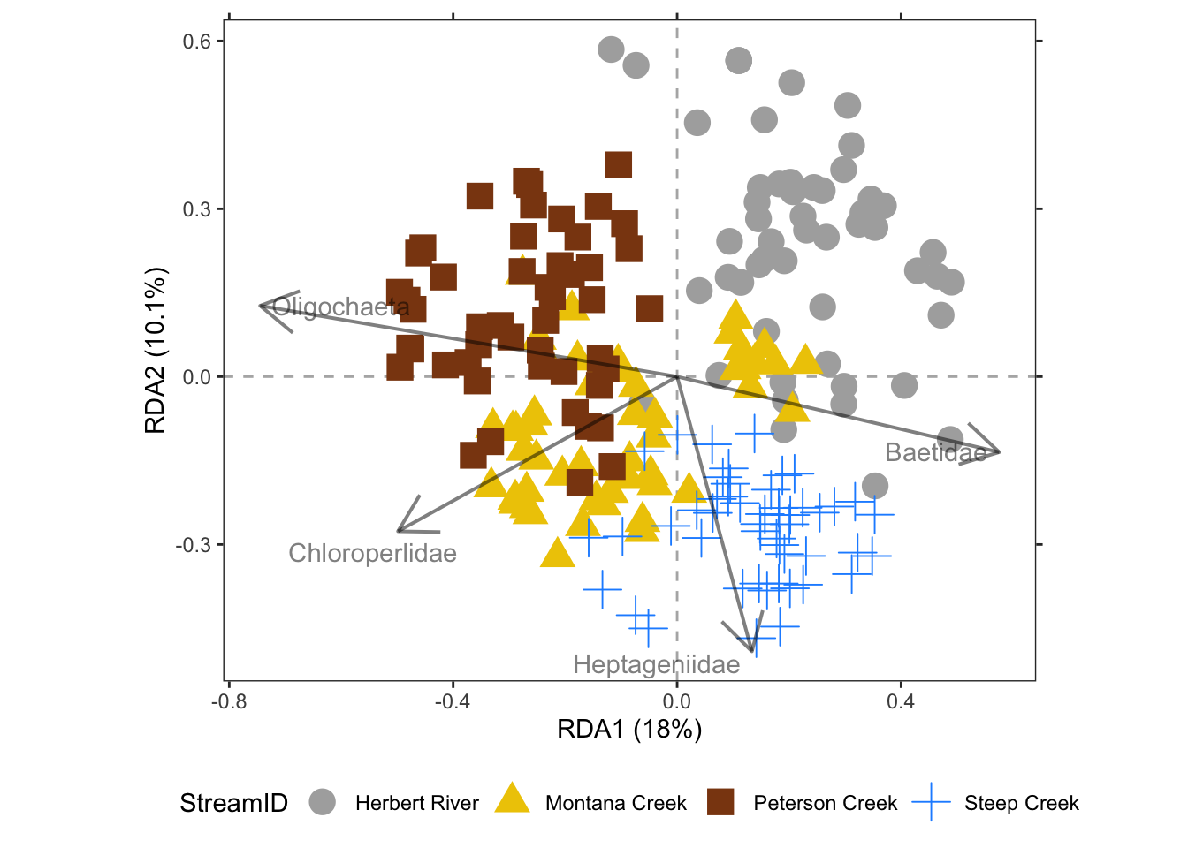

Add standard Ellipses

library(ggforce)  
plotgg3 <- ggplot() +   
 geom_vline(xintercept = c(0), color = "grey70", linetype = 2) +  
 geom_hline(yintercept = c(0), color = "grey70", linetype = 2) +   
 xlab(axis.long2[1, "label"]) +  
 ylab(axis.long2[2, "label"]) +   
 scale_x_continuous(sec.axis = dup_axis(labels=NULL, name=NULL)) +  
 scale_y_continuous(sec.axis = dup_axis(labels=NULL, name=NULL)) +  
 geom_mark_ellipse(data=sites.long2,   
 aes(x=axis1, y=axis2, colour=StreamID,   
 fill=after_scale(alpha(colour, 0.2))),   
 expand=0, size=0.2, show.legend=FALSE) +  
 geom_point(data=sites.long2,   
 aes(x=axis1, y=axis2, colour=StreamID, shape=StreamID),   
 size=5) +  
 geom_segment(data=species.long3,   
 aes(x=0, y=0, xend=axis1, yend=axis2),   
 colour="black",alpha = .5, size=0.7, arrow=arrow()) +  
 geom_text_repel(data=species.long3,   
 aes(x=axis1, y=axis2, label=labels),  
 colour="black",alpha = .5,) +  
 scale_colour_manual(values = c("grey68","gold2","chocolate4","dodgerblue"))+  
 coord_fixed(ratio=1)+  
 theme(legend.title = element_blank())  
  
plotgg3

