DOKUMEN

SPESIFIKASI KEBUTUHAN PERANGKAT LUNAK

LETTREQUEST

letter request information system

untuk:

Department of Informatics Engineering ITS

Prepared by:

Magista Bella Puspita (5114100007)

Faiz Ainun Karima (5114100138)

Muhammad Ishar Kadir (5114100702)

Jurusan Teknik Informatika - Institut Teknologi Sepuluh Nopember

Kampus ITS Keputih Sukolilo Surabaya

|  |  |  |  |  |
| --- | --- | --- | --- | --- |
|  | **Jurusan**  **Teknik Informatika ITS** | Nomor Dokumen | | Halaman |
| *SKPL-001* | | 1/#52 |
| Revisi | - | DD MM YYYY |

DAFTAR PERUBAHAN

|  |  |
| --- | --- |
| Revisi | Deskripsi |
| A |  |
| B |  |
| C |  |
| D |  |
| E |  |
| F |  |
| G |  |

|  |  |  |  |  |  |  |  |  |
| --- | --- | --- | --- | --- | --- | --- | --- | --- |
| DATE INDEX | - | A | B | C | D | E | F | G |
| Ditulis oleh |  |  |  |  |  |  |  |  |
| Diperiksa oleh |  |  |  |  |  |  |  |  |
| Disetujui oleh |  |  |  |  |  |  |  |  |

Daftar Halaman Perubahan

|  |  |  |  |
| --- | --- | --- | --- |
| Halaman | Revisi | Halaman | Revisi |
|  |  |  |  |

Daftar Isi

1 Pendahuluan

1.1 Tujuan Penulisan Dokumen

1.2 Lingkup Masalah

1.3 Definisi dan Istilah

1.4 Aturan Penamaan dan Penomoran

1.5 Referensi

1.6 Ikhtisar Dokumen

2 Deskripsi Umum Perangkat Lunak

2.1 Deskripsi Umum Sistem

2.2 Fungsi Produk

2.3 Karakteristik Pengguna

2.4 Batasan

2.5 Lingkungan Operasi

3 Deskripsi Umum Kebutuhan

3.1 Kebutuhan antarmuka eksternal

3.1.1 Antarmuka pengguna

3.1.2 Antarmuka perangkat keras

3.1.3 Antarmuka perangkat lunak

3.1.4 Antarmuka komunikasi

3.2 Deskripsi Fungsional

3.2.1 Use Case Diagram

3.2.2 Function 1: Requesting Letter to the Staffs

3.2.2.1 Scenario:  Requesting Letter to the Staffs

3.2.2.2 Activity Diagram:  Requesting Letter to the Staffs

3.2.2.3 Sequence Diagram:  Requesting Letter to the Staffs

3.2.2.4 Object Collaboration Diagram:  Requesting Letter to the Staffs

3.2.3 Function 2: Showing Profile

3.2.3.1 Scenario: Showing Profile

3.2.3.2 Activity Diagram:  Showing Profile

3.2.3.3 Sequence Diagram:  Showing Profile

3.2.3.4 Object Collaboration Diagram:  Showing Profile

3.2.4 Function 3: Editing Account

3.2.4.1 Scenario:  Editing Account

3.2.4.2 Activity Diagram:  Editing Account

3.2.4.3 Sequence Diagram:  Editing Account

3.2.4.4 Object Collaboration Diagram:  Editing Account

3.2.5 Function 4: Changing Password

3.2.5.1 Scenario:  Changing Password

3.2.5.2 Activity Diagram:  Changing Password

3.2.5.3 Sequence Diagram:  Changing Password

3.2.5.4 Object Collaboration Diagram:  Changing Password

3.2.6 Function 5: See the Letter Request History

3.2.6.1 Scenario:  See the Letter Request History

3.2.6.2 Activity Diagram:  See the Letter Request History

3.2.6.3 Sequence Diagram: See the Letter Request History

3.2.6.4 Object Collaboration Diagram:  See the Letter Request History

3.2.7 Function 6: Cancelling Requested Letter

3.2.7.1 Scenario:  Cancelling Requested Letter

3.2.7.2 Activity Diagram:  Cancelling Requested Letter

3.2.7.3 Sequence Diagram:  Cancelling Requested Letter

3.2.7.4 Object Collaboration Diagram:  Cancelling Requested Letter

3.2.8 Function 7: Editing Requested Letter

3.2.8.1 Scenario:  Editing Requested Letter

3.2.8.2 Activity Diagram:  Editing Requested Letter

3.2.8.3 Sequence Diagram:  Editing Requested Letter

3.2.8.4 Object Collaboration Diagram:  Editing Requested Letter

3.2.9 Function 8: Responding Letter Request

3.2.9.1 Scenario:  Responding Letter Request

3.2.9.2 Activity Diagram:  Responding Letter Request

3.2.9.3 Sequence Diagram:  Responding Letter Request

3.2.9.4 Object Collaboration Diagram:  Responding Letter Request

3.3 Deskripsi Kelas-kelas

3.3.1 Class Diagram

3.3.2 Deskripsi Domain Persoalan

3.3.3  Deskripsi Kelas Pengendali

3.3.4 Deskripsi Kelas *Entity (Persisten)*

3.3.5 Deskripsi Kelas *Boundary*

3.4 Data Flow Diagram

3.5 Kebutuhan Non Fungsional

3.6 Batasan Perancangan

3.7 Ringkasan Kebutuhan

3.7.1 Ringkasan Kebutuhan Fungsional

3.7.2 Ringkasan Kebutuhan Non Fungsional

Daftar Tabel

Tabel 1 Aturan Penamaan dan Penomoran

Tabel 2 Karakteristik Pengguna

Tabel 3 Deskripsi Kelas Domain Persoalan

Tabel 4 Deskripsi Kelas Pengendali

Tabel 5 Deskripsi Kelas *Entity*

Tabel 6 Deskripsi Kelas *Boundary*

Tabel 7 Deskripsi Kebutuhan Non Fungsional

Tabel 8 Ringkasan Kebutuhan Fungsional

Tabel 9 Ringkasan Kebutuhan Non Fungsional

Daftar Gambar

Picture 1. Use Case Diagram. 14

Picture 2. Activity Diagram “Requesting Letter to the Staffs” 16

Picture 3. Sequence Diagram “Requesting Letter to the Staffs” 17

Picture 4. Object Collaboration Diagram “Requesting Letter to the Staffs” 18

Picture 5. Activity Diagram “Showing Profile” 20

Picture 6. Sequence Diagram “Showing Profile” 21

Picture 7. Object Collaboration Diagram “Showing Profile” 22

Picture 8. Activity Diagram “Editing Account” 24

Picture 9. Sequence Diagram “Editing Account” 25

Picture 10. Object Collaboration Diagram “Editing Account” 26

Picture 11. Activity Diagram “Changing Password” 27

Picture 12. Sequence Diagram “Changing Password” 28

Picture 13. Object Collaboration Diagram “Changing Password” 29

Picture 14. Activity Diagram “See the Letter Request History” 30

Picture 15. Sequence Diagram “See the Letter Request History” 31

Picture 16. Object Collaboration Diagram “See the Letter Request History” 32

Picture 17. Activity Diagram “Cancelling Request” 33

Picture 18. Sequence Diagram “Cancelling Request” 34

Picture 19. Object Collaboration Diagram “Cancelling Request” 35

Picture 20. Activity Diagram “Editing Request” 36

Picture 21. Sequence Diagram “Editing Request” 37

Picture 22. Object Collaboration Diagram “Editing Request” 38

Picture 23. Activity Diagram “Responding Letter Request” 39

Picture 24. Sequence Diagram “Responding Letter Request” 40

Picture 25. Object Collaboration Diagram “Responding Letter Request” 41

Picture 29. Class Diagram 46

Picture 30. Physical Data Model 49

Picture 31. Data Flow Diagram Level 0 51

Picture 31. Data Flow Diagram Level 1 51

# Deskripsi Umum Kebutuhan

## Kebutuhan antarmuka eksternal

### Antarmuka pengguna

*Lettrequest* menggunakan antarmuka grafis (GUI). Pengguna dapat menginputkan melalui *keyboard* dan *mouse* serta digunakan dengan sistem operasi *Windows.*

### Antarmuka perangkat keras

Sistem *Lettrequest* berjalan di komputer *server*. Komputer yang ingin mengakses *Lettrequest* harus terhubung dengan jaringan internet.

### Antarmuka perangkat lunak

*Lettrequest* adalah program yang akan dibangun menggunakan bahasa HTML, ASP C# , SQL-Server dan akan berjalan pada Sistem Operasi WINDOWS.

### Antarmuka komunikasi

*Lettrequest* merupakan sistem yang terhubung di jaringan internet.

## Deskripsi Fungsional

### Function 5: See the Letter Request History

#### Scenario: See the Letter Request History

|  |  |
| --- | --- |
| Use Case Code | UC5 |
| Use Case Name | Letter Request History |
| Actor | Mahasiswa |
| Description | Mahasiswa bisa melihat riwayat permintaan surat yang pernah mereka buat |
| Pre-Condition | Home page dari sistem |
| Main Flow | 1. Mahasiswa memilih Letter Request History menu 2. Sistem akan menampilkan riwayat permintaan surat dan menampilkan edit and cancel button pada setiap surat yang belum direspon oleh admin |
| Alternate Flow |  |
| Post-Condition | Halaman Letter Request History akan ditampilkan oleh sistem |

#### Activity Diagram: See the Letter Request History

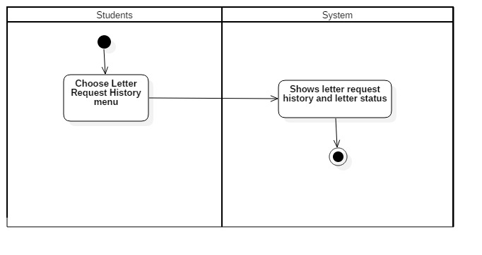

Picture 14. “See the Letter Request History”Activity Diagram

#### Sequence Diagram: See the Letter Request History

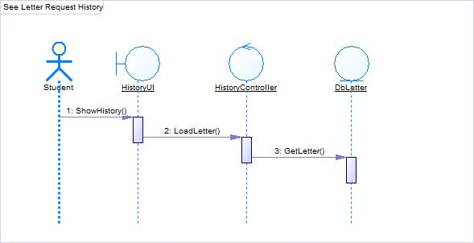

Picture 15. “See the Letter Request History” Sequence Diagram

#### Object Collaboration Diagram: See the Letter Request History

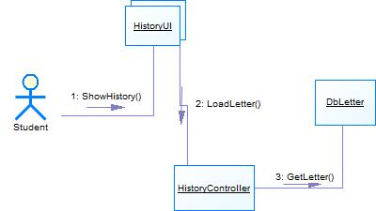

Picture 16. “See the Letter Request History” Collaboration Diagram

### Function 6: Canceling Requested Letter

#### Scenario: Canceling Requested Letter

|  |  |
| --- | --- |
| Use Case Code | UC7 |
| Use Case Name | Cancel Request |
| Actor | Mahasiswa |
| Description | Mahasiswa bisa membatalkan permintaan surat yang dibuat |
| Pre-Condition | Halaman Letter Request History |
| Main Flow | 1. Mahasiswa mengeklik Cancel button yang terletak pada sebelah kanan surat yang ingin di*cancel* 2. Sistem akan menampilkan “Are you sure to cancel your request?” pop-up 3. Jika mahasiswa menekan tombol OK pada pop-up, sistem akan menghapus surat tersebut dari daftar permintaan surat pada halaman admin dan merubah status surat menjadi CANCELED di halaman Letter Request History 4. Jika mahasiswa menekan tombol NO pada pada pop-up, sistem akan tetap menampilkan surat tersebut pada halaman Letter Request History |
| Alternate Flow |  |
| Post-Condition | Permintaan surat berhasil dibatalkan |

#### Activity Diagram: Canceling Requested Letter

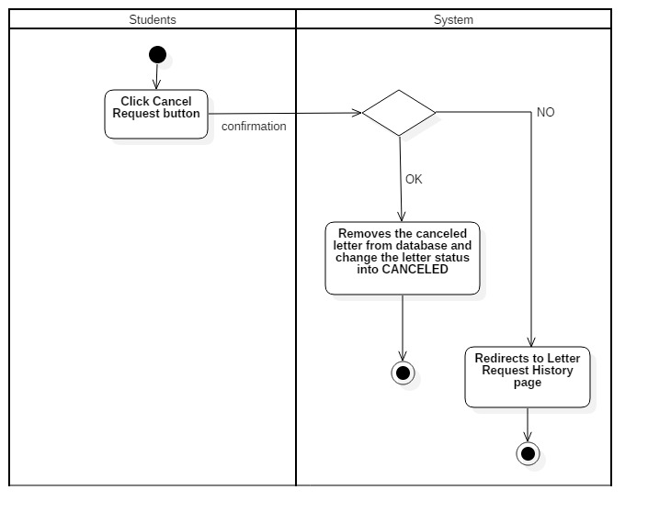

Picture 17. “Canceling Requested Letter” Activity Diagram

#### Sequence Diagram: Canceling Requested Letter

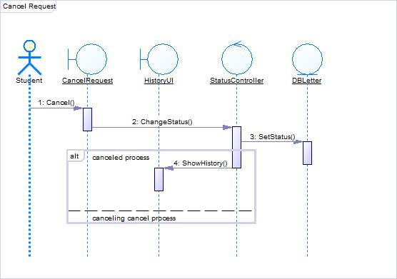

Picture 18. “Canceling Requested Letter” Sequence Diagram

#### Object Collaboration Diagram: Canceling Requested Letter

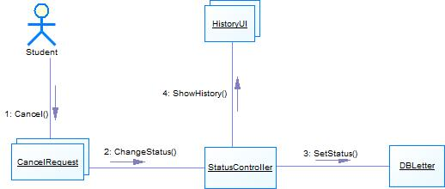

Picture 19. “Canceling Requested Letter” Object Collaboration Diagram

### Function 7: Editing Requested Letter

#### Scenario: Editing Requested Letter

|  |  |
| --- | --- |
| Use Case Code | UC6 |
| Use Case Name | Edit Request |
| Actor | Mahasiswa |
| Description | Mahasiswa bisa mengedit surat yang telah mereka minta |
| Pre-Condition | Halaman Letter Request History |
| Main Flow | 1. Mahasiswa memilih tombol Edit yang terletak di sebelah kanan surat yang ingin mereka edit 2. Sistem akan menampilkan form untuk mengedit surat 3. Mahasiswa bisa mengedit surat yang diminta 4. Mahasiswa bisa mensubmit surat yang telah diedit dengan mengeklik tombol Submit 5. Sistem akan menyimpan dan memproses permintaan surat terbaru dari mahasiswa |
| Alternate Flow | * 1. Jika mahasiswa ingin membatalkan proses pengeditan, mahasiswa bisa mengeklik tombol Cancel   2. Sistem akan menampilkan “Are you sure to cancel your change?” pop-up   3. Jika mahasiswa mengeklik tombol OK yang ada pada pop-up, maka sistem akan mengalihkan mahasiswa ke halaman Letter Request History   4. Jika mahasiswa mengeklik tombol NO yang ada pada pop-up maka mahasiswa bisa melanjutkan mengedit surat |
| Post-Condition | Sistem akan menyimpan dan memproses permintaan surat terbaru dari mahasiswa |

#### Activity Diagram: Editing Requested Letter

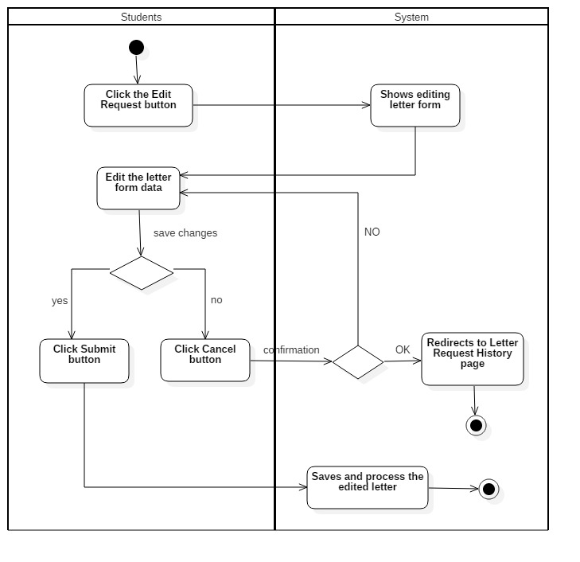

Picture 20. “Editing Requested Letter” Activity Diagram

#### Sequence Diagram: Editing Requested Letter

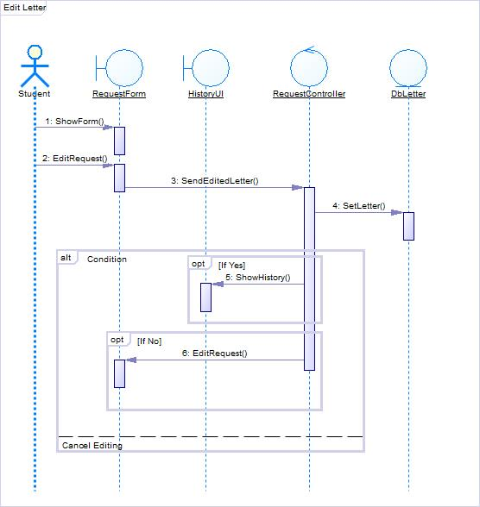

Picture 21. “Editing Requested Letter” Sequence Diagram

#### Object Collaboration Diagram: Editing Requested Letter

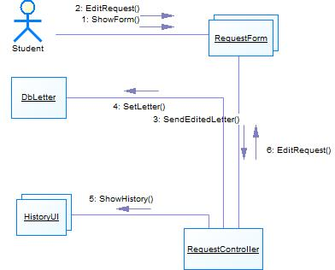

Picture 22. “Editing Requested Letter” Object Collaboration Diagram

## Data Flow Diagram

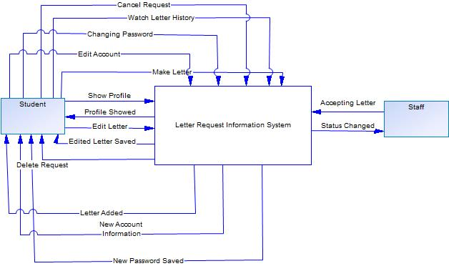

Picture 31. Data Flow Diagram Level 0

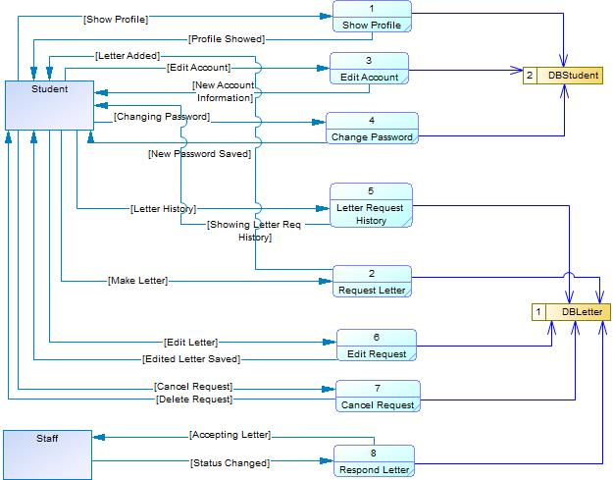

Picture 32. Data Flow Diagram Level 1

## Ringkasan Kebutuhan

### Ringkasan Kebutuhan Fungsional

**Tabel 8 Ringkasan Kebutuhan Fungsional**

|  |  |
| --- | --- |
| **SKPL-Id** | **Keterangan** |
| SKPL-F000 | Make New Letter Request |
| SKPL-F001 | See the Student Profile |
| SKPL-F002 | Edit the Student Profile |
| SKPL-F003 | Change the Student Password |
| SKPL-F004 | See the Letter Request History |
| SKPL-F005 | Edit the Requested Letter |
| SKPL-F006 | Cancel Requesting Letter |
| SKPL-F007 | Approve the Requested Letter |