**OJAS BUSINESS SUITE Deploy JARS into jfrog Artifactory Repo**

1. On the Jenkins dashboard, click on Manage Jenkins and select Manage Plugins. Click on the Available tab and write artifactory plugin in the search box.
2. Click the checkbox and click on the button, Download now and install without restart.

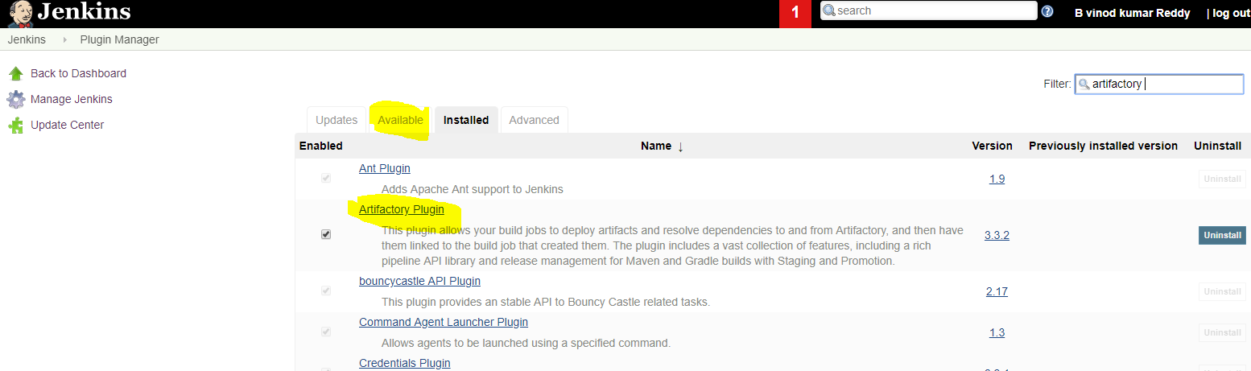

Confiruration artifactory credentials :

1. On the Jenkins dashboard, click on Manage Jenkins and select Configure systems.

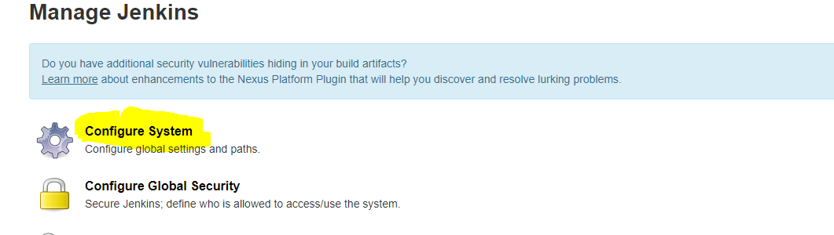

Click on the Available  artifactor   and write all information related to jfrog url, credentials.

Click Apply and save button.

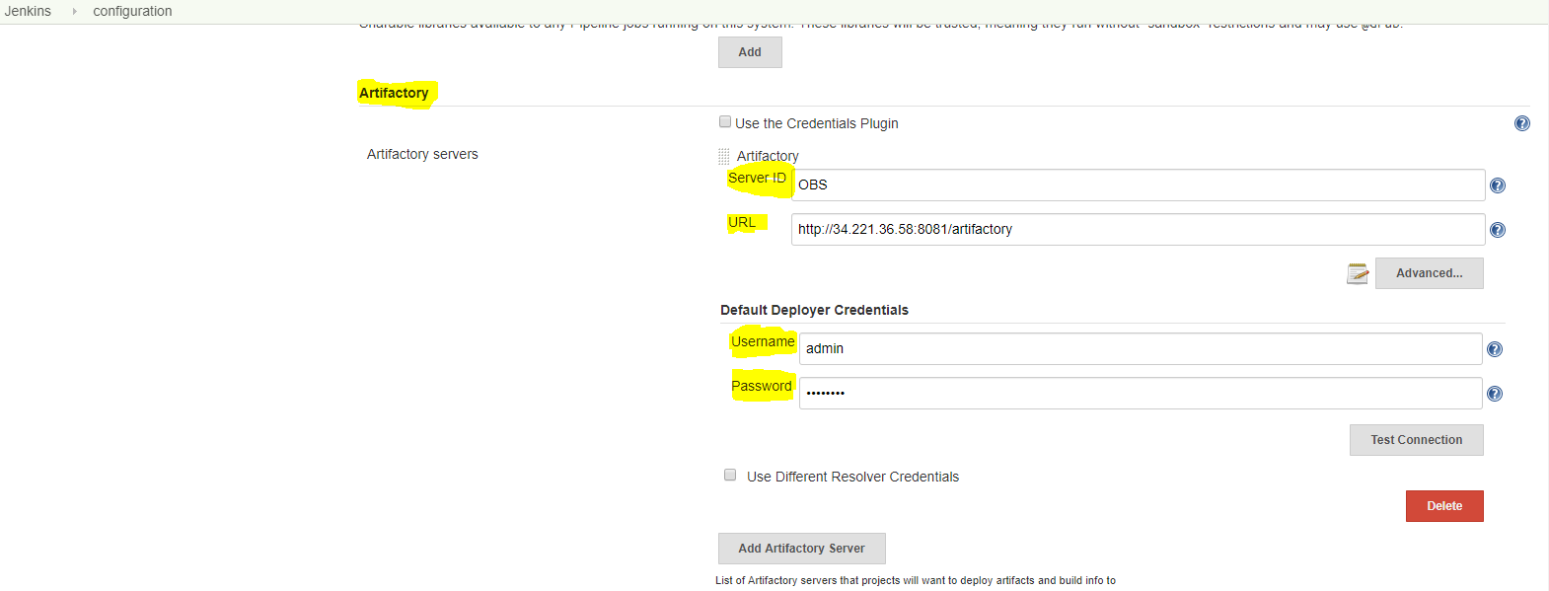

**Creating a Freestyle Build Job**

The freestyle build job is a highly flexible and easy-to-use option. You can use it for any type of project; it is easy to set up, and many of its options appear in other build jobs.

**Step 1)**To create a Jenkins freestyle job, log on to your Jenkins dashboard by visiting your Jenkins installation path. Usually, it will be hosted on localhost at [http://localhost:8080](http://localhost:8080/) If you have installed Jenkins in another path, use the appropriate URL to access your dashboard.

[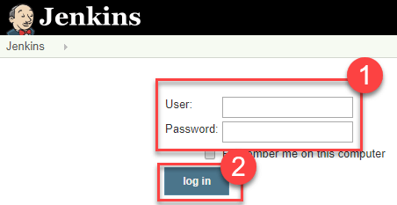](https://www.guru99.com/images/1/091318_0458_HowtoCreate2.png)

**Step 2)**Click on "**New Item**" at the top left-hand side of your dashboard.

[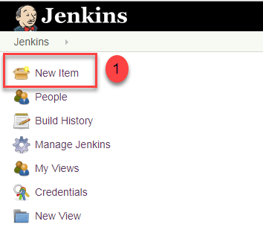](https://www.guru99.com/images/1/091318_0458_HowtoCreate3.png)

**Step 3)**In the next screen,

1. Enter the name of the item you want to create. We shall use the "Hello world" for this demo.
2. Select Freestyle project
3. Click Okay

[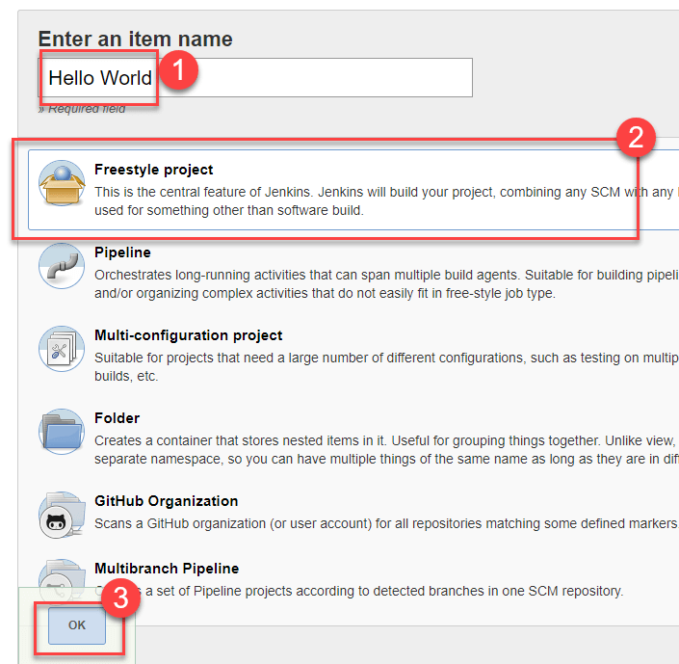](https://www.guru99.com/images/1/091318_0458_HowtoCreate4.png)

**Step 4)**Enter the details of the project you want to test.

[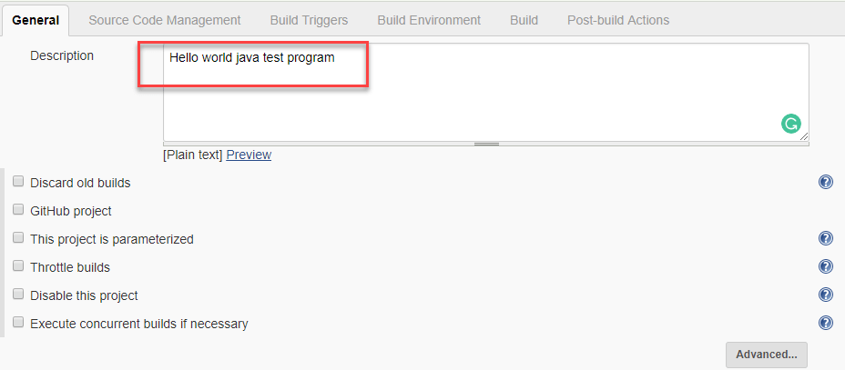](https://www.guru99.com/images/1/091318_0458_HowtoCreate5.png)

**Step 5)**

**Next step, we will configure Git SCM information.**

This step allows Jenkins to clone the code from Git systems.

Go to the Source Code Management and click on Git as follows:

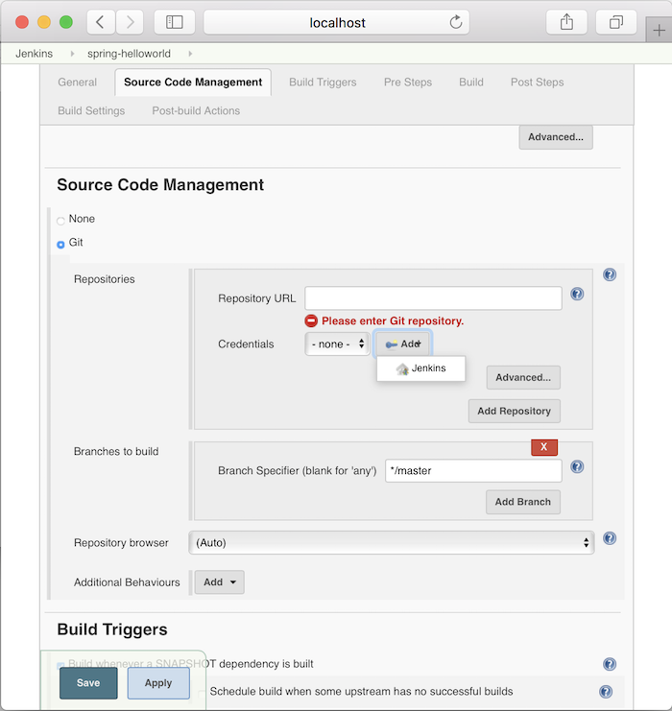

There are 3 things we need to configure for this Git SCM:

* The first is the URL to clone the code in the Repository URL section
* Second is the credentials login to the Git system we have declared in the Repository URL
* And finally, the Git branch we want to build.

In the Credentials login information, please click the Add button

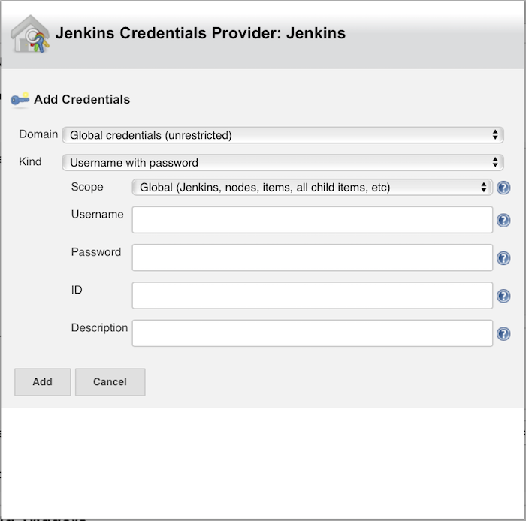

to add information about username and password.

In the window above, you only need to enter Username, Password and then click the Add button is okay.

Then the credentials login information will appear information about the Username that we just added.

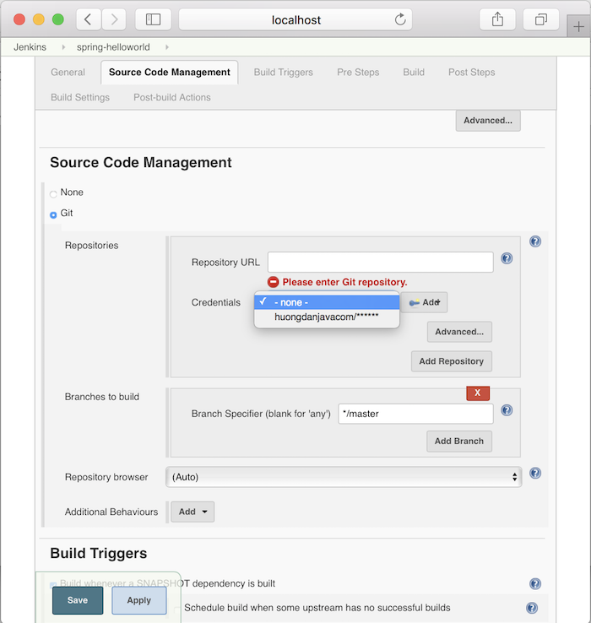

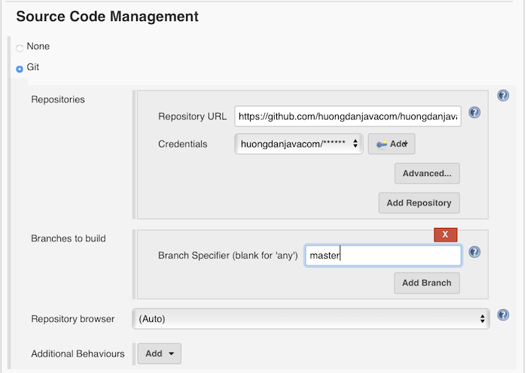

It is also possible for you to use a local repository.

If your GitHub repository is private, Jenkins will first validate your login credentials with GitHub and only then pull the source code from your GitHub repository.

**6) Artifactory Configuration**

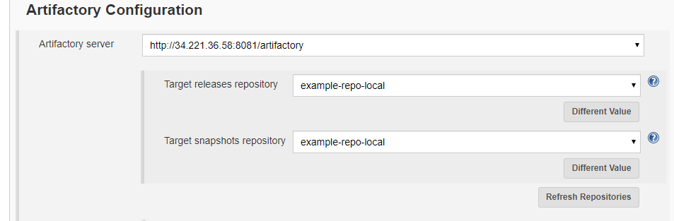

Please go to the Build section:

7) CLICK INVOKE ARTIFACTORY MAVEN 3 IN BUILD PHASE

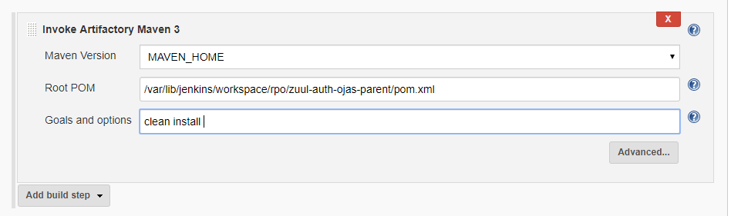

**Step 7)** When you have entered all the data,

1. Click **Apply**
2. **Save**the project.

**Step 8)**Now, in the main screen, Click the **Build Now**button on the left-hand side to build the source code.

[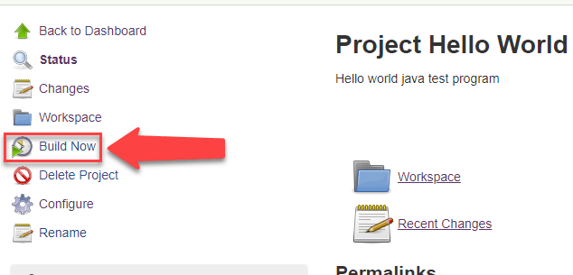](https://www.guru99.com/images/1/091318_0458_HowtoCreate9.png)

**Step 9)**After clicking on **Build now,**you can see the status of the build you run under **Build History**.

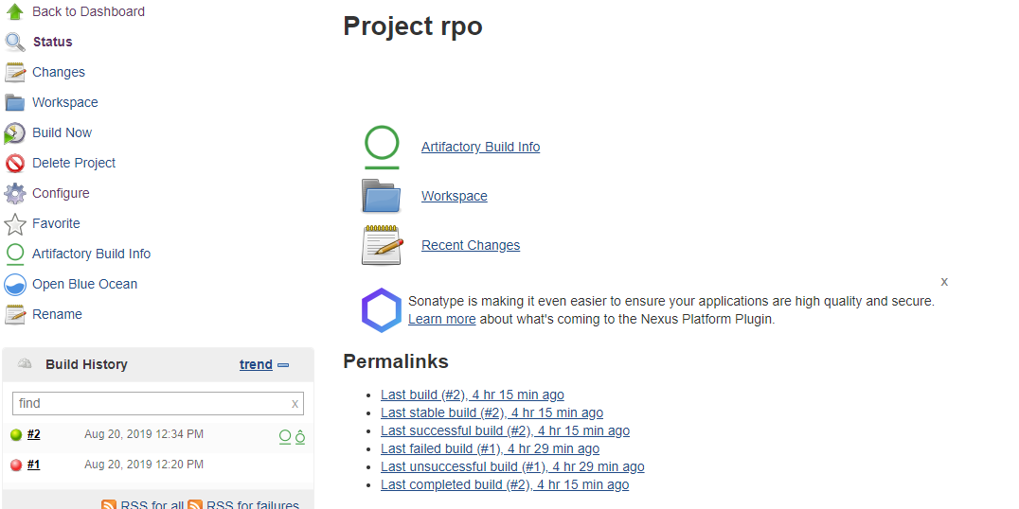

**Step 10)**Click on the **build number**andthenClick on **console output**to see the status of the build you run. It should show you a success message, provided you have followed the setup properly.

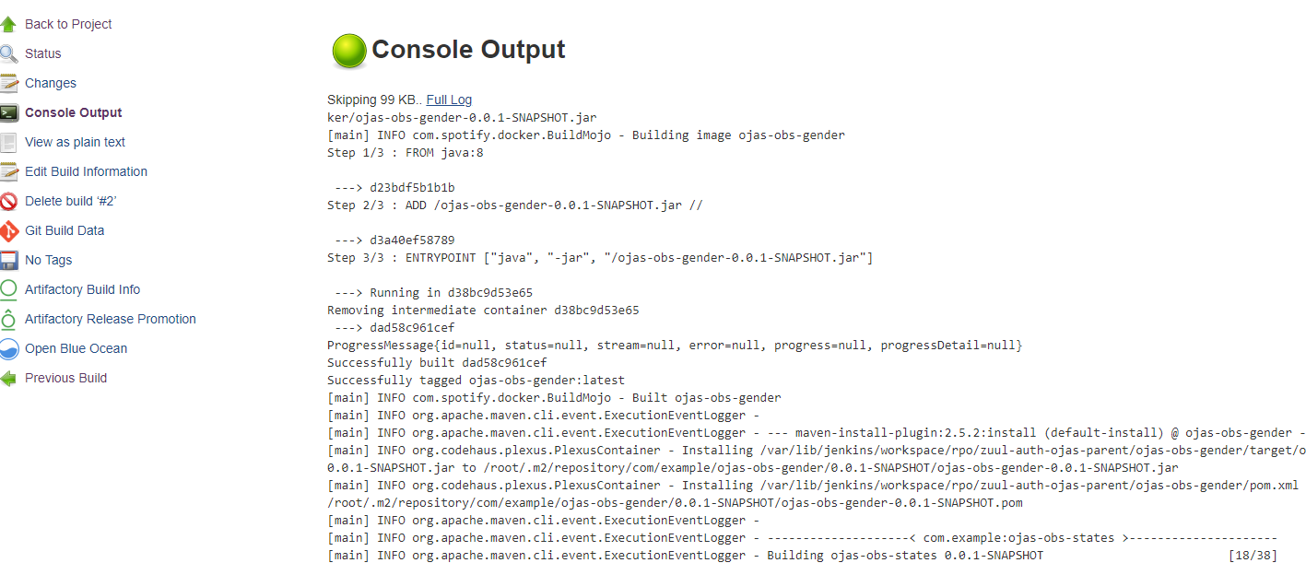

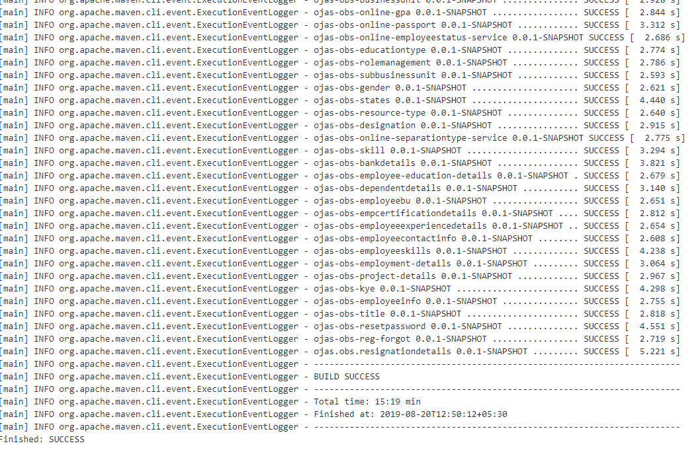

**Jfrog artifactory and check your repository :**

Login your Jfrog artifactory :

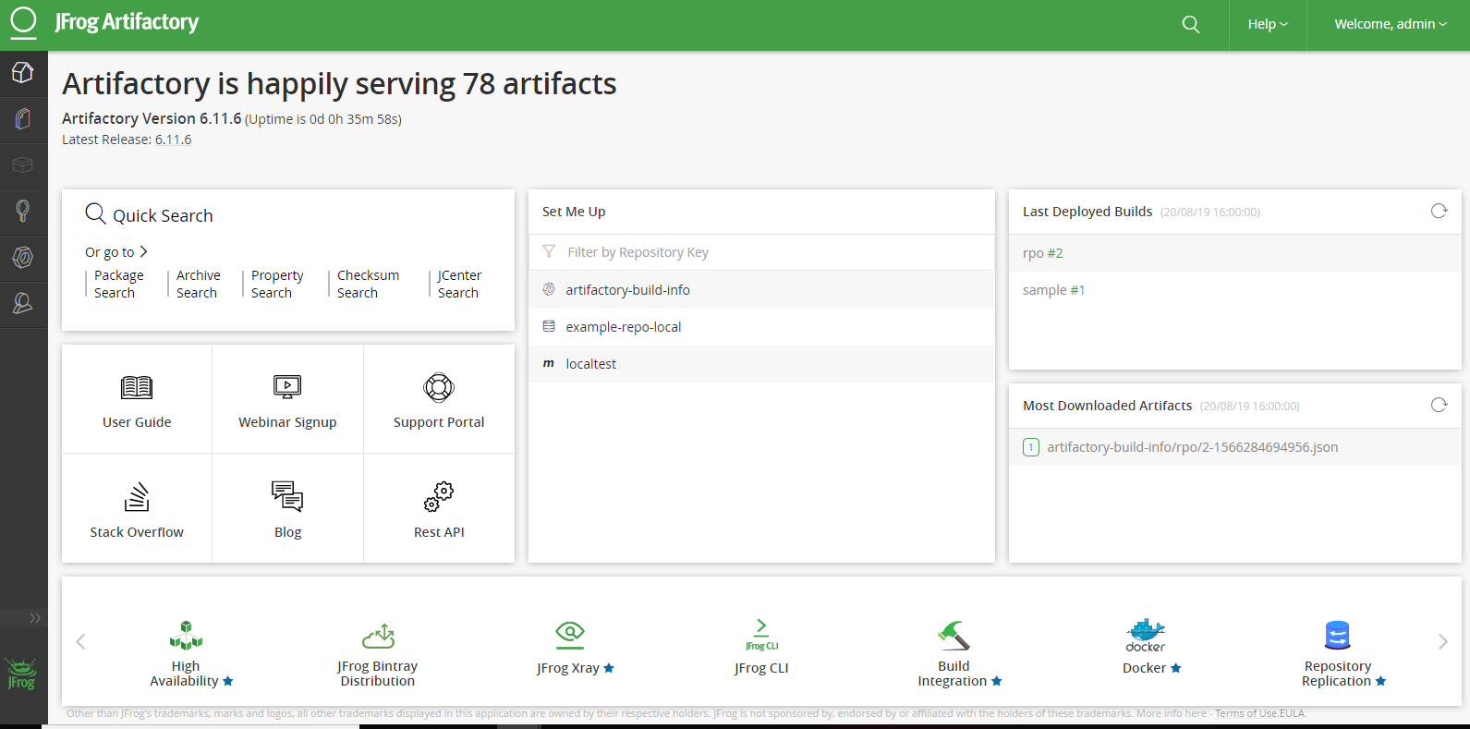

Go to your jfrog -----🡪 click Artifact repository browser

And display your total repository see like below slide :

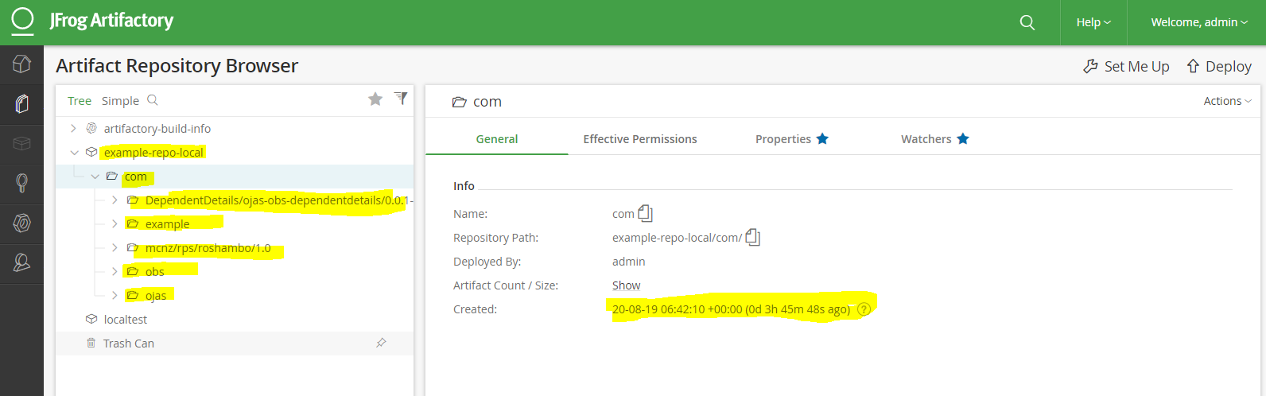

And go to Builds see your no of Builds .

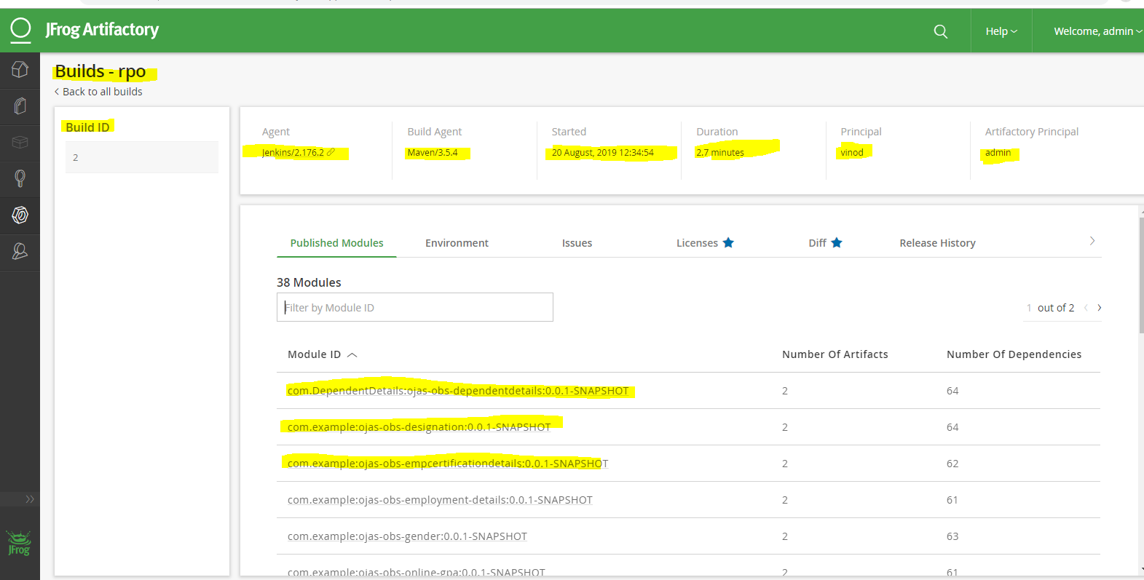

And if you want download your repos on your machine

1. Click your required repo and copy the URL .
2. Goto your machine terminal and paste it.
3. wget http://54.212.81.171:8081/artifactory/example-repo-local/com/ojas/ojas-obs-bankdetails/0.0.1-SNAPSHOT

