Angel Levaomana
10/15/2026
CS-499
Milestone Three: Algorithms and Data Structures
Artifact Description
The artifact I selected is my Grazioso Salvare Rescue Candidate Dashboard, which I originally created in February 2026 for CS 340: Advanced Programming Concepts. The application uses Python, MongoDB, Dash, Pandas, Plotly Express, and Dash Leaflet to work with Austin Animal Center data. Its purpose is to help a user review shelter records and identify animals that may fit different search-and-rescue categories. The original project included rescue-category filters, a data table, a breed-distribution chart, and a map connected to the selected animal.
Before completing the Algorithms and Data Structures enhancement, I had already improved the artifact through the Software Design and Engineering milestone. That enhancement separated the application into smaller modules, moved database credentials out of the source code, added search and candidate-detail functionality, improved error handling, and introduced automated testing. The Algorithms and Data Structures enhancement builds on that stronger foundation rather than starting over.
Why I Included the Artifact and How It Was Improved
I included this artifact in my ePortfolio because it shows how a working application can be improved by applying algorithms and data structures to a practical problem. Before this enhancement, the dashboard could filter animals into Water Rescue, Mountain/Wilderness Rescue, or Disaster/Individual Tracking categories, but every matching animal was presented in the same way. The filters could narrow the records, but they did not help the user determine which matching candidates should be reviewed first.
My goal was to turn the original filtering process into a rescue-candidate ranking process that calculates suitability scores and displays the strongest candidates first. The main improvement is a scoring and ranking system in services.py.
I created a RESCUE_PROFILES dictionary that stores the scoring rules for each rescue category. The dictionary contains breed weights and preferred age ranges so that the rules are centralized rather than spread throughout the application. This makes the rules easier to understand, maintain, and update later.
The score_candidate() function uses the selected rescue type, animal type, breed information, and age information already available in the dataset. A candidate can receive up to 20 points for being a dog record, up to 50 points for matching a preferred breed for the selected rescue category, and up to 30 points for falling within the preferred age range. The scoring function also produces an explanation of how the score was calculated. This gives the user more information than simply displaying a number and makes the ranking process easier to understand.
After each candidate receives a score, the rank_candidates() function uses a priority queue implemented as a bounded min-heap with Python's heapq module. Instead of sorting every matching animal, the heap keeps only the strongest top-k candidates.
As each record is processed, a candidate is added to the heap when space is available. Once the heap reaches the requested size, a new candidate replaces the current lowest-ranked item only if the new candidate ranks higher. For n records and a top-k request, the main ranking process has approximately O(n log k) time complexity and requires O(k) additional heap space. This is a more efficient approach when the dashboard only needs to display a small number of the strongest candidates.
I also updated the dashboard interface so the ranking algorithm is visible to the user. The Top Rescue Candidates table displays rank, suitability score, animal ID, name, breed, age, and a Why Ranked explanation. The ranking results update when the rescue type or search criteria change. The original matching-record table, candidate details, breed chart, and other dashboard features remain available, so the new ranking functionality expands the application without removing its previous capabilities.
Course Outcome Progress
This enhancement strongly demonstrates the course outcome related to designing and evaluating computing solutions using algorithmic principles and appropriate computer science practices.
I had to break the ranking problem into several smaller steps: define the rescue-category rules, normalize age information, calculate candidate scores, maintain the strongest candidates, handle ties, and present the results clearly to the user. I also had to evaluate the trade-off between sorting every matching record and using a bounded heap that retains only the top candidates.
The heap approach better matches the needs of the dashboard because the interface only needs a short list of the strongest candidates. This required me to think about both time complexity and memory usage instead of only whether the final result was correct.
The enhancement also demonstrates professional communication. The Why Ranked field explains why each candidate received its score, while the README documents the scoring rules, data structures, and complexity in language another developer can follow.
The project also demonstrates the use of appropriate computing tools and techniques through Python dictionaries, heapq, modular functions, input validation, and pytest. The security improvements created during the Software Design and Engineering enhancement were preserved, including environment-based database credentials, search-term escaping, input validation, and user-friendly error handling.
I believe this enhancement fully demonstrates the outcome related to designing and evaluating algorithmic solutions and provides strong evidence for professional communication and the use of appropriate computing tools. Collaboration and security are also supported, although those outcomes are demonstrated more fully through the complete ePortfolio and the other enhancement categories.
Reflection on the Enhancement Process
The most important thing I learned from this enhancement is that choosing a data structure should be based on what the program actually needs to accomplish. One possible solution would have been to calculate every score and sort the entire result set from highest to lowest. That approach would work, but it would perform more work than necessary when the interface only needs a small group of top candidates.
Using a bounded min-heap helped me understand the relationship between the size of the input, the number of results the user needs, and the amount of additional memory an algorithm requires. This made time and space complexity feel more practical instead of being concepts that only appear in textbooks.
Another important lesson was separating the scoring rules from the algorithm that uses them. Storing the rescue profiles in dictionaries made the logic easier to read and maintain. For example, a breed weight or preferred age range can be changed later without rewriting the ranking algorithm itself.
Working with real data also created challenges because the information was not always consistent. Some records represented age numerically, while others used text such as "3 years," and some did not contain usable age information. I created an age_to_weeks() helper function that normalizes age information when possible and returns a safe missing value when the age cannot be interpreted. This allows the ranking algorithm to continue functioning even when some data is incomplete.
Another challenge involved candidates that received identical scores. Heap entries could not safely fall through to comparing entire dictionaries, so I added animal ID and original input position as tie-breaking values. This makes the ranking deterministic and prevents tied scores from producing a type error.
I also added validation for unsupported rescue types, invalid top-k values, malformed records, and missing ages. These checks strengthened the application because the algorithm does not assume every input will be perfect.
Incorporation of Instructor Feedback
When I originally completed the Algorithms and Data Structures enhancement, I had not yet received instructor feedback. I later received feedback confirming that the enhancement successfully demonstrated the intended skills and represented a meaningful improvement to the artifact.
My instructor specifically recognized the use of the centralized rescue-profile dictionary, weighted candidate scoring, and bounded min-heap as strong algorithm and data-structure choices. The feedback also noted that the ranking process improved both scalability and efficiency compared with simply processing or sorting every possible result.
Another important part of the feedback was that the enhancement moved the application beyond basic filtering. Instead of only identifying animals that matched a rescue category, the application now provides decision support by ranking the strongest candidates and explaining why they were ranked.
Because the instructor feedback supported the technical approach and did not identify corrective problems, I preserved the core scoring and ranking design in the final version. I focused my final review on maintaining clear documentation, preserving the automated tests, confirming the ranking behavior, and making sure the algorithm was presented clearly in the ePortfolio.
The feedback reinforced that the enhancement was not simply adding more code. It showed that the data structures and algorithm were selected to solve a specific problem more efficiently and provide additional value to the user.
Verification and Testing
I expanded the automated service test suite from eight tests to sixteen tests for this enhancement. The additional tests verify age conversion, numeric-age precedence, rescue-profile scoring, missing-age behavior, top-k ranking order, deterministic ties, malformed-record handling, and validation of rescue types and k values.
The complete automated test suite passed all 16 tests. I also ran a Python syntax compilation check on app.py, callbacks.py, config.py, database.py, layout.py, and services.py, and all files compiled successfully.
I also tested the ranking feature through the running dashboard using the local MongoDB dataset. The application successfully produced ranked candidate lists for Water Rescue, Mountain/Wilderness Rescue, and Disaster/Individual Tracking. These tests confirmed that the algorithm worked not only in isolated unit tests but also when connected to the application's user interface.
Overall, this enhancement changed the artifact from a dashboard that only filters records into one that also prioritizes the strongest matching candidates. It demonstrates my ability to use dictionaries to organize rules, create a scoring algorithm, use a priority queue to solve a top-k ranking problem, analyze time and space complexity, handle edge cases, test the solution, and integrate the algorithm into a working application.

Verification Evidence
Figure 1. Water Rescue filter showing the Top 10 candidates ranked by suitability score using the bounded min-heap.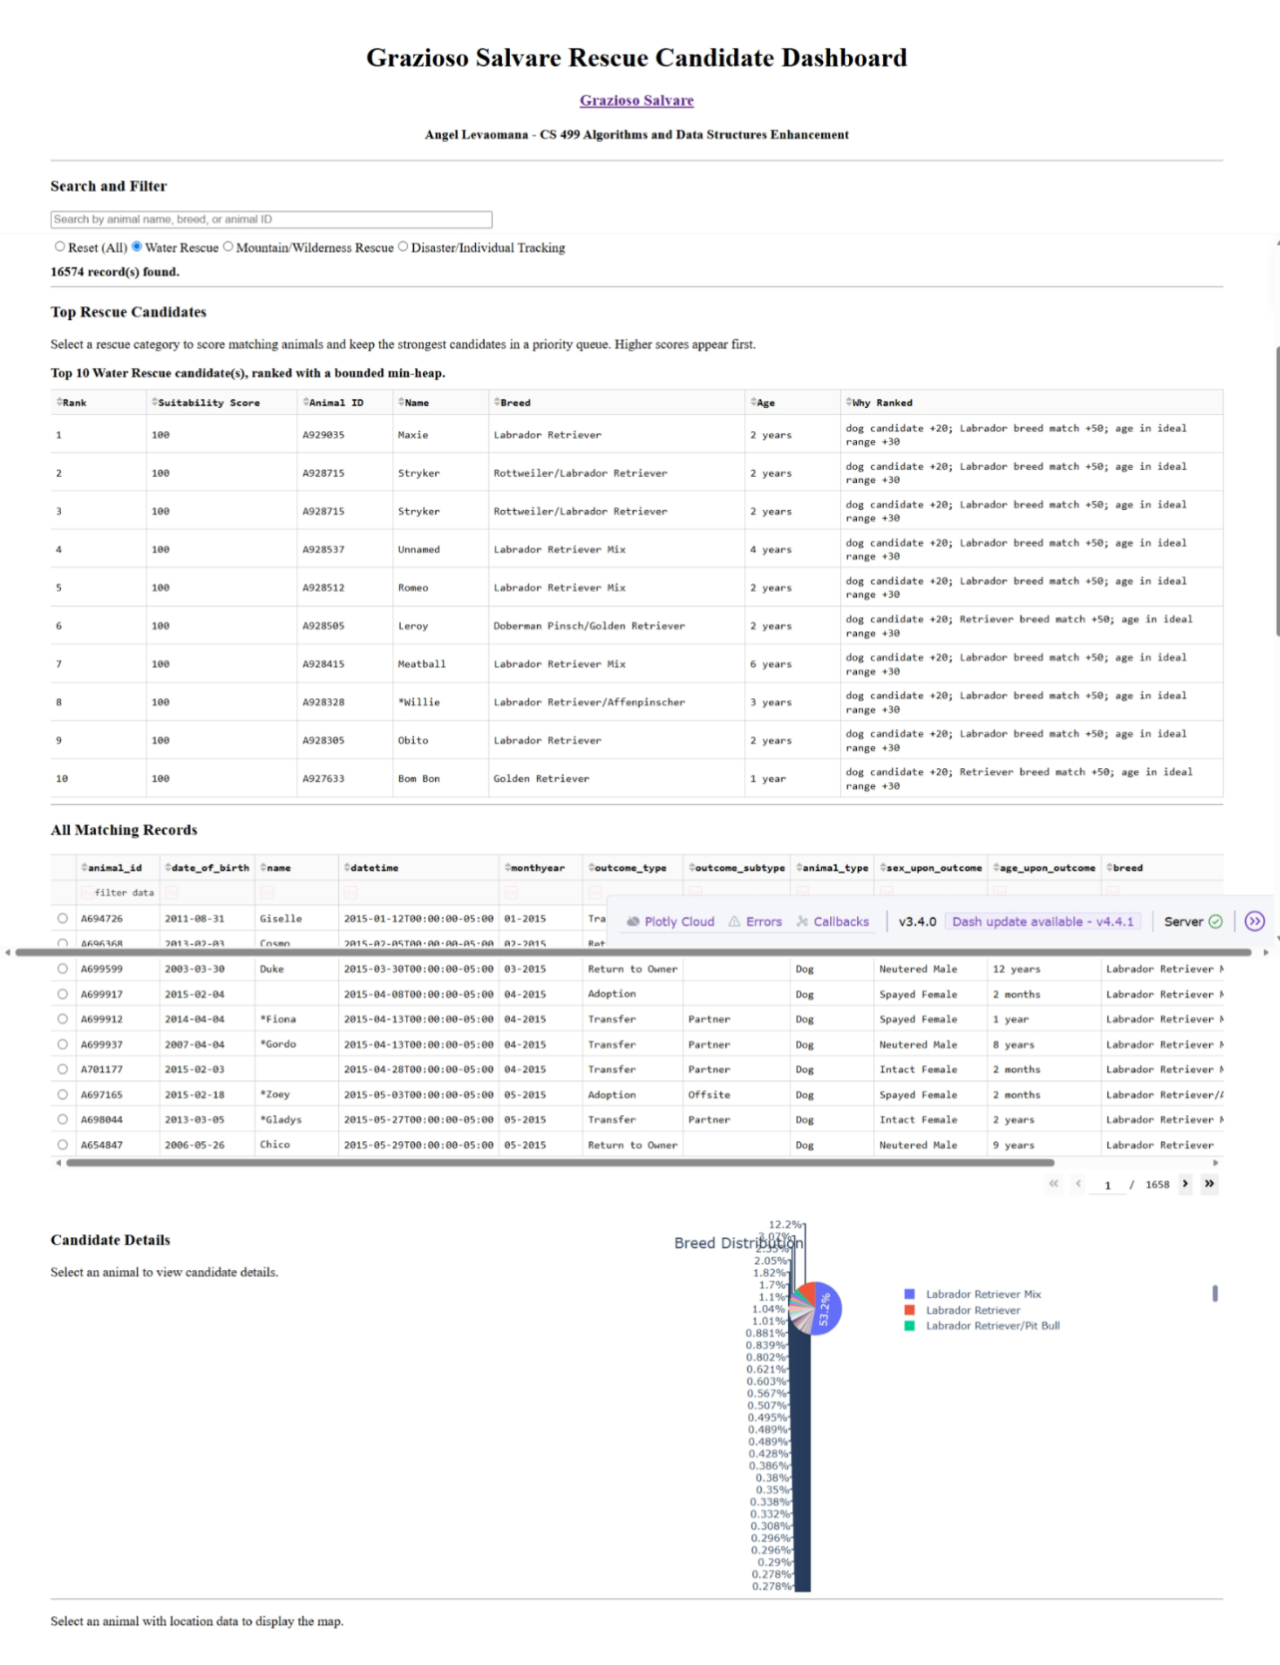
Figure 2. Automated pytest run showing all 16 tests passed successfully.
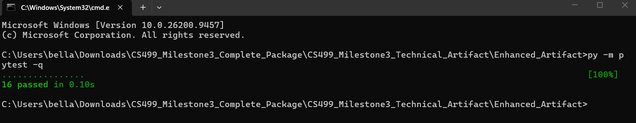

References
City of Austin. (2025). Austin Animal Center Outcomes (10/01/2013 to 05/05/2025) [Data set]. Austin Open Data.
Python Software Foundation. (n.d.). heapq — Heap queue algorithm. Python documentation.

