Angel Levaomana
10/15/2026
CS 499
Milestone Two: Software Design and Engineering
Artifact Description
The artifact I selected for the Software Design and Engineering category is my Grazioso Salvare Rescue Candidate Dashboard. I originally created this project in February 2026 for CS 340: Advanced Programming Concepts. The application uses Python, MongoDB, Dash, Pandas, Plotly Express, and Dash Leaflet to work with Austin Animal Center outcome data. Its purpose is to help users review animal records and identify possible candidates for different search-and-rescue categories.
The original version of the project worked, but most of the application logic was contained in one notebook-style implementation. Database connections, dashboard layout, filtering logic, callbacks, and other responsibilities were closely connected. This made the application more difficult to maintain, test, and expand.
For my Software Design and Engineering enhancement, I reorganized the project into a modular application with separate files for application startup, configuration, database access, services, layout generation, and callback handling. I also improved security, searching, error handling, candidate details, testing, and documentation.

Why I Included the Artifact and How It Was Improved
I included this artifact in my ePortfolio because it demonstrates how a working application can be improved through professional software engineering practices. The original dashboard already provided useful functionality, but the code structure made future changes more difficult than necessary.
One of the largest improvements was separating the application into smaller modules with clearly defined responsibilities. The enhanced version includes files such as app.py, config.py, database.py, services.py, layout.py, and callbacks.py.
The app.py file is responsible for starting the application. Configuration information is handled separately in config.py. Database access is contained in database.py, while reusable application logic is placed in services.py. The dashboard interface is created in layout.py, and interactive behavior is handled in callbacks.py.
This structure makes the application easier to understand because a developer does not have to search through one large file to find every feature. It also makes changes safer because one part of the application can be modified without unnecessarily affecting unrelated components.
Another important enhancement involved database credentials. In the original project, connection information was more closely connected to the source code. In the enhanced version, sensitive values such as the MongoDB username and password are stored in environment variables using a private .env file.
The actual .env file is excluded from the submitted project through .gitignore. I included an .env.example file so another developer can understand which values are required without exposing private credentials. This improvement demonstrates a stronger security mindset and makes the project more appropriate for a public ePortfolio.
I also improved the dashboard's search functionality. Users can search by animal name, breed, or animal ID. Search input is processed more safely, including escaping user-provided text before it is used in regular-expression searches. This reduces the chance that unexpected search characters will change the intended behavior of the query.
The enhanced dashboard also includes a Candidate Details section. When a user selects a record, the application displays useful information about that specific animal. This makes the interface easier to use because users can examine an individual candidate without searching through every column of the larger table.
I also improved how the application handles location information. Records with valid coordinates can still be displayed on the map, while records with incomplete or missing location information are handled without causing the dashboard to fail. Instead of crashing, the application provides a more understandable message.
Sorting, filtering, and pagination were also retained and improved so users can continue working with a large dataset without displaying every record at once.
Together, these enhancements changed the project from a working academic dashboard into a more organized, maintainable, testable, secure, and user-friendly application.
Course Outcome Progress
This enhancement helped me demonstrate several of the Computer Science program outcomes.
The modular design supports collaboration because another developer can understand where different responsibilities belong. Instead of every feature being located in one large file, the application is divided into components that could be reviewed or modified independently. This would make it easier for multiple developers to work on the same project.
The enhancement also demonstrates professional communication. The file organization, README documentation, understandable function names, user-facing messages, and written narrative explain how the application works. These details help both technical and nontechnical users understand the purpose of the project and the improvements that were made.
The enhancement also required me to evaluate software-design decisions and trade-offs. Separating the application into modules adds more files to the project, but the additional structure makes the code easier to maintain, test, and expand. I decided that this trade-off was worthwhile because the enhanced artifact is intended to demonstrate professional-quality software rather than only prove that the program runs.
I also used appropriate computing tools and techniques throughout the enhancement. The project uses Python, Dash, MongoDB, PyMongo, Pandas, Plotly, environment variables, and pytest. These tools work together to support a complete data-driven application.
Security was another important outcome. Database credentials were moved out of the source code, the private .env file was excluded from the technical artifact, search input was handled more safely, and database failures were converted into understandable messages rather than exposing unnecessary internal information.
Overall, I believe this enhancement strongly demonstrates professional communication, appropriate computing tools and techniques, and a security mindset. It also provides evidence of collaboration-ready design and software-engineering decision-making.
Reflection on the Enhancement Process
One of the biggest lessons I learned during this enhancement was that software can work correctly while still being difficult to maintain. When I originally completed the CS 340 project, my main goal was to make the dashboard function correctly. During the capstone, I had to look at the same project from a different perspective.
Instead of only asking whether the application worked, I began asking whether another developer could understand it, whether the code could be tested easily, whether new features could be added safely, and whether sensitive information was being handled appropriately.
Breaking the project into separate modules was one of the most useful improvements. It made the responsibilities of each part of the application clearer and gave me a stronger foundation for the later Algorithms and Data Structures and Database enhancements.
Another challenge occurred when I prepared the project to run again on my local computer. I had to recreate the local MongoDB environment and import the Austin Animal Center dataset. The restored database contained 173,775 records. This process reminded me that a program depends on more than source code. Configuration, database setup, environment variables, and external data are also important parts of making software reproducible.
I also had to correct the MongoDB user configuration so the application could connect securely through the environment variables. This reinforced why credentials and configuration should be separated from the source code.
Testing the application helped me identify whether the refactoring had accidentally changed existing behavior. After the enhancements, the dashboard successfully loaded the 173,775 records from MongoDB.
I tested the search feature with a specific animal ID and confirmed that it returned one matching result. I also verified that the Candidate Details section displayed information for selected records.
When I selected the Water Rescue filter, the dashboard returned 16,574 matching records, confirming that the rescue filtering functionality still worked after the application was reorganized.
I also tested records with missing location information to make sure the map feature handled them without causing the application to crash.
These tests showed me why refactoring should not only make code look cleaner. A successful refactor should improve the internal structure while preserving the useful behavior of the original application.
Incorporation of Instructor Feedback
The instructor feedback I received confirmed that the software-design enhancement represented meaningful progress and successfully addressed the goals of the milestone.
My instructor described the enhancement as a substantial refactoring of the Grazioso Salvare Dashboard and specifically recognized the transition from a single notebook-based implementation to a modular application architecture.
The feedback also recognized the clear separation of responsibilities between application startup, configuration, database access, services, layout generation, and callback handling. My instructor noted that this professional software-engineering approach improved maintainability, readability, scalability, and testability.
The feedback also connected to my earlier code review. My instructor recognized that my review went beyond simply describing the existing code and instead evaluated concerns involving maintainability, scalability, security, and usability.
Because the instructor feedback supported the design of the enhancement and did not identify corrective problems, I kept the modular architecture as the foundation for the final artifact. I focused my final review on maintaining the organization, testing, security improvements, documentation, and usability features that had already been successfully implemented.
This feedback helped confirm that the enhancement was not simply reorganizing files. The restructuring made the project easier to maintain and created a stronger foundation for the algorithms, data structures, and database improvements that followed in later milestones.
Verification and Testing
I created an automated pytest test suite to verify important application behavior without depending entirely on manual dashboard testing. For this enhancement, all 8 automated tests passed.
The tests helped verify important service and application logic after the project was reorganized. This provided additional confidence that separating the application into modules did not break the original functionality. I also manually verified the running dashboard with the restored local MongoDB dataset.
The dashboard successfully loaded 173,775 records. A specific animal-ID search returned the expected result, Candidate Details displayed information for a selected record, and the Water Rescue filter returned 16,574 matching records. I also confirmed that records without usable map coordinates were handled gracefully rather than causing the application to fail.
These results demonstrated that the enhanced version preserved the original capabilities while improving the overall design, maintainability, security, testability, and usability of the software.

Verification Evidence
Figure 1. Enhanced Grazioso Salvare Dashboard showing the Water Rescue filter and Candidate Details functionality.
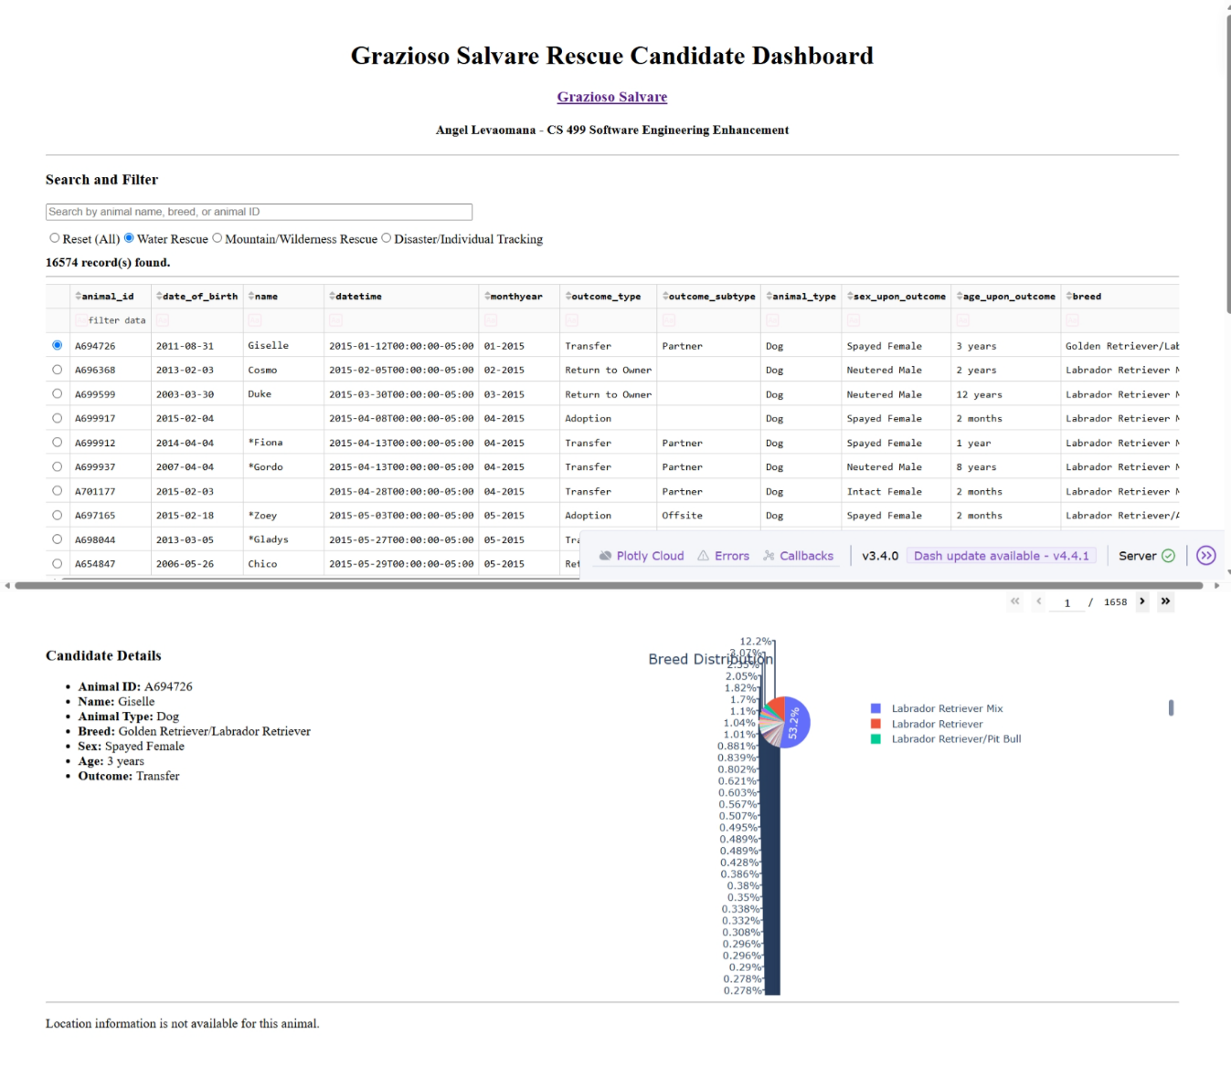Figure 2. Automated pytest results showing all eight Software Design and Engineering tests passed successfully.
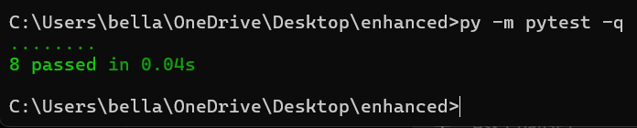
References
City of Austin. (2025). Austin Animal Center Outcomes (10/01/2013 to 05/05/2025) [Data set]. Austin Open Data.

