2012-11598 민두기

1.

eigenvalue = 0, 0.8377, 7.1623

corresponding eigenvector = [-0.4082, 0.8164, -0.4082], [-0.8863, -0.2475, 0.3913], [0.2185, 0.5216, 0.8247]

2-(a).

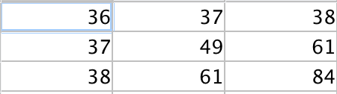M^T \* M =

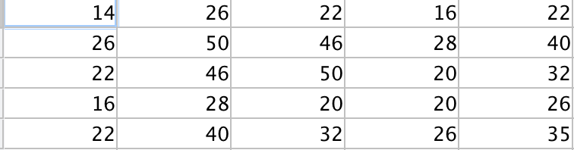M \* M^T =

2-(b), (c)

eigenvalue of M^T \* M = 0, 15.4330, 153.5670

corresponding eigenvector = [-0.4082, 0.8164, -0.4082], [-0.8160, -0.1259, 0.5642], [0.4093, 0.5635, 0.7176]

eigenvalue of M \* M^T = 0, 0, 0, 15.4330, 153.5670

corresponding eigenvector =

[0.819083117570684,

-0.513337242448826,

0.122896317849225,

-0.197871799165985,

0.106447020529668]

[-0.413250313398046,

-0.639057855441842,

0.397057464215007,

0.379546257878910,

0.345136558648537]

[-0.210720132769024,

0.0388285260098380,

-0.120762731511627,

-0.672483774673870,

0.698048212297649]

[0.159063930284883,

-0.0332003042935725,

-0.735856634020250,

0.510392095148222,

0.414259977858995]

[0.297695678025794,

0.570508561088987,

0.520742971163787,

0.322578472988394,

0.458984914519991]

2-(d).

M = U \* sigma \* V^T

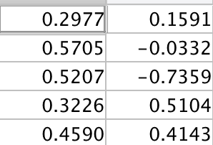U =

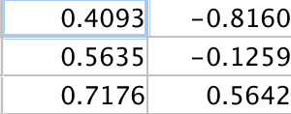V =

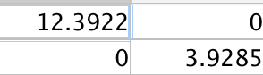Sigma =

2-(e).

M =

1.5099 2.0787 2.6474

2.8936 3.9836 5.0736

2.6412 3.6361 4.6310

1.6361 2.2524 2.8687

2.3279 3.2049 4.0818

2-(f)

original energy = 169

expectation matrix energy = 153.5670 retained.

3.

[1.7400 2.8400]

4.

There are only 3 independent row vector.

[1,1,1,0,0], [0,1,0,2,2], [0,0,0,5,5]

So the row vector space’s dimension is 3.

There are only 3 independent column vector too.

[1;3;4;5;0;0;0], [1;3;4;5;2;0;1], [0;0;0;4;5;2]

So the column vector space’s dimension is 3

So the rank of matrix is 3