2012-11598 민두기

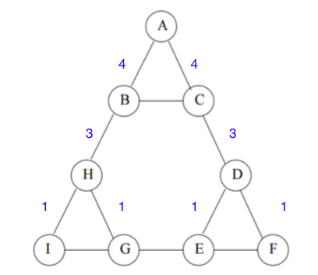1-(a).

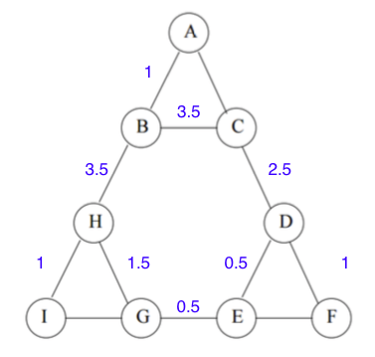1-(b).

2.

Using symmetry: AB = AC = DF = EF = HI = IG = 8/2 = 4

BC = HG = DE = 13/2 = 6.5

HB = CD = GE = 19/2 = 9.5

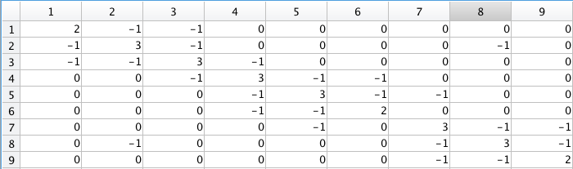3-(a).

3-(b)

second smallest eigenvalue is 0.6972. (choose first appeared)

corresponding eigen vector is

-0.267711462007941

-0.0690631920115511

-0.279704778634009

-0.307322695976124

-0.108674425979734

-0.319316012602192

0.376385887987675

0.388379204613743

0.587027474610133

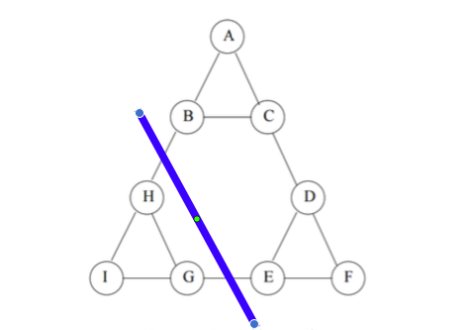split point is zero

4-(a).6

4-(b). none