**An UBIQUITOUS SMART DUMPSTER WITH USER INTERFACE IMPLEMENTED USING SENSORS AND ARDUINO UNO**

Himaja.K#1, Mounika.P#2, Rebecca.N#3, Yugandhari.B#4,Lavanya.K#5.

*Information Technology Department#1-4,Vidya Jyothi Institute of Technology#1-4.*

*Computer Science and Engineering#5,MLR Institute of Technology#5.*

[1iamhimaja@gmail.com](mailto:1iamhimaja@gmail.com)

[2mounikapolasani@gmail.com](mailto:2mounikapolasani@gmail.com)

[3nrebeccaaishwarya@gmail.com](mailto:3nrebeccaaishwarya@gmail.com)

[*4*byugandhari1@gmail.com](mailto:4byugandhari1@gmail.com)

[5lav.k.2496@gmail.com](mailto:5lav.k.2496@gmail.com)

*Abstract*— **In this growing world having a check on minute details in our vicinity is at task. However, they need to be acknowledged and problems need to be solved. The most diseases borne area in our vicinity is an open garbage bin. Though we find garbage bins in every nook and corner of the city that maintain the city clean, the question is how well they are maintained, how quickly they are emptied, when full. This can be successfully achieved through Internet of Things(IoT) in an economical and an efficient way. In this paper we present a simple yet efficient IoT based solution –‘The Smart Dumpster’ to the problem faced by overflowing of a garbage bin. The proposed solution automates the garbage bin when full, which will inhibit the diseases spreading from an overflowing garbage bin. The paper also discusses the flaws in the existing IoT based dumpsters and an easy fix for them. The possible enhancements are as well discussed to extend the proposed prototype. The proposed solution is designed to replace the municipal bins.**

***Keywords***—**Internet of Things, Arduino, Push Button, Automated Garbage Bin, Municipal bins.**

1. Introduction

IoT-Internet of Things is an interconnection of multiple devices which serve a great purpose that are controlled by a microcontroller which is programmed by a programmer. IoT makes automation a cake walk. Though different sensors individually serve different purpose, a combination of different sensors that work together give a different yet an efficient output. Arduino is an open-source electronics platform, based on easy-to-use hardware and software. Arduino is a microcontroller with 14 digital pins that can read digital data and 6 analog pins that can read analog data. Arduino IDE is a software required to program Arduino boards. The Arduino software is chosen over other software for its efficiency, simplicity and availability of multiple drivers.

1. Related work

Every city has become health conscious and smart, as well with the invent of smart cities from the early 2016s

The implementation of smart cities started with making municipal dumpsters smart. The solution proposed in this paper was shaped after scanning a few existing smart dumpsters.

1. In [1],the idea of smart trash bins was implemented with the use of an ultrasonic sensor which sends readings to the municipal server which alerts the employees to clean the garbage as early as possible to avoid an unpleasant look of the city. However, the authors did not throw light on the size of the dumpster, their proposed system may fail when dumpster is way too wide and when the ultrasonic sensor fails to give accurate reading because of garbage accumulating only on one side of the bin which is freely accessible to public. The solution proposed in our paper uses 2 IR sensors that are diagonally positioned to avoid such inaccuracy, the sensors are not only diagonally placed but they are also programmed in such a way that the complete smart system activates only when both of them read "HIGH" or encounter an opaque body at one moment of time, this will make sure that the bin is completely full from all sides before it sends a reading or notification to the control room.
2. Meanwhile the authors in [2] have given a very profound solution to help Swachh Bharat, by setting up a smart dumpster with an ultrasonic sensor, a few LEDs to detect the level of the dumpster. When the dumpster crosses the threshold value the system sends the data to concerned authority via GSM ,the system also segregates the wet and dry waste with the help of a moisture sensor and a load sensor was used to send the weight of the garbage in the bin. The segregation concept was systematic but least light was thrown on emptying of the bin in a systematic way. The authors nowhere mentioned a systematic way of emptying such organised dumpster whereas the solution in our paper uses a way which is as easy as pushing a button. The dumpster must be lifted onto the collection truck with the help of a crane and a button which is installed near the bottom of the dumpster must be pressed which will open the lid in the bottom of the dumpster allowing the garbage to shift from bin to truck effortlessly.

1. We also came across an innovative smart dumpster by the author in [3],which had an ultrasonic sensor on the top of a bin which will detect the level of the bin with the help of a simple formula and update it to the blynk app which will send the notification to the authorities saying that the bin needs to be emptied. This was a simple yet convenient solution, but no solution was mentioned to solve the problem of air borne diseases or odour that spread from an overflowing garbage before it is emptied. The author also doesn't seem to consider the case in which the opening of the bin is high and did not us any methodology to notify the people around the bin about bin being full which will lead people to continuously dump the garbage even when the bin is full. Whereas in our proposed solution we installed a servo motor that controls the lid on the top of the dumpster. When the dumpster is full the lid automatically falls stopping people from throwing the garbage into a full bin and inhibiting the spread of viral diseases. We also installed a GUI ,an LCD in front of the dumpster which displays a message saying the "Bin is full" to notify the inhibits, this GUI will be of great help if the garbage bins are very high not allowing the passer-by to peep into them. LEDs are installed on all the free sides of the bin to help the uneducated to understand that the bin is full.
2. In [4],the authors gave a vigilant idea about the implementation of IoT for urban development which triggered our thought of implementing IoT to make a Smart Dumpster to solve the problems caused by an ordinary municipal garbage bins.
3. The authors in [5], were very keen and observant in their motto of giving the readers a complete and vivid understanding of Internet of Things. We used this as a reference to understand IoT in a better and efficient way.
4. The Smart Dumpster
5. *Components used*
6. *Arduino UNO:* It is a microcontroller programmable by Arduino IDE, an open source software that uses embedded C programming language. Arduino UNO is the vital part of any IoT project. The proposed solution uses one Arduino UNO.
7. *Push Button:* It is a simple switch which controls the action of a device when clicked on. The proposed solution uses one Push Button.
8. *Servo motors:* A servo motor is a component used for precise control of position, velocity and acceleration. Its functionality depends on how the gears in it are programmed to rotate by the programmer. The proposed solution uses two servo motors. One controlling the lid on the top of the garbage bin and the other controlling the lid on the bottom of the garbage bin.
9. *IR Sensors:* An infrared sensor is used to sense obstacle in its horizontal vicinity. The proposed solution uses two IR sensors positioned diagonal to each other at the brim of the dumpster.
10. *Buzzer:* A buzzer is an electronic device that gives sound as an output for a triggered event. The proposed solution uses a buzzer located in the nearby garbage monitoring room to notify the garbage collectors about the bin being full.
11. *LCD:* Liquid Crystal Display is a flat panel display that uses the light modulating properties of liquid crystals. The proposed solution uses an LCD positioned in front of the dumpster to notify the passer-by whether the bin is full or empty.
12. *LED*:A light-emitting diode is a p-n junction diode that emits light when activated using the principle of electroluminescence. The proposed solution uses three LEDs, one in front and one each to the right and left of the dumpster.
13. *Jumper wires:* Jumper wires are wires used to connect two physical devices with the help of connect pins at each end. Jumper wires help us avoid soldering. There are 3 types of jumper wires: male to male, female to female and male to female. The jumper wires in the proposed solution were used as per the requirement.
14. *Working:* When the garbage bin is empty i.e. when the garbage in the bin is not filled to the brim, the LCD in the front of the bin will display the message “Bin is empty” notifying the passer-by that there is place for more garbage in the bin. The LEDs around the bin will be in OFF state making it easy for an uneducated to understand that the bin is not yet full. Once the bin is full i.e. when both the IR sensors that are diagonally positioned at the brim of the bin read HIGH detecting the garbage in its horizontal vicinity, the lid on the top of the garbage bin falls automatically and the LEDs around the bin glow. The message on the LCD changes to “Bin is full”. The buzzer placed in the control room buzzes. When the garbage bin needs to be emptied, the garbage collectors lift the bin over the collection truck with a crane and press the push button, that is near the bottom of the bin, which will automatically open the lid in the bottom and the garbage falls into the collection bin. As soon as the bin is emptied all the components will get back to their initial state, the LCD will display the message “Bin is empty”, the LEDs will not glow, the lid on the top opens and the buzzer in the control room goes off.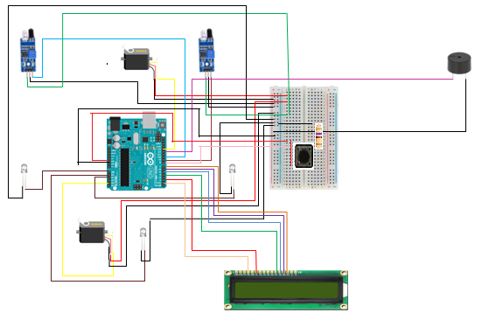

Figure :Schematic Diagram of the prototype.

1. The Figure 2 shows the work flow of the proposed solution. Explaining all the cases in a powerful manner.

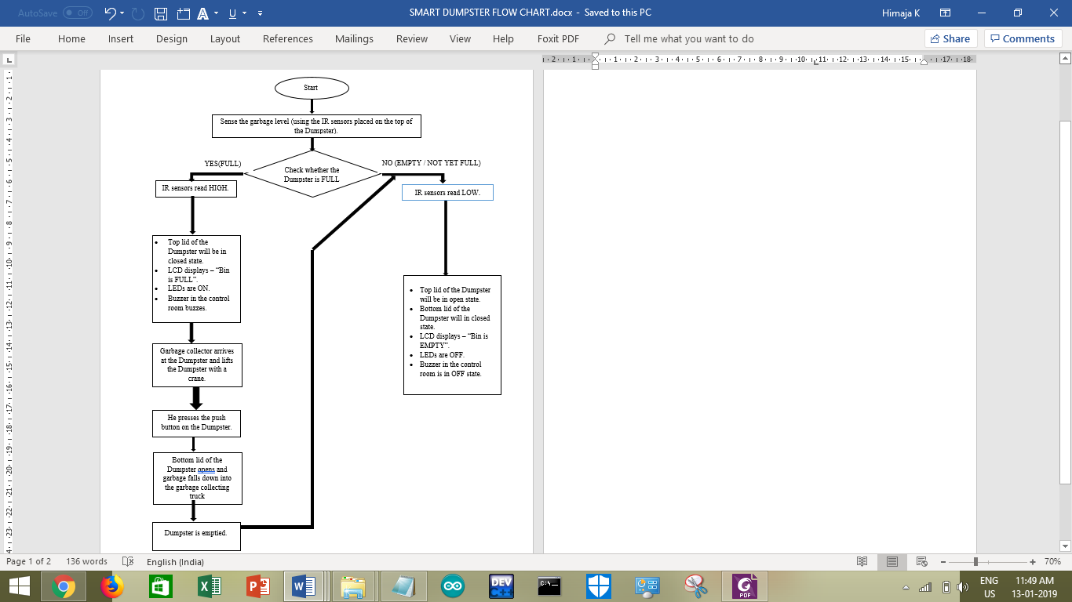

Figure :Work flow of the proposed solution.

1. *Further Enhancements*
2. The Smart Dumpster can be connected to the buzzer in the control room using internet protocols rather than jumper wires.
3. An app can be developed to monitor multiple garbage bins in an area.
4. Garbage segregator can be developed that can segregate the garbage ,dumped in the bin, as recyclable and non-recyclable.
5. Cloud can be maintained to store the reading of the IR sensors, frequently that will make it easier to analysis how quickly a bin is filling so that another bin can be installed in its vicinity.
6. Conclusions

There are many petit things that need to be corrected to maintain a healthy life style. One of which is garbage bins. The heavy garbage bins at the end of the street or in a gated community produce much more diseases than estimated. The proposed solution ‘Smart Dumpster’ provides a simple yet efficient solution to overcome the problems and issues faced. A hygienic environment is much more important than a hygienic lifestyle because environment is what makes us feel comfortable.

V.References

1. Shamlee Rashinkar , Sneha Ghatole , Swati Kadapatti , Varsha Yadave ,Chaitanya Jambotkar , *IoT Based Smart Trash Bins – A Step Toward Smart City,* Department of Electrical and Electronics Engineering, KLE.I.T, Hubli, Karnataka, India. Submitted in December 2017.
2. Janaki.S,Nanthini.N, Yamini.S, *Internet of Things [IoT]Based Smart Garbage Monitoring and Clearance System*

Department of Electronics and communication Engineering,Vel Tech, Avadi - Alamathi Road,Avadi, Tamil Nadu, India.Submitted in March 2017.

1. Anitha A,*Garbage monitoring system using IoT ,*School of Information Technology and Engineering, VIT University, Vellore 632014, Tamil Nadu, India Submitted in 2017.
2. A. Zanella, N. Bui, A. P. Castellani, L. Vangelista, and M. Zorzi, *Internet of Things for smart cities*, IEEE Internet Things J., vol. 1, no. 1, pp. 22–32. Submitted in February 2014.
3. Somayya Madakam, R. Ramaswamy, Siddharth Tripathi, *Internet of Things (IoT): A Literature Review,* IT Applications Group, National Institute of Industrial Engineering (NITIE), Vihar Lake, Mumbai, India. Submitted in April 2015.
4. Sagnik Kanta,Srinjoy Jash,Himadri Nath Saha, *Internet of Things based garbage monitoring system*,University of Engineering and Management,Kolkata,India.Published in 2017 8th Annual Industrial Automation and Electromechanical Engineering Conference (IEMECON).