**Using FSL to slice time correct files called f.nii.gz** (of raw dicom data)

7/25/17

Command line: fsl

On Gui:

* Click ‘FEAT FMRI analysis‘

On FEAT - FMRI Expert Analysis Tool GUI

* Top two buttons: set to
  + ‘First-level analysis’
  + ‘Pre-stats’
* Misc Tab (leave untouched):

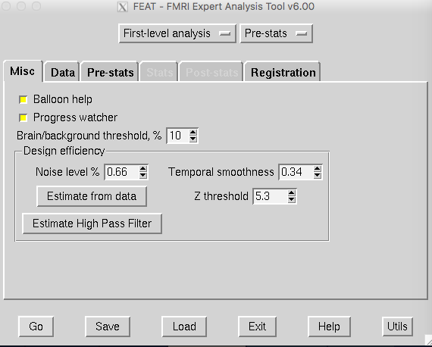

* Data tab
  + Select 4D data as the .nii.gz file (f.nii.gz)
    - As a result, the Total volumes and TR (s) blanks should automatically update based on the .nii.gz header

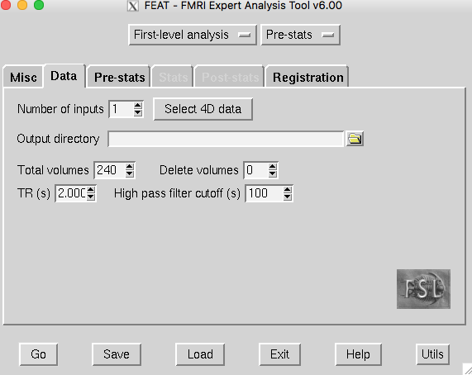

* Pre-stats tab
  + Uncheck everything, set everything to 0 except:
  + Slice timing correction - select use slice timings file & the corresponding path
  + Note: the slice timings file was generated from the code slicedelay
    - Use the code slicedelay via:

**Slice time correction**

Command for creating slicetimer custom delay file called slicedelayfile:

cd to /Jess/V1_REST_STUDY

./slicedelay --o slicedelayfile --nslices 64 --order even --ngroups 2

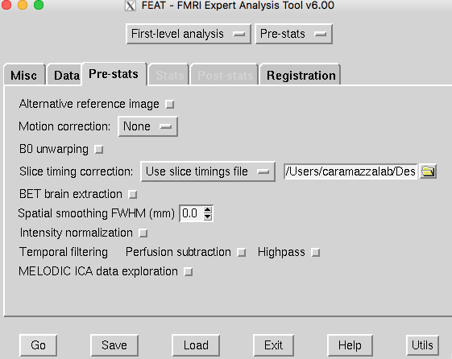

* Registration tab
  + Uncheck everything

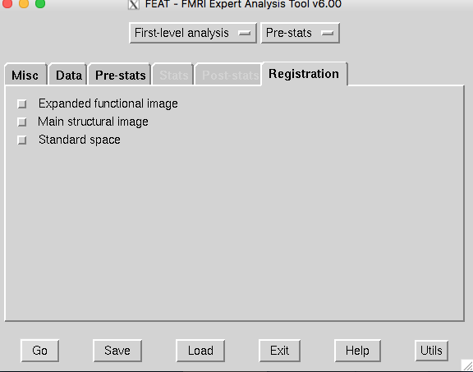

4D data to load:

[x] = running

[xx] = ran and checked

[xx] /Users/caramazzalab/Desktop/Jess/V1_REST_STUDY/dicomdir/B101/bold/001/f.nii.gz

[xx] /Users/caramazzalab/Desktop/Jess/V1_REST_STUDY/dicomdir/B102/bold/001/f.nii.gz

[xx] /Users/caramazzalab/Desktop/Jess/V1_REST_STUDY/dicomdir/B103/bold/001/f.nii.gz

[xx] /Users/caramazzalab/Desktop/Jess/V1_REST_STUDY/dicomdir/B104_1/bold/001/f.nii.gz

[xx] /Users/caramazzalab/Desktop/Jess/V1_REST_STUDY/dicomdir/B104_2/bold/001/f.nii.gz

[xx] /Users/caramazzalab/Desktop/Jess/V1_REST_STUDY/dicomdir/B105/bold/001/f.nii.gz

[xx] /Users/caramazzalab/Desktop/Jess/V1_REST_STUDY/dicomdir/B106/bold/001/f.nii.gz

[xx] /Users/caramazzalab/Desktop/Jess/V1_REST_STUDY/dicomdir/B107/bold/001/f.nii.gz

[xx] /Users/caramazzalab/Desktop/Jess/V1_REST_STUDY/dicomdir/B108/bold/001/f.nii.gz

[xx] /Users/caramazzalab/Desktop/Jess/V1_REST_STUDY/dicomdir/B109/bold/001/f.nii.gz

[xx] /Users/caramazzalab/Desktop/Jess/V1_REST_STUDY/dicomdir/B110/bold/001/f.nii.gz

[xx] /Users/caramazzalab/Desktop/Jess/V1_REST_STUDY/dicomdir/B111/bold/001/f.nii.gz

[xx] /Users/caramazzalab/Desktop/Jess/V1_REST_STUDY/dicomdir/B112/bold/001/f.nii.gz

[xx] /Users/caramazzalab/Desktop/Jess/V1_REST_STUDY/dicomdir/S201/bold/001/f.nii.gz

[xx] /Users/caramazzalab/Desktop/Jess/V1_REST_STUDY/dicomdir/S203/bold/001/f.nii.gz

[xx] /Users/caramazzalab/Desktop/Jess/V1_REST_STUDY/dicomdir/S204/bold/001/f.nii.gz

[xx] /Users/caramazzalab/Desktop/Jess/V1_REST_STUDY/dicomdir/S205/bold/001/f.nii.gz

[xx] /Users/caramazzalab/Desktop/Jess/V1_REST_STUDY/dicomdir/S206/bold/001/f.nii.gz

[xx] /Users/caramazzalab/Desktop/Jess/V1_REST_STUDY/dicomdir/S207/bold/001/f.nii.gz

[xx] /Users/caramazzalab/Desktop/Jess/V1_REST_STUDY/dicomdir/S208/bold/001/f.nii.gz

[xx] /Users/caramazzalab/Desktop/Jess/V1_REST_STUDY/dicomdir/S209/bold/001/f.nii.gz

[xx] /Users/caramazzalab/Desktop/Jess/V1_REST_STUDY/dicomdir/S212/bold/001/f.nii.gz

[xx] /Users/caramazzalab/Desktop/Jess/V1_REST_STUDY/dicomdir/S213/bold/001/f.nii.gz

[xx] /Users/caramazzalab/Desktop/Jess/V1_REST_STUDY/dicomdir/S214/bold/001/f.nii.gz

[xx] /Users/caramazzalab/Desktop/Jess/V1_REST_STUDY/dicomdir/S215/bold/001/f.nii.gz

[xx] /Users/caramazzalab/Desktop/Jess/V1_REST_STUDY/dicomdir/S216/bold/001/f.nii.gz

What does this script produce? What files?

**Using freesurfer mri_info to check the contents of files created**

I can use mri_info in freesurfer too

Orig (f.nii.gz): 112 112 64 240

example_func: 112 112 64 1

mean_func: 112 112 64 1

**filtered_func_data**: 112 112 64 240

mask: 112 112 64 1

Realization: the data that has been processed is:

/Users/caramazzalab/Desktop/Jess/V1_REST_STUDY/dicomdir/B102/bold/001/f.feat/**filtered_func_data.nii.gz**