<https://www.facebook.com/groups/ProgramersDevelopers/posts/4260587977336741>

<https://github.com/joserodny/evacuationcenter>

**Login Form**

**Admin Dashboard**

* Number of Family/household
* Number of Evacuees
* Number of Male
* Number of Female

**Type of Calamity**

* Name – typhoon, flood, earthquake

**Barangay Information**

* Barangay name

**Evacuation Center**

* Name
* Address
* Contact Info

**Evacuee Information**

* Lastname
* Firstname
* Middle Initial
* Contact
* Age
* Gender
* Brgy
* Complete Address
* Head of Family – checkbox
* Evacuation Center

**LGU Settings**

* City
* Contact Info
* Email Address
* Website
* Facebook page

**User Accounts**

* Username
* Password
* Fullname
* Designation
* Contact Info
* Account Category – encoder, admin
* Account Status – active, inactive

Reports

**List of Evacuees**

|  |  |  |
| --- | --- | --- |
| Name | Brgy | Age |
| 1. John Doe | Brgy 1 | 45 |

**List of Evacuees by Gender**

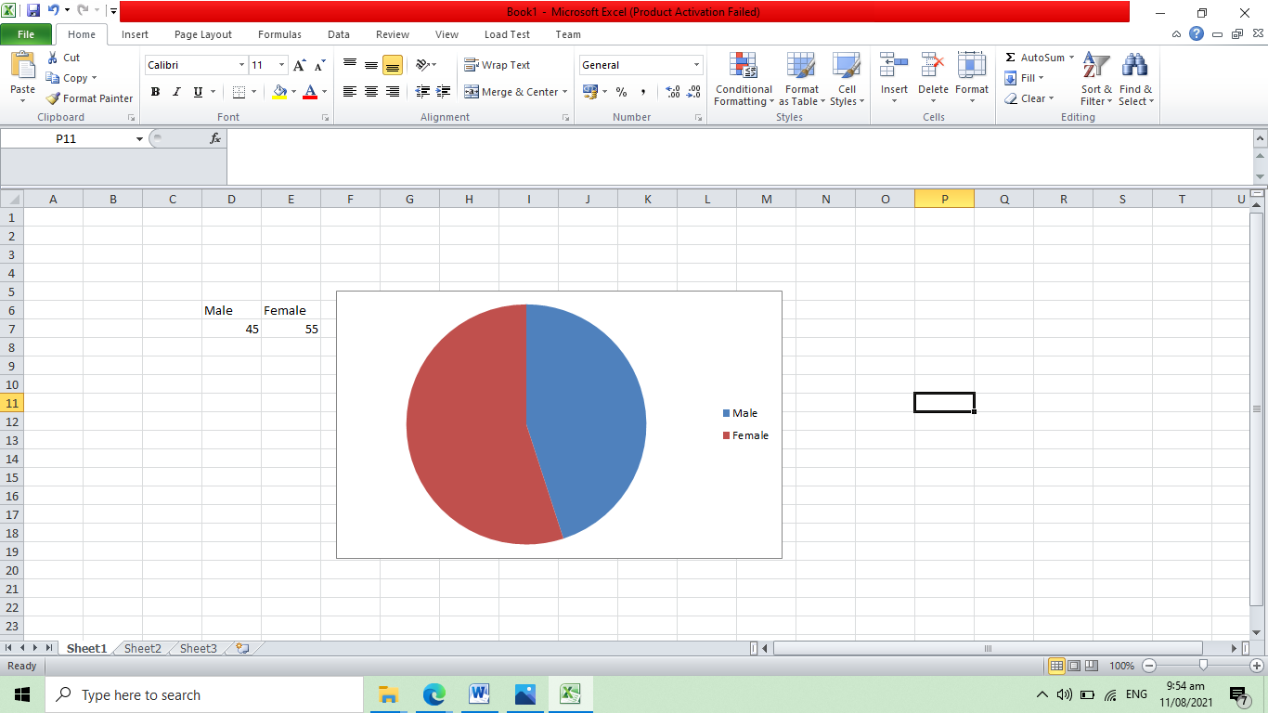

**Number of Evacuees by Brgy**

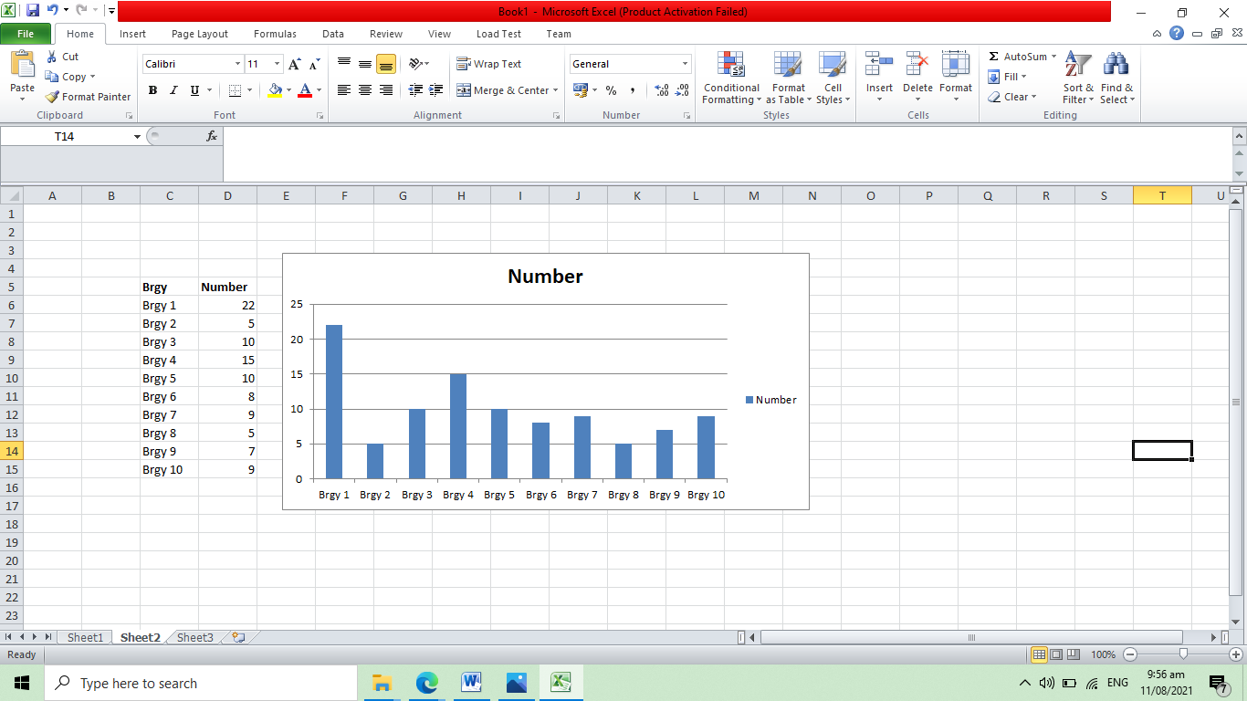

**Number of Evacuees by Age Bracket**

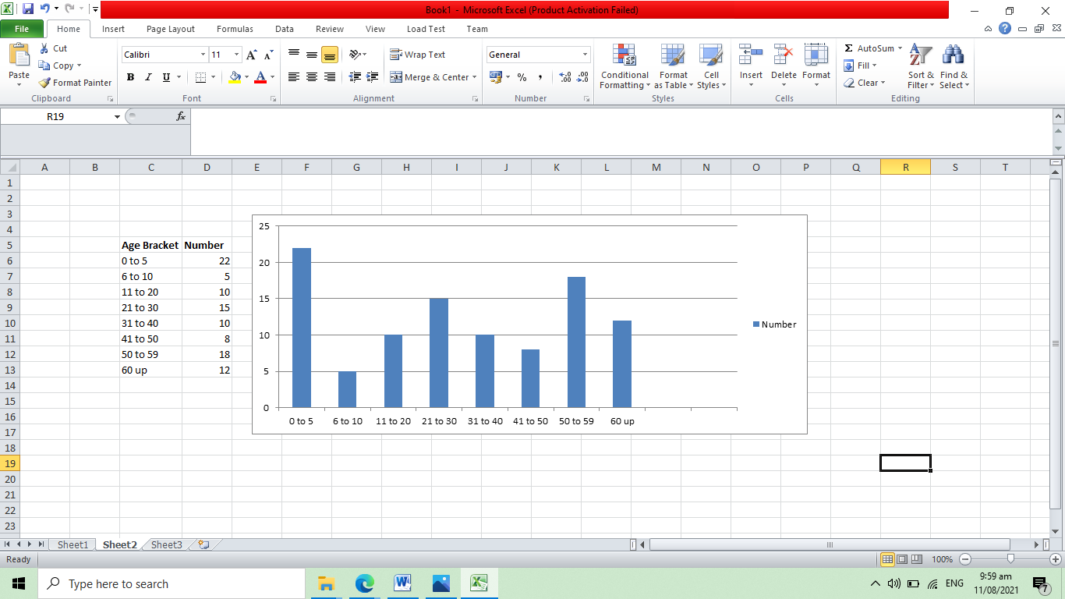

**Number of Evacuees by Calamity**

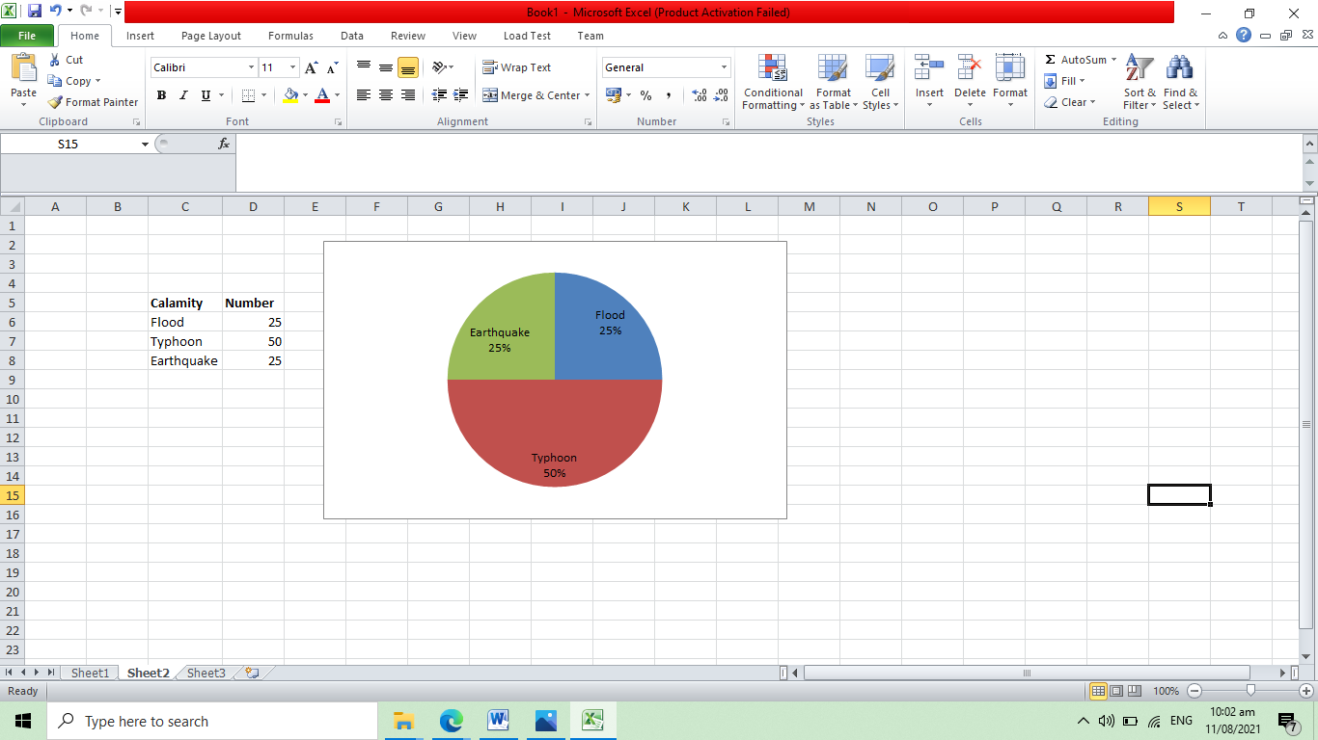

**Number of Evacuees by Center**

