Write a program to this spec: (do it the way I say unless you ask and get approval for doing it another way. I have added yellow to highlight requirements. Reading “requirements” carefully and accurately is an important software engineering skill. You will lose points if you don’t follow each word in this assignment.

[1] Ask user to enter 3 words using a loop with prompts, store each word in an array. Assume they entered these 3 words

apple

grape

banana

Have one html section that displays those 3 words from the array after the person enters them using an unordered list <ul> and <li>’s

[2] Have a new button that is only visible when the 3 words are showing. The result of the button event should cause that "page" (section) to be replaced with a new "page" (section) which shows the words from a new array that have been transformed. The words in the array for the second page should be the same words from the first array where the last and first letters are swapped. So using my example words, the 2nd array would contain:

eppla

erapg

aananb

Use the array.map capability to create a 2nd array from the first

This code might help you swap the first and last letters:

oneWord.charAt(oneWord.length - 1) + oneWord.substring(1, oneWord.length - 1) + oneWord.charAt(0); });

Do this "page swapping" by having 2 HTML sections, hiding one, showing the other, and then showing the one and hiding the other (see the Swap2PartOf1Page program we went over in class).

Now make sure each of the 2 sections (pages) have unique and quite distinctive CSS, including at least 2 features from this list. (But don’t repeat the same feature on the 2nd page. It would, for example, be ok to have a gradient on the first and second page, as long as they were different gradients, as in my example below).

* Backgrounds
* Gradients
* Shadows
* MouseOvers
* Transitions
* Fonts

Make sure you test using my 3 words, since that is how I will test it.

Below shows my running version. Yours does not have to look exactly the same, just follow the requirements above.

**Program as loaded**

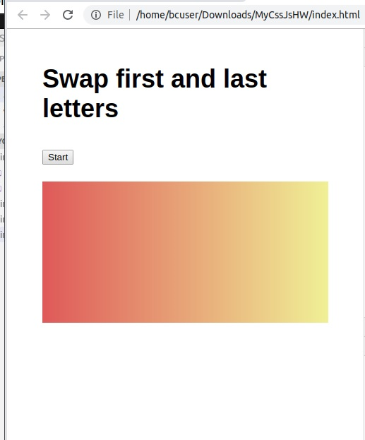

**Pop up comes up 3 times to gather 3 words**

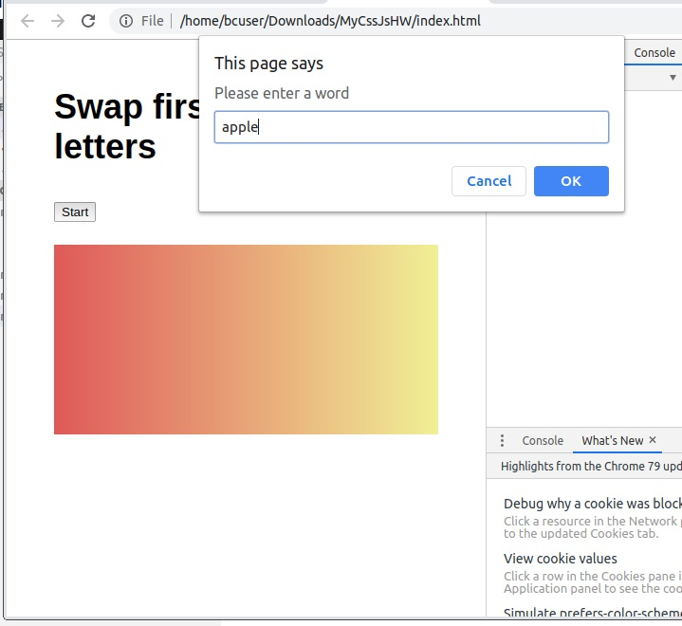

**After entering 3 words, they are listed in <ul> and a button is now visable**

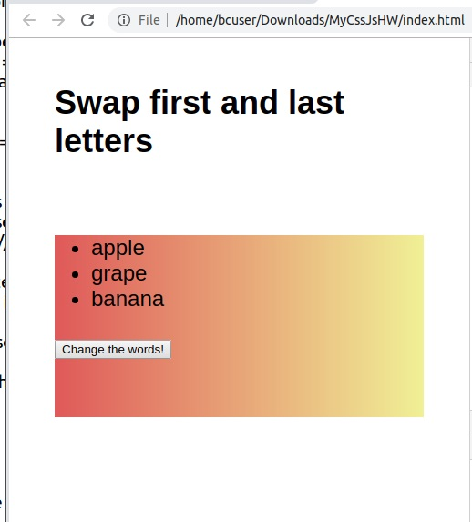

**After clicking change button, a new background, with swapped letters is displayed, with a different font.**

