Assignment 04

Nosky, Christopher

1/10/2021

# Markdown Basics

## Favorite Foods

1. Brisket
2. Pizza
3. Bacon

## Images

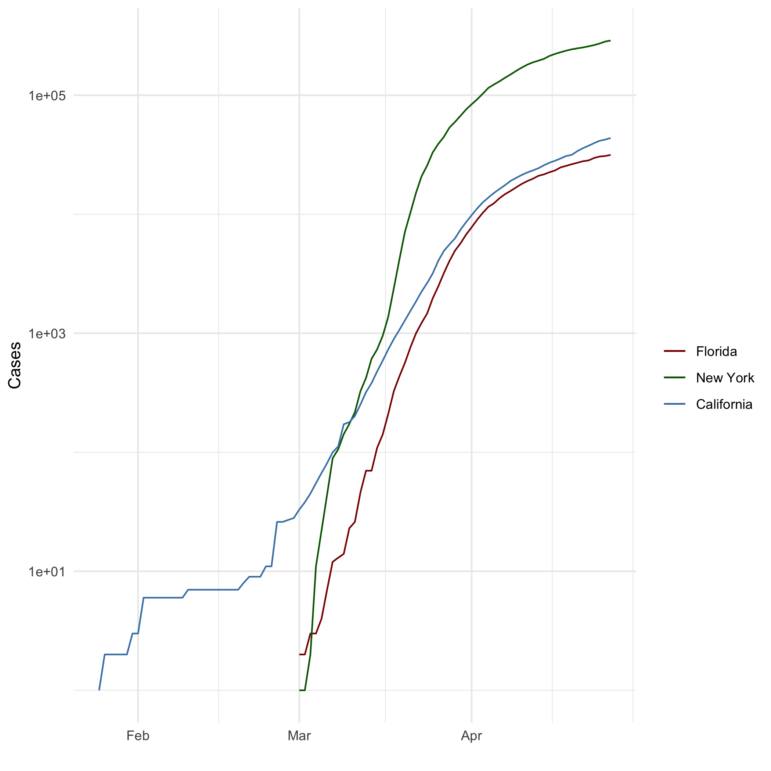

All Cases (Log Plot)

## Add a Quote

### *“Be yourself; everyone else is already taken.”* *Oscar Wilde*

## Add an Equation

$E=mc^{2}$

##### 

## Add a Footnote

A footnote you say?,[1] and since I didn’t know which is preferred.[2]

## Add Citations

* R for Everyone (see Lander 2014)
* Discovering Statistics Using R (see Field, Miles, and Field 2012)

# Inline Code

## NY Times COVID-19 Data

## Warning: package 'ggplot2' was built under R version 4.0.3

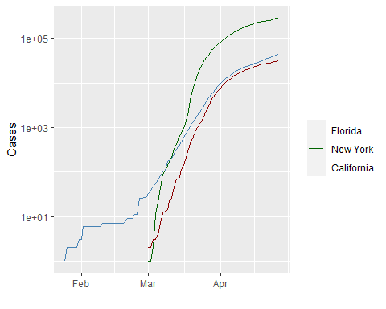

## R4DS Height vs Earnings

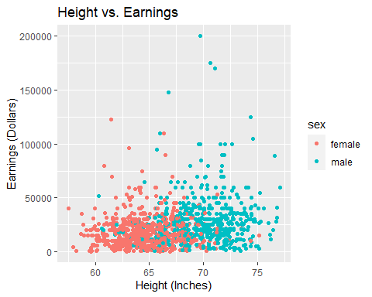

# Tables

## Knitr Table with Kable

One Ring to Rule Them All

|  |  |  |  |  |
| --- | --- | --- | --- | --- |
| name | race | in_fellowship | ring_bearer | age |
| Aragon | Men | TRUE | FALSE | 88 |
| Bilbo | Hobbit | FALSE | TRUE | 129 |
| Frodo | Hobbit | TRUE | TRUE | 51 |
| Galadriel | Elf | FALSE | FALSE | 7000 |
| Sam | Hobbit | TRUE | TRUE | 36 |
| Gandalf | Maia | TRUE | TRUE | 2019 |
| Legolas | Elf | TRUE | FALSE | 2931 |
| Sauron | Maia | FALSE | TRUE | 7052 |
| Gollum | Hobbit | FALSE | TRUE | 589 |

## Pandoc Table

Name Race In Fellowship? Is Ring Bearer? Age   
----- ------- --------------- ---------------- ------  
Aragon Men Yes No 88  
Bilbo Hobbit No Yes 129  
Frodo Hobbit Yes Yes 51  
Sam Hobbit Yes Yes 36  
Sauron Maia No Yes 7052

# References

Field, A., J. Miles, and Z. Field. 2012. *Discovering Statistics Using R*. SAGE Publications. <https://books.google.com/books?id=wd2K2zC3swIC>.

Lander, J. P. 2014. *R for Everyone: Advanced Analytics and Graphics*. Addison-Wesley Data and Analytics Series. Addison-Wesley. <https://books.google.com/books?id=3eBVAgAAQBAJ>.

1. Where would I get an idea like that.
2. Both examples of a footnote, choose which works best for you.

   You can also indent paragraphs and code to include them in the footnote.

   { my code }

   Add as many paragraphs as you like.