ASSIGNMENT 4

Brett Sutow

2020-09-24

# Markdown Basics

## Favorite Foods

1. Burger
2. Steak
3. Onion Rings

## Images

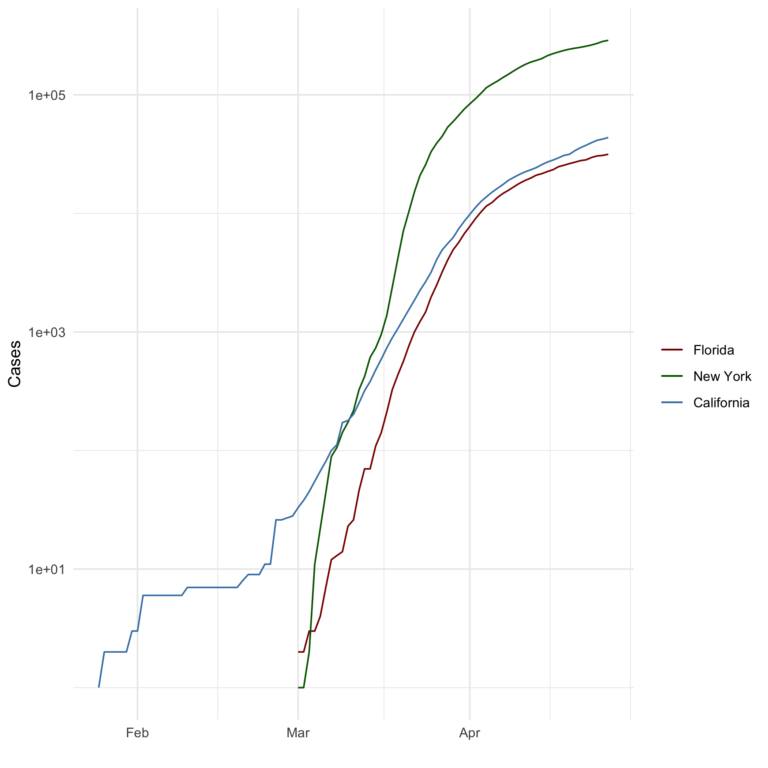

All Cases (Log Plot)

## Add a Quote

I have no idea what I’m doing. But I know I’m doing it really, really well.

## Add an Equation

$$10+10$$

## Add a Footnote

Footnote[1]

## Add Citations

* R for Everyone(Lander 2014)
* Discovering Statistics Using R(Field, Miles, and Field 2012)

# Inline Code

## NY Times COVID-19 Data

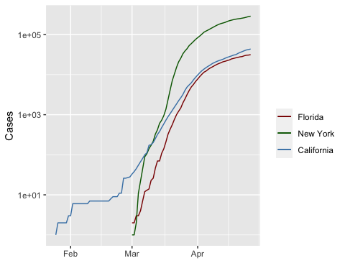

## R4DS Height vs Earnings

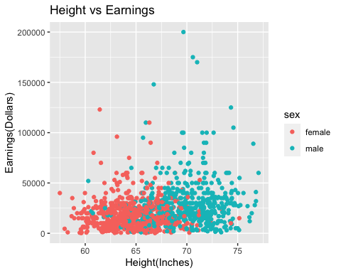

# Tables

## Knitr Table with Kable

One Ring to Rule Them All

|  |  |  |  |  |
| --- | --- | --- | --- | --- |
| name | race | in_fellowship | ring_bearer | age |
| Aragon | Men | TRUE | FALSE | 88 |
| Bilbo | Hobbit | FALSE | TRUE | 129 |
| Frodo | Hobbit | TRUE | TRUE | 51 |
| Galadriel | Elf | FALSE | FALSE | 7000 |
| Sam | Hobbit | TRUE | TRUE | 36 |
| Gandalf | Maia | TRUE | TRUE | 2019 |
| Legolas | Elf | TRUE | FALSE | 2931 |
| Sauron | Maia | FALSE | TRUE | 7052 |
| Gollum | Hobbit | FALSE | TRUE | 589 |

## Pandoc Table

One Ring to Rule Them All

|  |  |  |  |  |
| --- | --- | --- | --- | --- |
| Name | Race | In Fellowship? | Is Ring Bearer? | Age |
| Aragon | Men | TRUE | FALSE | 88 |
| Bilbo | Hobbit | FALSE | TRUE | 129 |
| Frodo | Hobbit | TRUE | TRUE | 51 |
| Galadriel | Elf | FALSE | FALSE | 7000 |
| Sam | Hobbit | TRUE | TRUE | 36 |
| Gandalf | Maia | TRUE | TRUE | 2019 |
| Legolas | Elf | TRUE | FALSE | 2931 |
| Sauron | Maia | FALSE | TRUE | 7052 |
| Gollum | Hobbit | FALSE | TRUE | 589 |

# References

Field, A., Miles, J., & Field, Z. (2012). Discovering Statistics Using R (1st ed.). SAGE Publications Ltd.

Lander, J. (2017). R for Everyone: Advanced Analytics and Graphics (Addison-Wesley Data & Analytics Series) (2nd ed.). Addison-Wesley Professional.

1. This is a footnote for the assignment