ASSIGNMENT 4

Abhijit Mandal

2020-09-26

# Markdown Basics

## Favorite Foods

1. Paste  
2. Noodles  
3. Pizza

## Images

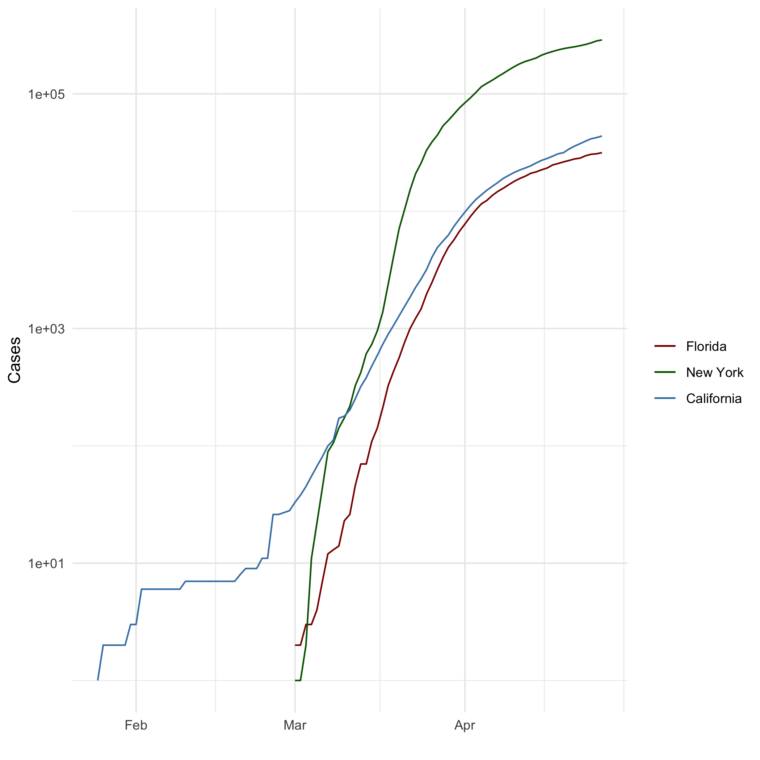

‘All Cases (Log Plot)’

## Add a Quote

The secret of getting ahead is getting started. The secret of getting started is breaking your complex overwhelming tasks into small manageable tasks, and then starting on the first one.

## Add an Equation

$$s2=Σ(xi–x_{b}ar)2/(n–1)$$

## Add a Footnote

A Footnote[1]

## Add Citations

* R for Everyone (Lander 2014)
* Discovering Statistics Using R (Field, Miles, and Field 2012)

# Inline Code

## NY Times COVID-19 Data

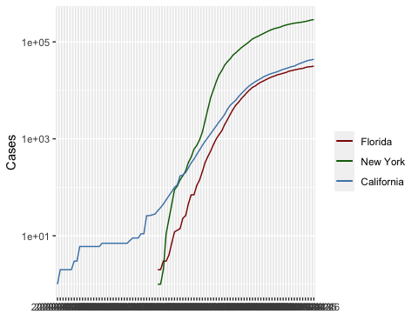

## R4DS Height vs Earnings

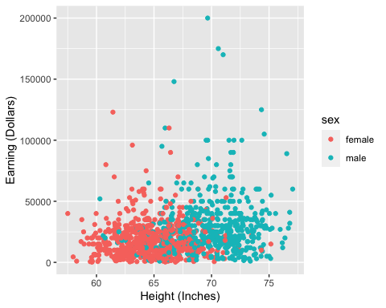

# Tables

## Knitr Table with Kable

One Ring to Rule Them All

|  |  |  |  |  |
| --- | --- | --- | --- | --- |
| name | race | in_fellowship | ring_bearer | age |
| Aragon | Men | TRUE | FALSE | 88 |
| Bilbo | Hobbit | FALSE | TRUE | 129 |
| Frodo | Hobbit | TRUE | TRUE | 51 |
| Galadriel | Elf | FALSE | FALSE | 7000 |
| Sam | Hobbit | TRUE | TRUE | 36 |
| Gandalf | Maia | TRUE | TRUE | 2019 |
| Legolas | Elf | TRUE | FALSE | 2931 |
| Sauron | Maia | FALSE | TRUE | 7052 |
| Gollum | Hobbit | FALSE | TRUE | 589 |

## Pandoc Table

##   
## --------------------------------------------------------------  
## Name Race In Fellowship? Is Ring Bearer? Age   
## ----------- -------- ---------------- ----------------- ------  
## Aragon Men TRUE FALSE 88   
##   
## Bilbo Hobbit FALSE TRUE 129   
##   
## Frodo Hobbit TRUE TRUE 51   
##   
## Galadriel Elf FALSE FALSE 7000   
##   
## Sam Hobbit TRUE TRUE 36   
##   
## Gandalf Maia TRUE TRUE 2019   
##   
## Legolas Elf TRUE FALSE 2931   
##   
## Sauron Maia FALSE TRUE 7052   
##   
## Gollum Hobbit FALSE TRUE 589   
## --------------------------------------------------------------  
##   
## Table: One Ring to Rule Them All

# References

Field, A., J. Miles, and Z. Field. 2012. *Discovering Statistics Using R*. SAGE Publications. <https://books.google.com/books?id=wd2K2zC3swIC>.

Lander, J. P. 2014. *R for Everyone: Advanced Analytics and Graphics*. Addison-Wesley Data and Analytics Series. Addison-Wesley. <https://books.google.com/books?id=3eBVAgAAQBAJ>.

1. Registered Footnote for DSC520 Assignment 4 Markdown, 2020