ASSIGNMENT 4

Isabella Sturm

2021-01-05

# Markdown Basics

## Favorite Foods

1. Cupcakes
2. Mac n Cheese
3. Pizza

## Images

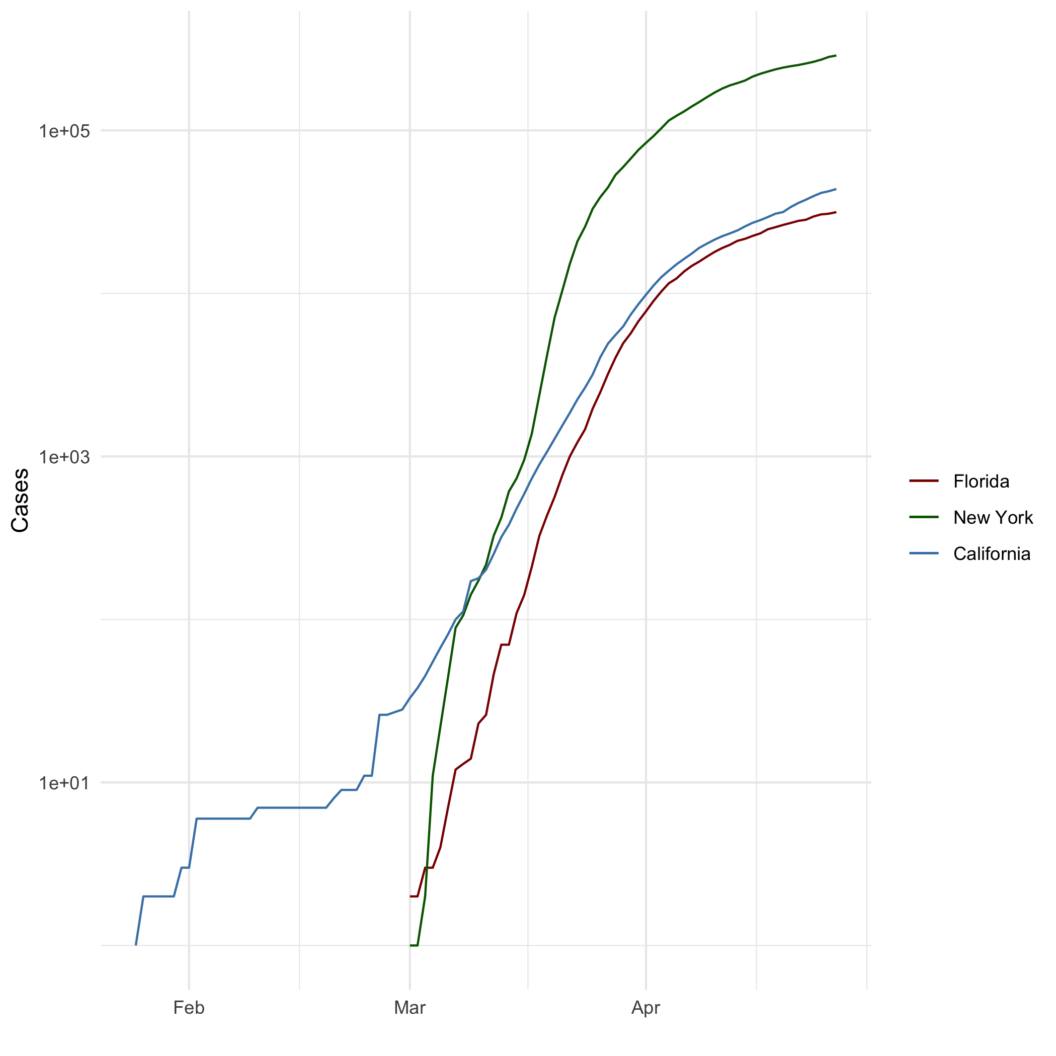

All Cases (Log Plot)

## Add a Quote

Success is most often achieved by those who don’t know that failure is inevitable.

- Coco Chanel

## Add an Equation

$x=\frac{−b±\sqrt{(}b^{2}−4ac)}{2a}$

## Add a Footnote

I have a cat.[1]

## Add Citations

* R for Everyone (Lander 2014)
* Discovering Statistics Using R (Field, Miles, and Field 2012)

# Inline Code

## NY Times COVID-19 Data

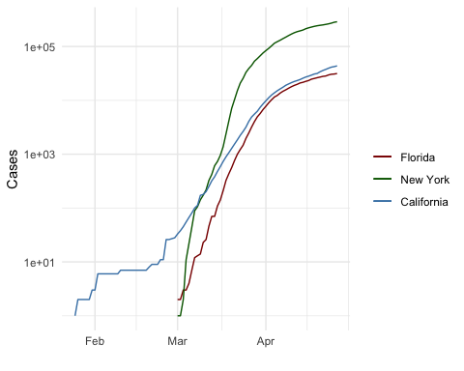

## R4DS Height vs Earnings

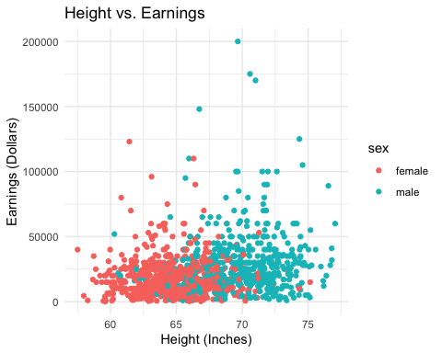

# Tables

## Knitr Table with Kable

One Ring to Rule Them All

|  |  |  |
| --- | --- | --- |
| person_id | personal_name | family_name |
| dyer | William | Dyer |
| pb | Frank | Pabodie |
| lake | Anderson | Lake |
| roe | Valentina | Roerich |
| danforth | Frank | Danforth |

## Pandoc Table

|  |  |  |  |  |
| --- | --- | --- | --- | --- |
| Name | Race | In Fellowship? | Is Ring Bearer? | Age |
| Aragon | Men | Yes | No | 88 |
| Bilbo | Hobbit | No | Yes | 129 |
| Frodo | Hobbit | Yes | Yes | 51 |
| Sam | Hobbit | Yes | Yes | 36 |
| Sauron | Maia | No | Yes | 7052 |

# References

Field, A., J. Miles, and Z. Field. 2012. *Discovering Statistics Using R*. SAGE Publications. <https://books.google.com/books?id=wd2K2zC3swIC>.

Lander, J. P. 2014. *R for Everyone: Advanced Analytics and Graphics*. Addison-Wesley Data and Analytics Series. Addison-Wesley. <https://books.google.com/books?id=3eBVAgAAQBAJ>.

1. Her name is Cupcake.