Exercise 12

Jyoti Sahu

01-29-2021

# Housing Data

Problem Statement : Work individually on this assignment. You are encouraged to collaborate on ideas and strategies pertinent to this assignment. Data for this assignment is focused on real estate transactions recorded from 1964 to 2016 and can be found in Week 6 Housing.xlsx. Using your skills in statistical correlation, multiple regression and R programming, you are interested in the following variables: Sale Price and several other possible predictors.

Using your ‘clean’ data set from the previous week complete the following:

## Set the working directory to the root of your DSC 520 directory  
setwd("/Users/sahujyot/Documents/DSC520")  
## Load the `readxl` library  
library(readxl)  
## Load the `completed/Exercise 12/week-6-housing.xlsx` to  
housing_df <- read_excel(path = 'Week 7/week-7-housing.xlsx' , skip = 0, sheet = 'Sheet2')  
str(housing_df)

## tibble [12,865 × 24] (S3: tbl_df/tbl/data.frame)  
## $ Sale Date : POSIXct[1:12865], format: "2006-01-03" "2006-01-03" ...  
## $ Sale Price : num [1:12865] 698000 649990 572500 420000 369900 ...  
## $ sale_reason : num [1:12865] 1 1 1 1 1 1 1 1 1 1 ...  
## $ sale_instrument : num [1:12865] 3 3 3 3 3 15 3 3 3 3 ...  
## $ sale_warning : chr [1:12865] NA NA NA NA ...  
## $ sitetype : chr [1:12865] "R1" "R1" "R1" "R1" ...  
## $ addr_full : chr [1:12865] "17021 NE 113TH CT" "11927 178TH PL NE" "13315 174TH AVE NE" "3303 178TH AVE NE" ...  
## $ zip5 : num [1:12865] 98052 98052 98052 98052 98052 ...  
## $ ctyname : chr [1:12865] "REDMOND" "REDMOND" NA "REDMOND" ...  
## $ postalctyn : chr [1:12865] "REDMOND" "REDMOND" "REDMOND" "REDMOND" ...  
## $ lon : num [1:12865] -122 -122 -122 -122 -122 ...  
## $ lat : num [1:12865] 47.7 47.7 47.7 47.6 47.7 ...  
## $ building_grade : num [1:12865] 9 9 8 8 7 7 10 10 9 8 ...  
## $ square_feet_total_living: num [1:12865] 2810 2880 2770 1620 1440 4160 3960 3720 4160 2760 ...  
## $ bedrooms : num [1:12865] 4 4 4 3 3 4 5 4 4 4 ...  
## $ bath_full_count : num [1:12865] 2 2 1 1 1 2 3 2 2 1 ...  
## $ bath_half_count : num [1:12865] 1 0 1 0 0 1 0 1 1 0 ...  
## $ bath_3qtr_count : num [1:12865] 0 1 1 1 1 1 1 0 1 1 ...  
## $ year_built : num [1:12865] 2003 2006 1987 1968 1980 ...  
## $ year_renovated : num [1:12865] 0 0 0 0 0 0 0 0 0 0 ...  
## $ current_zoning : chr [1:12865] "R4" "R4" "R6" "R4" ...  
## $ sq_ft_lot : num [1:12865] 6635 5570 8444 9600 7526 ...  
## $ prop_type : chr [1:12865] "R" "R" "R" "R" ...  
## $ present_use : num [1:12865] 2 2 2 2 2 2 2 2 2 2 ...

## a. Explain why you chose to remove data points from your ‘clean’ dataset.

I have removed/not used followinf data points in my analysis. Sale Date- It does not affect housing price so there wont be any pattern. sale_reason-I do not think this will play a major role on house pricing. sale_instrument- do not think this will play a major role on house pricing. sale_warning- do not think this will play a major role on house pricing. sitetype- I do not think this will play a major role on house pricing.It is always great to know the area and criminal activities in deciding a house. AAlso this field is not useful in my current data set addr_full-I do not think this will play a major role on house pricing.It is always great to know the area and criminal activities in deciding a house. Also this field is not useful in my current data set. zip5-I do not think this will play a major role on house pricing.It is always great to know the area and criminal activities in deciding a house. Also this field is not useful in my current data set. ctyname-I do not think this will play a major role on house pricing.It is always great to know the area and criminal activities in deciding a house. Also this field is not useful in my current data set. postalctyn-I do not think this will play a major role on house pricing.It is always great to know the area and criminal activities in deciding a house. Also this field is not useful in my current data set. lon-I do not think this will play a major role on house pricing.It is always great to know the area and criminal activities in deciding a house. Also this field is not useful in my current data set. lat-I do not think this will play a major role on house pricing.It is always great to know the area and criminal activities in deciding a house. Also this field is not useful in my current data set. building_grade- It has very minimal effect on housing price current_zoning- Current does not matter here because it is all R (Residence) prop_type-This field does not matter here because it is all R (Residence) present_use- It does not matter.

summary(housing_df)

## Sale Date Sale Price sale_reason   
## Min. :2006-01-03 00:00:00 Min. : 698 Min. : 0.00   
## 1st Qu.:2008-07-07 00:00:00 1st Qu.: 460000 1st Qu.: 1.00   
## Median :2011-11-17 00:00:00 Median : 593000 Median : 1.00   
## Mean :2011-07-28 15:07:32 Mean : 660738 Mean : 1.55   
## 3rd Qu.:2014-06-05 00:00:00 3rd Qu.: 750000 3rd Qu.: 1.00   
## Max. :2016-12-16 00:00:00 Max. :4400000 Max. :19.00   
## sale_instrument sale_warning sitetype addr_full   
## Min. : 0.000 Length:12865 Length:12865 Length:12865   
## 1st Qu.: 3.000 Class :character Class :character Class :character   
## Median : 3.000 Mode :character Mode :character Mode :character   
## Mean : 3.678   
## 3rd Qu.: 3.000   
## Max. :27.000   
## zip5 ctyname postalctyn lon   
## Min. :98052 Length:12865 Length:12865 Min. :-122.2   
## 1st Qu.:98052 Class :character Class :character 1st Qu.:-122.1   
## Median :98052 Mode :character Mode :character Median :-122.1   
## Mean :98053 Mean :-122.1   
## 3rd Qu.:98053 3rd Qu.:-122.0   
## Max. :98074 Max. :-121.9   
## lat building_grade square_feet_total_living bedrooms   
## Min. :47.46 Min. : 2.00 Min. : 240 Min. : 0.000   
## 1st Qu.:47.67 1st Qu.: 8.00 1st Qu.: 1820 1st Qu.: 3.000   
## Median :47.69 Median : 8.00 Median : 2420 Median : 4.000   
## Mean :47.68 Mean : 8.24 Mean : 2540 Mean : 3.479   
## 3rd Qu.:47.70 3rd Qu.: 9.00 3rd Qu.: 3110 3rd Qu.: 4.000   
## Max. :47.73 Max. :13.00 Max. :13540 Max. :11.000   
## bath_full_count bath_half_count bath_3qtr_count year_built   
## Min. : 0.000 Min. :0.0000 Min. :0.000 Min. :1900   
## 1st Qu.: 1.000 1st Qu.:0.0000 1st Qu.:0.000 1st Qu.:1979   
## Median : 2.000 Median :1.0000 Median :0.000 Median :1998   
## Mean : 1.798 Mean :0.6134 Mean :0.494 Mean :1993   
## 3rd Qu.: 2.000 3rd Qu.:1.0000 3rd Qu.:1.000 3rd Qu.:2007   
## Max. :23.000 Max. :8.0000 Max. :8.000 Max. :2016   
## year_renovated current_zoning sq_ft_lot prop_type   
## Min. : 0.00 Length:12865 Min. : 785 Length:12865   
## 1st Qu.: 0.00 Class :character 1st Qu.: 5355 Class :character   
## Median : 0.00 Mode :character Median : 7965 Mode :character   
## Mean : 26.24 Mean : 22229   
## 3rd Qu.: 0.00 3rd Qu.: 12632   
## Max. :2016.00 Max. :1631322   
## present_use   
## Min. : 0.000   
## 1st Qu.: 2.000   
## Median : 2.000   
## Mean : 6.598   
## 3rd Qu.: 2.000   
## Max. :300.000

cleaned_housing_df <- subset(housing_df,select=c("Sale Price","square_feet_total_living","bedrooms","bath_full_count","bath_half_count","bath_3qtr_count","year_built","year_renovated","sq_ft_lot"))

summary(cleaned_housing_df)

## Sale Price square_feet_total_living bedrooms bath_full_count   
## Min. : 698 Min. : 240 Min. : 0.000 Min. : 0.000   
## 1st Qu.: 460000 1st Qu.: 1820 1st Qu.: 3.000 1st Qu.: 1.000   
## Median : 593000 Median : 2420 Median : 4.000 Median : 2.000   
## Mean : 660738 Mean : 2540 Mean : 3.479 Mean : 1.798   
## 3rd Qu.: 750000 3rd Qu.: 3110 3rd Qu.: 4.000 3rd Qu.: 2.000   
## Max. :4400000 Max. :13540 Max. :11.000 Max. :23.000   
## bath_half_count bath_3qtr_count year_built year_renovated   
## Min. :0.0000 Min. :0.000 Min. :1900 Min. : 0.00   
## 1st Qu.:0.0000 1st Qu.:0.000 1st Qu.:1979 1st Qu.: 0.00   
## Median :1.0000 Median :0.000 Median :1998 Median : 0.00   
## Mean :0.6134 Mean :0.494 Mean :1993 Mean : 26.24   
## 3rd Qu.:1.0000 3rd Qu.:1.000 3rd Qu.:2007 3rd Qu.: 0.00   
## Max. :8.0000 Max. :8.000 Max. :2016 Max. :2016.00   
## sq_ft_lot   
## Min. : 785   
## 1st Qu.: 5355   
## Median : 7965   
## Mean : 22229   
## 3rd Qu.: 12632   
## Max. :1631322

## b. Create two variables; one that will contain the variables Sale Price and Square Foot of Lot (same variables used from previous assignment on simple regression) and one that will contain Sale Price and several additional predictors of your choice. Explain the basis for your additional predictor selections.

# This is Simple Linear Regression Model  
saleprice_slm <- lm(cleaned_housing_df$`Sale Price` ~ cleaned_housing_df$sq_ft_lot, cleaned_housing_df)  
summary(saleprice_slm )

##   
## Call:  
## lm(formula = cleaned_housing_df$`Sale Price` ~ cleaned_housing_df$sq_ft_lot,   
## data = cleaned_housing_df)  
##   
## Residuals:  
## Min 1Q Median 3Q Max   
## -2016064 -194842 -63293 91565 3735109   
##   
## Coefficients:  
## Estimate Std. Error t value Pr(>|t|)   
## (Intercept) 6.418e+05 3.800e+03 168.90 <2e-16 ***  
## cleaned_housing_df$sq_ft_lot 8.510e-01 6.217e-02 13.69 <2e-16 ***  
## ---  
## Signif. codes: 0 '***' 0.001 '**' 0.01 '*' 0.05 '.' 0.1 ' ' 1  
##   
## Residual standard error: 401500 on 12863 degrees of freedom  
## Multiple R-squared: 0.01435, Adjusted R-squared: 0.01428   
## F-statistic: 187.3 on 1 and 12863 DF, p-value: < 2.2e-16

print("Calculating coefficient of other Predictos")

## [1] "Calculating coefficient of other Predictos"

print("Correlation of Sale Price and square_feet_total_living ")

## [1] "Correlation of Sale Price and square_feet_total_living "

cor(cleaned_housing_df$`Sale Price`,cleaned_housing_df$square_feet_total_living)

## [1] 0.4545876

print("Correlation of Sale Price and bedrooms")

## [1] "Correlation of Sale Price and bedrooms"

cor(cleaned_housing_df$`Sale Price`,cleaned_housing_df$bedrooms)

## [1] 0.2254675

print("Correlation of Sale Price and bath_full_count")

## [1] "Correlation of Sale Price and bath_full_count"

cor(cleaned_housing_df$`Sale Price`,cleaned_housing_df$bath_full_count)

## [1] 0.284849

print("Correlation of Sale Price and bath_half_count")

## [1] "Correlation of Sale Price and bath_half_count"

cor(cleaned_housing_df$`Sale Price`,cleaned_housing_df$bath_half_count)

## [1] 0.1658284

print("Correlation of Sale Price and bath_3qtr_count")

## [1] "Correlation of Sale Price and bath_3qtr_count"

cor(cleaned_housing_df$`Sale Price`,cleaned_housing_df$bath_3qtr_count)

## [1] 0.03574175

print("Correlation of Sale Price and year_built")

## [1] "Correlation of Sale Price and year_built"

cor(cleaned_housing_df$`Sale Price`,cleaned_housing_df$year_built)

## [1] 0.2426713

print("Correlation of Sale Price and year_renovated")

## [1] "Correlation of Sale Price and year_renovated"

cor(cleaned_housing_df$`Sale Price`,cleaned_housing_df$year_renovated)

## [1] 0.03286429

Based on the Correlation between Sales price and other variables, I am picking the fields with correlation over 0.2 because of strong relationship and feeding them into the model.

# This is Multiple Linear Regression Model  
saleprice_mlm <- lm(cleaned_housing_df$`Sale Price` ~ cleaned_housing_df$square_feet_total_living + cleaned_housing_df$bedrooms + cleaned_housing_df$bath_full_count + cleaned_housing_df$year_built )

## c. Execute a summary() function on two variables defined in the previous step to compare the model results. What are the R2 and Adjusted R2 statistics? Explain what these results tell you about the overall model. Did the inclusion of the additional predictors help explain any large variations found in Sale Price?

summary(saleprice_slm)

##   
## Call:  
## lm(formula = cleaned_housing_df$`Sale Price` ~ cleaned_housing_df$sq_ft_lot,   
## data = cleaned_housing_df)  
##   
## Residuals:  
## Min 1Q Median 3Q Max   
## -2016064 -194842 -63293 91565 3735109   
##   
## Coefficients:  
## Estimate Std. Error t value Pr(>|t|)   
## (Intercept) 6.418e+05 3.800e+03 168.90 <2e-16 ***  
## cleaned_housing_df$sq_ft_lot 8.510e-01 6.217e-02 13.69 <2e-16 ***  
## ---  
## Signif. codes: 0 '***' 0.001 '**' 0.01 '*' 0.05 '.' 0.1 ' ' 1  
##   
## Residual standard error: 401500 on 12863 degrees of freedom  
## Multiple R-squared: 0.01435, Adjusted R-squared: 0.01428   
## F-statistic: 187.3 on 1 and 12863 DF, p-value: < 2.2e-16

summary(saleprice_mlm)

##   
## Call:  
## lm(formula = cleaned_housing_df$`Sale Price` ~ cleaned_housing_df$square_feet_total_living +   
## cleaned_housing_df$bedrooms + cleaned_housing_df$bath_full_count +   
## cleaned_housing_df$year_built)  
##   
## Residuals:  
## Min 1Q Median 3Q Max   
## -1719151 -120511 -42398 45744 3904824   
##   
## Coefficients:  
## Estimate Std. Error t value  
## (Intercept) -4.430e+06 4.195e+05 -10.559  
## cleaned_housing_df$square_feet_total_living 1.744e+02 4.423e+00 39.424  
## cleaned_housing_df$bedrooms -1.375e+04 4.517e+03 -3.045  
## cleaned_housing_df$bath_full_count 1.730e+04 6.095e+03 2.838  
## cleaned_housing_df$year_built 2.340e+03 2.117e+02 11.053  
## Pr(>|t|)   
## (Intercept) < 2e-16 ***  
## cleaned_housing_df$square_feet_total_living < 2e-16 ***  
## cleaned_housing_df$bedrooms 0.00234 **   
## cleaned_housing_df$bath_full_count 0.00454 **   
## cleaned_housing_df$year_built < 2e-16 ***  
## ---  
## Signif. codes: 0 '***' 0.001 '**' 0.01 '*' 0.05 '.' 0.1 ' ' 1  
##   
## Residual standard error: 357300 on 12860 degrees of freedom  
## Multiple R-squared: 0.2194, Adjusted R-squared: 0.2192   
## F-statistic: 903.7 on 4 and 12860 DF, p-value: < 2.2e-16

The R2 of model tells us the prediction % of the model. Higher the R2 value, means better the Correlation coefficient, which is square root of R2.So based on the values from two models, the first model which has value of 0.01435 , which means square foot of the lot only contributes 1.4% to the sales price.However in the other model, other predictors together the R2 value is 0.2194 contribute approx 21% towards the sale price. However I noticed bedrooms is negatively co-related.

The Adjusted R2 gives an idea how well our model generalizes, and ideally we expect a similar value or close to R2.In both of our model the the difference is minimal which is a good sign For both of our models R2 and Adjusted R2 is very similar which indicates that cross-validity of the model is good.

## d. Considering the parameters of the multiple regression model you have created. What are the standardized betas for each parameter and what do the values indicate?

library(QuantPsyc)

## Loading required package: boot

## Loading required package: MASS

##   
## Attaching package: 'QuantPsyc'

## The following object is masked from 'package:base':  
##   
## norm

lm.beta(saleprice_mlm)

## cleaned_housing_df$square_feet_total_living   
## 0.42677620   
## cleaned_housing_df$bedrooms   
## -0.02979645   
## cleaned_housing_df$bath_full_count   
## 0.02783809   
## cleaned_housing_df$year_built   
## 0.09966661

In general, it tells that if the specific attribute changes by one standard deviation, then the sales price(or outcome variable) increase by the Standardized Beta times(the value it displays) the standard deviation. If Beta is negative, it means decreases by same factor of Standard Deviation.

## e. Calculate the confidence intervals for the parameters in your model and explain what the results indicate.

confint(saleprice_mlm)

## 2.5 % 97.5 %  
## (Intercept) -5252187.0182 -3607553.8714  
## cleaned_housing_df$square_feet_total_living 165.6868 183.0244  
## cleaned_housing_df$bedrooms -22607.0742 -4898.3341  
## cleaned_housing_df$bath_full_count 5351.3294 29243.8018  
## cleaned_housing_df$year_built 1925.4259 2755.5146

From the confidence interval values here we can say that square_feet_total_living,bedrooms,bath_full_count and bath_half_count are on the same side of Zero. So these are fine.

The gap between square_feet_total_living is tight, so seems its estimates using this are more likely representing the true population. However the bedrooms, bath_full_count ,bedrooms are less representatives.

## f. Assess the improvement of the new model compared to your original model (simple regression model) by testing whether this change is significant by performing an analysis of variance.

anova(saleprice_slm, saleprice_mlm)

## Analysis of Variance Table  
##   
## Model 1: cleaned_housing_df$`Sale Price` ~ cleaned_housing_df$sq_ft_lot  
## Model 2: cleaned_housing_df$`Sale Price` ~ cleaned_housing_df$square_feet_total_living +   
## cleaned_housing_df$bedrooms + cleaned_housing_df$bath_full_count +   
## cleaned_housing_df$year_built  
## Res.Df RSS Df Sum of Sq F Pr(>F)   
## 1 12863 2.0734e+15   
## 2 12860 1.6420e+15 3 4.3134e+14 1126 < 2.2e-16 ***  
## ---  
## Signif. codes: 0 '***' 0.001 '**' 0.01 '*' 0.05 '.' 0.1 ' ' 1

The F(3,12860) = 1126 for p<0.001 So the Fit of the model has significantly improved from the original model.

## g. Perform casewise diagnostics to identify outliers and/or influential cases, storing each function’s output in a dataframe assigned to a unique variable name.

# Outliers  
cleaned_housing_df$residuals <- resid(saleprice_mlm)  
cleaned_housing_df$standardized.residuals <- rstandard(saleprice_mlm)  
cleaned_housing_df$rstudent <- rstudent(saleprice_mlm)  
# Influential Cases  
cleaned_housing_df$cooks.distance <- cooks.distance(saleprice_mlm)  
cleaned_housing_df$dfbeta <- dfbeta(saleprice_mlm)  
cleaned_housing_df$dffits <- dffits(saleprice_mlm)  
cleaned_housing_df$leverage <- hatvalues(saleprice_mlm)  
cleaned_housing_df$covariance.ratios <- covratio(saleprice_mlm)

## h. Calculate the standardized residuals using the appropriate command, specifying those that are +-2, storing the results of large residuals in a variable you create.

cleaned_housing_df$large.residuals<-cleaned_housing_df$standardized.residuals > 2 | cleaned_housing_df$standardized.residuals< -2

## i. Use the appropriate function to show the sum of large residuals.

sum(cleaned_housing_df$large.residuals)

## [1] 329

## j. Which specific variables have large residuals (only cases that evaluate as TRUE)?

cleaned_housing_df[cleaned_housing_df$large.residuals, c("Sale Price", "square_feet_total_living", "bedrooms", "bath_full_count", "bath_half_count", "year_built")]

## # A tibble: 329 x 6  
## `Sale Price` square_feet_tot… bedrooms bath_full_count bath_half_count  
## <dbl> <dbl> <dbl> <dbl> <dbl>  
## 1 184667 4160 4 2 1  
## 2 265000 4920 4 4 1  
## 3 1390000 660 0 1 0  
## 4 390000 5800 5 4 1  
## 5 1588359 3360 2 2 1  
## 6 1450000 900 2 1 0  
## 7 163000 4710 4 2 1  
## 8 270000 5060 4 23 1  
## 9 200000 6880 5 1 1  
## 10 300000 4490 4 2 1  
## # … with 319 more rows, and 1 more variable: year_built <dbl>

## k. Investigate further by calculating the leverage, cooks distance, and covariance rations. Comment on all cases that are problematics.

cleaned_housing_df[cleaned_housing_df$large.residuals, c("cooks.distance", "leverage", "covariance.ratios")]

## # A tibble: 329 x 3  
## cooks.distance leverage covariance.ratios  
## <dbl> <dbl> <dbl>  
## 1 0.000328 0.000341 0.999  
## 2 0.00143 0.00119 0.999  
## 3 0.00359 0.00185 0.998  
## 4 0.00162 0.00130 0.999  
## 5 0.000570 0.000677 0.999  
## 6 0.00471 0.00194 0.998  
## 7 0.000836 0.000628 0.998  
## 8 0.376 0.120 1.13   
## 9 0.00700 0.00300 0.999  
## 10 0.000407 0.000485 0.999  
## # … with 319 more rows

## l. Perform the necessary calculations to assess the assumption of independence and state if the condition is met or not.

library(car)

## Loading required package: carData

##   
## Attaching package: 'car'

## The following object is masked from 'package:boot':  
##   
## logit

durbinWatsonTest(saleprice_mlm)

## lag Autocorrelation D-W Statistic p-value  
## 1 0.7210338 0.5579232 0  
## Alternative hypothesis: rho != 0

As per the Durbin Watson Test, if the values is in between 1-3, the model is considered good. Closer the value to 2, better the model. This model is bad

## m. Perform the necessary calculations to assess the assumption of no multicollinearity and state if the condition is met or not.

vif(saleprice_mlm)

## cleaned_housing_df$square_feet_total_living   
## 1.930570   
## cleaned_housing_df$bedrooms   
## 1.577994   
## cleaned_housing_df$bath_full_count   
## 1.584923   
## cleaned_housing_df$year_built   
## 1.339428

print("Tolerance = 1/VIF")

## [1] "Tolerance = 1/VIF"

1/vif(saleprice_mlm)

## cleaned_housing_df$square_feet_total_living   
## 0.5179818   
## cleaned_housing_df$bedrooms   
## 0.6337161   
## cleaned_housing_df$bath_full_count   
## 0.6309454   
## cleaned_housing_df$year_built   
## 0.7465875

print("Mean VIF")

## [1] "Mean VIF"

mean(vif(saleprice_mlm))

## [1] 1.608229

The average VIF is 1.60 which is <10 So no cause for concern which is not substantially greater than 1 as well. (Substantially more is considered more than 2.5, as from <https://statisticalhorizons.com/multicollinearity>) .All Tolerance are above 0.2, meaning it should be fine.(Less than 0.2 is potential problem, less than 0.1 is significant problem. Its same as VIF >10, as tolerance = 1/VIF)

## n. Visually check the assumptions related to the residuals using the plot() and hist() functions. Summarize what each graph is informing you of and if any anomalies are present.

plot(saleprice_mlm)

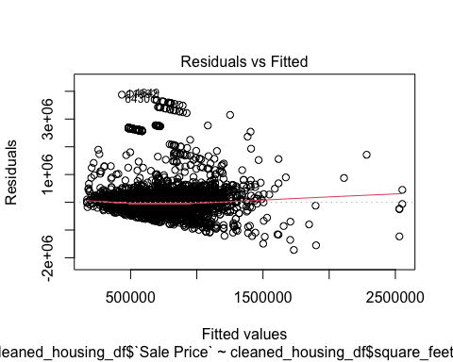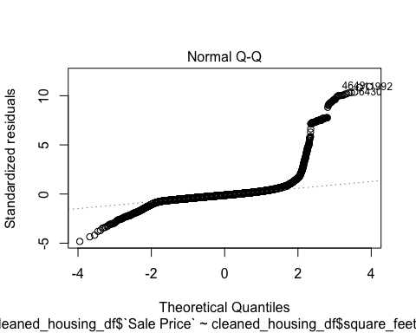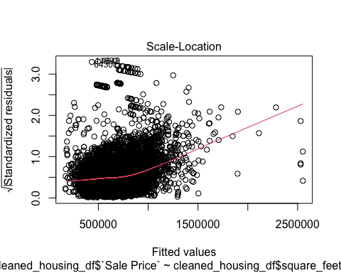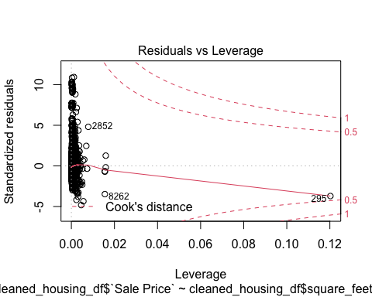

The I am not noticing any heteroscedasticity. Residuals vs Fitted Graph shows random dots evenly dispersed around 0. Though not fully dispersed but evenly dispersed. It does not funnel out as well. .The data points also do not form a curve, so should be linear. With the QQ plot we can see that the plot curves of at extremes, so it means has more extreme values than would be expected if they truly came from a Normal distribution.

hist(cleaned_housing_df$rstudent)

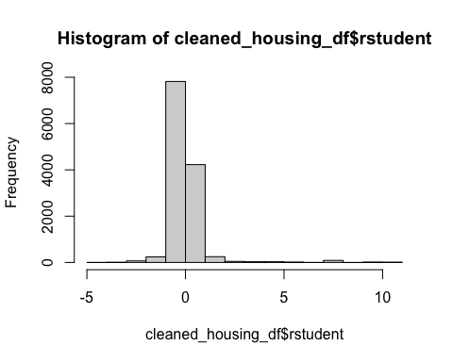

hist(rstudent(saleprice_mlm))

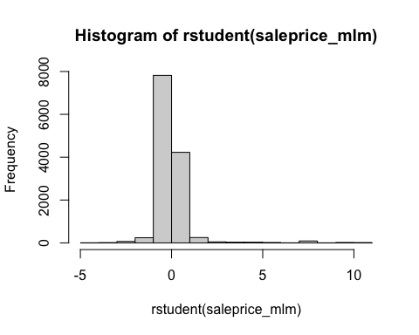

Looks like a Bell slight skewed towards right. It could be assumed as normal.

## o. Overall, is this regression model unbiased? If an unbiased regression model, what does this tell us about the sample vs. the entire population model?

We can say that we have bias present in this model due to following reason 1. The QQ plot that the plot curves away in opposite directions when approaching extreme values. This means there are outliers present at extremes. This tells that the model could be biased. 2. As we saw with year_built and bathrooms attribute the confint() output shows to affect the model in a bad way.

If the model is unbiased, it means that it holds true for both sample as well as it could be used confidently over the entire population.

To make this model better 1. We should try to clean the outliers based on the analysis so far. 2. We should also try to re-look at the parameters being used in the model. The one’s which have bad effect on the model, should be removed. Additional parameters should also be added, if needed to improve the model. 3. We should try testing if these predictors are overfitting.