# Assignment: ASSIGNMENT 3
# Name: Thangaraj, Arunkumar
# Date: 2020-12-16
> ## Load the ggplot2 package
> library(ggplot2)
> theme_set(theme_minimal())
> ## Set the working directory to the root of your DSC 520 directory
> setwd("C:/Users/arun8/R/dsc520_fork")
> ## Load the `data/r4ds/heights.csv` to
> heights_df <- read.csv("data/r4ds/heights.csv")

# https://ggplot2.tidyverse.org/reference/geom_point.html
## Using `geom_point()` create three scatterplots for
## `height` vs. `earn`
ggplot(heights_df, aes(x=height, y=earn)) + geom_point()
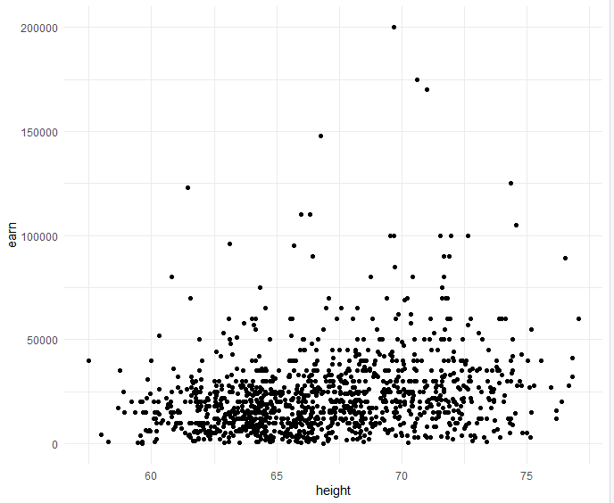
## `age` vs. `earn`
ggplot(heights_df, aes(x=age, y=earn)) + geom_point()
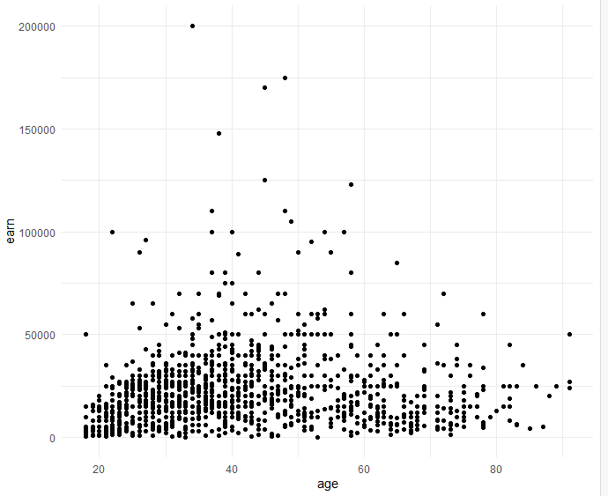
## `ed` vs. `earn`
ggplot(heights_df, aes(x=ed, y=earn)) + geom_point()
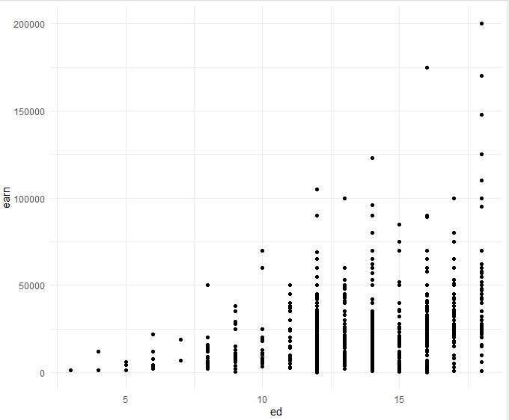

## Re-create the three scatterplots and add a regression trend line using
## the `geom_smooth()` function
## `height` vs. `earn`
ggplot(heights_df, aes(x=height, y=earn)) + geom_point() +
geom_smooth(method = NULL, colour = "Blue")
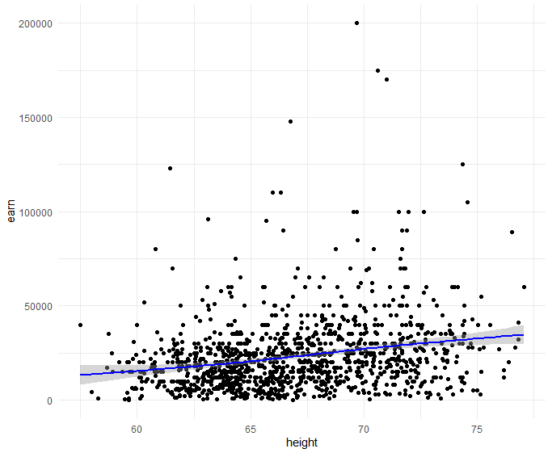
## `age` vs. `earn`
ggplot(heights_df, aes(x=age, y=earn)) + geom_point() +
geom_smooth(method = NULL, colour = "Blue")
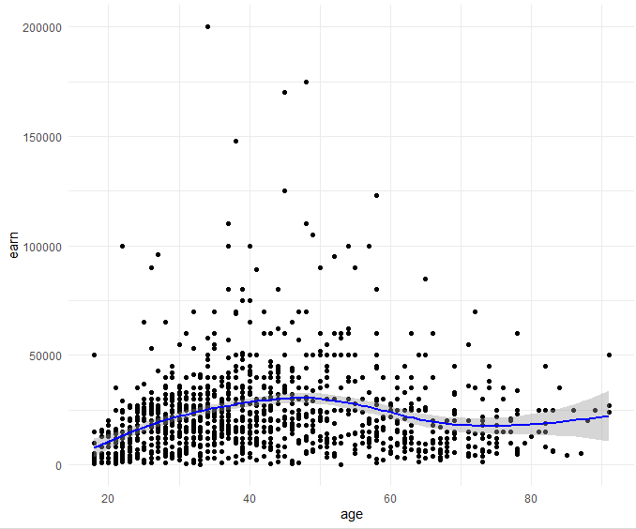
## `ed` vs. `earn`
ggplot(heights_df, aes(x=ed, y=earn)) + geom_point() +
geom_smooth(method = NULL, colour = "Blue")
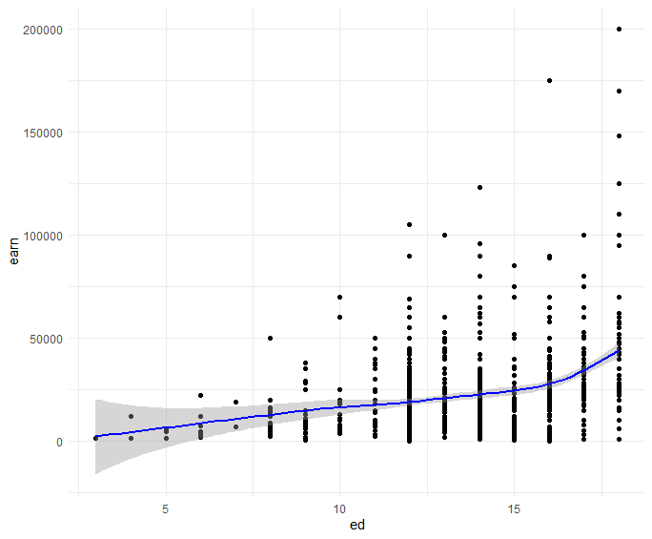
## Create a scatterplot of `height`` vs. `earn`. Use `sex` as the `col` (color) attribute
ggplot(heights_df, aes(x=height, y=earn, col=sex)) + geom_point()
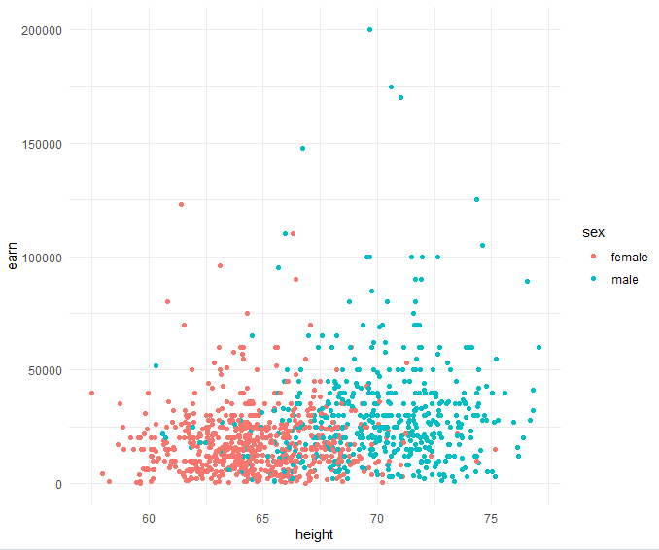

## Using `ggtitle()`, `xlab()`, and `ylab()` to add a title, x label, and y label to the previous plot
## Title: Height vs. Earnings
## X label: Height (Inches)
## Y Label: Earnings (Dollars)
ggplot(heights_df, aes(x=height, y=earn, col=sex)) +
geom_point() +
labs(x = "Height (Inches)", y = "Earnings (Dollars)", title = "Height vs. Earnings")

or
ggplot(heights_df, aes(x=height, y=earn, col=sex)) +
geom_point() +
xlab("Height (Inches)") + ylab("Earnings (Dollars)")+ggtitle("Height vs. Earnings")

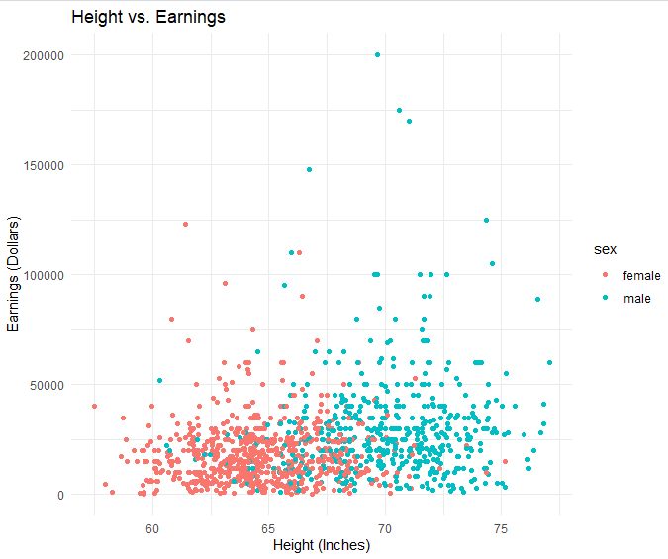

## https://ggplot2.tidyverse.org/reference/geom_histogram.html
## Create a histogram of the `earn` variable using `geom_histogram()`
ggplot(heights_df, aes(earn)) + geom_histogram(colour="Blue", fill="black")

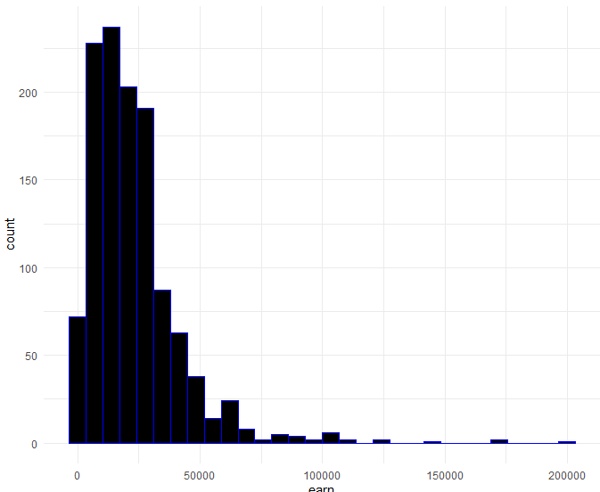
## Create a histogram of the `earn` variable using `geom_histogram()`
## Use 10 bins
ggplot(heights_df, aes(earn)) + geom_histogram(colour="Blue", fill="black",bins=10)
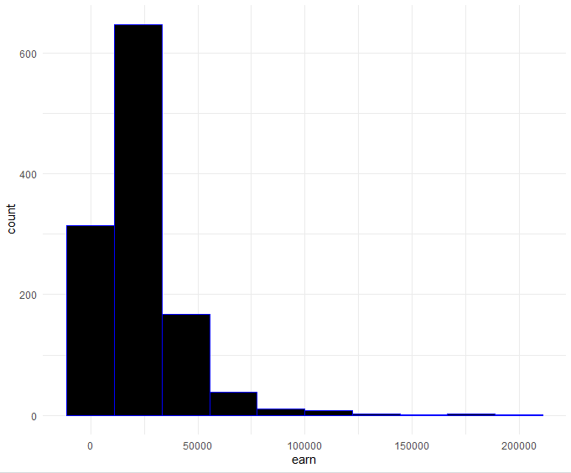
# https://ggplot2.tidyverse.org/reference/geom_density.html
## Create a kernel density plot of `earn` using `geom_density()`
ggplot(heights_df, aes(earn)) + geom_density(color="darkblue", fill="lightblue")

