R Markdown
Title: Assignment 4
Author: Carla Bradley
Date: 01/05/2021

Favorite Foods
- Ceviche * Lasagna * Burger Casserole

Images
All Cases (Log Plot)
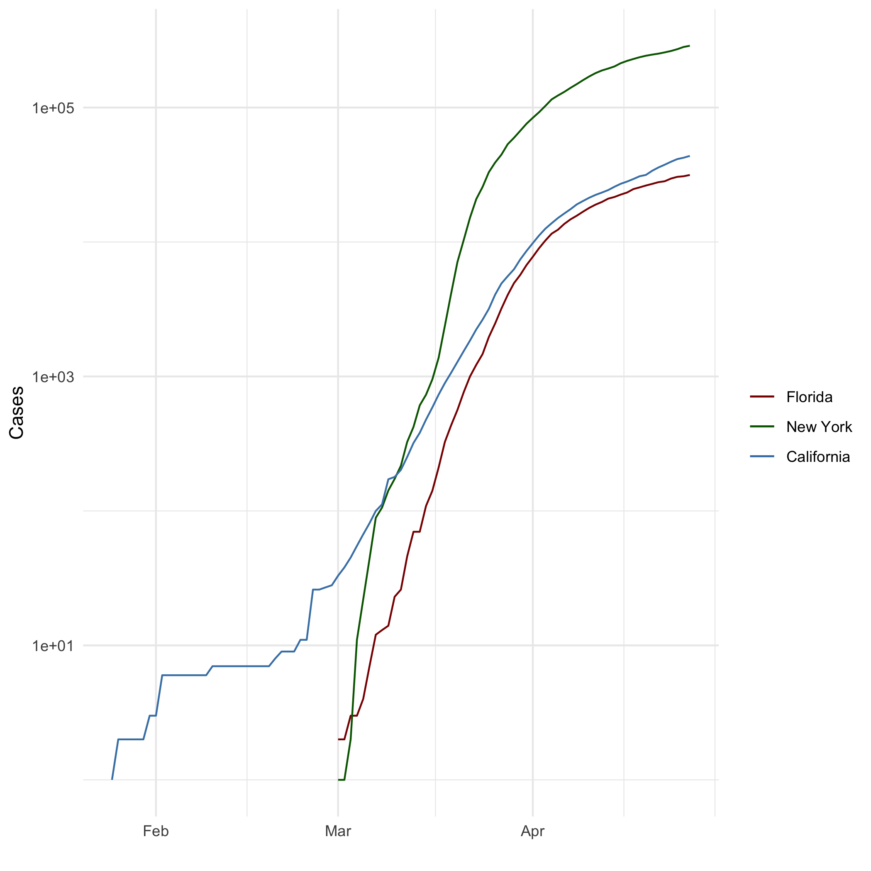

My Quote
“Every moment of your life is infinitely creative and the universe is endlessly bountiful. Just put forth a clear enough request, and everything your heart desires must come to you.” ―Mahatma Gandhi

Equation Formula
$$\int_{−∞}^{+∞}{e^{−(ax^{2}+bx)}}dx$$
}

R4DS Height vs Earnings
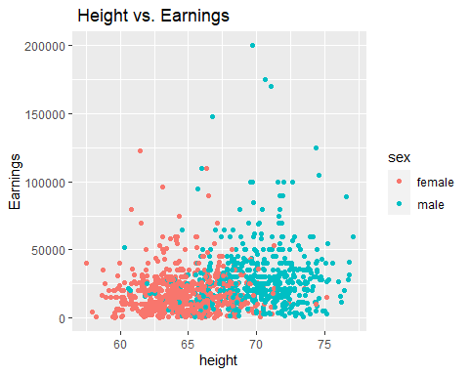

NY Times COVID-19 Data
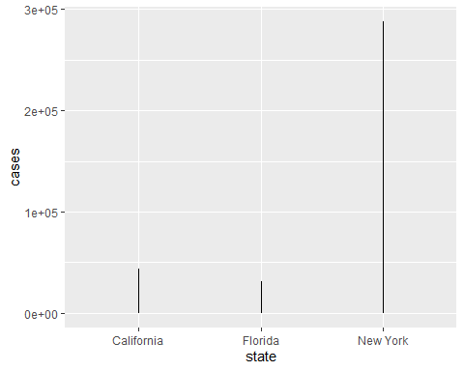

Knitr Table with Kable
One Ring to Rule Them All
Name | Race | Fellowship | Ring bearer | Age
Aragon | Men | TRUE | FALSE | 88
Bilbo | Hobbit | FALSE | TRUE | 129
Frodo | Hobbit | TRUE | TRUE | 51
Galadriel | Elf | FALSE | FALSE | 7000
Sam | Hobbit | TRUE | TRUE | 36
Gandalf | Maia | TRUE | TRUE | 2019
Legolas | Elf | TRUE | FALSE | 2931
Sauron | Maia | FALSE | TRUE | 7052
Gollum | Hobbit | FALSE | TRUE | 589

Pandoc Table
name | race | in_fellowship | ring_bearer | age
Aragon | Men | TRUE | FALSE | 88
Bilbo | Hobbit | FALSE | TRUE | 129
Frodo | Hobbit | TRUE | TRUE | 51
Galadriel | Elf | FALSE | FALSE | 7,000
Sam | Hobbit | TRUE | TRUE | 36
Gandalf | Maia | TRUE | TRUE | 2,019

This is a Footnote
*Footnote

Citations
- Field, A., J. Miles, and Z. Field. 2012. Discovering Statistics Using R. SAGE Publications.
- https://books.google.com/books?id=wd2K2zC3swIC.
- Lander, J. P. 2014. R for Everyone: Advanced Analytics and Graphics. Addison-Wesley Data and Analytics Series. Addison-Wesley.
- https://books.google.com/books?id=3eBVAgAAQBAJ.

This is a Footnote

