ASSIGNMENT 4
Bilal Kudaimi
2020-09-25

Markdown Basics

Favorite Foods
- Fruits
- Pizza
- Fish

Images
All Cases (Log Plot)
All Cases (Log Plot)

Add a Quote
We have nothing to fear but fear itself

Add an Equation
$$q=mCΔT$$

Add a Footnote

Add Citations
- R for Everyone
- Discovering Statistics Using R

Inline Code

NY Times COVID-19 Data
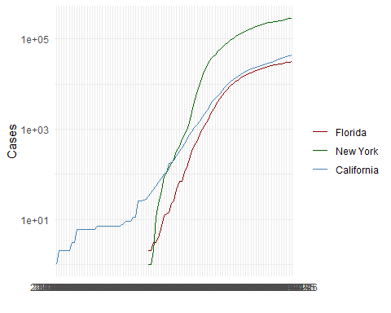

R4DS Height vs Earnings
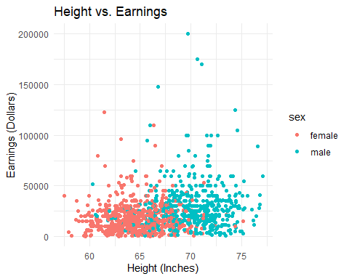

Tables

Knitr Table with Kable
One Ring to Rule Them All
name | race | in_fellowship | ring_bearer | age
Aragon | Men | TRUE | FALSE | 88
Bilbo | Hobbit | FALSE | TRUE | 129
Frodo | Hobbit | TRUE | TRUE | 51
Galadriel | Elf | FALSE | FALSE | 7000
Sam | Hobbit | TRUE | TRUE | 36
Gandalf | Maia | TRUE | TRUE | 2019
Legolas | Elf | TRUE | FALSE | 2931
Sauron | Maia | FALSE | TRUE | 7052
Gollum | Hobbit | FALSE | TRUE | 589

## Pandoc Table
Name | Race | In Fellowship? | Is Ring Bearer? | Age
Aragon | Men | Yes | No | 88
Bilbo | Hobbit | No | Yes | 129
Frodo | Hobbit | Yes | Yes | 51
Sam | Hobbit | Yes | Yes | 36
Sauron | Maia | No | Yes | 7052

References
Lander (2014) Field, Miles, and Field (2012)
Field, A., J. Miles, and Z. Field. 2012. Discovering Statistics Using R. SAGE Publications. https://books.google.com/books?id=wd2K2zC3swIC.
Lander, J. P. 2014. R for Everyone: Advanced Analytics and Graphics. Addison-Wesley Data and Analytics Series. Addison-Wesley. https://books.google.com/books?id=3eBVAgAAQBAJ.

This is a footnote.

