ASSIGNMENT 4
Femal, Amy
2020-06-14

Markdown Basics

Favorite Foods
- Steak
- Tacos
- Pizza

Images
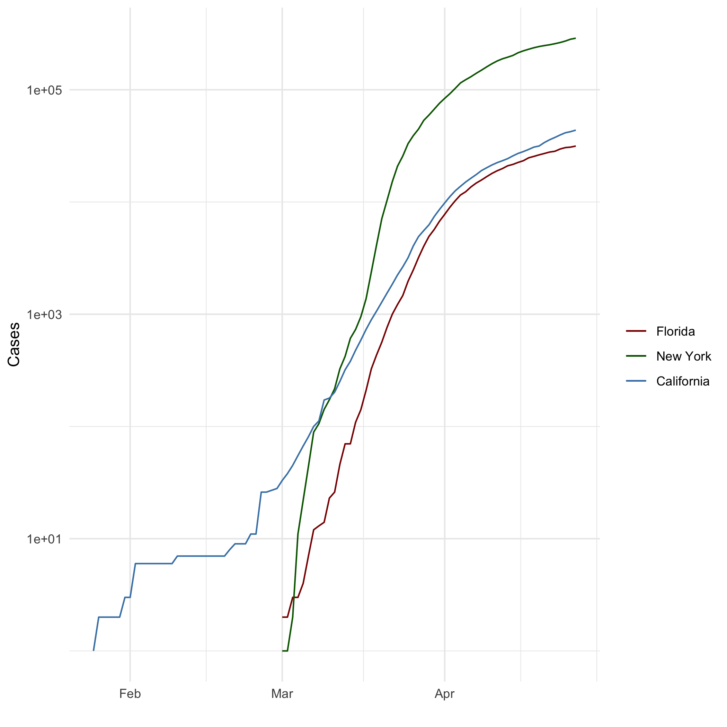
All Cases (Log Plot)

Add a Quote
“If I have seen further than others, it is by standing upon the shoulders of giants.” — Isaac Newton

Add an Equation
Quadratic Formula: $x=\frac{−b±\sqrt{b^{2}−4ac}}{2a}$

Add a Footnote
This is a footnote

Add Citations
- R for Everyone (Lander 2014)
- Discovering Statistics Using R (Field, Miles, and Field 2012)

Inline Code

NY Times COVID-19 Data
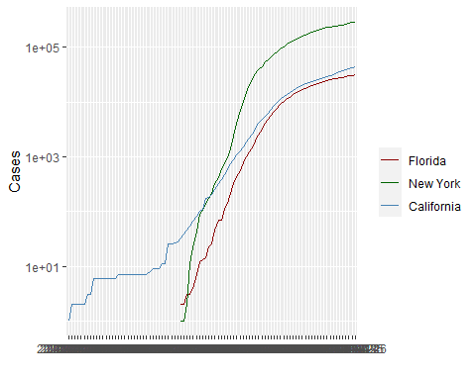

R4DS Height vs Earnings
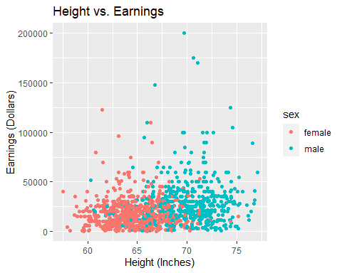

Tables

Knitr Table with Kable
One Ring to Rule Them All
name | race | in_fellowship | ring_bearer | age
Aragon | Men | TRUE | FALSE | 88
Bilbo | Hobbit | FALSE | TRUE | 129
Frodo | Hobbit | TRUE | TRUE | 51
Galadriel | Elf | FALSE | FALSE | 7000
Sam | Hobbit | TRUE | TRUE | 36
Gandalf | Maia | TRUE | TRUE | 2019
Legolas | Elf | TRUE | FALSE | 2931
Sauron | Maia | FALSE | TRUE | 7052
Gollum | Hobbit | FALSE | TRUE | 589

Pandoc Table
Name | Race | In Fellowship? | Is Ring Bearer? | Age
Aragon | Men | Yes | No | 88
Bilbo | Hobbit | No | Yes | 129
Frodo | Hobbit | Yes | Yes | 51
Sam | Hobbit | Yes | Yes | 36
Sauron | Maia | No | Yes | 7052

References
Field, A., J. Miles, and Z. Field. 2012. Discovering Statistics Using R. SAGE Publications. https://books.google.com/books?id=wd2K2zC3swIC.
Lander, J. P. 2014. R for Everyone: Advanced Analytics and Graphics. Addison-Wesley Data and Analytics Series. Addison-Wesley. https://books.google.com/books?id=3eBVAgAAQBAJ.

That is a footnote.

