ASSIGNMENT 4
Paul Hart
2020-01-08

Markdown Basics

Favorite Foods
- Pizza
- Pasta
- Burger

Images
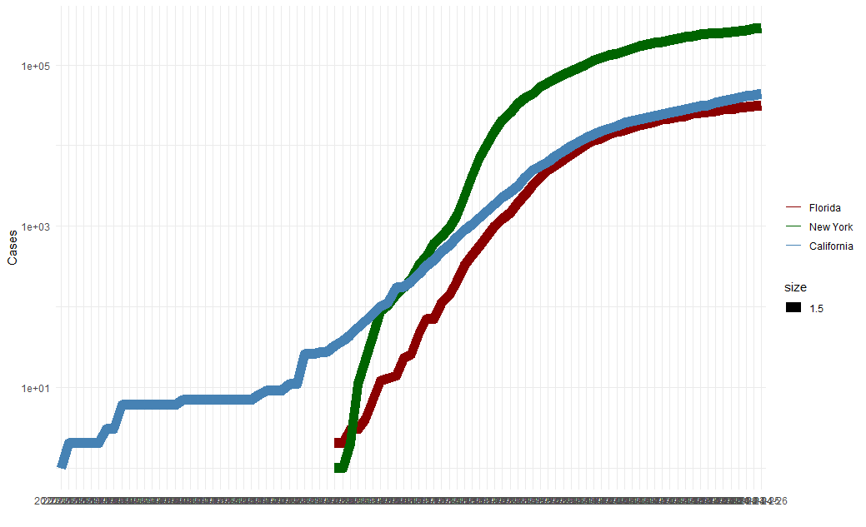
All Cases Log Plot

Add a Quote
- “Imagination is more important than knowledge. For knowledge is limited to all we now know and understand, while imagination embraces the entire world, and all there ever will be to know and understand.” - Albert Einstein

Add an Equation
$$
E=mc^2
$$

Add a Footnote
R Markdown is pretty cool

Add Citations
- R for Everyone (Jared P. Lander)
- Discovering Statistics Using R (Andy Field, Jeremy Miles, Zoe Field)

Inline Code

NY Times COVID-19 Data
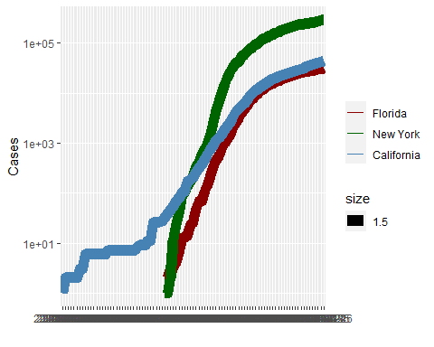

R4DS Height vs Earnings
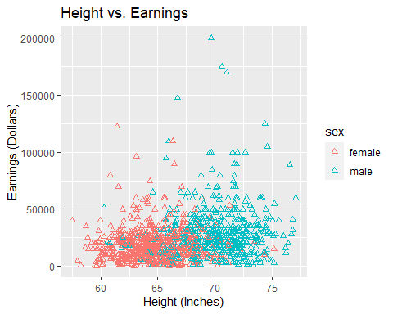

Tables

Knitr Table with Kable
One Ring To Rule Them ALL
name | race | in_fellowship | ring_bearer | age
Aragon | Men | TRUE | FALSE | 88
Bilbo | Hobbit | FALSE | TRUE | 129
Frodo | Hobbit | TRUE | TRUE | 51
Galadriel | Elf | FALSE | FALSE | 7000
Sam | Hobbit | TRUE | TRUE | 36
Gandalf | Maia | TRUE | TRUE | 2019
Legolas | Elf | TRUE | FALSE | 2931
Sauron | Maia | FALSE | TRUE | 7052
Gollum | Hobbit | FALSE | TRUE | 589

Pandoc Table
## +-----------+--------+---------------+-------------+------+
## | name | race | in_fellowship | ring_bearer | age |
## +===========+========+===============+=============+======+
## | Aragon | Men | TRUE | FALSE | 88 |
## +-----------+--------+---------------+-------------+------+
## | Bilbo | Hobbit | FALSE | TRUE | 129 |
## +-----------+--------+---------------+-------------+------+
## | Frodo | Hobbit | TRUE | TRUE | 51 |
## +-----------+--------+---------------+-------------+------+
## | Galadriel | Elf | FALSE | FALSE | 7000 |
## +-----------+--------+---------------+-------------+------+
## | Sam | Hobbit | TRUE | TRUE | 36 |
## +-----------+--------+---------------+-------------+------+
## | Gandalf | Maia | TRUE | TRUE | 2019 |
## +-----------+--------+---------------+-------------+------+
## | Legolas | Elf | TRUE | FALSE | 2931 |
## +-----------+--------+---------------+-------------+------+
## | Sauron | Maia | FALSE | TRUE | 7052 |
## +-----------+--------+---------------+-------------+------+
## | Gollum | Hobbit | FALSE | TRUE | 589 |
## +-----------+--------+---------------+-------------+------+

References
- Field, A., J. Miles, and Z. Field. 2012. Discovering Statistics Using R. SAGE Publications. https://books.google.com/books?id=wd2K2zC3swIC.
- Lander, J. P. 2014. R for Everyone: Advanced Analytics and Graphics. Addison-Wesley Data and Analytics Series. Addison-Wesley. https://books.google.com/books?id=3eBVAgAAQBAJ.

