ASSIGNMENT 4
Brett Sutow
2020-09-24

Markdown Basics

Favorite Foods
- Burger
- Steak
- Onion Rings

Images
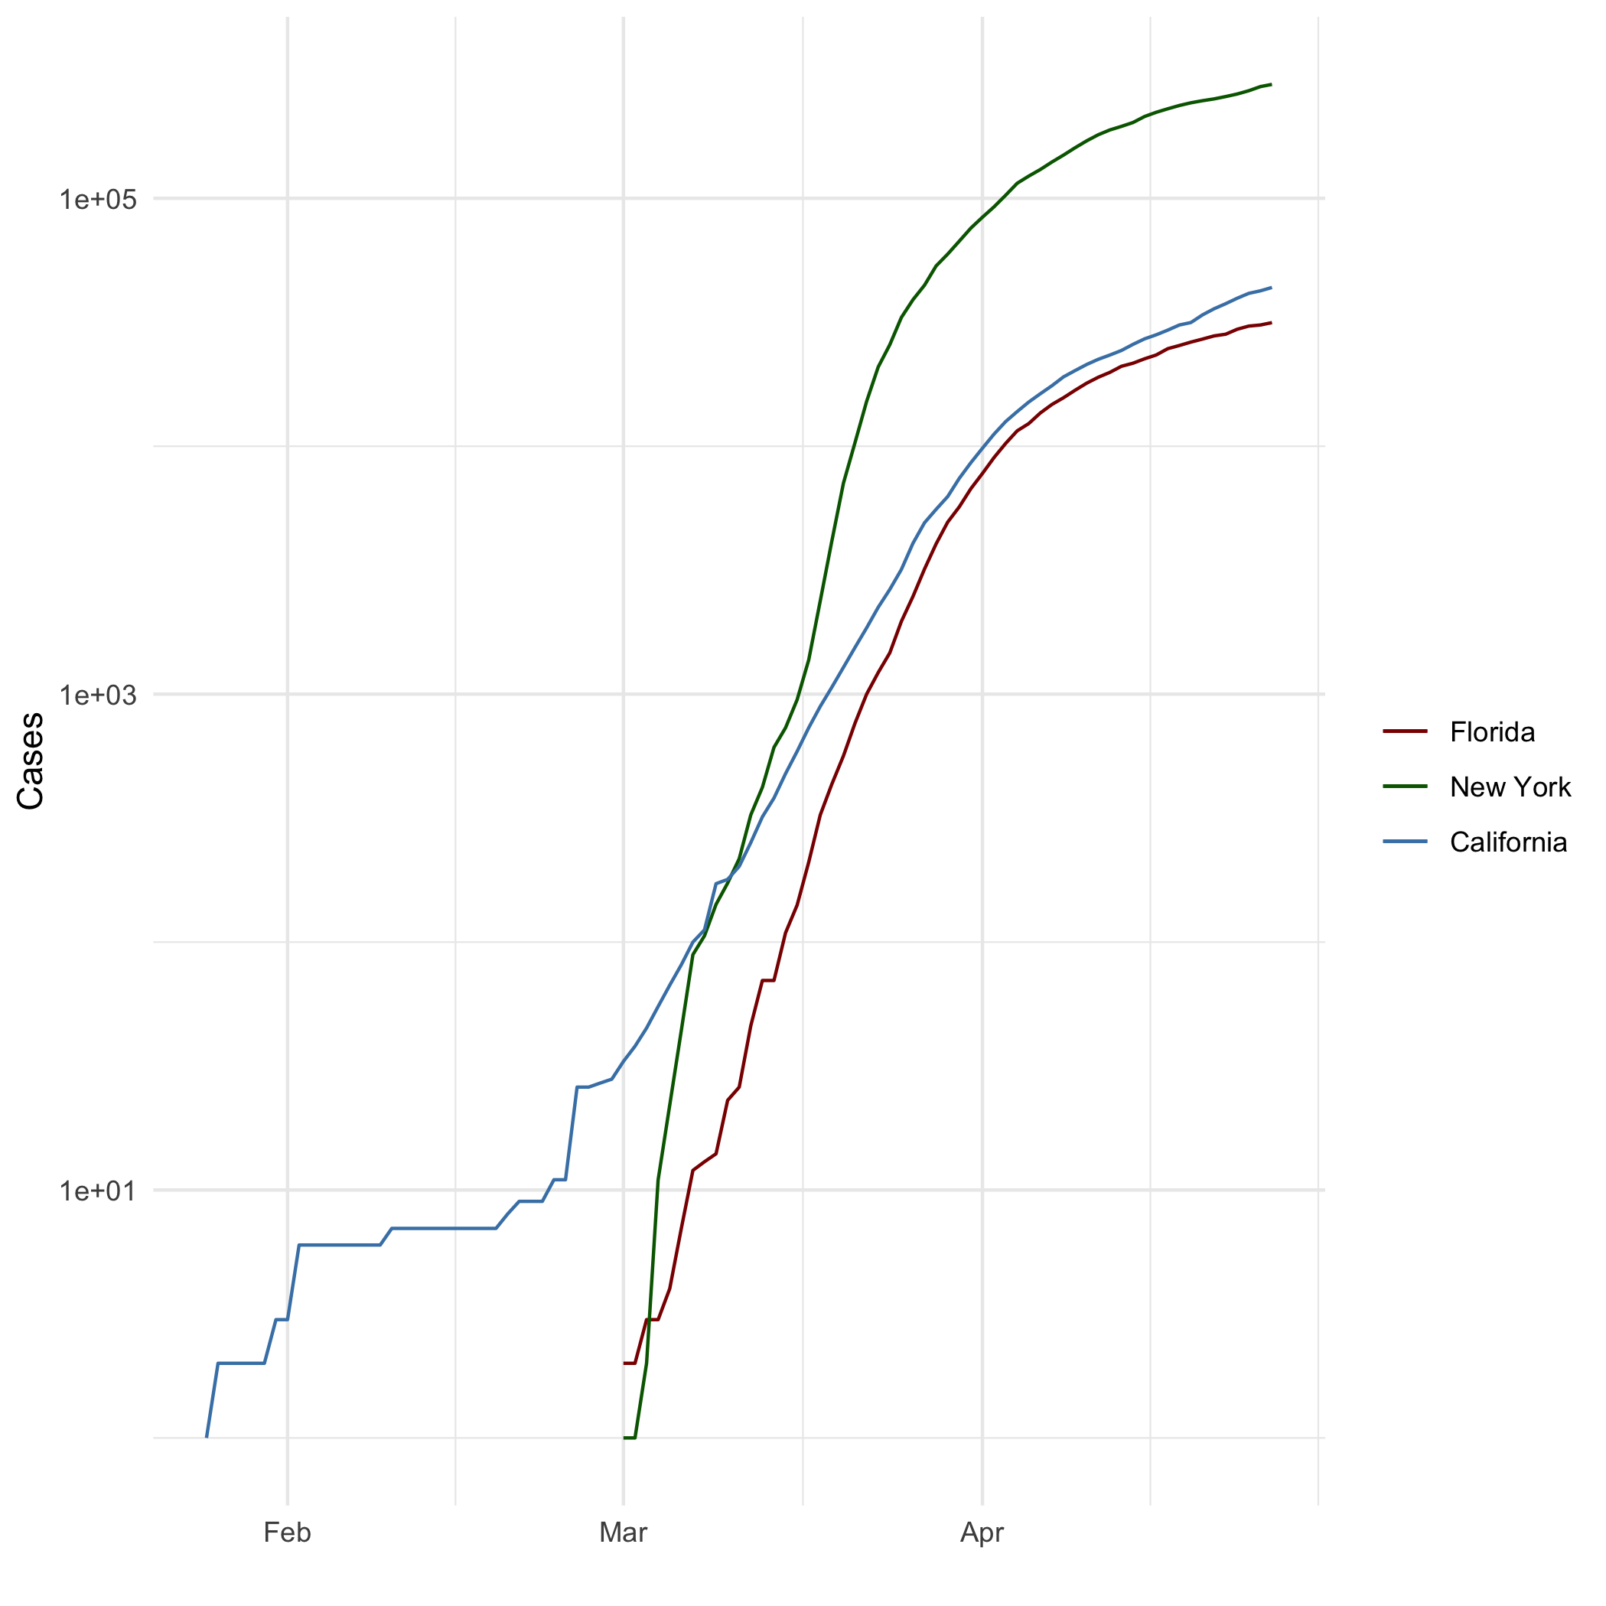
All Cases (Log Plot)

Add a Quote
I have no idea what I’m doing. But I know I’m doing it really, really well.

Add an Equation
$$10+10$$

Add a Footnote
Footnote

Add Citations
- R for Everyone(Lander 2014)
- Discovering Statistics Using R(Field, Miles, and Field 2012)

Inline Code

NY Times COVID-19 Data
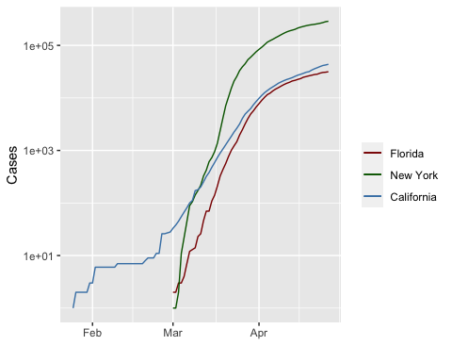

R4DS Height vs Earnings
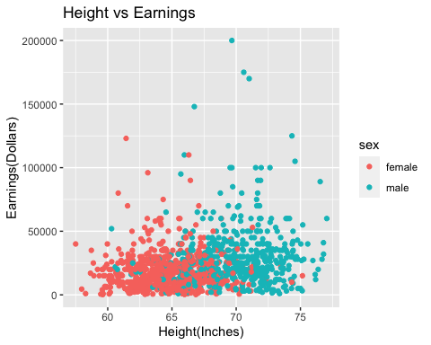

Tables

Knitr Table with Kable
One Ring to Rule Them All
name | race | in_fellowship | ring_bearer | age
Aragon | Men | TRUE | FALSE | 88
Bilbo | Hobbit | FALSE | TRUE | 129
Frodo | Hobbit | TRUE | TRUE | 51
Galadriel | Elf | FALSE | FALSE | 7000
Sam | Hobbit | TRUE | TRUE | 36
Gandalf | Maia | TRUE | TRUE | 2019
Legolas | Elf | TRUE | FALSE | 2931
Sauron | Maia | FALSE | TRUE | 7052
Gollum | Hobbit | FALSE | TRUE | 589

Pandoc Table
One Ring to Rule Them All
Name | Race | In Fellowship? | Is Ring Bearer? | Age
Aragon | Men | TRUE | FALSE | 88
Bilbo | Hobbit | FALSE | TRUE | 129
Frodo | Hobbit | TRUE | TRUE | 51
Galadriel | Elf | FALSE | FALSE | 7000
Sam | Hobbit | TRUE | TRUE | 36
Gandalf | Maia | TRUE | TRUE | 2019
Legolas | Elf | TRUE | FALSE | 2931
Sauron | Maia | FALSE | TRUE | 7052
Gollum | Hobbit | FALSE | TRUE | 589

References
Field, A., Miles, J., & Field, Z. (2012). Discovering Statistics Using R (1st ed.). SAGE Publications Ltd.
Lander, J. (2017). R for Everyone: Advanced Analytics and Graphics (Addison-Wesley Data & Analytics Series) (2nd ed.). Addison-Wesley Professional.

This is a footnote for the assignment

