ASSIGNMENT 4
Michael Paris
2020-01-06

Markdown Basics

Favorite Foods
- Barbecue Brisket
- Lasagna
- Mexican (Any Mexican)

Images
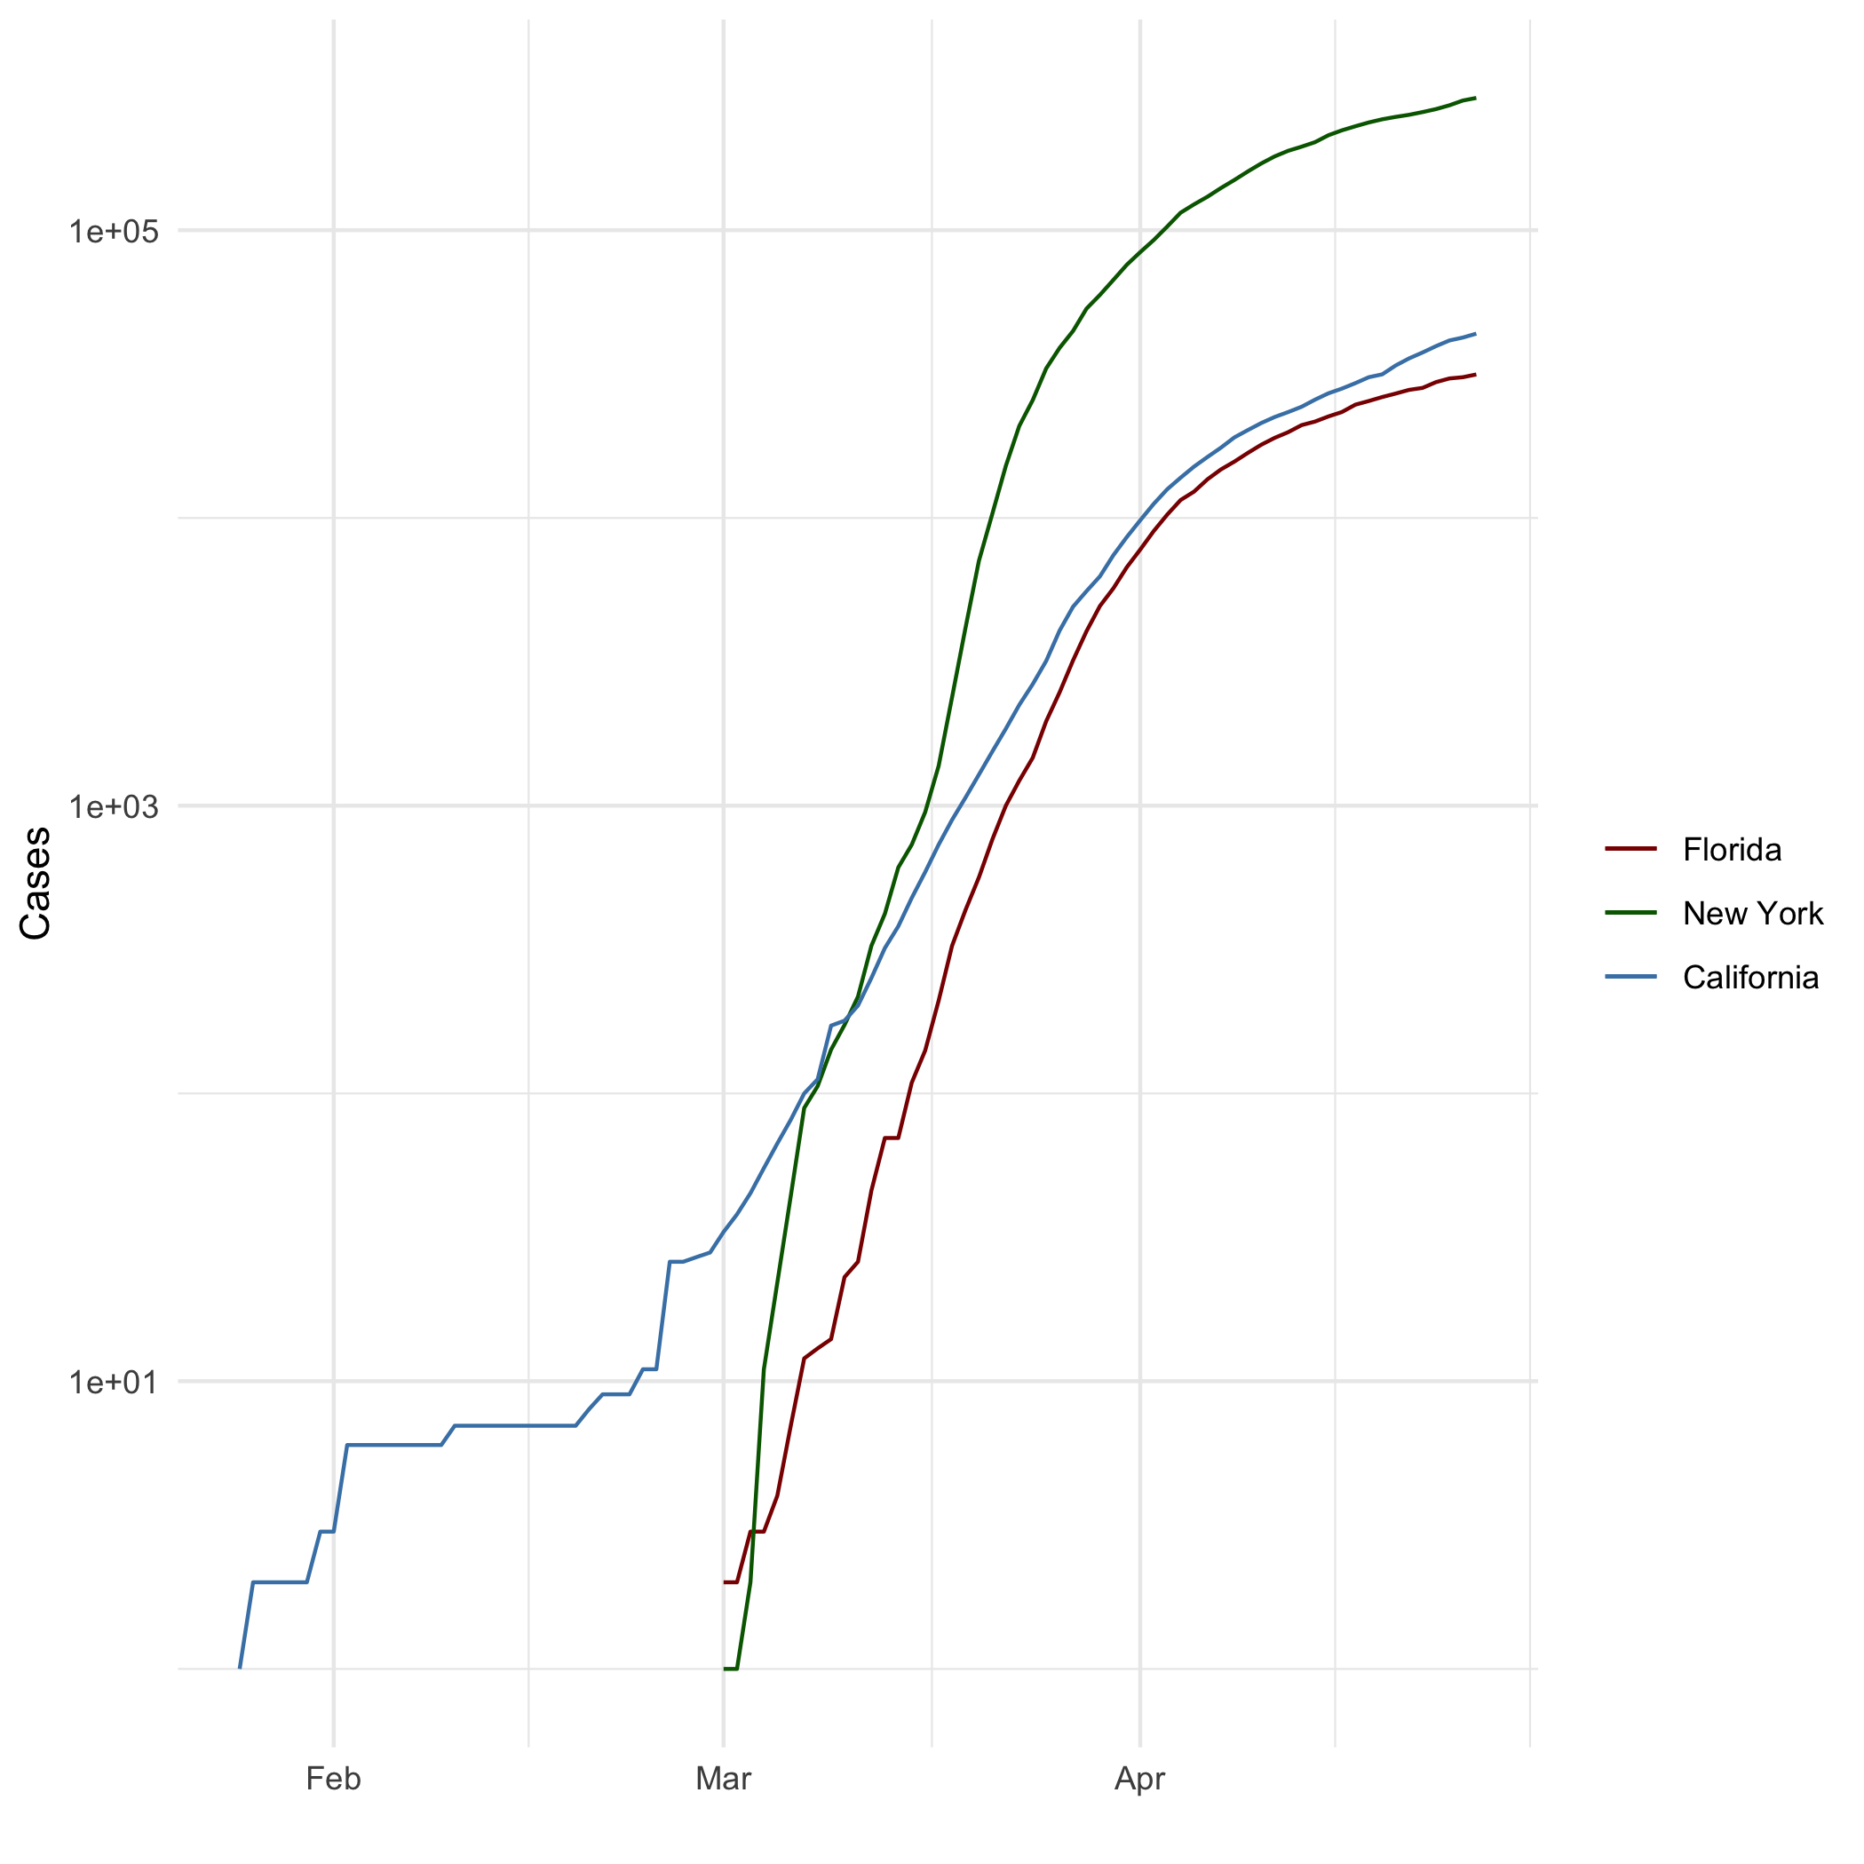
All Cases (Log Plot)

Add a Quote
As far back as I can remember, I always wanted to be a gangster.

Add an Equation
$y=mx+b$
$$y=mx+b$$

Add a Footnote
Here is the first footnote[^1] And here is the second footnote[^2]

Add Citations
- R for Everyone
- Discovering Statistics Using R

Inline Code
library(ggplot2)
theme_set(theme_minimal())
## Set the working directory to the root of your DSC 520 directory
setwd("C:/Users/mpari/OneDrive/DSC520/dsc520/")
## Load the `data/r4ds/heights.csv` to
heights_df <- read.csv("data/r4ds/heights.csv")
## Load the file `"data/nytimes/covid-19-data/us-states.csv"` and
## assign it to the `covid_df` dataframe
covid_df <- read.csv("data/nytimes/covid-19-data/us-states.csv")
## Parse the date column using `as.Date()``
covid_df$date <- as.Date(covid_df$date)
View(covid_df)
typeof(covid_df$date)
## [1] "double"
## Create three dataframes named `california_df`, `ny_df`, and `florida_df`
## containing the data from California, New York, and Florida
california_df <- covid_df[ which( covid_df$state == "California"), ]
ny_df <- covid_df[ which( covid_df$state == "New York"), ]
florida_df <- covid_df[ which( covid_df$state == "Florida"), ]

NY Times COVID-19 Data

R4DS Height vs Earnings

Tables

Knitr Table with Kable

Pandoc Table

References

