Exercise15

R Exercise 15
setwd("~/MadR/Workspaces/dsc520")

Loading data from file
data.binary=read.csv("data/binary-classifier-data.csv")
data.trinary=read.csv("data/trinary-classifier-data.csv")
summary(data.binary)
## label x y
## Min. :0.000 Min. : -5.20 Min. : -4.019
## 1st Qu.:0.000 1st Qu.: 19.77 1st Qu.: 21.207
## Median :0.000 Median : 41.76 Median : 44.632
## Mean :0.488 Mean : 45.07 Mean : 45.011
## 3rd Qu.:1.000 3rd Qu.: 66.39 3rd Qu.: 68.698
## Max. :1.000 Max. :104.58 Max. :106.896
summary(data.trinary)
## label x y
## Min. :0.000 Min. :-10.26 Min. : -1.541
## 1st Qu.:0.000 1st Qu.: 31.15 1st Qu.: 35.906
## Median :1.000 Median : 45.59 Median : 55.073
## Mean :1.037 Mean : 48.86 Mean : 55.282
## 3rd Qu.:2.000 3rd Qu.: 66.27 3rd Qu.: 77.403
## Max. :2.000 Max. :108.56 Max. :104.293

a. Plot the data from each dataset using a scatter plot.
plot(data.binary$x,data.binary$y,col=data.binary$label +1,
main="Scatterplot Binary Classifier", xlab="X ", ylab="Y ")
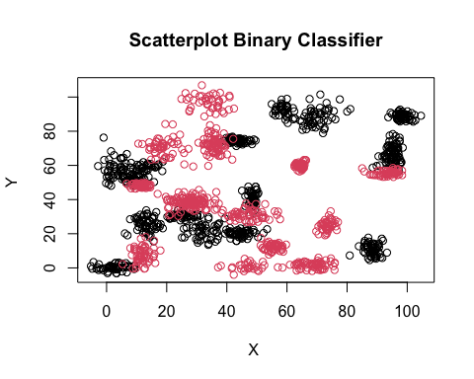
plot(data.trinary$x,data.trinary$y,col=data.trinary$label +1,
main="Scatterplot Trinary Classifier", xlab="X ", ylab="Y ")
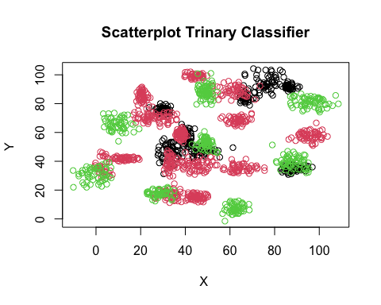 ### b - Binary data set
set.seed(9850)
gp<-runif(nrow(data.binary))
data.binary<-data.binary[order(gp),]
head(data.binary)
## label x y
## 216 0 12.006713 58.20435
## 405 0 88.024357 13.26384
## 316 0 7.993121 54.15258
## 804 1 16.669075 73.98231
## 103 0 40.565872 74.84798
## 20 0 69.521713 89.94501
normalize<-function(x){
return (
(x - min(x))/max(x)-min(x)
)
}
data.binary.n<-as.data.frame(lapply(data.binary[,c(2:3)], normalize))
str(data.binary.n)
## 'data.frame': 1498 obs. of 2 variables:
## $ x: num 5.37 6.09 5.33 5.41 5.64 ...
## $ y: num 4.6 4.18 4.56 4.75 4.76 ...
summary(data.binary.n)
## x y
## Min. :5.200 Min. :4.019
## 1st Qu.:5.439 1st Qu.:4.255
## Median :5.650 Median :4.475
## Mean :5.681 Mean :4.478
## 3rd Qu.:5.885 3rd Qu.:4.700
## Max. :6.250 Max. :5.057
r<-round(0.8*nrow(data.binary.n))
l<-nrow(data.binary.n)
data.train<-data.binary.n[1:r,]
data.test<-data.binary.n[r:l,]
data.train.target<-data.binary[1:r,1]
data.test.target<-data.binary[r:l,1]
k_value<-round(sqrt(nrow(data.binary)))

calculatig knn and accuracy for each k =3 , 5 ,10 ,15 ,20 , 25 and 39
library("class")
knn.3<- knn(train = data.train, test=data.test,cl=data.train.target, k=3)
ACC.3<-100 * sum( data.test.target == knn.3) / NROW(data.test.target)
table(data.test.target,knn.3)
## knn.3
## data.test.target 0 1
## 0 156 2
## 1 2 141
ACC.3
## [1] 98.6711
knn.5<- knn(train = data.train, test=data.test,cl=data.train.target, k=5)
ACC.5<-100 * sum( data.test.target == knn.5) / NROW(data.test.target)
table(data.test.target,knn.5)
## knn.5
## data.test.target 0 1
## 0 156 2
## 1 1 142
ACC.5
## [1] 99.00332
knn.10<- knn(train = data.train, test=data.test,cl=data.train.target, k=10)
ACC.10<-100 * sum( data.test.target == knn.10) / NROW(data.test.target)
table(data.test.target,knn.10)
## knn.10
## data.test.target 0 1
## 0 156 2
## 1 0 143
ACC.10
## [1] 99.33555
knn.15<- knn(train = data.train, test=data.test,cl=data.train.target, k=15)
ACC.15<-100 * sum( data.test.target == knn.15) / NROW(data.test.target)
table(data.test.target,knn.15)
## knn.15
## data.test.target 0 1
## 0 156 2
## 1 1 142
ACC.15
## [1] 99.00332
knn.20<- knn(train = data.train, test=data.test,cl=data.train.target, k=20)
ACC.20<-100 * sum( data.test.target == knn.20) / NROW(data.test.target)
table(data.test.target,knn.20)
## knn.20
## data.test.target 0 1
## 0 156 2
## 1 0 143
ACC.20
## [1] 99.33555
knn.25<- knn(train = data.train, test=data.test,cl=data.train.target, k=25)
ACC.25<-100 * sum( data.test.target == knn.25) / NROW(data.test.target)
table(data.test.target,knn.25)
## knn.25
## data.test.target 0 1
## 0 156 2
## 1 1 142
ACC.25
## [1] 99.00332
knn.39<- knn(train = data.train, test=data.test,cl=data.train.target, k=k_value)
ACC.39<-100 * sum( data.test.target == knn.39) / NROW(data.test.target)
table(data.test.target,knn.39)
## knn.39
## data.test.target 0 1
## 0 156 2
## 1 1 142
ACC.39
## [1] 99.00332

Plot for binary knn data
binary.plot<- data.frame("K.Value"=c(3,5,10,15,20,25,39),
"Accuracy"=c(ACC.3,ACC.5,ACC.10,ACC.15,ACC.20,ACC.25,ACC.39)
)
library(caret)
## Loading required package: lattice
## Loading required package: ggplot2
plot(binary.plot,
main="K Value vs Accuracy",
xlab="K Value ", ylab="Accuracy",type="l"
)
text(binary.plot[, 'K.Value'], binary.plot[, 'Accuracy'], binary.plot$K.Value,
cex = 0.88, pos = 2, col = "darkgreen")
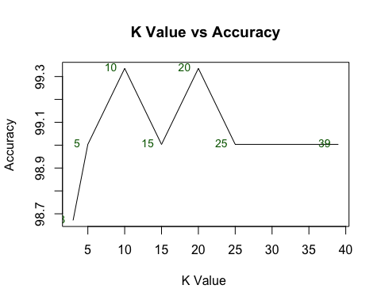

decision plot function
decisionplot <- function(model, data, class = NULL, predict_type = "class",
resolution = 100, showgrid = TRUE, ...) {
if(!is.null(class)) cl <- data[,class] else cl <- 1
data <- data[,2:3]
k <- length(unique(cl))
plot(data, col = as.integer(cl)+1L, pch = as.integer(cl)+1L, ...)
# make grid
r <- sapply(data, range, na.rm = TRUE)
xs <- seq(r[1,1], r[2,1], length.out = resolution)
ys <- seq(r[1,2], r[2,2], length.out = resolution)
g <- cbind(rep(xs, each=resolution), rep(ys, time = resolution))
colnames(g) <- colnames(r)
g <- as.data.frame(g)
### guess how to get class labels from predict
### (unfortunately not very consistent between models)
p <- predict(model, g, type = predict_type)
if(is.list(p)) p <- p$class
p <- as.factor(p)
if(showgrid) points(g, col = as.integer(p)+1L, pch = ".")
z <- matrix(as.integer(p), nrow = resolution, byrow = TRUE)
contour(xs, ys, z, add = TRUE, drawlabels = FALSE,
lwd = 2, levels = (1:(k-1))+.5)
invisible(z)
}

c. Decision boundry for binary dataset
library(lattice)
model <- glm(label ~., data = data.binary)
class(model) <- c("lr", class(model))
predict.lr <- function(object, newdata, ...)
predict.glm(object, newdata, type = "response") > .5
decisionplot(model, data.binary, class = "label", main = "Logistic Regression")
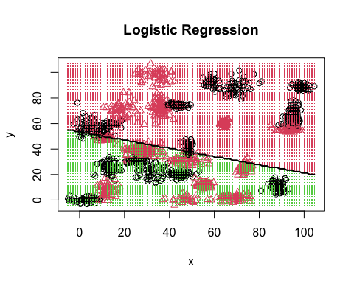

Trinary

b - Trinary data set
set.seed(9850)
gp<-runif(nrow(data.trinary))
data.trinary<-data.trinary[order(gp),]
head(data.trinary)
## label x y
## 216 0 30.10783 74.34244
## 405 1 38.91000 37.00775
## 316 0 41.34978 61.17379
## 804 1 37.79238 57.31985
## 1554 2 98.14194 80.07052
## 103 0 90.54824 36.35014
normalize<-function(x){
return (
(x - min(x))/max(x)-min(x)
)
}
data.trinary.n<-as.data.frame(lapply(data.trinary[,c(2:3)], normalize))
str(data.trinary.n)
## 'data.frame': 1568 obs. of 2 variables:
## $ x: num 10.6 10.7 10.7 10.7 11.3 ...
## $ y: num 2.27 1.91 2.14 2.11 2.32 ...
summary(data.trinary.n)
## x y
## Min. :10.26 Min. :1.541
## 1st Qu.:10.64 1st Qu.:1.900
## Median :10.78 Median :2.084
## Mean :10.81 Mean :2.086
## 3rd Qu.:10.97 3rd Qu.:2.298
## Max. :11.36 Max. :2.556
r<-round(0.8*nrow(data.trinary.n))
l<-nrow(data.trinary.n)
data.train<-data.trinary.n[1:r,]
data.test<-data.trinary.n[r:l,]
data.train.target<-data.trinary[1:r,1]
data.test.target<-data.trinary[r:l,1]
k_value<-round(sqrt(nrow(data.trinary)))

calculatig knn and accuracy for each k =3 , 5 ,10 ,15 ,20 , 25 and 39
library("class")
knn.3<- knn(train = data.train, test=data.test,cl=data.train.target, k=3)
ACC.3<-100 * sum( data.test.target == knn.3) / NROW(data.test.target)
table(data.test.target,knn.3)
## knn.3
## data.test.target 0 1 2
## 0 65 9 4
## 1 6 126 8
## 2 8 4 85
ACC.3
## [1] 87.61905
knn.5<- knn(train = data.train, test=data.test,cl=data.train.target, k=5)
ACC.5<-100 * sum( data.test.target == knn.5) / NROW(data.test.target)
table(data.test.target,knn.5)
## knn.5
## data.test.target 0 1 2
## 0 65 9 4
## 1 6 127 7
## 2 8 5 84
ACC.5
## [1] 87.61905
knn.10<- knn(train = data.train, test=data.test,cl=data.train.target, k=10)
ACC.10<-100 * sum( data.test.target == knn.10) / NROW(data.test.target)
table(data.test.target,knn.10)
## knn.10
## data.test.target 0 1 2
## 0 68 8 2
## 1 7 124 9
## 2 10 5 82
ACC.10
## [1] 86.98413
knn.15<- knn(train = data.train, test=data.test,cl=data.train.target, k=15)
ACC.15<-100 * sum( data.test.target == knn.15) / NROW(data.test.target)
table(data.test.target,knn.15)
## knn.15
## data.test.target 0 1 2
## 0 66 10 2
## 1 6 125 9
## 2 12 4 81
ACC.15
## [1] 86.34921
knn.20<- knn(train = data.train, test=data.test,cl=data.train.target, k=20)
ACC.20<-100 * sum( data.test.target == knn.20) / NROW(data.test.target)
table(data.test.target,knn.20)
## knn.20
## data.test.target 0 1 2
## 0 65 10 3
## 1 6 126 8
## 2 11 3 83
ACC.20
## [1] 86.98413
knn.25<- knn(train = data.train, test=data.test,cl=data.train.target, k=25)
ACC.25<-100 * sum( data.test.target == knn.25) / NROW(data.test.target)
table(data.test.target,knn.25)
## knn.25
## data.test.target 0 1 2
## 0 63 13 2
## 1 8 124 8
## 2 10 3 84
ACC.25
## [1] 86.03175
knn.39<- knn(train = data.train, test=data.test,cl=data.train.target, k=k_value)
ACC.39<-100 * sum( data.test.target == knn.39) / NROW(data.test.target)
table(data.test.target,knn.39)
## knn.39
## data.test.target 0 1 2
## 0 64 11 3
## 1 9 121 10
## 2 13 1 83
ACC.39
## [1] 85.07937

Plot for trinary knn data
library(purrr)
##
## Attaching package: 'purrr'
## The following object is masked from 'package:caret':
##
## lift
trinary.plot<- data.frame("K.Value"=c(3,5,10,15,20,25,39),
"Accuracy"=c(ACC.3,ACC.5,ACC.10,ACC.15,ACC.20,ACC.25,ACC.39)
)
library(caret)
plot(trinary.plot,
main="K Value vs Accuracy",
xlab="K Value ", ylab="Accuracy",type="l"
)
text(trinary.plot[, 'K.Value'], trinary.plot[, 'Accuracy'],
trinary.plot$K.Value,
cex = 0.88, pos = 2, col = "darkgreen")
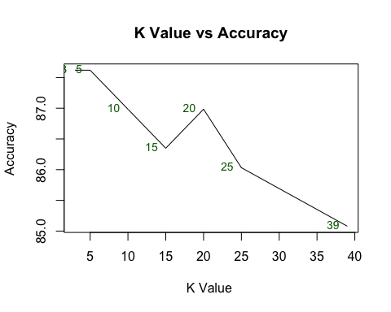

Decision boundry for trinary dataset
model <- glm(label ~., data = data.trinary)
class(model) <- c("lr", class(model))
predict.lr <- function(object, newdata, ...)
predict.glm(object, newdata, type = "response") > .5
decisionplot(model, data.trinary, class = "label", main = "Logistic Regression")
## Warning in contour.default(xs, ys, z, add = TRUE, drawlabels = FALSE, lwd = 2, :
## all z values are equal
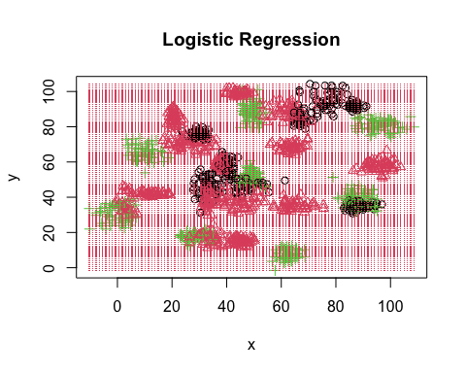

data doesn’t look suitable for linear classifier

