Ayachit Madhukar Exercise16

Exercise 16

reading file to create data frame
setwd("~/MadR/Workspaces/dsc520")
data.cluster=read.csv("data/clustering-data.csv")

a. Creating initial plot and observing data /structure using str() and summary()
summary(data.cluster)
## x y
## Min. : 0.0 Min. :134.0
## 1st Qu.: 56.0 1st Qu.:141.0
## Median : 82.0 Median :154.0
## Mean :109.6 Mean :175.7
## 3rd Qu.:180.0 3rd Qu.:218.0
## Max. :249.0 Max. :236.0
str(data.cluster)
## 'data.frame': 4022 obs. of 2 variables:
## $ x: int 46 69 144 171 194 195 221 244 45 47 ...
## $ y: int 236 236 236 236 236 236 236 236 235 235 ...
plot(data.cluster,col=c("red","blue"),type="b")
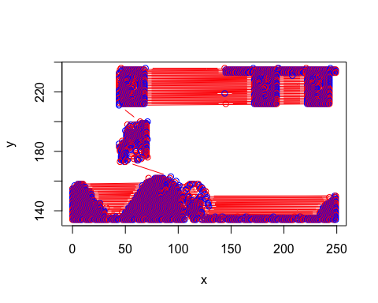

b. Preparing clusters for k=2 to 12 and plotting all the results for visualization
library(factoextra)
## Loading required package: ggplot2
## Welcome! Want to learn more? See two factoextra-related books at https://goo.gl/ve3WBa
library(gridExtra)
result<-NULL
for (i in 2:12) result[i]<-sum(kmeans(data.cluster,centers = i)$tot.withinss)
plot(1:12,result,type="b",xlab = "k",ylab = "cluster")
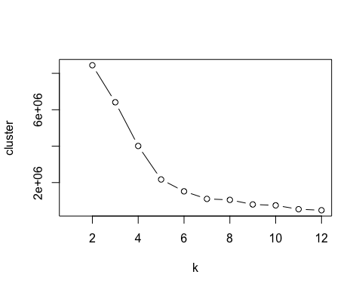
results2<-kmeans(data.cluster,2)
results3<-kmeans(data.cluster,3)
results4<-kmeans(data.cluster,4)
results5<-kmeans(data.cluster,5)
results6<-kmeans(data.cluster,6)
results7<-kmeans(data.cluster,7)
results8<-kmeans(data.cluster,8)
results9<-kmeans(data.cluster,9)
results10<-kmeans(data.cluster,10)
results11<-kmeans(data.cluster,11)
results12<-kmeans(data.cluster,12)
p2 <- fviz_cluster(results2, geom = "point", data = data.cluster) + ggtitle("k = 2")
p3 <- fviz_cluster(results3, geom = "point", data = data.cluster) + ggtitle("k = 3")
p4 <- fviz_cluster(results4, geom = "point", data = data.cluster) + ggtitle("k = 4")
p5 <- fviz_cluster(results5, geom = "point", data = data.cluster) + ggtitle("k = 5")
p6 <- fviz_cluster(results6, geom = "point", data = data.cluster) + ggtitle("k = 6")
p7 <- fviz_cluster(results7, geom = "point", data = data.cluster) + ggtitle("k = 7")
p8 <- fviz_cluster(results8, geom = "point", data = data.cluster) + ggtitle("k = 8")
p9 <- fviz_cluster(results9, geom = "point", data = data.cluster) + ggtitle("k = 9")
p10 <- fviz_cluster(results10, geom = "point", data = data.cluster) + ggtitle("k = 10")
p11 <- fviz_cluster(results11, geom = "point", data = data.cluster) + ggtitle("k = 11")
p12 <- fviz_cluster(results12, geom = "point", data = data.cluster) + ggtitle("k = 12")
grid.arrange(p2,p3,p4,p5,nrow = 2)
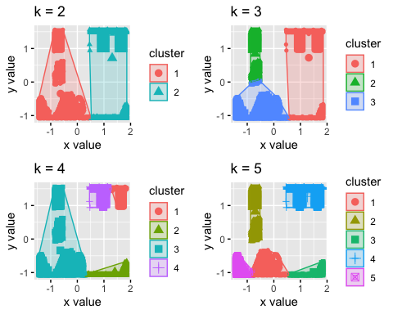
grid.arrange(p6,p7,p8,p9,nrow = 2)
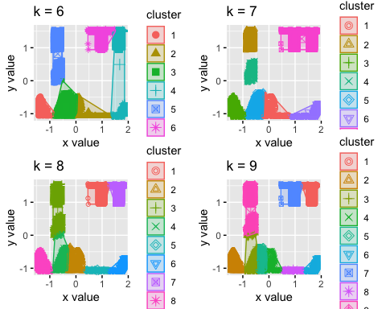
grid.arrange(p11,p12,nrow = 2)
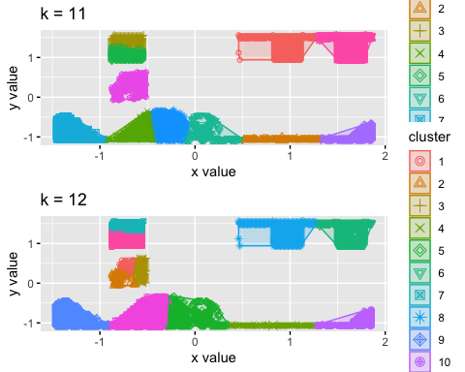

c. measuring distance and depicting in the graph
fviz_cluster(results2, data.cluster, ellipse.type = "norm")
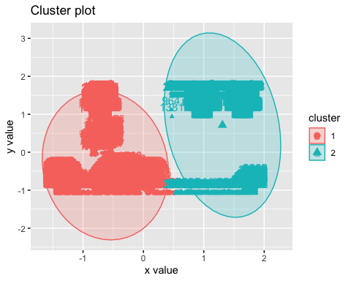
distance2 <- get_dist(data.cluster)
fviz_dist(distance2, gradient = list(low = "#00AFBB", mid = "white", high = "#FC4E07") )
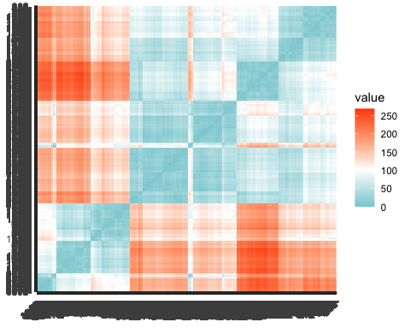

Euclidean Distance
df<-data.cluster
distances <- c()
for(i in 1:12){
model <- kmeans(df, i)
df$label <- as.factor(model$cluster)
centers <- as.data.frame(model$centers)
df$distance <- sqrt((df$x - model$centers[df$label,'x']) ** 2 + (df$y - model$centers[df$label,'y']) ** 2)
distances[i] <- mean(df$distance)
}
k.values <- 1:12
dist.df <- data.frame(k.values, distances)
dist.df
## k.values distances
## 1 1 77.167350
## 2 2 41.978341
## 3 3 36.592068
## 4 4 32.784284
## 5 5 20.312355
## 6 6 18.426538
## 7 7 14.396121
## 8 8 13.213105
## 9 9 15.613320
## 10 10 11.806528
## 11 11 11.783259
## 12 12 9.689453

Elbow
library(purrr)
library(cluster)
# function to compute total within-cluster sum of square
wss <- function(k) {
kmeans(data.cluster, k, nstart = 10 )$tot.withinss
}
# Compute and plot wss for k = 1 to k = 15
k.values <- 2:12
# extract wss for 2-12 clusters
wss_values <- map_dbl(k.values, wss)
plot(k.values, wss_values,main="Elbow",
type="b", pch = 19, frame = FALSE,
xlab="Number of clusters K",
ylab="Total within-clusters sum of squares")
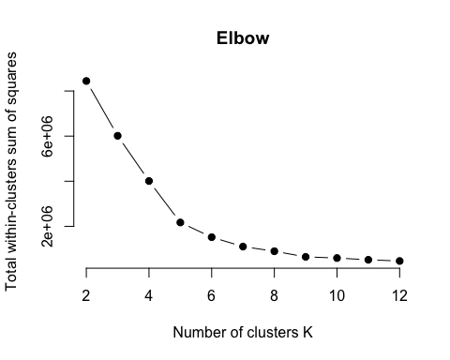
fviz_nbclust(data.cluster, kmeans, method = "silhouette")
