ASSIGNMENT 4
Ayachit Madhukar
2020-09-21

Markdown Basics

Favorite Foods
1.Pizza
2.Tacos
3.Pad Thai

Images
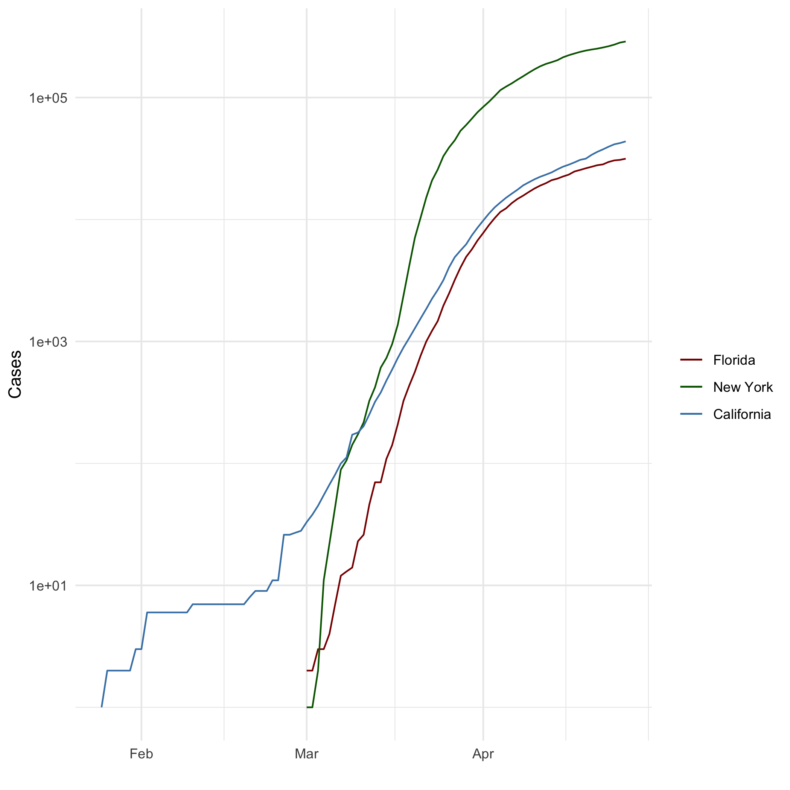
‘All Cases (Log Plot)’

Add a Quote
The path of the righteous man is beset on all sides by the iniquities of the selfish and the tyranny of evil men. Blessed is he who, in the name of charity and good will, shepherds the weak through the valley of darkness, for he is truly his brother’s keeper and the finder of lost children. And I will strike down upon thee with great vengeance and furious anger those who would attempt to poison and destroy My brothers. And you will know My name is the Lord when I lay My vengeance upon thee.

Add an Equation
$$P(A|B)=P(B|A)P(A)/P(B)$$

Add a Footnote
This is a footnote from assigbnment 4 Markdown

Add Citations
- R for Everyone (Lander 2014)
- Discovering Statistics Using R (Field, Miles, and Field 2012)

Inline Code

NY Times COVID-19 Data
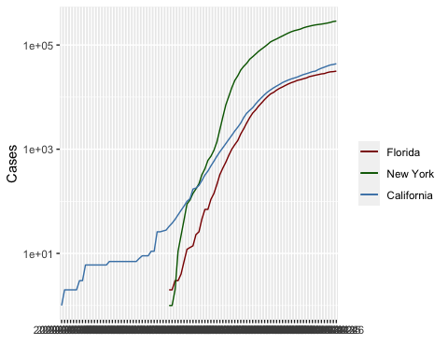

R4DS Height vs Earnings
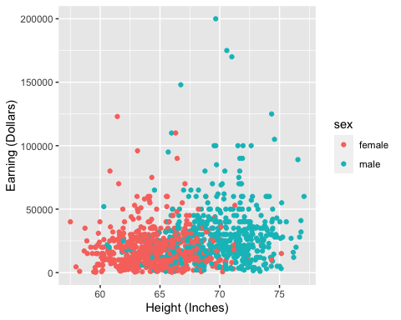

Tables

Knitr Table with Kable
name <- c("Aragon", "Bilbo", "Frodo", "Galadriel", "Sam", "Gandalf", "Legolas", "Sauron", "Gollum")
race <- c("Men", "Hobbit", "Hobbit", "Elf", "Hobbit", "Maia", "Elf", "Maia", "Hobbit")
in_fellowship <- c(TRUE, FALSE, TRUE, FALSE, TRUE, TRUE, TRUE, FALSE, FALSE)
ring_bearer <- c(FALSE, TRUE, TRUE, FALSE, TRUE, TRUE, FALSE, TRUE, TRUE)
age <- c(88, 129, 51, 7000, 36, 2019, 2931, 7052, 589)
characters_df <- data.frame(name, race, in_fellowship, ring_bearer, age)
knitr::kable(characters_df,row.names = NA,caption ="One Ring to Rule Them All" )
One Ring to Rule Them All
name | race | in_fellowship | ring_bearer | age
Aragon | Men | TRUE | FALSE | 88
Bilbo | Hobbit | FALSE | TRUE | 129
Frodo | Hobbit | TRUE | TRUE | 51
Galadriel | Elf | FALSE | FALSE | 7000
Sam | Hobbit | TRUE | TRUE | 36
Gandalf | Maia | TRUE | TRUE | 2019
Legolas | Elf | TRUE | FALSE | 2931
Sauron | Maia | FALSE | TRUE | 7052
Gollum | Hobbit | FALSE | TRUE | 589

Pandoc Table
##
## --------------------------------------------------------------
## Name Race In Fellowship? Is Ring Bearer? Age
## ----------- -------- ---------------- ----------------- ------
## Aragon Men TRUE FALSE 88
##
## Bilbo Hobbit FALSE TRUE 129
##
## Frodo Hobbit TRUE TRUE 51
##
## Galadriel Elf FALSE FALSE 7000
##
## Sam Hobbit TRUE TRUE 36
##
## Gandalf Maia TRUE TRUE 2019
##
## Legolas Elf TRUE FALSE 2931
##
## Sauron Maia FALSE TRUE 7052
##
## Gollum Hobbit FALSE TRUE 589
## --------------------------------------------------------------
##
## Table: One Ring to Rule Them All

References
Field, A., J. Miles, and Z. Field. 2012. Discovering Statistics Using R. SAGE Publications. https://books.google.com/books?id=wd2K2zC3swIC.
Lander, J. P. 2014. R for Everyone: Advanced Analytics and Graphics. Addison-Wesley Data and Analytics Series. Addison-Wesley. https://books.google.com/books?id=3eBVAgAAQBAJ.

