ASSIGNMENT 4
Orrin Boese
2020-01-08

Markdown Basics

Favorite Foods
- Pizza
- Quesadillas
- BBQ Brisket

Images
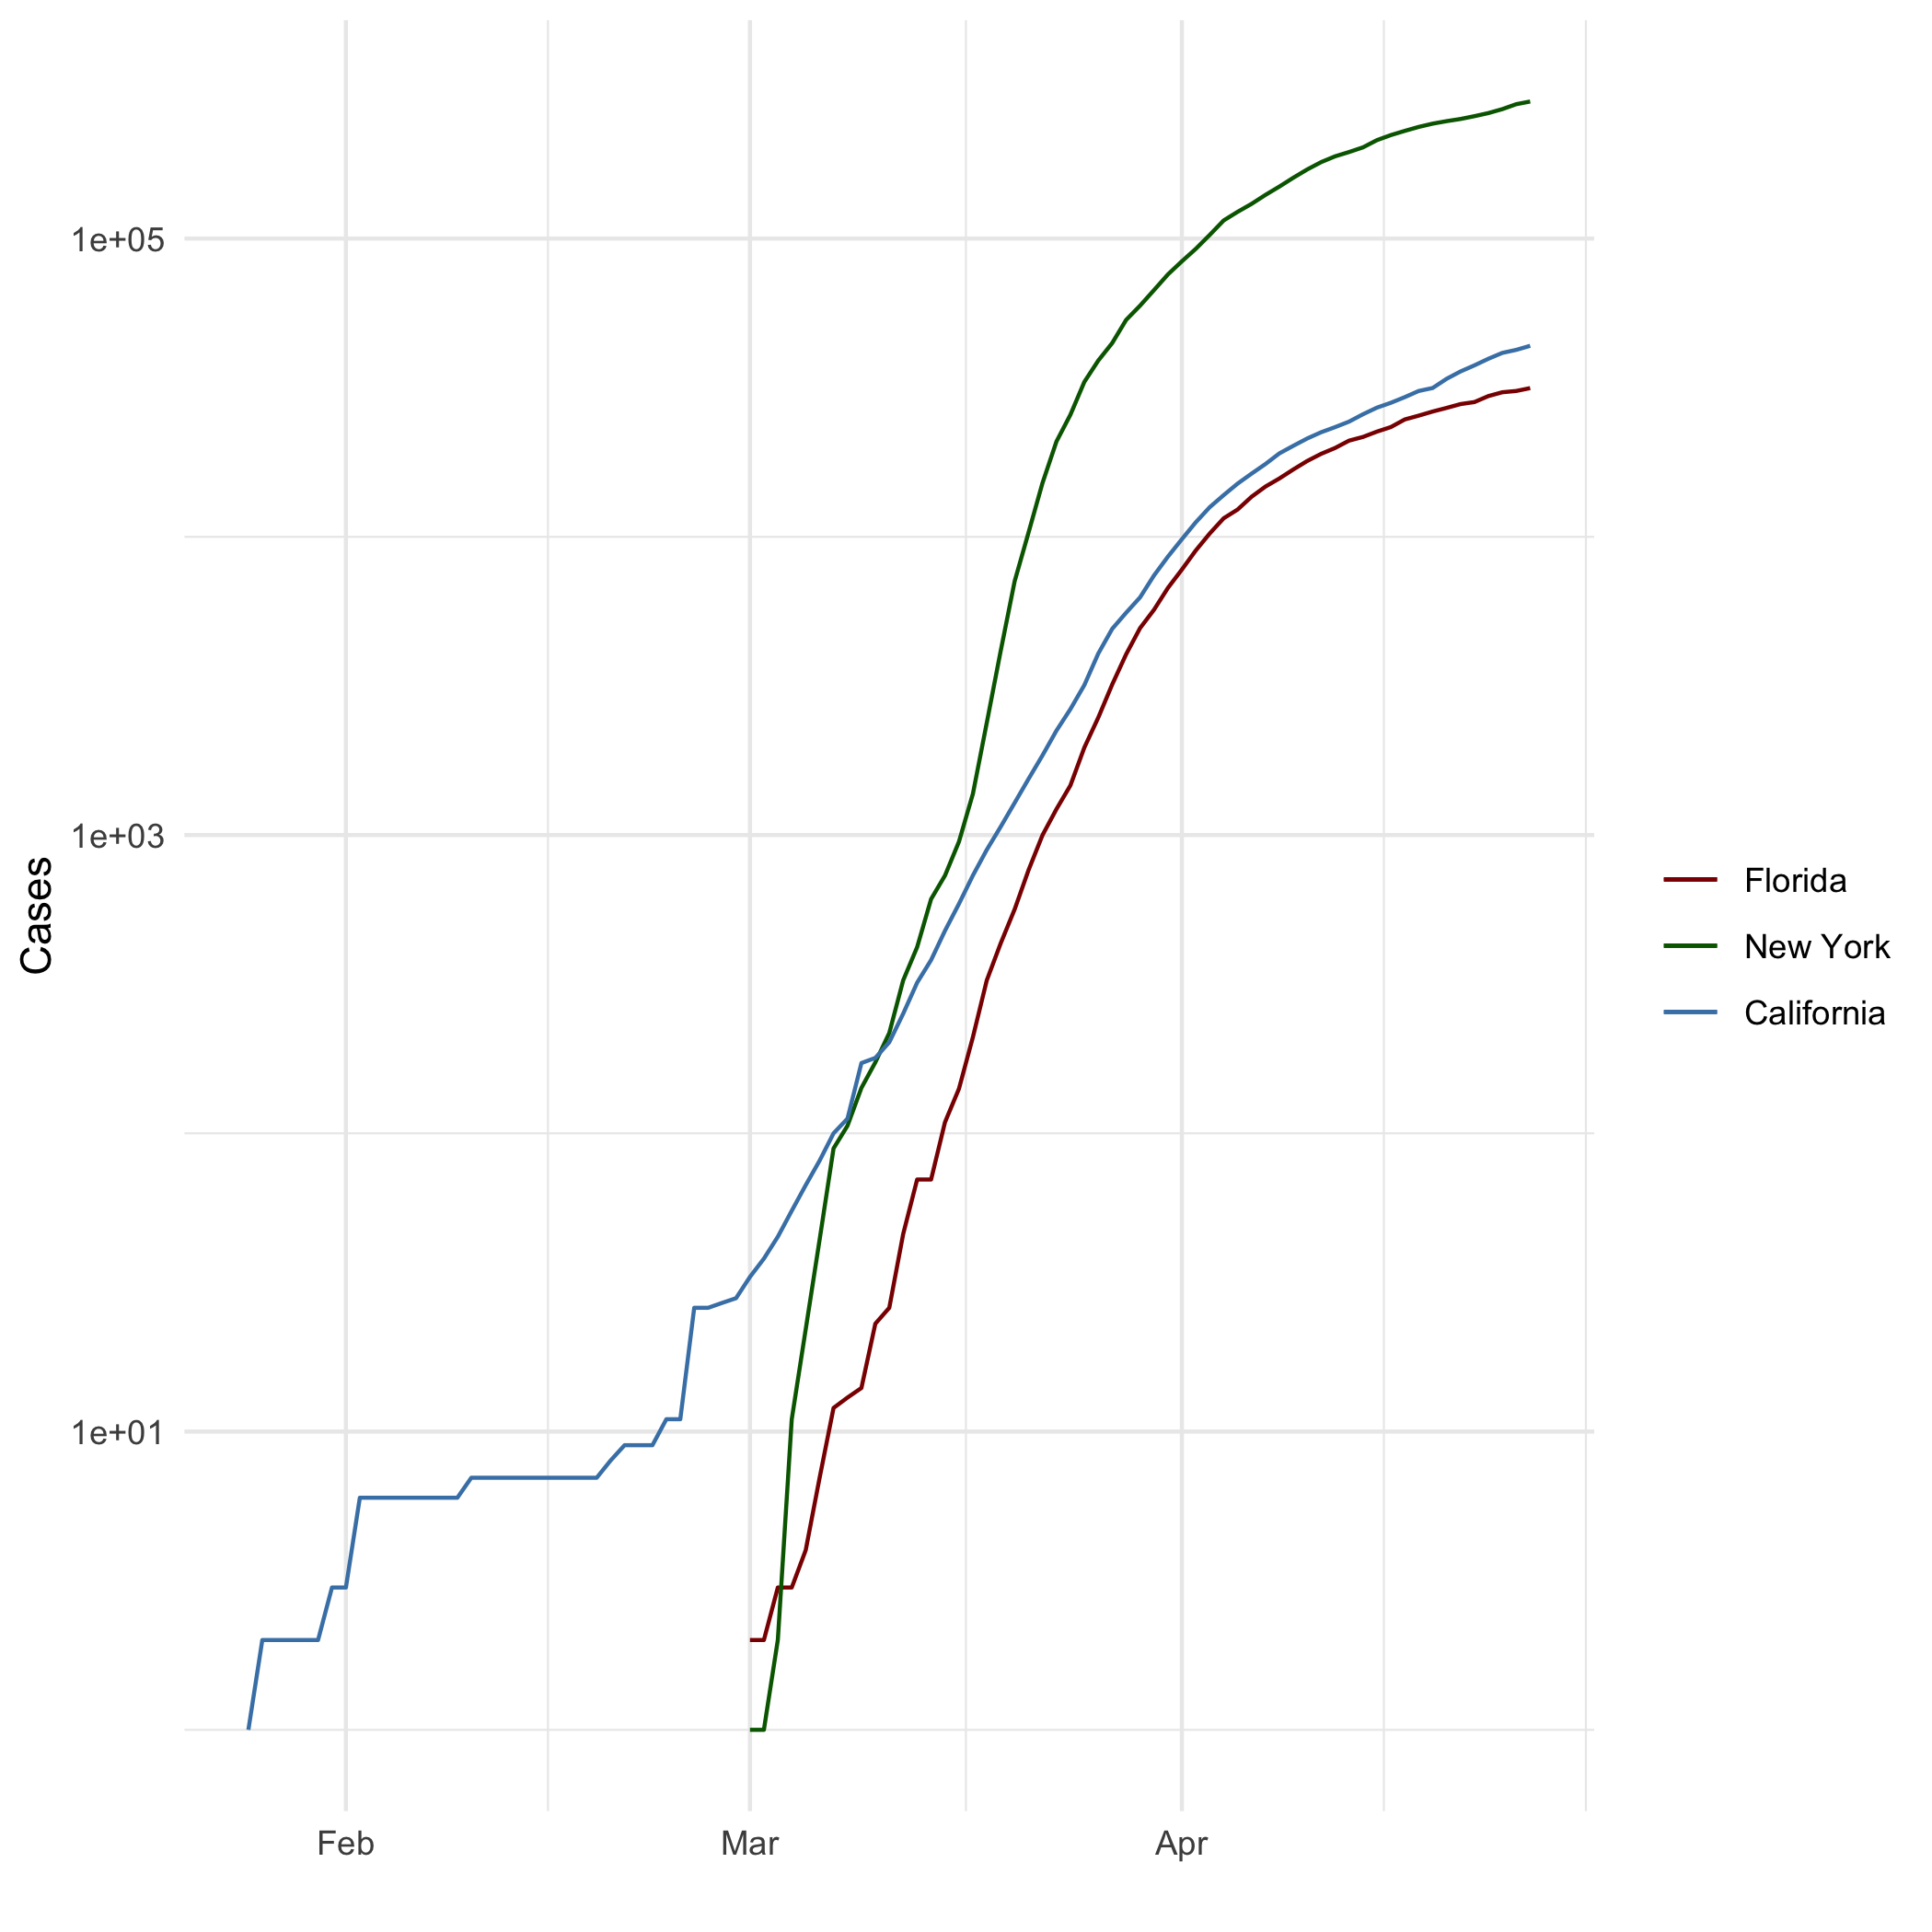
All Cases (Log Plot)

Add a Quote
“The inability to predict outliers implies the inability to predict the course of history”
― Nassim Nicholas Taleb, The Black Swan: The Impact of the Highly Improbable

Add an Equation:
Faraday’s Law: δΣ​E⋅dl=−Σ​δBδt⋅dA

Add a Footnote
See footnote

Add Citations
- R for Everyone (Lander 2014)
- Discovering Statistics Using R (Field, Miles, and Field 2012)

Inline Code

NY Times COVID-19 Data
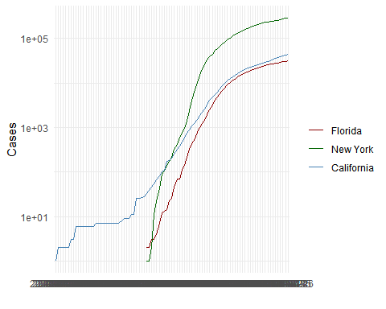

R4DS Height vs Earnings
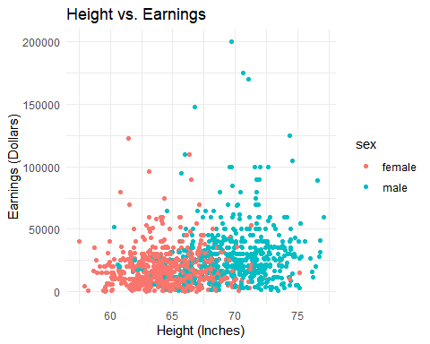

Tables

Knitr Table with Kable
knitr::kable(characters_df, caption = "One Ring to Rule Them All")
One Ring to Rule Them All
name | race | in_fellowship | ring_bearer | age
Aragon | Men | TRUE | FALSE | 88
Bilbo | Hobbit | FALSE | TRUE | 129
Frodo | Hobbit | TRUE | TRUE | 51
Galadriel | Elf | FALSE | FALSE | 7000
Sam | Hobbit | TRUE | TRUE | 36
Gandalf | Maia | TRUE | TRUE | 2019
Legolas | Elf | TRUE | FALSE | 2931
Sauron | Maia | FALSE | TRUE | 7052
Gollum | Hobbit | FALSE | TRUE | 589

Pandoc Table
library(pander)
pandoc.table(characters_df, caption = "One Ring to Rule Them All")
##
## ---------------------------------------------------------
## name race in_fellowship ring_bearer age
## ----------- -------- --------------- ------------- ------
## Aragon Men TRUE FALSE 88
##
## Bilbo Hobbit FALSE TRUE 129
##
## Frodo Hobbit TRUE TRUE 51
##
## Galadriel Elf FALSE FALSE 7000
##
## Sam Hobbit TRUE TRUE 36
##
## Gandalf Maia TRUE TRUE 2019
##
## Legolas Elf TRUE FALSE 2931
##
## Sauron Maia FALSE TRUE 7052
##
## Gollum Hobbit FALSE TRUE 589
## ---------------------------------------------------------
##
## Table: One Ring to Rule Them All

References
Field, A., J. Miles, and Z. Field. 2012. Discovering Statistics Using R. SAGE Publications. https://books.google.com/books?id=wd2K2zC3swIC.
Lander, J. P. 2014. R for Everyone: Advanced Analytics and Graphics. Addison-Wesley Data and Analytics Series. Addison-Wesley. https://books.google.com/books?id=3eBVAgAAQBAJ.

You found the footnote!

