ASSIGNMENT 4
Jolene Butt
2020-09-27

Markdown Basics

Favorite Foods
- SeaFood (Shrimp/Crab)
- Sushi (pickled or cooked)
- Pasta

Images
Please look for image on next page
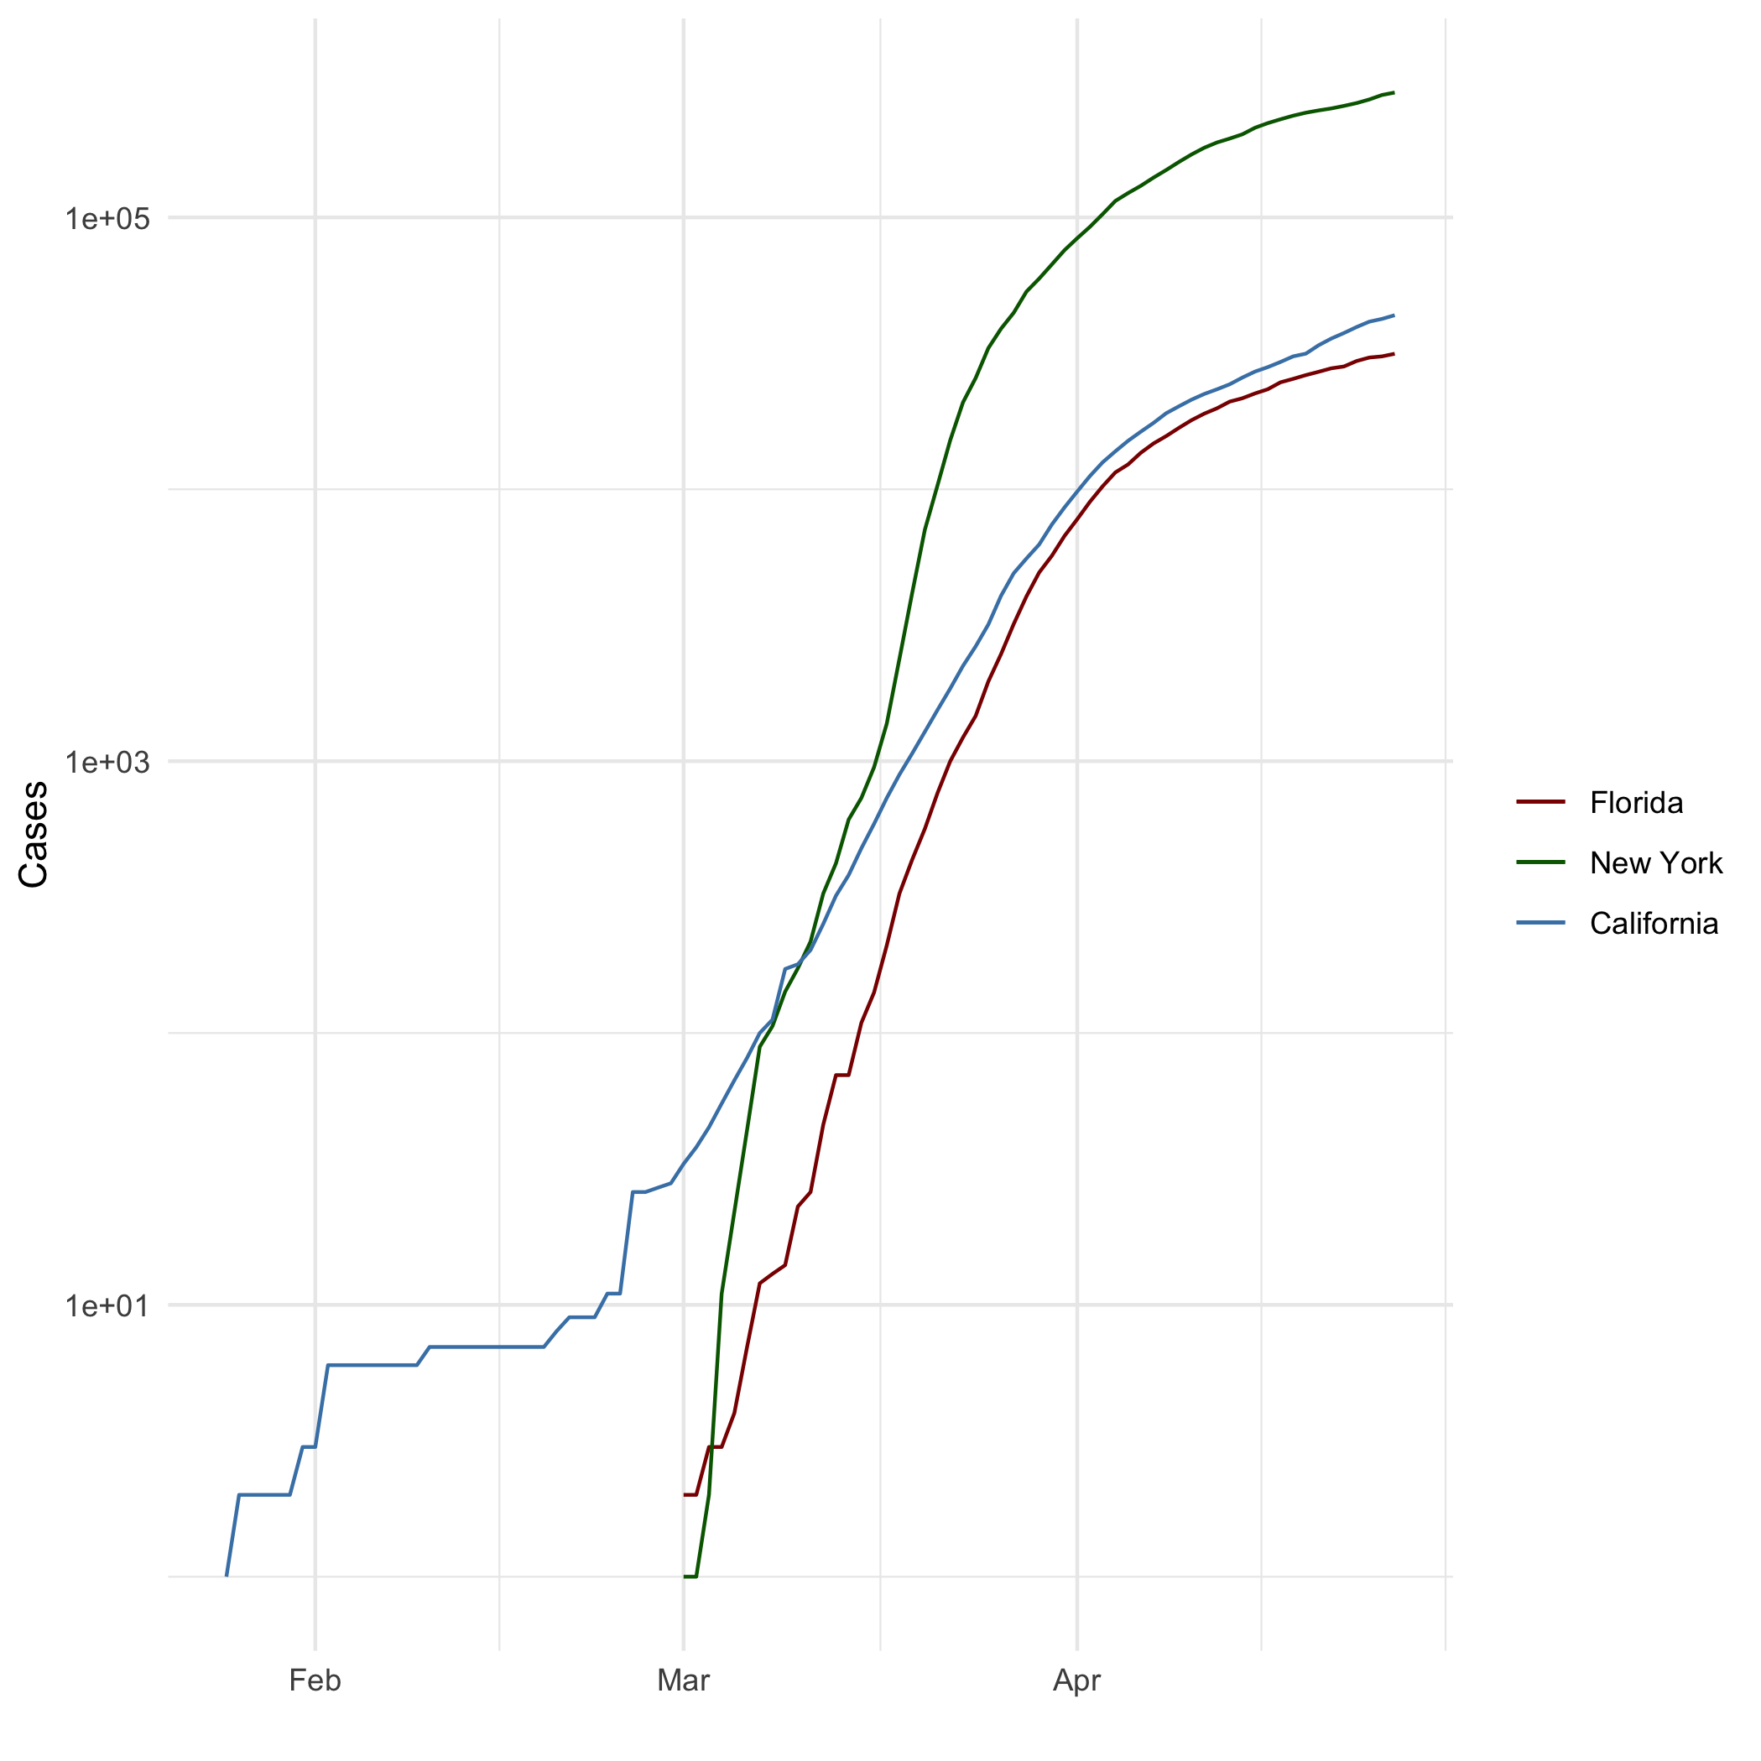
All Cases (Log Plot)

Add a Quote
Hello my name is Inigo Montoya, you killed my father prepare to die.

Add an Equation
$$\sum_{i=1}^{n}{\left(\frac{X_{i}}{Y_{i}}\right)}$$

Add a Footnote
No six fingered men were injured during the making of this footnote.

Add Citations
- R for Everyone Lander (2014)
- Discovering Statistics Using R Field, Miles, and Field (2012)

Inline Code

NY Times COVID-19 Data
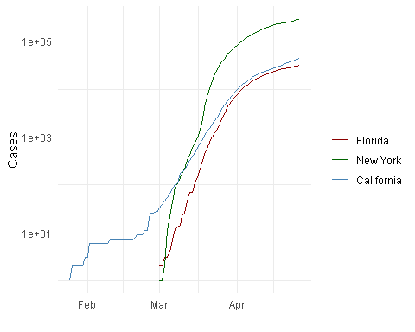

R4DS Height vs Earnings
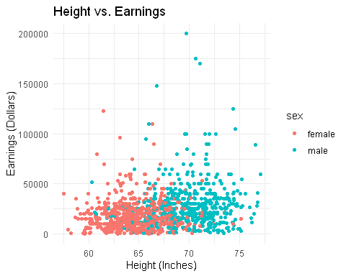

Tables

Knitr Table with Kable
One Ring to Rule Them All
name | race | in_fellowship | ring_bearer | age
Aragon | Men | TRUE | FALSE | 88
Bilbo | Hobbit | FALSE | TRUE | 129
Frodo | Hobbit | TRUE | TRUE | 51
Galadriel | Elf | FALSE | FALSE | 7000
Sam | Hobbit | TRUE | TRUE | 36
Gandalf | Maia | TRUE | TRUE | 2019
Legolas | Elf | TRUE | FALSE | 2931
Sauron | Maia | FALSE | TRUE | 7052
Gollum | Hobbit | FALSE | TRUE | 589

Pandoc Table
Name | Race | In Fellowship? | Is Ring Bearer | Age
Aragon | Men | TRUE | |FALSE | |88
Bilbo | Hobbit | FALSE | TRUE | |129
Frodo | Hobbit | TRUE | |TRUE | |51
Galadriel | Elf | FALSE | FALSE | |7000
Sam | |Hobbit | |TRUE | |TRUE | |36
Gandalf | |Maia | |TRUE | |TRUE | |2019
Legolas | |Elf | |TRUE | |FALSE | |2931
Sauron | Maia | |FALSE | |TRUE | |7052
Gollum | Hobbit | FALSE | TRUE | |589

References
Field, A., J. Miles, and Z. Field. 2012. Discovering Statistics Using R. SAGE Publications. https://books.google.com/books?id=wd2K2zC3swIC.
Lander, J. P. 2014. R for Everyone: Advanced Analytics and Graphics. Addison-Wesley Data and Analytics Series. Addison-Wesley. https://books.google.com/books?id=3eBVAgAAQBAJ.

Princess Bride footnote

