ASSIGNMENT 4
Isabella Sturm
2021-01-05

Markdown Basics

Favorite Foods
- Cupcakes
- Mac n Cheese
- Pizza

Images
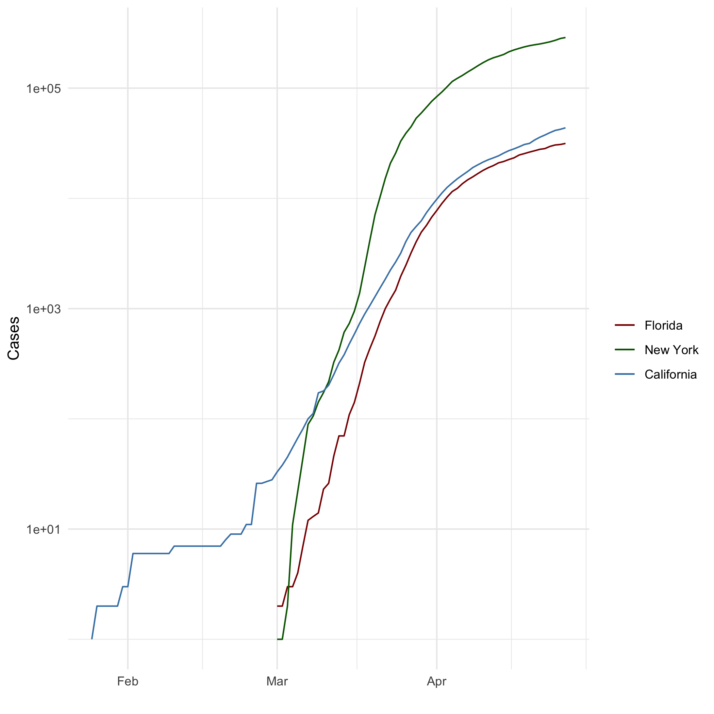
All Cases (Log Plot)

Add a Quote
Success is most often achieved by those who don’t know that failure is inevitable.
- Coco Chanel

Add an Equation
$x=\frac{−b±\sqrt{(}b^{2}−4ac)}{2a}$

Add a Footnote
I have a cat.

Add Citations
- R for Everyone (Lander 2014)
- Discovering Statistics Using R (Field, Miles, and Field 2012)

Inline Code

NY Times COVID-19 Data
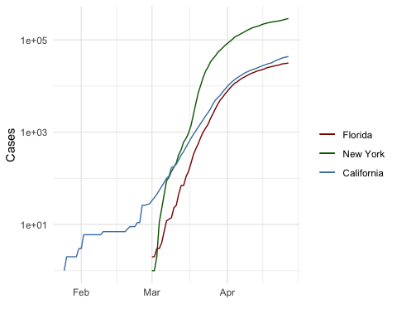

R4DS Height vs Earnings
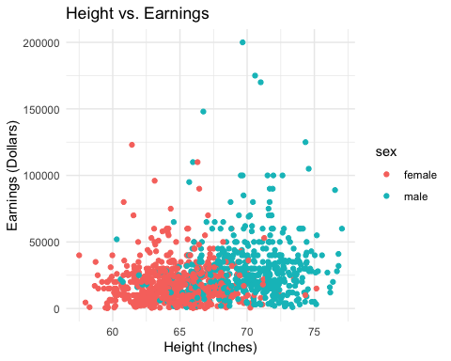

Tables

Knitr Table with Kable
One Ring to Rule Them All
person_id | personal_name | family_name
dyer | William | Dyer
pb | Frank | Pabodie
lake | Anderson | Lake
roe | Valentina | Roerich
danforth | Frank | Danforth

Pandoc Table
Name | Race | In Fellowship? | Is Ring Bearer? | Age
Aragon | Men | Yes | No | 88
Bilbo | Hobbit | No | Yes | 129
Frodo | Hobbit | Yes | Yes | 51
Sam | Hobbit | Yes | Yes | 36
Sauron | Maia | No | Yes | 7052

References
Field, A., J. Miles, and Z. Field. 2012. Discovering Statistics Using R. SAGE Publications. https://books.google.com/books?id=wd2K2zC3swIC.
Lander, J. P. 2014. R for Everyone: Advanced Analytics and Graphics. Addison-Wesley Data and Analytics Series. Addison-Wesley. https://books.google.com/books?id=3eBVAgAAQBAJ.

Her name is Cupcake.

