ASSIGNMENT 4
Sumbaraju Aditya
2020-01-07

Markdown Basics
- Under the ## Favorite Foods section, add an ordered list of your top three favorite foods
- Under the ## Images section, insert the image 10-all-cases-log.png from completed/assignment04/plots/ directory with the caption All Cases (Log Plot)
- Add one of your favorite quotes under the ## Add a Quote section.
- Add a LaTeX formatted equation under the ## Add an Equation section.
- Add any footnote under the ## Add a Footnote section.
- Under the ## Add Citations section, create an unordered list with R for Everyone and Discovering Statistics Using R with the proper citations.

Favorite Foods
- Pizza
- spicy poblano omelette
- Mexican Tres Leches Pancakes

Images
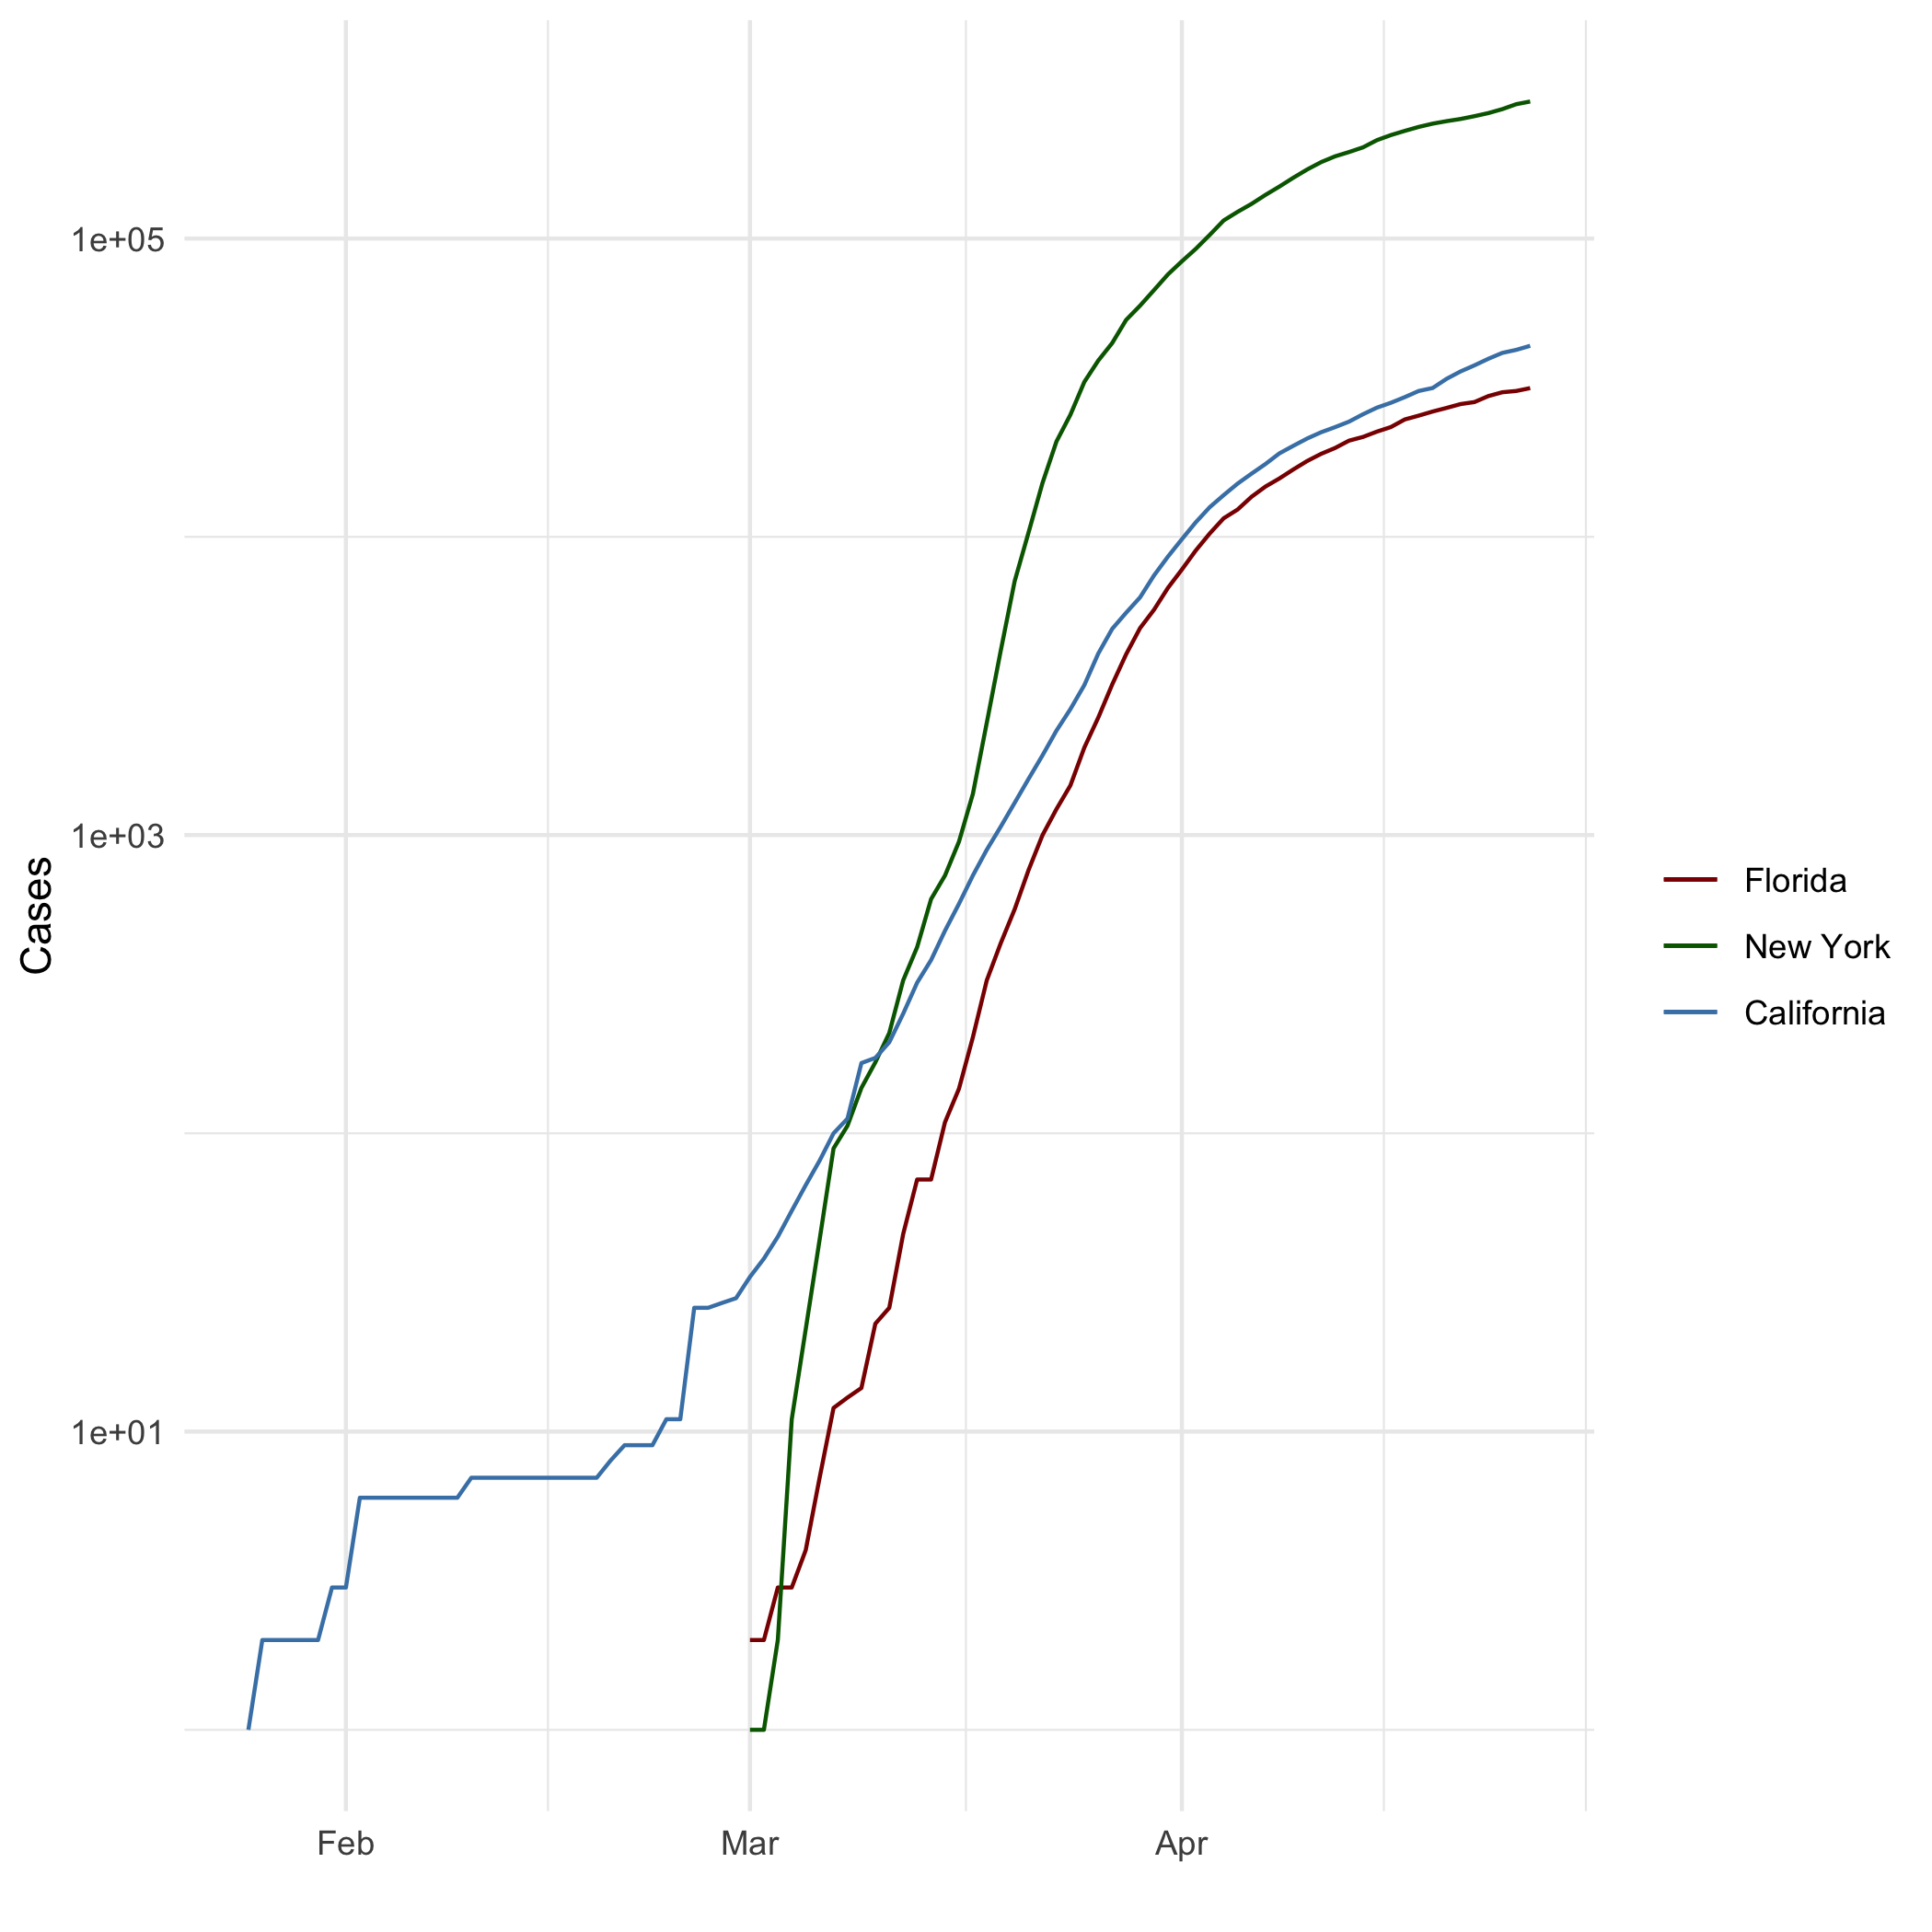
All Cases (Log Plot).

Add a Quote
Remembering that you are going to die is the best way I know to avoid the trap of thinking you have something to lose. You are already naked. There is no reason not to follow your heart. – Steve Jobs, CEO of Apple

Add an Equation
$$E=mc^{2}$$
$$\sqrt{a^{2}−b^{2}}$$
$$\frac{2xy^{2}}{4}$$

Add a Footnote
This is a footnote.

Add Citations
- R for Everyone (Lander 2014)
- Discovering Statistics Using R (Field, Miles, and Field 2012)

Inline Code

NY Times COVID-19 Data
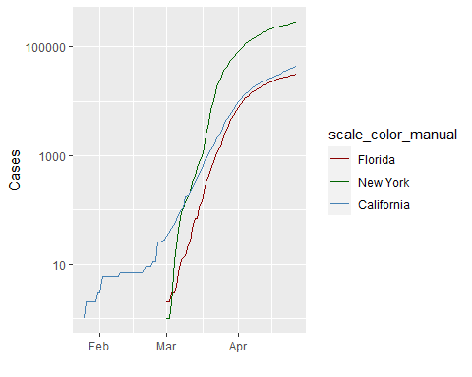

R4DS Height vs Earnings
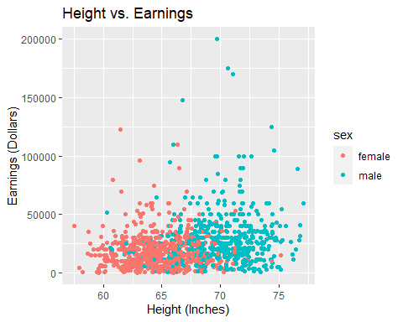

Tables

Knitr Table with Kable
Table 1: One Ring to Rule Them All
name | race | in_fellowship | ring_bearer | age
Aragon | Men | TRUE | FALSE | 88
Bilbo | Hobbit | FALSE | TRUE | 129
Frodo | Hobbit | TRUE | TRUE | 51
Galadriel | Elf | FALSE | FALSE | 7000
Sam | Hobbit | TRUE | TRUE | 36
Gandalf | Maia | TRUE | TRUE | 2019
Legolas | Elf | TRUE | FALSE | 2931
Sauron | Maia | FALSE | TRUE | 7052
Gollum | Hobbit | FALSE | TRUE | 589

Pandoc Table
##
##
## +--------+--------+----------------+-----------------+------+
## | Name | Race | In Fellowship? | Is Ring Bearer? | Age |
## +========+========+================+=================+======+
## | Aragon | Men | Yes | No | 88 |
## +--------+--------+----------------+-----------------+------+
## | Bilbo | Hobbit | No | Yes | 129 |
## +--------+--------+----------------+-----------------+------+
## | Frodo | Hobbit | Yes | Yes | 51 |
## +--------+--------+----------------+-----------------+------+
## | Sam | Hobbit | Yes | Yes | 36 |
## +--------+--------+----------------+-----------------+------+
## | Sauron | Maia | No | Yes | 7052 |
## +--------+--------+----------------+-----------------+------+
Name | Race | In Fellowship? | Is Ring Bearer? | Age
Aragon | Men | Yes | No | 88
Bilbo | Hobbit | No | Yes | 129
Frodo | Hobbit | Yes | Yes | 51
Sam | Hobbit | Yes | Yes | 36
Sauron | Maia | No | Yes | 7052

References
Field, A., J. Miles, and Z. Field. 2012. Discovering Statistics Using R. SAGE Publications. https://books.google.com/books?id=wd2K2zC3swIC.
Lander, J. P. 2014. R for Everyone: Advanced Analytics and Graphics. Addison-Wesley Data and Analytics Series. Addison-Wesley. https://books.google.com/books?id=3eBVAgAAQBAJ.

Assignment 04

