Exercise15

## R Exercise 15

setwd("~/MadR/Workspaces/dsc520")

### Loading data from file

data.binary=read.csv("data/binary-classifier-data.csv")  
data.trinary=read.csv("data/trinary-classifier-data.csv")  
  
summary(data.binary)

## label x y   
## Min. :0.000 Min. : -5.20 Min. : -4.019   
## 1st Qu.:0.000 1st Qu.: 19.77 1st Qu.: 21.207   
## Median :0.000 Median : 41.76 Median : 44.632   
## Mean :0.488 Mean : 45.07 Mean : 45.011   
## 3rd Qu.:1.000 3rd Qu.: 66.39 3rd Qu.: 68.698   
## Max. :1.000 Max. :104.58 Max. :106.896

summary(data.trinary)

## label x y   
## Min. :0.000 Min. :-10.26 Min. : -1.541   
## 1st Qu.:0.000 1st Qu.: 31.15 1st Qu.: 35.906   
## Median :1.000 Median : 45.59 Median : 55.073   
## Mean :1.037 Mean : 48.86 Mean : 55.282   
## 3rd Qu.:2.000 3rd Qu.: 66.27 3rd Qu.: 77.403   
## Max. :2.000 Max. :108.56 Max. :104.293

### a. Plot the data from each dataset using a scatter plot.

plot(data.binary$x,data.binary$y,col=data.binary$label +1,  
 main="Scatterplot Binary Classifier", xlab="X ", ylab="Y ")

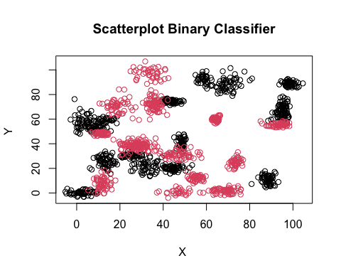

plot(data.trinary$x,data.trinary$y,col=data.trinary$label +1,  
 main="Scatterplot Trinary Classifier", xlab="X ", ylab="Y ")

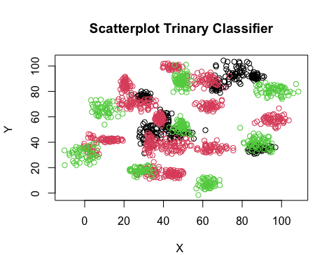 ### b - Binary data set

set.seed(9850)  
gp<-runif(nrow(data.binary))  
data.binary<-data.binary[order(gp),]  
head(data.binary)

## label x y  
## 216 0 12.006713 58.20435  
## 405 0 88.024357 13.26384  
## 316 0 7.993121 54.15258  
## 804 1 16.669075 73.98231  
## 103 0 40.565872 74.84798  
## 20 0 69.521713 89.94501

normalize<-function(x){  
 return (  
 (x - min(x))/max(x)-min(x)  
 )  
}  
data.binary.n<-as.data.frame(lapply(data.binary[,c(2:3)], normalize))  
  
str(data.binary.n)

## 'data.frame': 1498 obs. of 2 variables:  
## $ x: num 5.37 6.09 5.33 5.41 5.64 ...  
## $ y: num 4.6 4.18 4.56 4.75 4.76 ...

summary(data.binary.n)

## x y   
## Min. :5.200 Min. :4.019   
## 1st Qu.:5.439 1st Qu.:4.255   
## Median :5.650 Median :4.475   
## Mean :5.681 Mean :4.478   
## 3rd Qu.:5.885 3rd Qu.:4.700   
## Max. :6.250 Max. :5.057

r<-round(0.8*nrow(data.binary.n))  
l<-nrow(data.binary.n)  
  
data.train<-data.binary.n[1:r,]  
data.test<-data.binary.n[r:l,]  
  
data.train.target<-data.binary[1:r,1]  
data.test.target<-data.binary[r:l,1]  
  
k_value<-round(sqrt(nrow(data.binary)))

### calculatig knn and accuracy for each k =3 , 5 ,10 ,15 ,20 , 25 and 39

library("class")  
  
  
  
  
  
knn.3<- knn(train = data.train, test=data.test,cl=data.train.target, k=3)  
ACC.3<-100 * sum( data.test.target == knn.3) / NROW(data.test.target)  
   
table(data.test.target,knn.3)

## knn.3  
## data.test.target 0 1  
## 0 156 2  
## 1 2 141

ACC.3

## [1] 98.6711

knn.5<- knn(train = data.train, test=data.test,cl=data.train.target, k=5)  
ACC.5<-100 * sum( data.test.target == knn.5) / NROW(data.test.target)  
   
table(data.test.target,knn.5)

## knn.5  
## data.test.target 0 1  
## 0 156 2  
## 1 1 142

ACC.5

## [1] 99.00332

knn.10<- knn(train = data.train, test=data.test,cl=data.train.target, k=10)  
ACC.10<-100 * sum( data.test.target == knn.10) / NROW(data.test.target)  
   
table(data.test.target,knn.10)

## knn.10  
## data.test.target 0 1  
## 0 156 2  
## 1 0 143

ACC.10

## [1] 99.33555

knn.15<- knn(train = data.train, test=data.test,cl=data.train.target, k=15)  
ACC.15<-100 * sum( data.test.target == knn.15) / NROW(data.test.target)  
   
table(data.test.target,knn.15)

## knn.15  
## data.test.target 0 1  
## 0 156 2  
## 1 1 142

ACC.15

## [1] 99.00332

knn.20<- knn(train = data.train, test=data.test,cl=data.train.target, k=20)  
ACC.20<-100 * sum( data.test.target == knn.20) / NROW(data.test.target)  
   
table(data.test.target,knn.20)

## knn.20  
## data.test.target 0 1  
## 0 156 2  
## 1 0 143

ACC.20

## [1] 99.33555

knn.25<- knn(train = data.train, test=data.test,cl=data.train.target, k=25)  
ACC.25<-100 * sum( data.test.target == knn.25) / NROW(data.test.target)  
   
table(data.test.target,knn.25)

## knn.25  
## data.test.target 0 1  
## 0 156 2  
## 1 1 142

ACC.25

## [1] 99.00332

knn.39<- knn(train = data.train, test=data.test,cl=data.train.target, k=k_value)  
ACC.39<-100 * sum( data.test.target == knn.39) / NROW(data.test.target)  
   
table(data.test.target,knn.39)

## knn.39  
## data.test.target 0 1  
## 0 156 2  
## 1 1 142

ACC.39

## [1] 99.00332

### Plot for binary knn data

binary.plot<- data.frame("K.Value"=c(3,5,10,15,20,25,39),  
 "Accuracy"=c(ACC.3,ACC.5,ACC.10,ACC.15,ACC.20,ACC.25,ACC.39)  
 )  
library(caret)

## Loading required package: lattice

## Loading required package: ggplot2

plot(binary.plot,  
 main="K Value vs Accuracy",  
 xlab="K Value ", ylab="Accuracy",type="l"  
 )  
 text(binary.plot[, 'K.Value'], binary.plot[, 'Accuracy'], binary.plot$K.Value,   
 cex = 0.88, pos = 2, col = "darkgreen")

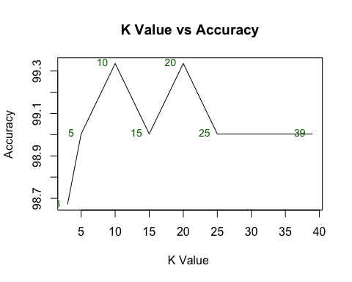

### decision plot function

decisionplot <- function(model, data, class = NULL, predict_type = "class",  
 resolution = 100, showgrid = TRUE, ...) {  
  
 if(!is.null(class)) cl <- data[,class] else cl <- 1  
 data <- data[,2:3]  
 k <- length(unique(cl))  
  
 plot(data, col = as.integer(cl)+1L, pch = as.integer(cl)+1L, ...)  
  
 # make grid  
 r <- sapply(data, range, na.rm = TRUE)  
 xs <- seq(r[1,1], r[2,1], length.out = resolution)  
 ys <- seq(r[1,2], r[2,2], length.out = resolution)  
 g <- cbind(rep(xs, each=resolution), rep(ys, time = resolution))  
 colnames(g) <- colnames(r)  
 g <- as.data.frame(g)  
  
 ### guess how to get class labels from predict  
 ### (unfortunately not very consistent between models)  
 p <- predict(model, g, type = predict_type)  
 if(is.list(p)) p <- p$class  
 p <- as.factor(p)  
  
 if(showgrid) points(g, col = as.integer(p)+1L, pch = ".")  
  
 z <- matrix(as.integer(p), nrow = resolution, byrow = TRUE)  
 contour(xs, ys, z, add = TRUE, drawlabels = FALSE,  
 lwd = 2, levels = (1:(k-1))+.5)  
  
 invisible(z)  
}

### c. Decision boundry for binary dataset

library(lattice)  
  
  
model <- glm(label ~., data = data.binary)  
class(model) <- c("lr", class(model))  
predict.lr <- function(object, newdata, ...)  
 predict.glm(object, newdata, type = "response") > .5  
  
  
decisionplot(model, data.binary, class = "label", main = "Logistic Regression")

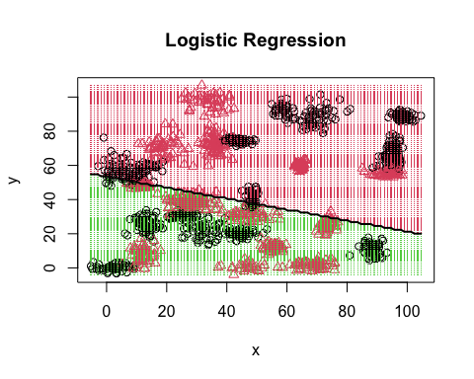

## Trinary

### b - Trinary data set

set.seed(9850)  
gp<-runif(nrow(data.trinary))  
data.trinary<-data.trinary[order(gp),]  
head(data.trinary)

## label x y  
## 216 0 30.10783 74.34244  
## 405 1 38.91000 37.00775  
## 316 0 41.34978 61.17379  
## 804 1 37.79238 57.31985  
## 1554 2 98.14194 80.07052  
## 103 0 90.54824 36.35014

normalize<-function(x){  
 return (  
 (x - min(x))/max(x)-min(x)  
 )  
}  
data.trinary.n<-as.data.frame(lapply(data.trinary[,c(2:3)], normalize))  
  
str(data.trinary.n)

## 'data.frame': 1568 obs. of 2 variables:  
## $ x: num 10.6 10.7 10.7 10.7 11.3 ...  
## $ y: num 2.27 1.91 2.14 2.11 2.32 ...

summary(data.trinary.n)

## x y   
## Min. :10.26 Min. :1.541   
## 1st Qu.:10.64 1st Qu.:1.900   
## Median :10.78 Median :2.084   
## Mean :10.81 Mean :2.086   
## 3rd Qu.:10.97 3rd Qu.:2.298   
## Max. :11.36 Max. :2.556

r<-round(0.8*nrow(data.trinary.n))  
l<-nrow(data.trinary.n)  
  
data.train<-data.trinary.n[1:r,]  
data.test<-data.trinary.n[r:l,]  
  
data.train.target<-data.trinary[1:r,1]  
data.test.target<-data.trinary[r:l,1]  
  
k_value<-round(sqrt(nrow(data.trinary)))

### calculatig knn and accuracy for each k =3 , 5 ,10 ,15 ,20 , 25 and 39

library("class")  
  
  
  
knn.3<- knn(train = data.train, test=data.test,cl=data.train.target, k=3)  
ACC.3<-100 * sum( data.test.target == knn.3) / NROW(data.test.target)  
   
table(data.test.target,knn.3)

## knn.3  
## data.test.target 0 1 2  
## 0 65 9 4  
## 1 6 126 8  
## 2 8 4 85

ACC.3

## [1] 87.61905

knn.5<- knn(train = data.train, test=data.test,cl=data.train.target, k=5)  
ACC.5<-100 * sum( data.test.target == knn.5) / NROW(data.test.target)  
   
table(data.test.target,knn.5)

## knn.5  
## data.test.target 0 1 2  
## 0 65 9 4  
## 1 6 127 7  
## 2 8 5 84

ACC.5

## [1] 87.61905

knn.10<- knn(train = data.train, test=data.test,cl=data.train.target, k=10)  
ACC.10<-100 * sum( data.test.target == knn.10) / NROW(data.test.target)  
   
table(data.test.target,knn.10)

## knn.10  
## data.test.target 0 1 2  
## 0 68 8 2  
## 1 7 124 9  
## 2 10 5 82

ACC.10

## [1] 86.98413

knn.15<- knn(train = data.train, test=data.test,cl=data.train.target, k=15)  
ACC.15<-100 * sum( data.test.target == knn.15) / NROW(data.test.target)  
   
table(data.test.target,knn.15)

## knn.15  
## data.test.target 0 1 2  
## 0 66 10 2  
## 1 6 125 9  
## 2 12 4 81

ACC.15

## [1] 86.34921

knn.20<- knn(train = data.train, test=data.test,cl=data.train.target, k=20)  
ACC.20<-100 * sum( data.test.target == knn.20) / NROW(data.test.target)  
   
table(data.test.target,knn.20)

## knn.20  
## data.test.target 0 1 2  
## 0 65 10 3  
## 1 6 126 8  
## 2 11 3 83

ACC.20

## [1] 86.98413

knn.25<- knn(train = data.train, test=data.test,cl=data.train.target, k=25)  
ACC.25<-100 * sum( data.test.target == knn.25) / NROW(data.test.target)  
   
table(data.test.target,knn.25)

## knn.25  
## data.test.target 0 1 2  
## 0 63 13 2  
## 1 8 124 8  
## 2 10 3 84

ACC.25

## [1] 86.03175

knn.39<- knn(train = data.train, test=data.test,cl=data.train.target, k=k_value)  
ACC.39<-100 * sum( data.test.target == knn.39) / NROW(data.test.target)  
   
table(data.test.target,knn.39)

## knn.39  
## data.test.target 0 1 2  
## 0 64 11 3  
## 1 9 121 10  
## 2 13 1 83

ACC.39

## [1] 85.07937

### Plot for trinary knn data

library(purrr)

##   
## Attaching package: 'purrr'

## The following object is masked from 'package:caret':  
##   
## lift

trinary.plot<- data.frame("K.Value"=c(3,5,10,15,20,25,39),  
 "Accuracy"=c(ACC.3,ACC.5,ACC.10,ACC.15,ACC.20,ACC.25,ACC.39)  
 )  
library(caret)  
  
plot(trinary.plot,  
 main="K Value vs Accuracy",  
 xlab="K Value ", ylab="Accuracy",type="l"  
 )  
 text(trinary.plot[, 'K.Value'], trinary.plot[, 'Accuracy'],   
 trinary.plot$K.Value,   
 cex = 0.88, pos = 2, col = "darkgreen")

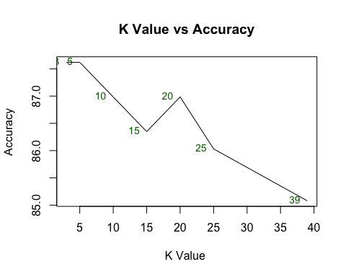

### Decision boundry for trinary dataset

model <- glm(label ~., data = data.trinary)  
class(model) <- c("lr", class(model))  
predict.lr <- function(object, newdata, ...)  
 predict.glm(object, newdata, type = "response") > .5  
  
  
decisionplot(model, data.trinary, class = "label", main = "Logistic Regression")

## Warning in contour.default(xs, ys, z, add = TRUE, drawlabels = FALSE, lwd = 2, :  
## all z values are equal

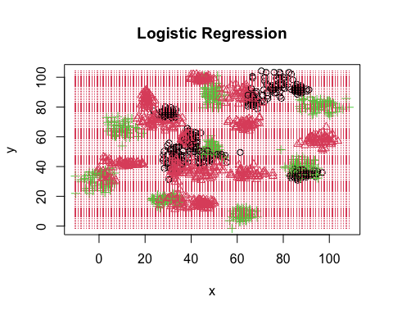

### data doesn’t look suitable for linear classifier