## R Markdown

Title: Assignment 4

Author: Carla Bradley

Date: 01/05/2021

# Favorite Foods

* Ceviche * Lasagna * Burger Casserole

# Images

All Cases (Log Plot)

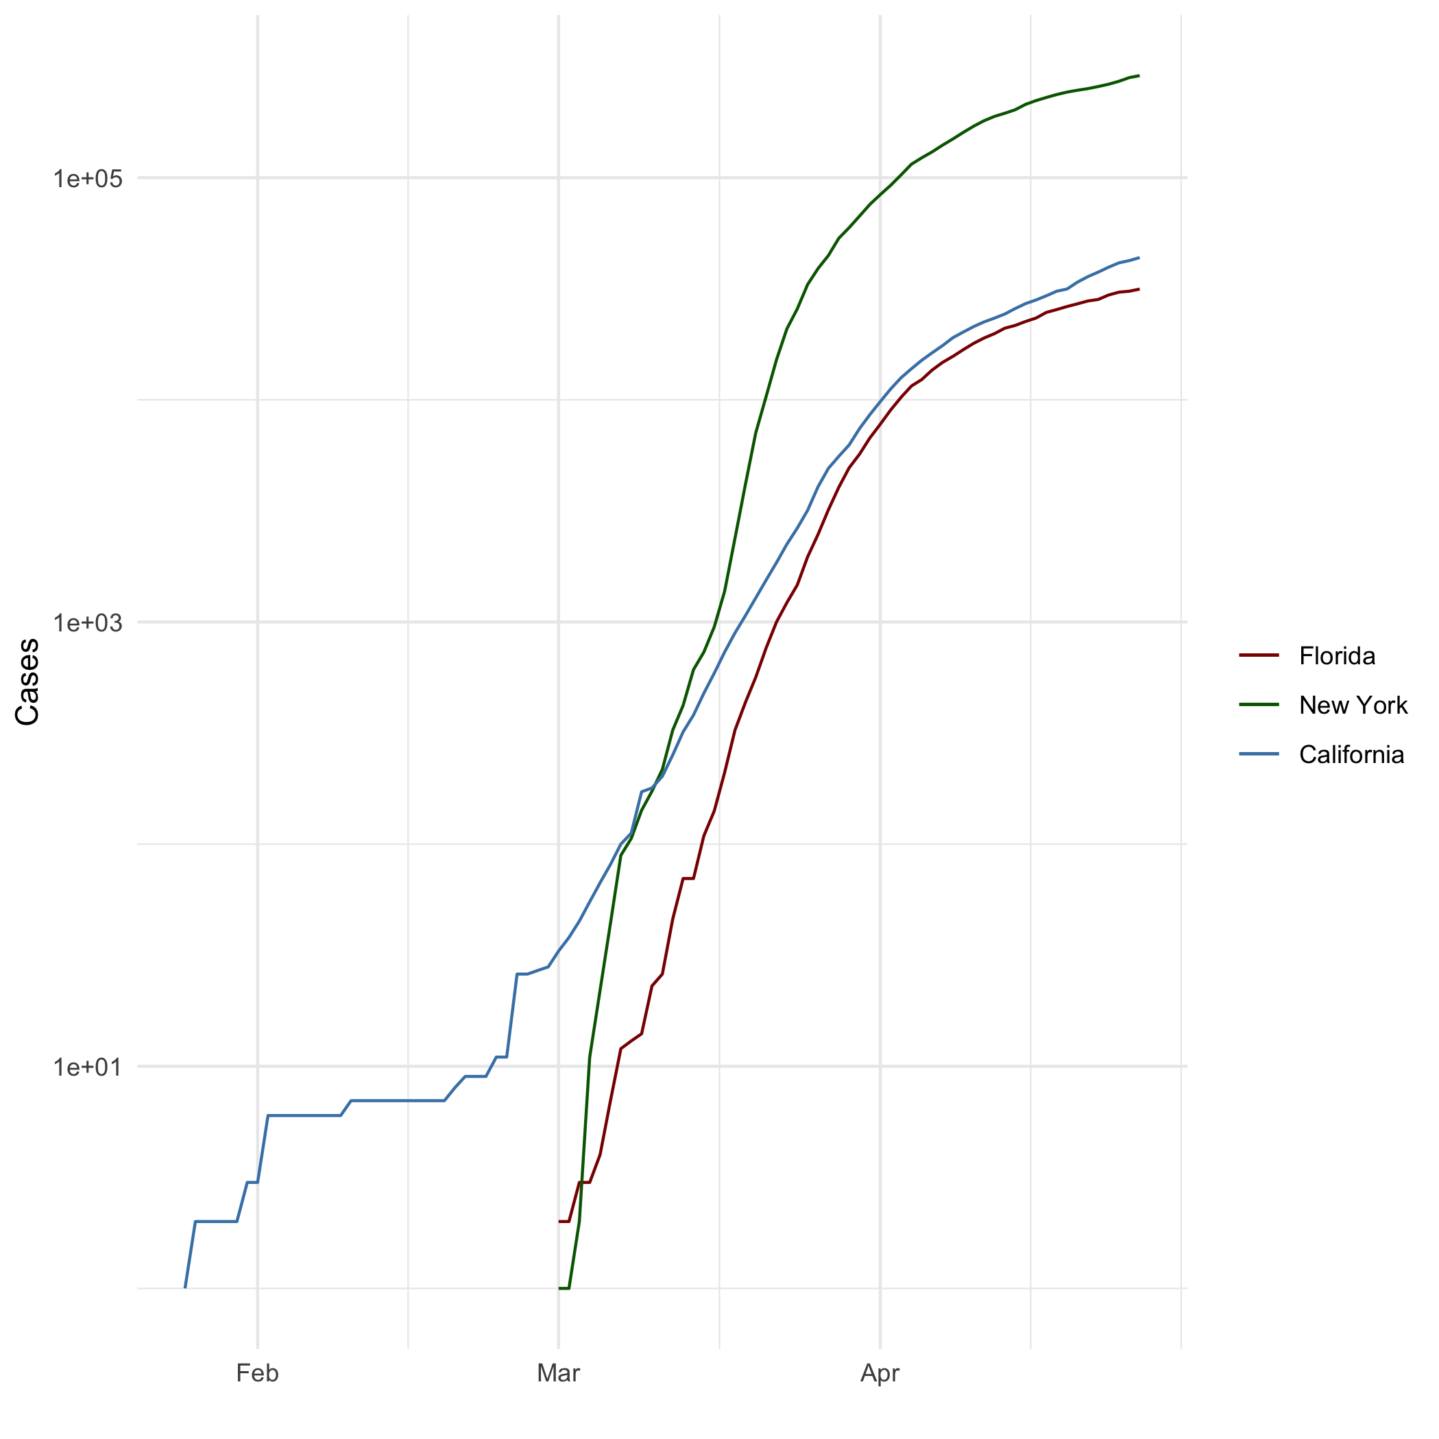

# My Quote

“Every moment of your life is infinitely creative and the universe is endlessly bountiful. Just put forth a clear enough request, and everything your heart desires must come to you.” ―Mahatma Gandhi

# Equation Formula

$$\int_{−∞}^{+∞}{e^{−(ax^{2}+bx)}}dx$$

}

# R4DS Height vs Earnings

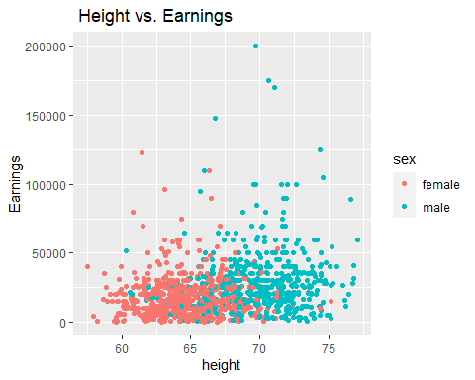

# NY Times COVID-19 Data

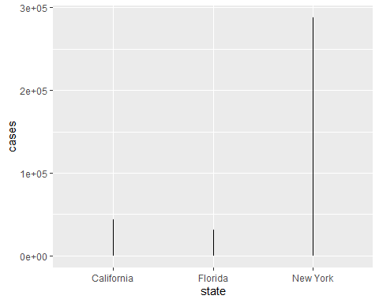

# Knitr Table with Kable

One Ring to Rule Them All

|  |  |  |  |  |
| --- | --- | --- | --- | --- |
| Name | Race | Fellowship | Ring bearer | Age |
| Aragon | Men | TRUE | FALSE | 88 |
| Bilbo | Hobbit | FALSE | TRUE | 129 |
| Frodo | Hobbit | TRUE | TRUE | 51 |
| Galadriel | Elf | FALSE | FALSE | 7000 |
| Sam | Hobbit | TRUE | TRUE | 36 |
| Gandalf | Maia | TRUE | TRUE | 2019 |
| Legolas | Elf | TRUE | FALSE | 2931 |
| Sauron | Maia | FALSE | TRUE | 7052 |
| Gollum | Hobbit | FALSE | TRUE | 589 |

# Pandoc Table

| name | race | in_fellowship | ring_bearer | age |
| --- | --- | --- | --- | --- |
| Aragon | Men | TRUE | FALSE | 88 |
| Bilbo | Hobbit | FALSE | TRUE | 129 |
| Frodo | Hobbit | TRUE | TRUE | 51 |
| Galadriel | Elf | FALSE | FALSE | 7,000 |
| Sam | Hobbit | TRUE | TRUE | 36 |
| Gandalf | Maia | TRUE | TRUE | 2,019 |

# This is a Footnote

*Footnote [1]

# Citations

* Field, A., J. Miles, and Z. Field. 2012. Discovering Statistics Using R. SAGE Publications.
* <https://books.google.com/books?id=wd2K2zC3swIC>.
* Lander, J. P. 2014. R for Everyone: Advanced Analytics and Graphics. Addison-Wesley Data and Analytics Series. Addison-Wesley.
* <https://books.google.com/books?id=3eBVAgAAQBAJ>.

1. This is a Footnote