ASSIGNMENT 4

Paul Hart

2020-01-08

# Markdown Basics

## Favorite Foods

* Pizza
* Pasta
* Burger

## Images

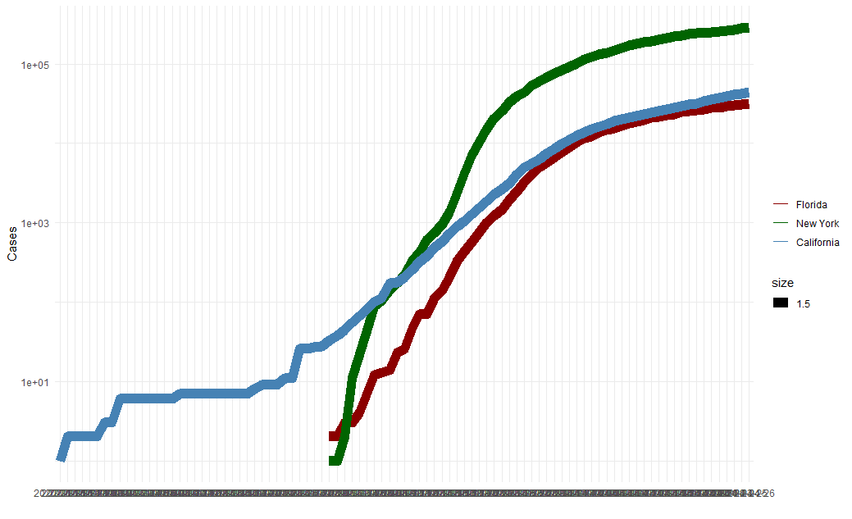

All Cases Log Plot

## Add a Quote

* “Imagination is more important than knowledge. For knowledge is limited to all we now know and understand, while imagination embraces the entire world, and all there ever will be to know and understand.” - Albert Einstein

## Add an Equation

$$

E=mc^2

$$

## Add a Footnote

R Markdown is pretty cool

## Add Citations

* R for Everyone (Jared P. Lander)
* Discovering Statistics Using R (Andy Field, Jeremy Miles, Zoe Field)

# Inline Code

## NY Times COVID-19 Data

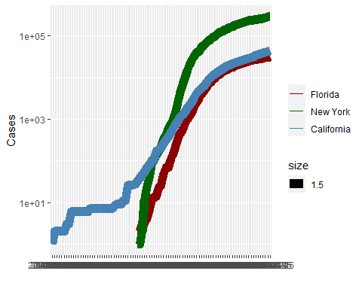

## R4DS Height vs Earnings

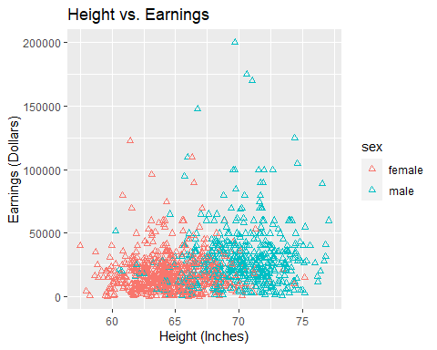

# Tables

## Knitr Table with Kable

One Ring To Rule Them ALL

|  |  |  |  |  |
| --- | --- | --- | --- | --- |
| name | race | in_fellowship | ring_bearer | age |
| Aragon | Men | TRUE | FALSE | 88 |
| Bilbo | Hobbit | FALSE | TRUE | 129 |
| Frodo | Hobbit | TRUE | TRUE | 51 |
| Galadriel | Elf | FALSE | FALSE | 7000 |
| Sam | Hobbit | TRUE | TRUE | 36 |
| Gandalf | Maia | TRUE | TRUE | 2019 |
| Legolas | Elf | TRUE | FALSE | 2931 |
| Sauron | Maia | FALSE | TRUE | 7052 |
| Gollum | Hobbit | FALSE | TRUE | 589 |

## 

## Pandoc Table

## +-----------+--------+---------------+-------------+------+  
## | name | race | in_fellowship | ring_bearer | age |  
## +===========+========+===============+=============+======+  
## | Aragon | Men | TRUE | FALSE | 88 |  
## +-----------+--------+---------------+-------------+------+  
## | Bilbo | Hobbit | FALSE | TRUE | 129 |  
## +-----------+--------+---------------+-------------+------+  
## | Frodo | Hobbit | TRUE | TRUE | 51 |  
## +-----------+--------+---------------+-------------+------+  
## | Galadriel | Elf | FALSE | FALSE | 7000 |  
## +-----------+--------+---------------+-------------+------+  
## | Sam | Hobbit | TRUE | TRUE | 36 |  
## +-----------+--------+---------------+-------------+------+  
## | Gandalf | Maia | TRUE | TRUE | 2019 |  
## +-----------+--------+---------------+-------------+------+  
## | Legolas | Elf | TRUE | FALSE | 2931 |  
## +-----------+--------+---------------+-------------+------+  
## | Sauron | Maia | FALSE | TRUE | 7052 |  
## +-----------+--------+---------------+-------------+------+  
## | Gollum | Hobbit | FALSE | TRUE | 589 |  
## +-----------+--------+---------------+-------------+------+

# References

* Field, A., J. Miles, and Z. Field. 2012. Discovering Statistics Using R. SAGE Publications. <https://books.google.com/books?id=wd2K2zC3swIC>.
* Lander, J. P. 2014. R for Everyone: Advanced Analytics and Graphics. Addison-Wesley Data and Analytics Series. Addison-Wesley. <https://books.google.com/books?id=3eBVAgAAQBAJ>.