ASSIGNMENT 4

Bilal Kudaimi

2020-09-25

# Markdown Basics

## Favorite Foods

1. Fruits
2. Pizza
3. Fish

## Images

All Cases (Log Plot)

All Cases (Log Plot)

## Add a Quote

We have nothing to fear but fear itself

## Add an Equation

$$q=mCΔT$$

## Add a Footnote

[1]

## Add Citations

* R for Everyone
* Discovering Statistics Using R

# Inline Code

## NY Times COVID-19 Data

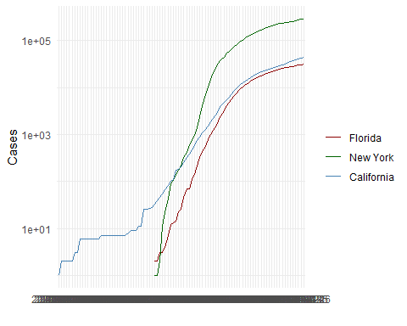

## R4DS Height vs Earnings

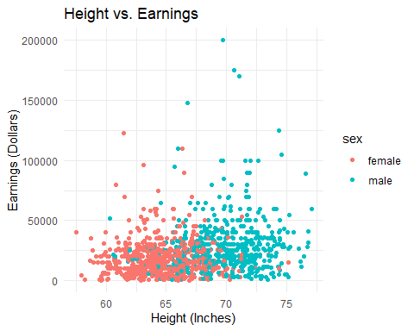

# Tables

## Knitr Table with Kable

One Ring to Rule Them All

|  |  |  |  |  |
| --- | --- | --- | --- | --- |
| name | race | in_fellowship | ring_bearer | age |
| Aragon | Men | TRUE | FALSE | 88 |
| Bilbo | Hobbit | FALSE | TRUE | 129 |
| Frodo | Hobbit | TRUE | TRUE | 51 |
| Galadriel | Elf | FALSE | FALSE | 7000 |
| Sam | Hobbit | TRUE | TRUE | 36 |
| Gandalf | Maia | TRUE | TRUE | 2019 |
| Legolas | Elf | TRUE | FALSE | 2931 |
| Sauron | Maia | FALSE | TRUE | 7052 |
| Gollum | Hobbit | FALSE | TRUE | 589 |

## ## Pandoc Table

|  |  |  |  |  |
| --- | --- | --- | --- | --- |
| Name | Race | In Fellowship? | Is Ring Bearer? | Age |
| Aragon | Men | Yes | No | 88 |
| Bilbo | Hobbit | No | Yes | 129 |
| Frodo | Hobbit | Yes | Yes | 51 |
| Sam | Hobbit | Yes | Yes | 36 |
| Sauron | Maia | No | Yes | 7052 |

# References

Lander (2014) Field, Miles, and Field (2012)

Field, A., J. Miles, and Z. Field. 2012. *Discovering Statistics Using R*. SAGE Publications. <https://books.google.com/books?id=wd2K2zC3swIC>.

Lander, J. P. 2014. *R for Everyone: Advanced Analytics and Graphics*. Addison-Wesley Data and Analytics Series. Addison-Wesley. <https://books.google.com/books?id=3eBVAgAAQBAJ>.

1. This is a footnote.