ASSIGNMENT 4

Michael Paris

2020-01-06

# Markdown Basics

## Favorite Foods

1. Barbecue Brisket
2. Lasagna
3. Mexican (Any Mexican)

## Images

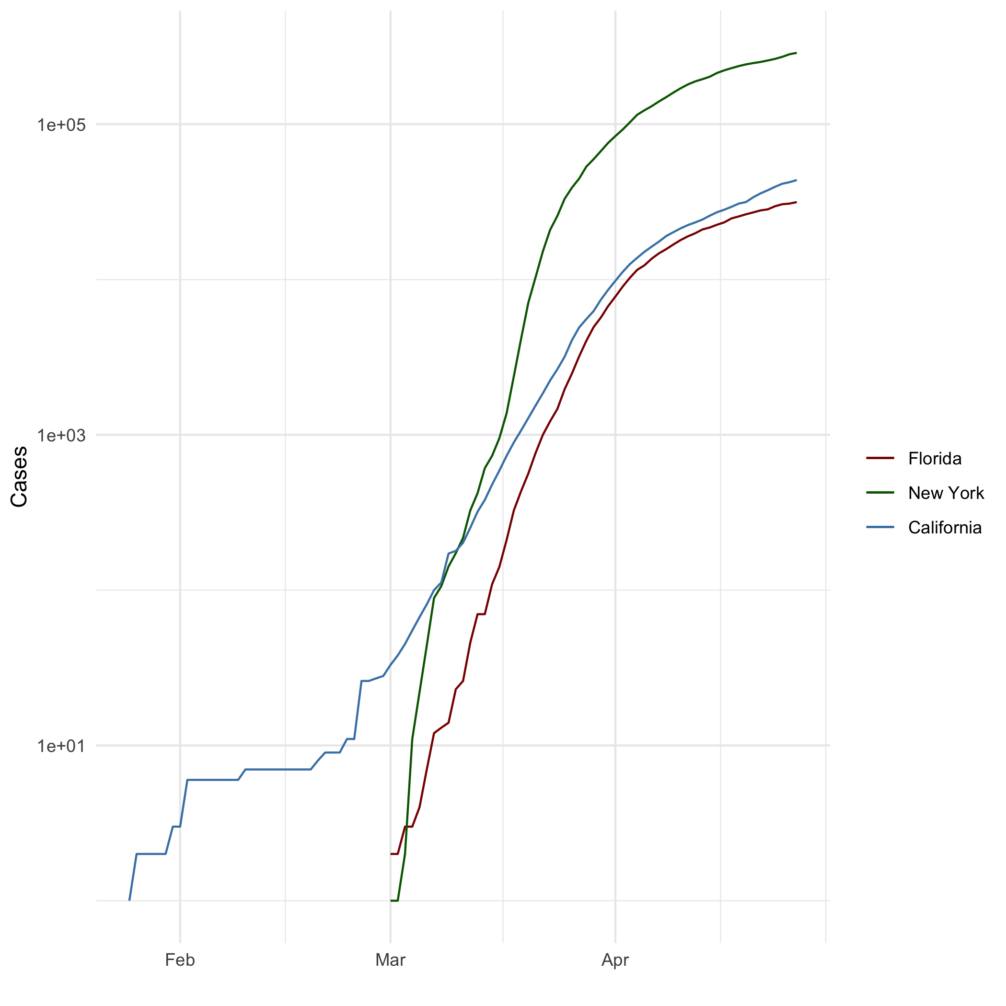

All Cases (Log Plot)

## Add a Quote

As far back as I can remember, I always wanted to be a gangster.

## Add an Equation

$y=mx+b$

$$y=mx+b$$

## Add a Footnote

Here is the first footnote[^1] And here is the second footnote[^2]

## Add Citations

* R for Everyone
* Discovering Statistics Using R

# Inline Code

library(ggplot2)  
theme_set(theme_minimal())  
  
## Set the working directory to the root of your DSC 520 directory  
setwd("C:/Users/mpari/OneDrive/DSC520/dsc520/")  
  
## Load the `data/r4ds/heights.csv` to  
heights_df <- read.csv("data/r4ds/heights.csv")  
  
## Load the file `"data/nytimes/covid-19-data/us-states.csv"` and  
## assign it to the `covid_df` dataframe  
covid_df <- read.csv("data/nytimes/covid-19-data/us-states.csv")  
  
  
## Parse the date column using `as.Date()``  
covid_df$date <- as.Date(covid_df$date)  
View(covid_df)  
typeof(covid_df$date)

## [1] "double"

## Create three dataframes named `california_df`, `ny_df`, and `florida_df`  
## containing the data from California, New York, and Florida  
california_df <- covid_df[ which( covid_df$state == "California"), ]  
ny_df <- covid_df[ which( covid_df$state == "New York"), ]  
florida_df <- covid_df[ which( covid_df$state == "Florida"), ]

## NY Times COVID-19 Data

## R4DS Height vs Earnings

# Tables

## Knitr Table with Kable

## Pandoc Table

# References