ASSIGNMENT 4

Sumbaraju Aditya

2020-01-07

# Markdown Basics

1. Under the ## Favorite Foods section, add an ordered list of your top three favorite foods
2. Under the ## Images section, insert the image 10-all-cases-log.png from completed/assignment04/plots/ directory with the caption All Cases (Log Plot)
3. Add one of your favorite quotes under the ## Add a Quote section.
4. Add a LaTeX formatted equation under the ## Add an Equation section.
5. Add any footnote under the ## Add a Footnote section.
6. Under the ## Add Citations section, create an unordered list with R for Everyone and Discovering Statistics Using R with the proper citations.

## Favorite Foods

1. Pizza
2. spicy poblano omelette
3. Mexican Tres Leches Pancakes

## Images

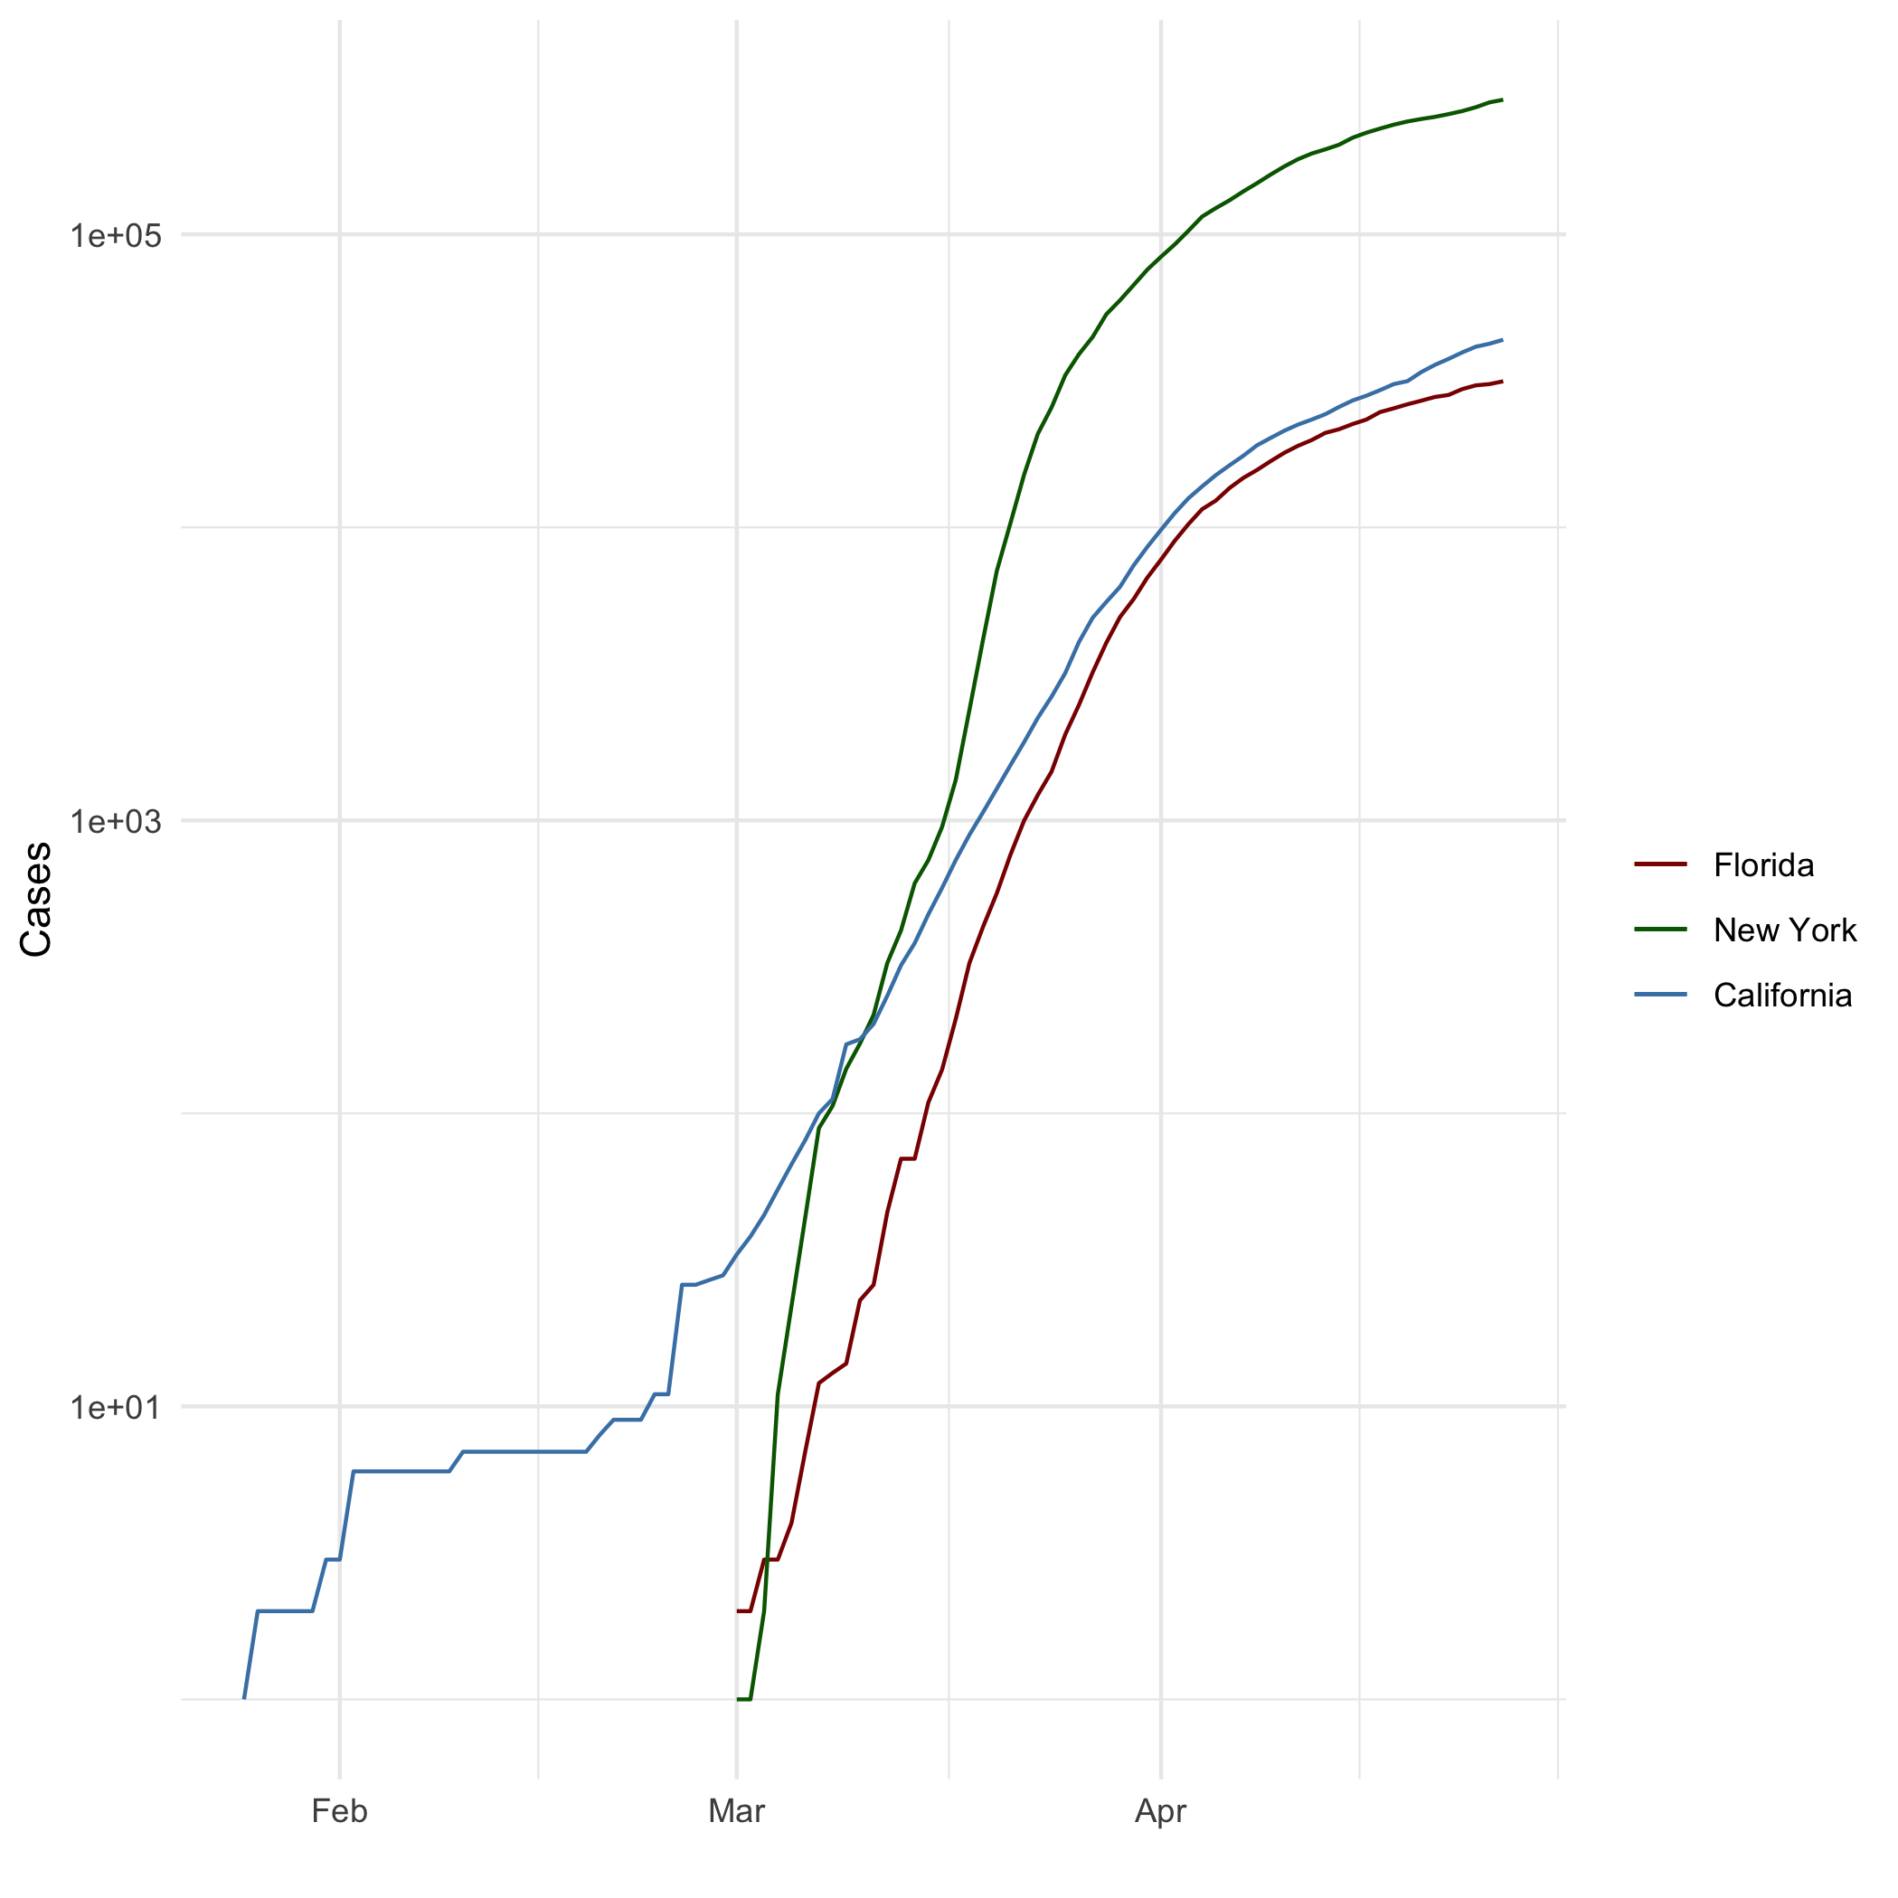

All Cases (Log Plot).

## Add a Quote

Remembering that you are going to die is the best way I know to avoid the trap of thinking you have something to lose. You are already naked. There is no reason not to follow your heart. – Steve Jobs, CEO of Apple

## Add an Equation

$$E=mc^{2}$$

$$\sqrt{a^{2}−b^{2}}$$

$$\frac{2xy^{2}}{4}$$

## Add a Footnote

This is a footnote.[1]

## Add Citations

* R for Everyone (Lander 2014)
* Discovering Statistics Using R (Field, Miles, and Field 2012)

# Inline Code

## NY Times COVID-19 Data

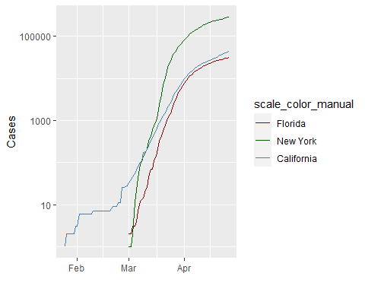

## R4DS Height vs Earnings

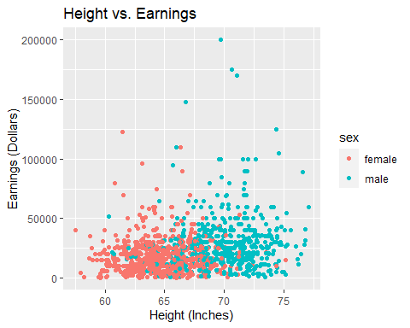

# Tables

## Knitr Table with Kable

Table 1: One Ring to Rule Them All

|  |  |  |  |  |
| --- | --- | --- | --- | --- |
| name | race | in_fellowship | ring_bearer | age |
| Aragon | Men | TRUE | FALSE | 88 |
| Bilbo | Hobbit | FALSE | TRUE | 129 |
| Frodo | Hobbit | TRUE | TRUE | 51 |
| Galadriel | Elf | FALSE | FALSE | 7000 |
| Sam | Hobbit | TRUE | TRUE | 36 |
| Gandalf | Maia | TRUE | TRUE | 2019 |
| Legolas | Elf | TRUE | FALSE | 2931 |
| Sauron | Maia | FALSE | TRUE | 7052 |
| Gollum | Hobbit | FALSE | TRUE | 589 |

## Pandoc Table

##   
##   
## +--------+--------+----------------+-----------------+------+  
## | Name | Race | In Fellowship? | Is Ring Bearer? | Age |  
## +========+========+================+=================+======+  
## | Aragon | Men | Yes | No | 88 |  
## +--------+--------+----------------+-----------------+------+  
## | Bilbo | Hobbit | No | Yes | 129 |  
## +--------+--------+----------------+-----------------+------+  
## | Frodo | Hobbit | Yes | Yes | 51 |  
## +--------+--------+----------------+-----------------+------+  
## | Sam | Hobbit | Yes | Yes | 36 |  
## +--------+--------+----------------+-----------------+------+  
## | Sauron | Maia | No | Yes | 7052 |  
## +--------+--------+----------------+-----------------+------+

|  |  |  |  |  |
| --- | --- | --- | --- | --- |
| Name | Race | In Fellowship? | Is Ring Bearer? | Age |
| Aragon | Men | Yes | No | 88 |
| Bilbo | Hobbit | No | Yes | 129 |
| Frodo | Hobbit | Yes | Yes | 51 |
| Sam | Hobbit | Yes | Yes | 36 |
| Sauron | Maia | No | Yes | 7052 |

# References

Field, A., J. Miles, and Z. Field. 2012. *Discovering Statistics Using R*. SAGE Publications. <https://books.google.com/books?id=wd2K2zC3swIC>.

Lander, J. P. 2014. *R for Everyone: Advanced Analytics and Graphics*. Addison-Wesley Data and Analytics Series. Addison-Wesley. <https://books.google.com/books?id=3eBVAgAAQBAJ>.

1. Assignment 04